European Union Risk Assessment Report

Lead metal
CAS No: 7439-92-1
EINECS No: [click here to insert EINECS No.]

Lead oxide
CAS No: 1317-36-8
EINECS No: [click here to insert EINECS No.]

Lead tetroxide
CAS No: 1314-41-6
EINECS No: [click here to insert EINECS No.]

Lead stabiliser compounds
Dibasic lead phthalate (CAS No: 69011-06-9)
Basic lead sulphate (CAS No: 12036-76-9)
Tribasic lead sulphate (CAS No: 12202-17-4)
Tetrabasic lead sulphate (CAS No: 12065-90-6)
Neutral lead stearate (CAS No: 1072-35-1)
Dibasic lead stearate (CAS No: 12578-12-0)
Dibasic lead phosphite (CAS No: 12141-20-7)
Polybasic lead fumarate (CAS No: 90268-59-0)
Basic lead carbonate (CAS No: 1319-46-6)
Basic lead sulphite (CAS No: 62229-08-7)
EINECS No: [click here to insert EINECS No.]

VOLUNTARY Risk Assessment
Lead Development Association International

Lead metal
CAS No: 7439-92-1

lead oxide
CAS No: 1317-36-8

Lead tetroxide
CAS No: 1314-41-6

lead stabiliser compounds
Dibasic lead phthalate (CAS No: 69011-06-9)
Basic lead sulphate (CAS No: 12036-76-9)
Tribasic lead sulphate (CAS No: 12202-17-4)
Tetrabasic lead sulphate (CAS No: 12065-90-6)
Neutral lead stearate (CAS No: 1072-35-1)
Dibasic lead stearate (CAS No: 12578-12-0)
Dibasic lead phosphite (CAS No: 12141-20-7)
Polybasic lead fumarate (CAS No: 90268-59-0)
Basic lead carbonate (CAS No: 1319-46-6)
Basic lead sulphite (CAS No: 62229-08-7)
EINECS No: [click here to insert EINECS No.]

Environmental Risk Assessment
Appendices to the Exposure assessment

Draft of April 2008

This report has been prepared by EURAS, ECOLAS and KUL under contract to the LDAI Lead Risk Assessment Working Group.

Forward
In response to a request from the European Commission to “start preparing the initial
assessments for substances on the EU working list as these were considered as Community priorities in the context of the industry voluntary initiatives for high production volume chemicals” the lead industry committed to undertake a Voluntary Risk Assessment (VRA) for lead metal, lead monoxide, lead tetraoxide, poly-basic lead fumerate, basic lead sulphate, basic lead carbonate, tetrabasic lead sulphate, dibasic lead phosphite, dibasic lead stearate, neutral lead stearate, dibasic lead phthalate, tetrabasic lead sulphate and basic lead sulphite. This initiative was endorsed by the EU Competent Authorities in 2001. Yearly summaries on progress were presented at the CA meetings.

This comprehensive VRA dossier took four years to draft before being submitted to the EU’s Technical Committee on New and Existing Substances (TCNES) for review, with the whole process managed by the Lead Development Association International. It was compiled in co-operation with expert consultants from EBRC and the International Lead Zinc Research Orgainisation for human health and from EURAS, ECOLAS and the Catholic University if Leuven for the environment. It is based on the principles of Regulation 793/93, 1488/94 and the detailed methodology laid down in the revised Technical Guidance Document on Risk Assessment for New and Existing Substances. Methodological experiences gained through other metal Risk Assessments were incorporated as appropriate. Additional up to date scientific information was integrated into the assessment where scientifically relevant. A broad cross section of the European lead industry and its downstream users were fully involved in the process and submitted a significant amount of proprietary data.

To ensure the transparency and quality of the dossier submitted to TCNES, the initial draft RA reports were refined by incorporating inputs from the Reviewing Country (Netherlands) and the independent peer review panels.

A single dossier covers the assessments for lead metal and the lead compounds, with
substance specific aspects provided where relevant. For the base data compilation, extensive literature searches were performed for each substance. Data gaps were filled with analogous data, where relevant, or by additional testing where possible. Where the information was either unnecessary for the lead risk assessment, or impossible to obtain, waiving for testing and/or justification to support derogation is discussed. Some remaining data gaps were identified and will be tackled as a follow-up to this report.

The draft risk assessment report was reviewed by TCNES between 2005 and 2008 and, based on the comments received, the report was significantly amended. Separate TCNES Opinions on the health and environmental parts of the report were prepared by the ECB and endorsed by TCNES. These Opinions summarise the views of TCNES on this report.

This Draft Risk Assessment Report and its appendices (the “Report”) is the property of the member companies of the Lead Reach Consortium companies. A full list of those companies is available upon request from the Lead Development Association International.

This Report is protected by the laws of copyrights in England and Wales, European Community Law, the Berne Convention the Universal Copyright Convention and other relevant international copyright.

Industries/companies or any other legal entity wishing to use all or any part of this Report and/or their appendices, for any purpose (including without limitation any regulatory purpose such as for EU REACH registrations) MAY NOT DO SO without having previously contacted the Lead Development Association International (acting as secretariat for the Lead Reach Consortium) and agreed in writing appropriate terms of access and paid the appropriate licence fee.

In order to avoid possible misinterpretations or misuse of the findings in this draft, anyone wishing to cite or quote any part of this report, or use its related appendices, is advised to contact Lead Development Association International beforehand.

Contact details of the responsible:

Dr Andy Bush, Lead Development Association International, 17a Welbeck Way, London, W1G 9YJ, United Kingdom. Tel +44 (0) 207 499 8422, email bush@ldaint.org

CONTENTS

APPENDIX A Targeted risk assessment of lead in ammunition 5
Appendix C Background report – Pb emission inventory – draft 02/2007 - ECOLAS 128
Appendix f Added risk approach. Derivation of local exposure values 270
Appendix g Use of measured agricultural soil concentrations for different European countries as regional background for PEClocal soil determination 282
Additional scenario next to the use of forest soil concentrations (natural soil) as regional background 282

APPENDIX A Targeted risk assessment of lead in ammunition

November 2007

This report has been prepared by EURAS, ECOLAS and D Peddicord under contract to AFEMS

Principal authors:    Kortrijksesteenweg 302  B-9000 Gent, Belgium  E-mail: Patrick.VanSprang@euras.be  Phone: 32 9 241 77 50  Fax: 32 9 241 77 02  http://www.euras.be |   Kortrijksesteenweg 302  B-9000 Gent, Belgium

Scientific expertise:

Frederik Verdonck, Marleen Vandenbroele, Patrick Van Sprang
EURAS bvba
Kortrijksesteenweg 302
B-9000 Gent
Belgium
Tel.: ++32 9 241 77 45
Fax: ++32 9 241 77 02
patrick.vansprang@euras.be

Annick Van Hyfte & Karen Callebaut
ECOLAS NV
Kortrijksesteenweg 302
B-9000 Gent
Belgium
Tel: ++ 32 9 241 77 28
Fax: ++ 32 9 241 77 01
avanhyfte@arcadisecolas.be

Richard K. "Dick" Peddicord
Dick Peddicord & Company, Inc.
1115 Cooper's Landing Road
Heathsville VA 22473
USA
Tel: +1 804 580-3320
Fax: +1 804 580-3360
http://www.dickpeddicord.com
dick@dickpeddicord.com

© Lead Development Association International

All rights reserved. No part of this document may be reproduced or transmitted in any form or by any means, electronic or mechanical, including photocopying, recording, or any information storage or retrieval system without prior permission from the author. This copyright is protected under the law of England and Wales, European Community Law, the Berne Copyright Convention, the Universal Copyright Convention and other relevant international copyright law.

Table of contents

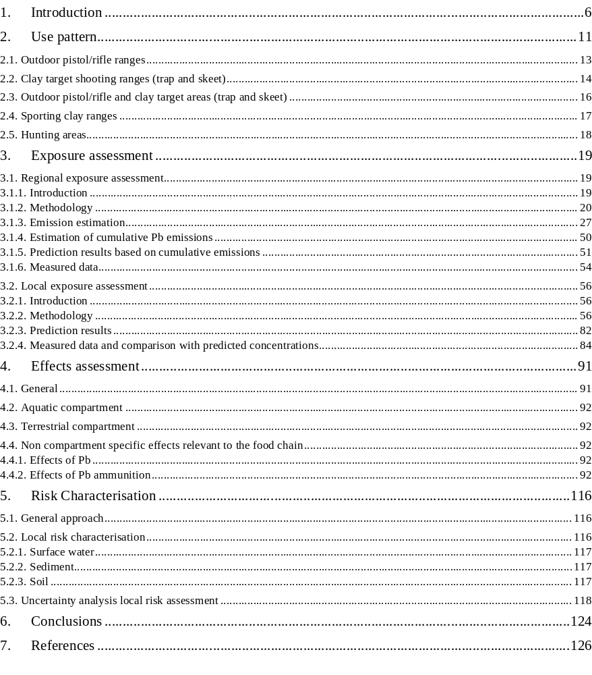
List of figures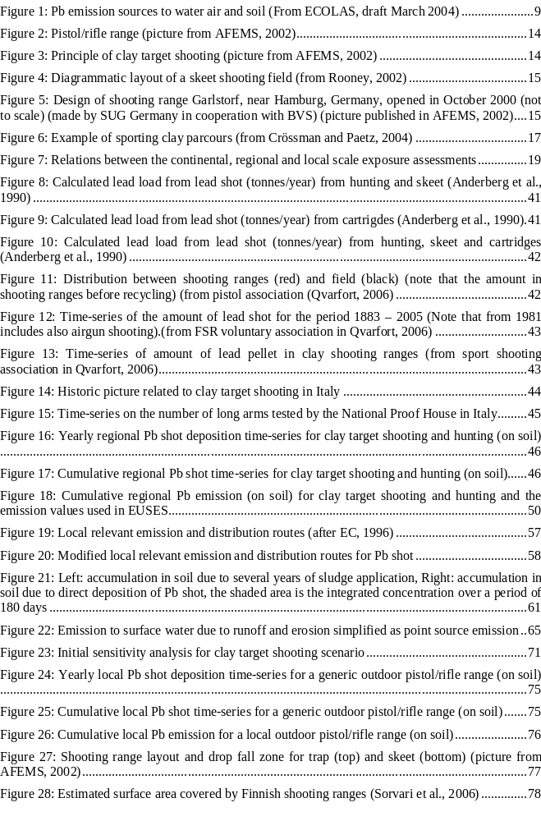

List of tables
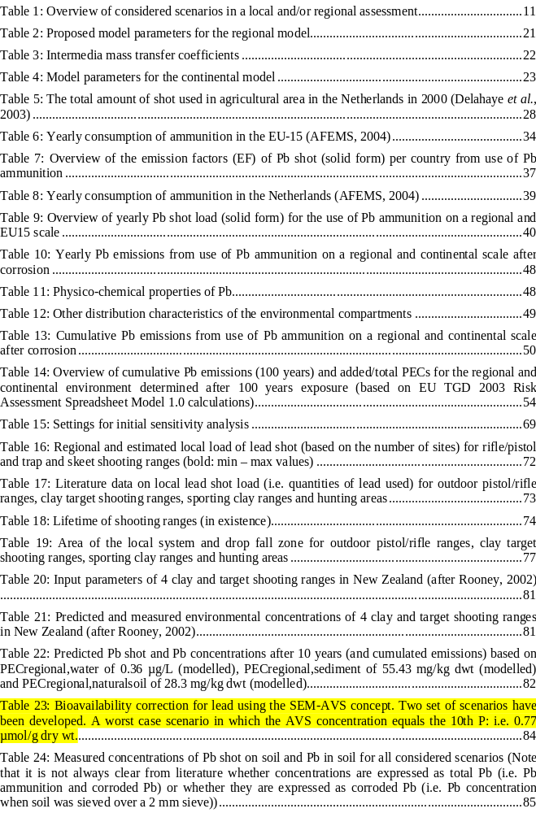

Introduction

The environmental risk assessment of metals in Europe is embedded in the European Council adopted Council Regulation (EEC) 793/93 that complements the already existing rules governed by Council Directive 67/548/EEC for "new" chemical substances. Substances that have been identified as a priority substance should embark into a full risk assessment following the guidelines as outlined in the Technical Guidance Document on Risk Assessment for New and Existing Substances (TGD, 1996/2003). Typically, an EU Member State volunteers or is appointed to act as rapporteur for that specific substance on the priority list and is responsible to perform an in-depth risk assessment covering both human health and environmental issues. During the process the quality and status of the risk assessment is scrutinized at the so called Technical Committees New and Existing Substances (TC-NES) composed of EU Member States and observers from industry, consumer organizations, trade unions, environmental organizations and certain international organizations (e.g. OECD, WHO). The Rapporteur’s final-draft Risk Assessment Report agreed at the Member State level is then submitted to the Scientific Committee on Toxicity, Ecotoxicity and the Environment (SCTEE) which advices the European Commission on the quality of the Risk Assessment Report (RAR) and its adherence to general scientific principles.

In simple terms risk assessment involves the identification of a hazard and the level of exposure at which it occurs, coupled with measurement of actual exposure levels of people and ecosystems. The combination of hazard and exposure data enables risks to be identified and appropriate risk management measures to be adopted. Emissions and consequently the environmental impacts have to be evaluated at each stage of the life-cycle of a chemical, from production, through processing, formulation and use, to recycling and disposal. Protection goals for the environment include aquatic organisms, sediment dwelling organisms, soil-dwelling organisms, micro-organisms in waste water treatment plants, and mammals and birds exposed via accumulation up the food chain.

This risk assessment focuses specifically on the issues related to the environmental part. The purpose of an environmental risk assessment is to determine the potential risk posed by a chemical or a chemical product to the ecosystem. Three phases can be distinguished in the assessment of the risks of a chemical: exposure assessment, effects assessment and risk characterization. The reader is referred to the EU Technical Guidance Documents for more detailed information (TGD, 1996/2003).

The international Lead Development Association (LDAI) has initiated voluntary risk assessments on the production and use of their materials across the EU that would allow them to comply in an anticipative way with the forthcoming legislative obligations. These voluntary risk assessments (VRAR) are carried out by the industry itself in cooperation with the appropriate authorities, within the EU and the Member States that are joining the process to ensure that the outcome of the risk assessment appropriately reflects any relevant risks that may be identified. This exercise consists of an in-depth assessment of both the effects, aiming at deriving thresholds that are protective for the ecosystem, and the exposure, aiming at reflecting the concentrations in the different compartments to which target organisms are exposed to, in accordance with the stipulations laid down in the Commission Regulation No. 1488/94 on risk assessment of existing substances.

In 2004, an initial draft of the regional exposure assessment was finalised in which emissions of diffuse environmental sources of lead (compounds) were quantified (ECOLAS, draft 2004). In this preliminary analysis shooting (as a sport or recreative activity) and hunting activities were identified as potential important lead sources for the soil compartment. Lead ammunition accounted for 30% of the total Pb-emissions to soil in the European Union (see Figure 1). As a result, it was deemed appropriate to initiate a more detailed study (targeted risk assessment) on the emissions due to the use of lead ammunition in order to assess the potential impact of shooting and hunting.

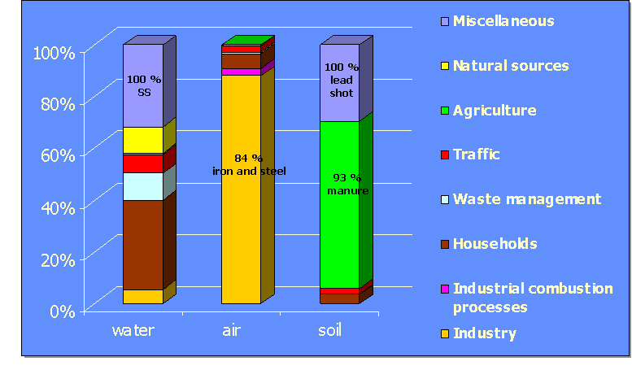
Figure 1: Pb emission sources to water air and soil (From ECOLAS, draft March 2004)

This targeted study will primarily focus on the following issues:
- Refinement/development of the methodologies used for the assessment of regional and continental emissions of lead associated with the use of lead ammunition and bullets for hunting and sport shooting. This includes a detailed literature study on the different types of activities involved, use of lead ammunition, the types of ammunition, corrosion rates of lead ammunition, management techniques for shooting ranges, measured environmental concentrations in the surrounding of shooting ranges etc.
- Development of generic regional and local exposure scenarios representative for hunting/shooting ranges in Europe (including future emissions from historic deposition).
- Regional and local risk characterisation

Use pattern

In this section, several scenarios on the use of lead ammunition are described. Lead ammunition is covering lead shot, lead pellets and bullets.

For the release estimation of substances according to the TGD (1996, 2003), a distinction is usually made between substances that are emitted through point sources at specific locations and substances that enter the environment over a wider area through diffuse releases. Point source releases have a major impact on the environmental concentration on a local scale (PEClocal) but also contribute to the environmental concentrations on a larger scale (PECregional) (EC, 1996). Local sites are considered as technical areas with no ecological value. Only ecologically relevant compartments receiving Pb emissions and surrounding the technical area are assessed. In a regional scenario, no technical area is defined and Pb emissions are spread out over a large area. Consequently, every ecological relevant compartment is assessed. For each of the scenarios discussed below, it is indicated whether a local and/or regional assessment is performed (overview is given in Table 1). The scenarios with a mark between brackets are only qualitatively assessed since there is insufficient TGD guidance to conduct a quantitative assessment (see further).

Table 1: Overview of considered scenarios in a local and/or regional assessment
Scenario | Local | regional
Outdoor pistol/rifle range | X
Outdoor pistol/rifle area | (X)
Clay target shooting range (trap and skeet) | X | X
Clay target shooting area (trap and skeet) | (X) | X
Sporting clay range | (X) | X
Hunting area | (X) | X

Sorvari et al. (2006) made an extensive inventory of Finnish shooting ranges collected using questionnaires. Regional environment Centres, local hunting associations, communal environmental authorities and the armed forces assisted with data collection. According to their survey, in Finland rifle ranges form the most common shooting range type, representing ca. 40% of the total number. The proportion of shotgun areas is ca. 30% and of pistol ranges ca. 20%.

A clear distinction should be made between shooting ranges and shooting areas:
- A shooting range is defined as “an area designed and operated specifically for recreational shooting”. The owner/operator of the site complies with environmental regulations and it is assumed there will be remediation upon closure. The range has a clearly defined boundary and it is assumed that lead ammunition is not allowed to exceed the boundary of the range. A shooting range can therefore be considered as technical area under the EU New and Existing Substances directive. Consequently, environmental risk for soil within the site is not considered because the drop fall zone of Pb shot is considered to be within the shooting range perimeters and the soil risk of local industrial sites is not considered in the TGD (1996; 2003).
- Shooting areas are “areas not specifically designed and operated for shooting but where shooting activities can take place”. These ranges do not comply with best practise guidelines and may not be subject to, or comply with, relevant environmental regulations. The definition of a shooting area clearly differs among the EU member states. For example in the Flemish environmental legislation (Belgium), shooting areas are defined as “shooting contests organised maximum twice per year on the same piece of land with a maximum duration of 4 consecutive days”. Shooting areas are exempted from the Flemish soil pollution regulation and can therefore not be considered as technical areas.

National environmental or other laws or ordinances vary in the extent to which deposition of lead shot outside the perimeter of the shooting range is permitted and in the extent to which remediation is required upon closure. The general trend is towards increasing restrictions on ammunition falling outside the range boundary. In addition to regulatory trends, industry promotes voluntary actions by range operators to avoid any Pb shot deposition outside the range perimeters. AFEMS (2002) recommends avoiding shooting over arable land and spent shot from clay target shooting should not fall into wetlands. In Europe, the shot fall zone is typically owned by a private person or company. Lead shot may also be restricted from falling outside the clay target range perimeters for human safety reasons alone (AFEMS, personal communication). In Finland, most shooting ranges are open and accessible (Sorvari et al., 2006). However according to Industry, shooting ranges are typically fenced areas in Europe. The concept is that clay target shooting ranges are increasingly becoming accessible only to the operators and shooters. In most countries today, remediation to an appropriate level is forced by law when closing a clay target shooting range.

Additional (legislative) information from three European regions/countries (Finland, Flanders (Belgium) and Germany) was collected to illustrate the definition of shooting range:
- In Finland, ownership is an important factor when remedial actions are needed. Finnish environmental legislation follows the polluter pays principle, which places the liability on the polluter (Sorvari et al., 2006). The Environmental Protection Act states that: "Any party whose activities have caused the pollution of soil or groundwater is required to restore said soil or groundwater to a condition that will not cause harm to health or the environment or represent a hazard to the environment”. In the case of recreational shooting activities, the polluters are individuals belonging to a non-profit-making club, a circumstance hardly likely to be proven liability for the adverse environmental consequences of their activities. According to the current legislation, if the polluter is indigent, liability can be transferred to the landowner and thence to the municipalities and finally to the state. According to Sorvari’s (2006) survey, Finnish shooting ranges are mainly privately owned (40%). Very often the landowner is a private person or a shooting or hunting club. Communally owned ranges represent 13%, and state owned ranges 10%, of the total number. Ownership data were unavailable for one-third of all ranges.
- In Flanders (Belgium), shooting ranges for fire arms (excluding paintball shooting) are subject to a preliminary and descriptive soil examination when land is transferred from ownership or every 20 years (Heyman & Smout, 2005; VLAREBO; 1996). A preliminary soil investigation provides indications on the degree of soil pollution. Remediation depends on the degree of pollution and the time it has been established (recently or long ago). The first step in the process of remediation is a descriptive soil study which tries to find out about the dispersion of the pollution and its future evolution. Moreover, the risks of the pollution are evaluated. If pollution limits are exceeded, a soil remediation project is worked out.
- According to the knowledge of Prof. Crössman (personal communication), there are no agricultural used sites within the boundaries of the ranges (shot fall zone) in Germany. There are often agreements (with financial compensation) between the operator and the farmer not to use these sites. In many cases the operator would like to buy the sites (Prof. Crössman, personal communication).

Although the picture may vary considerably from country to country within the EU, the trend is increasing towards containing the lead shot within the range perimeter. Indeed agricultural activities are either forbidden by law in many countries or discouraged in all the rest (AFEMS, personal communication).

Based on the information above, one can conclude that many clay target ranges throughout the EU can be considered as technical areas to be assessed in a local scenario. In this local assessment, it is assumed that clay target shooting ranges are properly managed according to several guidelines found in literature (ISS – Rules and Regulations; AFEMS 2002).

Following scenarios were excluded from this targeted risk assessment:
- A scenario covering use of lead ammunition for military or police purposes. Information on this use pattern is very hard to collect and military use is likely to be subject to a different legislative framework.
- Indoor shooting ranges. Well-managed indoor ranges are considered to be closed systems with no or negligible emissions to nearby water (direct or through runoff), with no leaching to groundwater and with recycling programmes. The amount of airborne lead released when a bullet is fired is small. However, repeated firing in an enclosed area can raise concentrations to harm levels (AFEMS, 2002). A separate human health assessment for indoor shooting is being assessed.

2.1. Outdoor pistol/rifle ranges

Target shooting involves the use of rifles and pistols to shoot at stationary, bulls-eye type targets. A main priority is to contain fired bullets for safety reasons but this, in turn, helps the control of the spent lead (AFEMS, 2002). Only direct emission to soil is considered because the line of fire is highly restricted and the trajectory of bullets is, effectively, horizontal. It is therefore unlikely that direct emissions to water will occur.

The bullets can be trapped after hitting the target and individual shooting ranges or the complex as a whole can be contained within earth berms. Periodically, as lead accumulates in the backstop berms it should be removed. This involves the excavation of the face of the berm, to up to 1.5 m, depending on the types of rifle/pistol being used. The soil is screened to remove lead bullets and fragments, and replaced onto the berm (AFEMS, 2002). It is assumed that 70% of rimfire, centerfire and pistol/revolver lead is collectable/collected and recycled (AFEMS, personal communication).

Outdoor pistol/rifle ranges are assessed as local sites. Consequently, environmental risk for soil within the site is not considered because the drop fall zone of Pb shot is within the range perimeters and the soil risk of local industrial sites is not considered in the TGD (1996; 2003). Only emissions to the surrounding environment are considered.

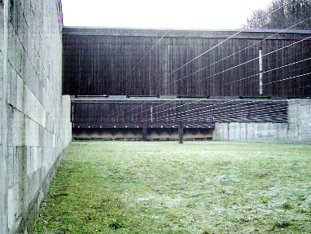
Figure 2: Pistol/rifle range (picture from AFEMS, 2002)

2.2. Clay target shooting ranges (trap and skeet)

Clay target shooting is an outdoor recreational and competitive sport which involves participants firing shotguns using cartridges of spherical pellets of Pb to break flying clay targets launched into the air (see Figure 3). Clay target shooting involves many variations of the sport in the way that targets are presented to the shooters, such as changes in the height and speed of the target, the direction of flight, and the locations of stations where shooters stand. The more common disciplines are trap, skeet and sporting clays.

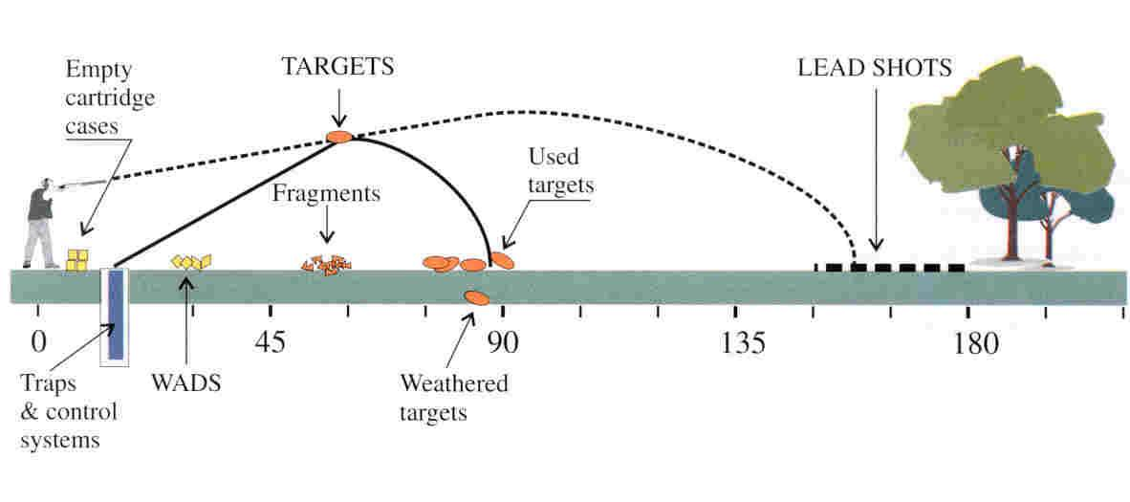
Figure 3: Principle of clay target shooting (picture from AFEMS, 2002)

Trap shooting, also referred to as ‘down the line’ shooting, involves targets launched from a machine put in a pit, everyone within a horizontal spread of approximately 90°. The shooters shoot at the launched target from different positions in five lanes. The five shooting stations must be arranged on a straight line at a distance 15 m behind the pit (ISSF – Rules and Regulations). The Pb shot appears to be deposited directly in front of the trap for a distance of some 210 m (AFEMS 2002).

Skeet shooting, also referred to as ‘across the line’ shooting, involves shooting two clay targets launched from two separate traps in towers located about 40 m apart. The targets are released alternately or simultaneously along intersecting flight paths and shooters stand in a series of 8 shooting stations (see Figure 4) (ISSF – Rules and Regulations).

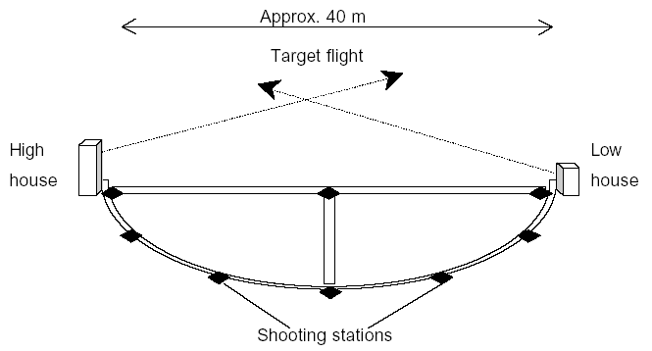
Figure 4: Diagrammatic layout of a skeet shooting field (from Rooney, 2002)

Pb shot is more and more recovered and recycled on clay target shooting ranges. Recovery typically means scraping off the top soil layers and screening pellets out of the non-lead material, which is returned to the ground. The separated pellets are collected and removed off-site. This can be conducted by hand raking and sifting, mechanical removal and professional removal (AFEMS, 2002). An obvious option to limit the dispersion of shot is by physically confining it to where the clay targets are shot. The further the pellets travel beyond that area the wider their environmental impact. Figure 5 schematically shows the use of berms (about 20m high) being used to combine trap, skeet and other layouts in Germany. However berms of such a size are likely to be much less common in other Member States. It is assumed that across the EU 5% of lead shot is collected and recycled (AFEMS, personal communication) although collection rates may vary considerably from country to country.

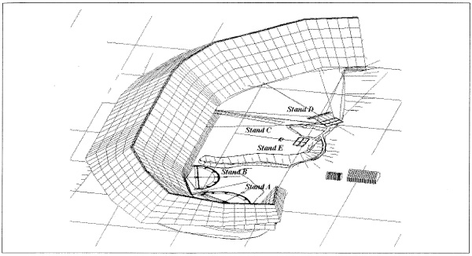
Figure 5: Design of shooting range Garlstorf, near Hamburg, Germany, opened in October 2000 (not to scale) (made by SUG Germany in cooperation with BVS) (picture published in AFEMS, 2002)

2.3. Outdoor pistol/rifle and clay target areas (trap and skeet)

Outdoor pistol/rifle and clay target (trap and skeet) areas may to a large extent be similar to the respective shooting ranges. However, they are not specifically designed and operated for shooting. These areas do typically not comply with best practise guidelines. These areas are not subject to, or comply with, relevant environmental regulations. For example, shooting areas are defined in the Flemish environmental legislation as “shooting contests organised maximum twice per year on the same piece of land with a maximum duration of 4 consecutive days”. Shooting areas are exempted from the Flemish soil pollution regulation and can therefore not be considered as technical areas. However, it is important to note that the definition of a shooting area varies between the national legislations of the EU Member States. For example, in other countries, these shooting areas can be located in the middle of the forest or arable land where wildlife can freely pass through the areas and forage on plants and invertebrates.

Given the difficulties and time constraints faced in building a generic scenario for such a widely varying practise, this scenario was not assessed quantitatively in the current risk assessment.

2.4. Sporting clay ranges

Sporting clays is a relatively new discipline which simulates actual field hunting by combining different target flight speeds and angles and different target sizes. The target might be crossing, climbing, incoming, outgoing, streaking high overhead, flying low, or any combination of the above (Rooney, 2002).

There are two types of sporting clays. In the first type, the shooters are staying on a fixed shooting position (similar to clay target shooting as in 2.2). The second type has a much wider surface area. Therefore, the area of Pb shot deposition from sporting clays is less well-defined and a predictable pattern of deposition is unlikely due to the use of mobile traps and target flight variations (see Figure 6). Sporting clays shooting typically takes place over 40-100 ha of land and the continually changing layout of the course means that heavy loadings of shot occur over a much wider area than for skeet and trap shooting (Rooney, 2002).

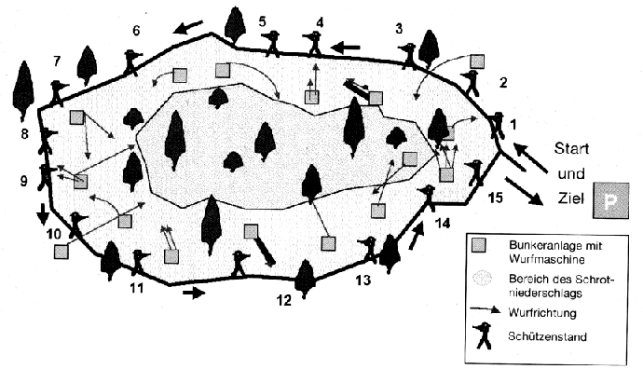
Figure 6: Example of sporting clay parcours (from Crössman and Paetz, 2004)

Although there are a number of these sporting clay sites throughout Europe (see Table 16), the first type of sporting clay was not further considered as a local scenario because clay target shooting is considered to be an equivalent scenario to sporting clay shooting. After all, the deposition zone of Pb shot in clay target shooting (1-4 ha) is much smaller compared to the deposition zone for sporting clay (Pb concentrations are smaller if Pb shot is dispersed over a wider area). However Pb shot emission due to sporting clay may vary from Pb shot emission due to clay target shooting, depending on the frequency of use of sporting clay ranges. The second type of sporting was also not assessed in a local scenario because of its wide-spread emission character.

For the second type of sporting clays, a regional assessment, in which wide-spread (local) target shooting ranges are emitting lead to the environment (surface water and agricultural soil), is assessed as a worst-case consideration because of the lack of available, reliable statistics and more detailed information whether Pb shot emission to agricultural soil can occur.

Since Pb emissions due to sporting clay could not unambiguously be separated from Pb emissions due to clay target shooting, and also because it cannot be guaranteed that shot from clay target shooting ranges will always fall within the boundary of the range, a regional scenario was assessed for both sporting clay and clay target shooting. This represents an unrealistic worst-case assumption since shot from clay target shooting can fall within the boundary of the range. Nevertheless, this worst case assumption is used here as a first tier approach. In case of potential risk, refinement of the assessment is recommended.

Note that clay target shooting will be used in this report as an umbrella term for trap and skeet (described in section 2.2) and sporting clays (section 2.4).

2.5. Hunting areas

Over 7 million Europeans take part in the hunting activities, which are for most species restricted to a specific season. Hunting is a recreational activity and a tool for wildlife management common to all European Union countries. The hunters vary from 0.2 to 6%, as a percentage of population in the various EU countries, most of them in rural areas. Hunting can be divided essentially in two main types: small game (mainly use of shotgun cartridges) and big game (mainly use of rifle cartridges). Note that in several countries (e.g. Sweden, Denmark, Switzerland), Roe deer are shot with shotgun-pellets and rifle bullets are also used for bird hunting.

Hunting is not an activity which is often repeated on the same area year after year. The hunting areas change continuously for a variety of reasons (e.g. wildlife presence, climate,…) and hunting is exercised over large areas (5 – 150 ha; Booij et al., 1993; Zentralstelle Österreichischer Landesjagdverbände, 2002). Hunting can also be exercised over more well defined (smaller) areas. Hunting can be exercised on dry areas such as agricultural land, grassland, forests and on wetlands such as lakes, ponds, marshes, rivers (inland waters) and estuaries, seashores (coastal waters) or a combination of both. A regional scenario was performed for hunting because hunting is exercised on a large area and the Pb shot emission is diffuse.

It must also be recognised however that in some countries hunting may take place over well defined but reasonably large areas of land, e.g. in the case of managed hunting areas. It is recognised that a local hunting scenario needs to be further developed. It is however not straightforward to develop such scenario as it is not clear how such areas should be assessed as they neither represent a true local scenario nor a true regional scenario and as TGD guidance is lacking. Monitoring data in hunting areas are scarce and a modelling exercise would require several assumptions on the size of a hunting area, spatial density of lead shot deposition loads, the fraction emitted to water and fraction emitted to soil and a reasonable lifetime for the area. Hence no quantitative assessment of such areas has been made in this report.

Exposure assessment

The concentrations of substances released from point and diffuse sources over a wider area are assessed for a generic regional environment. The PECregional takes into account the further distribution and fate of the chemical upon release. It also provides a background concentration (i.e. concentration in environmental compartments that enter the local system) to be incorporated in the calculation of the PEClocal. As with the local models, a generic standard environment is defined. The PECregional is assumed to be a steady-state concentration of the substance for one year of emission.

Concentrations in air and water are also estimated at a continental scale (Europe) to provide inflow concentrations for the regional environment. Figure 7 illustrates the relationship between the three spatial scales. The local scale receives the background from the regional scale; the regional scale receives the inflowing air and water from the continental scale.

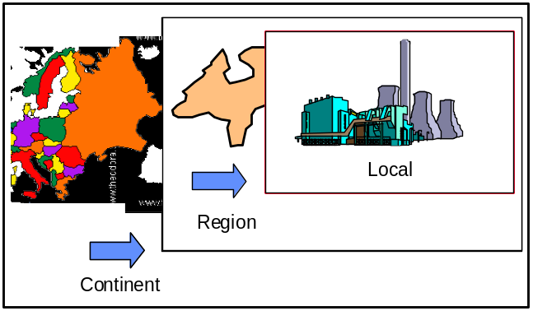
Figure 7: Relations between the continental, regional and local scale exposure assessments

The continental, regional and local assessment is subsequently conducted in this chapter.

3.1. Regional exposure assessment

3.1.1. Introduction

The CSTEE recommended that uncertainties and assumptions on Pb shot/ammunition emissions and corrosion rates are further examined and analysed through a focused literature review and possible dedicated research in order to reduce uncertainties associated with the present calculations in the Dutch emission inventory (VROM, 2002) (CSTEE, 2003).

After discussion of the methodology to be used (note that not all discussed processes are relevant for Pb shot), the regional emission is first estimated (in section 3.1.3) and second, the regional Predicted Environmental Concentrations (PECs) are estimated based on relevant release and fate processes (in section 3.1.4). For this second step, all lead sources (including from other sectors) were taken into account. A comparison in PECs prior and posterior to the emission refinement is made. Further information on the Pb emissions of the other sectors can be found in the main Pb RAR.

3.1.2. Methodology

3.1.2.1. Calculation of PECregional

Regional computations are performed by means of multi-media fate models based on the fugacity concept. Such models have been described by Mackay et al. (1992), Van de Meent (1993) and Brandes et al. (1996) (Simplebox). These models are box models, consisting of a number of compartments which are considered homogeneous and well mixed. A substance released into the model scenario is distributed between the compartments according to the properties of both the substance and the model environment.

Several types of fate process are distinguished in the regional assessment:
- Emission, direct and indirect (via STP) to the compartments air, water, industrial soil and agricultural soil
- Degradation, biotic and abiotic degradation processes in all compartments
- Diffusive transport, as e.g. gas absorption and volatilisation. Diffusive mass transfer between two compartments goes both ways, the net flow may be either way, depending on the concentrations in both compartments
- Advective transport, as e.g. deposition, run-off, erosion. In the case of advective transport, a substance is carried from one compartment into another by a carrier that physically flows from one compartment into the other. Therefore, advective transport is strictly one-way.

Substance input to the model is regarded as continuous and equivalent to continuous diffuse emission. The results from the model are steady-state concentrations, which can be regarded as estimates of long-term average exposure levels. The fact that a steady state between compartments is calculated does not imply that the compartment to which the emission takes place is of no importance. In a Mackay-type Level III model, the distribution and absolute concentrations may highly depend upon the compartment of entry.

Advective import and export (defined as inflow from outside the model or outflow from the model environment) can be very important for the outcome of both regional and local model calculations. Therefore the concentration of a substance at the “border” of the region must be taken into account. This is defined as the background concentration of a substance. The background concentration in a local model can be obtained from the outcome of the regional model. The background concentration in the regional model has to be calculated using a similar box model of a larger scale, e.g. with the size of the European continent. In this continental model, however, it is assumed that no inflow of air and water across the range perimeters occurs. Furthermore, it is assumed that all substance releases enter into this continental environment. The resulting steady-state concentrations are then used as transboundary or background concentrations in the regional model.

3.1.2.2. Model parameters for PECregional

When calculating the PECregional it is important which modelling parameters are chosen and what fraction of the total emissions is used as emission for the region. There are two different possibilities:
- Calculation of a PECregional on the basis of a standardised regional environment with agreed model parameters
- Calculation of a PECregional on the basis of country specific model parameters

A standardised regional environment should be used for the first approach in the calculation of PECregional. When more specific information is available on the location of production/emission sites, this information can be used to refine the regional assessment. The second approach may sometimes result in a better estimation of the concentrations for a specific country. However, depending on the information on production-site location, it will lead to a number of different PEC values which makes a risk characterisation at EU level more complicated.

Calculations are performed for a densely populated area of 200 x 200 km with 20 million inhabitants. Unless specific information on use or emission per capita is available, it is assumed that 10% of the European production and use takes place within this area, i.e. 10% of the estimated emission is used as input for the region. The model parameters proposed for this standard region are given in Table 2.

Table 2: Proposed model parameters for the regional model
Parameter | Value in regional model
Area of the region system | 4x10⁴ km²
Area fraction of water | 0.03
Area fraction of natural soil | 0.60
Area fraction agricultural soil | 0.27
Area fraction of industrial/urban soil | 0.10
Mixing depth of natural soil | 0.05 m
Mixing depth of agricultural soil | 0.2 m
Mixing depth of industrial/urban soil | 0.05 m
Atmospheric mixing height | 1000 m
Depth of water | 3 m
Depth of sediment | 0.03 m
Fraction of sediment compartment that is aerobic | 0.10
average annual precipitation | 700 mm/yr
Wind speed | 3 m/s
Residence time of air | 0.7 d
Residence time of water | 40 d
Fraction of rain water infiltrating soil | 0.25
Fraction of rain water running off soil | 0.25
EU average connection percentage to STP | 80%

The area fractions for water and for natural, agricultural and industrial/urban soils, are average values obtained from ECETOC (1994), supplemented with data received from Sweden and Finland. Data for Norway and Austria are obtained from the FAO statistical databases (http://apps.fao.org/).

The residence time for air (defined as the time between air entering and leaving the region) of 0.7 days is derived from the wind speed of 3 m/s and the area of the region. The residence time of water of 40 days is selected as a reasonable average for the European situation.

The flow of water through the system is the sum of the amount of rain (run off and directly into surface water), effluent discharges, and inflow of rivers. Given the average rainfall of 700 mm and runoff fraction of 0.25, the resulting flow of water through the model environment necessary to obtain this residence time is 6.9 x 10⁷ m³/d (EC, 1996).

The amount of wastewater discharged is the product of the amount of wastewater discharged per person equivalent and the number of inhabitants of the system. Using a flow per capita of 200 l/d (equivalent to the value used in the SimpleTreat model) and a population of 20 million, this results in an additional water flow through the model environment of 4.0 x 10⁶ m³/d. The inflow caused by inflowing river water is 6.5 x 10⁷ m³/d.

In addition to the environmental characteristics of the region, selected intermedia mass transfer coefficients are required in the multi-media fugacity model to ensure comparability of the outcome with other models. These transfer coefficients are summarised in Table 3.

Table 3: Intermedia mass transfer coefficients
Parameter | Value
Air-water interface: air side partial mass transfer coefficient | 1.39 x 10⁻³ m/s
Air-water interface: water side partial mass transfer coefficient | 1.39 x 10⁻⁵ m/s
Aerosol deposition rate | 0.001 m/s
Air-soil interface: air side partial mass transfer coefficient | 1.39 x 10⁻³ m/s
Air-soil interface: soil-air side partial mass transfer coefficient | 5.56 x 10⁻⁶ m/s
Air-soil interface: soil-water side partial mass transfer coefficient | 5.56 x 10⁻¹⁰ m/s
Sediment-water interface: water side partial mass transfer coefficient | 2.78 x 10⁻⁶ m/s
Sediment-water interface: pore water partial mass transfer coefficient | 2.78 x10⁻⁸ m/s
Net sedimentation rate | 3 mm/yr

3.1.2.3. Model parameters for the continental concentration

The continental box (Table 4) covers all 15 EU countries and Norway and has similar percentages for water and natural, agricultural and industrial/urban soils as given in Table 2. All other parameters are similar to the ones given in the TGD. Emission estimation for the continental box should be based on EU-wide production volume of the substance. The resulting concentrations in water and air must be used as background concentrations (i.e. concentrations in water and air that enter the system) in the regional model. When the model is built according to Figure 7 it is assumed that no inflow of the substance to the continental model takes place.

More recent versions of multi-media models do also contain so-called global scales for different temperature regions, for instance moderate, tropic and arctic (see e.g. Brandes et al., 1996). In this case the continent is embedded in the moderate scale just like the region is embedded in the continent. The size of the total global scale is that of the northern hemisphere. The global scales allow for a more accurate estimation of continental concentrations although this effect tends to be marginal (EC, 2003). Global scale is currently not accounted for.

Table 4: Model parameters for the continental model
Parameter | Value in continental model
Area of the continental system | 3.56 x 10⁶ km²
Area fraction of water | 0.03
Area fraction of natural soil | 0.60
Area fraction of agricultural soil | 0.27
Area fraction of industrial/urban soil | 0.10

The regional estimations yield the following input and output information:

Input
Physico-chemical properties
Characteristics of the environment
Parameters of the regional compartments
Emission data
Partitioning coefficients
Degradation rates
Fate in sewage treatment plants

Output
PECregional_{water} | Regional PEC in surface water (dissolved) | mg/l or µg/l
PECregional_{air} | Regional PEC in air (total) | mg/m³ or ng/m³
PECregional_{agr.soil} | Regional PEC in agricultural soil (total) | mg/kg
PECregional_{natural soil} | Regional PEC in natural soil (total) | mg/kg
PECregional_{ind./urban.soil} | Regional PEC in urban/industrial soil (total) | mg/kg
PECregional_{agr.soil, porew} | Regional PEC in porewater of agricultural soil (total) | mg/l
PECregional_{sediment} | Regional PEC in sediment (total) | mg/kg

3.1.2.4. EUSES model

The EUSES model will be used for calculating the regional PECvalues for each environmental compartment. The input data for the regional assessment are the (anthropogenic) emissions to air, wastewater, surface water, agricultural soil and industrial/urban soil.

Assumptions
The multi-media fate modelling on the regional and continental scales is done as in the original Simplebox version 1.0 (Van de Meent, 1993). As in all multi-media fate models, a number of simplifying assumptions are made:
- Environmental media (air, water, sediment, 3 soil types) are represented by compartments or ‘boxes’. Flows of the substance into and out of the boxes are modelled by writing mass balances for each of the boxes. Concentrations of chemicals in the boxes are computed by solving the set of mass-balance equations simultaneously.
- The environmental media are assumed to be homogeneous and well mixed. Spatial variation in properties of the medium and spatial differences in concentration is disregarded. Once emitted, chemicals are assumed to be instantaneously spread out through the entire box.
- The properties of the environmental media are assumed to be non-variable. Temporal variation in flow rates, temperatures or partition coefficients is disregarded.
- Emission rates are assumed to be constant in time
- Removal by (inter-media) transport and degradation are assumed to follow first-order kinetics, the removal rates are proportional to the concentration of the chemical in the box

It is assumed that the steady state has been achieved (concentrations have become constant in time). Most multi-media fate models are capable of computing the development of concentrations towards a steady state (‘level IV’). For the present purpose, the non-equilibrium (‘level III’) steady-state solution of the model is used.

Compartments
In the multi-media model used, the environmental media are represented by the following homogeneous and well-mixed compartment ‘boxes’.

Atmosphere
The air compartment consists of gas, rainwater and aerosol particles. The atmospheric sub-phases of air are assumed to be in thermodynamic equilibrium. Aerosol particles and raindrops act as carriers that physically transport chemicals from the atmosphere to the water and soil compartments. The air compartment of the regional and continental scales is modelled as ‘open’ in the sense that air flows to and from the larger spatial scale. Along with these air streams, chemicals are imported and exported from and to the larger scales. Only the lower, well mixed layer of the atmosphere is considered. The characteristics of the air compartment are set in the model by the following parameters:
- Area; the area of the air compartment is equal to the total area of the system
- Mixing height
- Residence time of air in the system; a value is found from the volume of the air compartment and the average wind speed
- Aerosol surface area; combined in this model with the specific affinity of chemicals for the aerosol material into the ‘Junge-equation constant’
- Precipitation rate
- Aerosol-collection efficiency of rainwater
- Deposition velocity of aerosol
- Temperature.

Surface water
The water compartment contains the chemical in a truly dissolved state, and associated with particulate matter (colloidal material, suspended sediment particles, aquatic biota). Analogous to the atmosphere, water and particulate phases are assumed to be in thermodynamic equilibrium. Also, sediment particles act as carriers of chemicals across the sediment-water interface. The water compartments of the regional and continental scales are modelled as ‘open’. The water boxes have a constant volume, through which water flows from streams from other spatial scales, run-off from soil, STP effluents and direct rainfall into surface water. The residence time of water in the system is determined by the values of these parameters. The characteristics of the water compartment are set in the model by the following parameters:
- Area (set by system area and fraction that is water);
- Water depth;
- Residence time of water in the system; the value for the residence time follows from the water balance and is governed by the volume of the water compartment, run-off from soil, inflowing river water, STP effluents (set by number of inhabitants, per-capita water use and percentage sewerage) and direct rainfall into surface waters;
- Concentration of suspended solids in water;
- Deposition velocity of suspended particles.

Sediment
The sediment compartment consists of a solid phase and a pore-water phase, which are assumed to be in thermodynamic equilibrium. Only the top few centimetres of the sediment are modelled. If sedimentation is greater than resuspension (positive net sedimentation), this top layer is continuously refreshed by newly deposited material, with the old sediment being buried. The characteristics of the sediment compartment are set in the model by:
- Area (set by system area and fraction that is water);
- Mixing depth;
- Aerobic fraction;
- Net sedimentation rate; a value for the net sedimentation follows from the solids balance, and is governed by (biogenic) production of suspended solids, concentration of suspended particles in the inflowing water, concentration of suspended solids in the STP effluent and soil erosion rate.

Soil
There are three soil compartments in the model. The different soil compartments reflect typical differences in characteristics (mixing depth, porosity, etc.) and use (emissions):
Natural soil: which receives input only from the atmosphere by deposition
Agricultural soil: which receives sludge from STPs in addition to atmospheric deposition
Industrial soil: which receives direct emissions.
The characteristics of the soil compartments are set in the model by:
- Area (set by system area and fraction that is soil);
- Mixing depth;
- Fraction of rainwater infiltrating into the soil;
- Fraction of rainwater running off to surface water;
- Soil erosion rate.

Processes
In the model, the mass flows of a chemical are formulated as functions of the characteristics of the environment and the properties of the chemical. The mechanistic formulations are as in the Simplebox model (Van de Meent, 1993). The following processes (mass flows) are accounted for in the model:

Emissions
Emissions are modelled as continuous and diffuse. The emission rates are specified as input to the model. Both the spatial scale and the environmental compartment to which the emission takes place need to be specified. This is important, because –as a result of the ‘level III’-character of the model- the predicted concentrations will, at least in principle, depend on where and into which compartment the emissions occur. The model accounts for direct non-point emissions to air, water and industrial soil, and indirect emissions with effluent and sludge from sewage treatment plants to water and agricultural soil. The regional and continental models require that the indirect emission to sewage systems is specified; the output of the STP model is used as input (indirect emissions to water and agricultural soil compartments) for the regional and continental models. Annual averaged STP output is used.

Import and export
Advective transport with air and water between the continental and regional scales (‘import’ and ‘export’) are accounted for in the model. The predicted exposure concentrations at the regional scale are the net result of emissions on both spatial scales, and the modelled rates of advection.

Degradation
Degradation in air, water, sediment and soil is accounted for. The overall results of abiotic and biotic transformation processes are considered. The model uses first-order degradation-rate constants (one for each compartment) as input.

Inter-media transport
Diffusive and advective inter-media transport mechanisms are accounted for. Diffusive mass transfer is two-way, and the net result flow may be either way, depending on the concentrations of the chemical on either side of the interface. The diffusive inter-media mass-transfer mechanisms modelled are: absorption of the chemical from the gas phase by water or soil, volatilisation from water or soil, and adsorption and desorption to and from biota and sediment. Advective transport is a one-way phenomenon: the chemical is carried by a physical medium from one compartment into another. The advective inter-media mass-transfer mechanisms modelled are: deposition of the chemical associated with aerosol particles, deposition of the chemical in rainwater, sedimentation/resuspension of the chemical associated with sediment particles, run-off and erosion. To set the inter-media transport rates, the model uses mass-transfer coefficients and partition coefficients as input.

Leaching
Downward transport of the chemical, from the top layer of the soil to the groundwater, is regarded for this purpose as removal. The receiving groundwater compartment is not part of the system considered here. The model assumes equilibrium between soil and percolating water, given by the soil-water partition coefficient.

Burial
In sedimentation areas, fresh material is added to the well-mixed top layer of the sediment at a constant rate. This leads to an apparent renewal of the top layer of the sediment and, consequently, to an apparent downward transport of chemical from the top layer to the deeper sediment. This transport is regarded as removal, since the deeper sediment layers are not part of the system.

3.1.2.5. Simplifications for Pb shot

Not all processes discussed above are relevant for Pb shot. The following simplifications can be made:
- There are no emissions to the air compartment.
- The exposure pathway via sludge application on agricultural soil is not applicable.
- Sewage treatment plants are not applicable.

3.1.3. Emission estimation

The aim of this section is to estimate the lead emissions to the environment from the use of ammunition as a basis for regional exposure assessment. The data needed as an input for the EUSES-model are emission data on a regional and a continental scale. The actions to be carried out to quantify these emissions are:
- Critical evaluation of available data on emission from use of ammunition by EU Member States and the selection of a representative EU region;
- Selection of an appropriate methodology to quantify regional and EU15 emissions;
- Quantification of total Pb to the environment from the use of ammunition.
The several actions are briefly described below.

3.1.3.1. Critical evaluation of available data on emissions from the use of ammunition

Evaluation of the available emission data in the EU was performed in three steps:
- Overview of available emission data in the EU-15;
- Critical evaluation of available data;
- Selection of an appropriate EU region.

3.1.3.1.1. Overview of available data in the EU-15
This chapter discusses the available information on lead emissions in the EU-15 countries. In the Framework of the emission estimation for the Risk Assessment study for lead (ECOLAS draft, May 2007), all European countries were contacted in order to gather the most recent available lead emission data and their quantification methods. Emission data from the following countries were processed: the Netherlands, Belgium, the UK, Austria, Luxembourg, Spain, Ireland, Denmark, Finland, France, Sweden and Germany. Italy, Portugal and Greece provided no information. Specifically on emissions, resulting from the use of ammunition, only Belgium, Denmark and the Netherlands provides some information.

Denmark
A substance flow analysis report for lead (Lassen and Hansen, 2000) mentions a lead consumption in ammunition of 350-465 tonnes in 1994, accounting for about 2% of the total consumption of Pb in Denmark in that year. It was indicated that the consumption of lead ammunition was, due to legislative restraints on the use, reduced significantly (870 tonnes lead in 1985). Emission due to the use of lead ammunition in 1994 was estimated to be about 195-270 tonnes. The report does not describe the methodology used to estimate the emissions. Apparently, the emissions are about 56% of the consumption of ammunition.

The Netherlands
The Dutch emission inventory (VROM, 2002) mentions for 1999 a total load of Pb shot in solid form of 36 tonnes from hunting and 208 tonnes from field shooting (as sport or recreative activity). How these emissions were estimated is explained below.

Hunting
The methodology to estimate the emissions from hunting is based on the following equation:

E = EF x A , where
E = Total load of Pb shot in solid form (kg Pb/year)
EF = Total emission factor for Pb (6.86 g Pb/cartridge (CUWVO, 1999))
A = The amount of used shot cartridges

The EF, used in this equation was determined as follows:
A Dutch study (Van Bon en Boersema, 1988 in CUWVO, 1999) estimated the emission of lead from the use of lead shot cartridges to be 230 tons/year. In 1993, a ban on the use of lead shot for hunting activities was introduced. Based on import data and expert judgement (RIVM) the number of used lead shot cartridges in 1995 was estimated at about 1.5 million cartridges. This amount corresponds with 48 tons of lead. As an alternative for lead cartridges, also zinc, iron and bismuth were used. The yearly total amount of cartridges, used for hunting in the Netherlands, is estimated at 7 million cartridges. Based on these data, for 1995 an emission factor of 0.00686 kg Pb shot/cartridge was calculated (= 48 tons of Pb shot/7x10⁶ cartridges).
In 1999 a study was performed on the emission of lead from the use of cartridges (De Straat, 1999 in Delahaye et al., 2003). In this report, an emission of total metals of 190 tons (in solid form) was estimated for 1997, of which 20% was emission of lead (= 38 tons). In order to estimate the Pb emissions from use of lead shot in 1998, is was assumed that the amount of Pb used in cartridges still decreases but that this decrease levels off. For 1998 - 1999 - 2000 and 2001 therefore a total load of 36 tons of lead shot was estimated.
The distribution of these 36 tons to the different environmental compartments was estimated by Bon and Boersema (1988, in CUWVO, 1999):
- emissions to soil: 0.85
- emissions to water: 0.15 (it must be noted that the Pb is emitted in solid form. It is assumed that about 1% of the Pb will dissolve each year)

Alternative methods for hunting based on the report of the CBS (Delahaye et al., 2003)
This report specifically tries to estimate all Pb-inputs to agricultural soil in the Netherlands. Two alternative methods were used to estimate emission from hunting, namely based on the total amount of animals shot and based on the sales of ammunition.

A) Based on the total amount of animals shot
In this methodology the total amount of shot used is estimated based on the amount of animals shot and the number of missed shots per animal. These data are given in Table 5 and show a total of 5 669 500 shots used in the Netherlands for hunting in 2000.

Table 5: The total amount of shot used in agricultural area in the Netherlands in 2000 (Delahaye et al., 2003)
Game species | Amount of animals shot | Ammunition used | Ammunition used
 | 1000 animals | per animal | Total (1000 shots)
Mallard | 376.2 | 3.5 | 1316.7
Other ducks (coot and wigeon) | 12.7 | 3.5 | 44.5
Goose | 24.7 | 2.5 | 61.8
Pheasant | 128 | 2.5 | 320
Woodpigeon | 434 | 4 | 1736
Carrion crow | 271.6 | 4 | 1086.4
Magpie, jay | 102.2 | 4 | 408.8
Hares | 220 | 2 | 440
Rabbits | 78 | 3 | 234
Big game (roe, red deer, wild pig) | 14.3 | 1.5 | 21.4
Total | 1661.7 | 3.4 ⁽¹⁾ | 5669.5
(1) calculated based on the total amount of ammunition used and the total amount of animals shot.

The Pb emission is calculated based on the assumption that one shot cartridge weighs about 32 g (CUWVO, 1997), the distribution between water and soil of respectively 15% and 85% and the share of lead shot of about 20% of total shot cartridges. These assumptions result in a total load of 36 tons of Pb shot in solid form.
Note that the method used in the Dutch emission inventory, based on the total amount of shot used (VROM, 2002) and the alternative method, based on the amount of animals shot and the average number of cartridges used per animal (Delahaye et al., 2003) result in a total emission of 36 tons.

B) Based on the sales of ammunition in the Netherlands
In this calculation it is assumed that the total consumption equals the total sales of ammunition. This total amount of 8 250 000 cartridges is diminished with the amount used for clay target shooting (5 million) and increased with the amount illegally imported in the Netherlands (0.5 million). The total weight is again estimated, assuming a weight of 32 g per shot. Again, a distribution between water and soil of respectively 15% and 85% and a share of lead shot of about 20% of total shot cartridges is assumed. This calculation brings us to a total load of 24 tons of Pb shot from hunting.

Delahaye et al. (2003) states that option A is the most reliable estimation of Pb emission due to hunting in the Netherlands.

Shooting as a sport or recreative activity
The Dutch inventory system includes emission estimations for the following sources:
- folkloristic shooting
- clay target shooting
For folkloristic shooting emission data are based on a questionnaire, held in 1988, showing an emission of 14 tons of Pb shot to the soil. Since 1999, emission estimations take into account the obliged use of butts. As a result, a total load of 8 tons lead shot in solid form is assumed in 1999.
For clay target shooting emission data are based on the number of shot cartridges used and the Pb-content of this ammunition in 1996. These data were derived from a questionnaire, held among 21 firing ranges in the Netherlands. It is assumed that the popularity of clay target shooting did not decrease over the last years. As a consequence, load data are held constant (200 tons Pb emitted to soil).

Belgium
The methodology used in Belgium is entirely based on the method used in the Dutch emission inventory. Only hunting is taken into account. The total Pb emission of 36 tons for the Netherlands is recalculated to the situation in Belgium by using the ratio of the total population in the Netherlands to Belgium (15.9 million to 10.2 million). This methodology assumes a relation between the hunting activity and the number of inhabitants.

3.1.3.1.2. Critical evaluation of available data
The availability of emission data from the use of ammunition through the different emission inventories of EU Member States is very scarce. Denmark only gives a raw estimation, not based on a detailed methodology description. The only fully described methodology, is the one used by the Netherlands. The Belgian emission inventory refers to the Dutch methodology and does not give any new information. Taking into account that the methodology used in the Dutch emission inventory (36 tons) is validated by the methodology described in Delahaye et al. (2003) (method A - 36 tons) justifies the assumption that this methodology is quite reliable.

3.1.3.1.3. Selection of a representative EU-region
“Regional” emissions are needed as an input for the regional exposure assessment in the EUSES-model. By default, it is assumed that 10% of the European production and use of a substance takes place within the regional area. Therefore:
regional emission = 10% of total European emission

Alternatively, regional emissions can be calculated for a selected region also. According to the TGD (1996), a general standard region is represented by a typical densely populated area with an area of 200 x 200 km2 and 20 million inhabitants, located in the margin of Western Europe. A country may also represent this area if it has similar characteristics (TGD, 1996). Therefore:
regional emission = emission of a selected region

Based on the definition of a region as described in the TGD (European Commission, 2001) and based on the degree of detail of the emission inventory per country, one country is selected as “EU region” in this report. In the RAR for Pb (draft march 2004) it was decided in consultation with the steering committee of this project to select the Netherlands as “EU region” based on the fact that:
- the Netherlands most closely resemble the definition of a region (European Commission, 2001);
- the Netherlands provided the most detailed information on the emission inventory, which gives the opportunity to start from a funded basis;
- this country was also selected as “EU region” in the Cd en Zn Risk Assessments.
Analogous to the assumptions in the Pb RAR, also in this report the Netherlands are selected as EU region. In the particular case of the use of lead shot it is important to indicate that, since 1993, in the Netherlands, a ban of the use of lead shot for hunting activities was introduced. Therefore it could be stated that the Netherlands is not really a representative EU-region. Therefore, second and third scenarios are being introduced to estimate regional emissions. For these scenarios, emissions on a regional scale will be calculated based on the emissions on a continental scale. Details on these scenarios are therefore given in chapter 3.1.2.3. of this report.

3.1.3.2. Selection of a methodology to quantify regional and EU15 total load of lead shot to the environment.

To select an appropriate methodology to quantify regional emissions, the Dutch emission inventory method can be used as a basis (see p.25-Hunting). This method will be refined on several topics:
- Amounts used per type of ammunition;
- Pb-content per type of ammunition;
- Distribution factor;
- Collection and recycling factors.

The total load of Pb shot to the environment (Pb in solid form) from the use of ammunition can be estimated by means of the adapted formula:
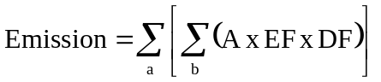where,
a | = | the different activities in which lead-containing ammunition (hereafter referred to as “leaded ammunition”) is used
b | = | the different types of leaded ammunition used per activity a
A | = | the annual amount of leaded ammunition used per activity a and per type of leaded ammunition b
EF | = | the amount of lead per ammunition unit used (per type b), being the total load of Pb shot to the environment
DF | = | the distribution of the emitted lead to the environmental compartments (air, water, soil)

“Emission” in this formula refers to “the lead entering the environment in solid form”. The fact that this emitted Pb only can become bio-available after corrosion will be taken into account further on in this study. Each individual parameter in the abovementioned formula is described in detail in the following sections.

The different activities included (a)
The activities in which leaded ammunition is used can be distinguished in:
- hunting: over dry land and over wetland;
- clay target shooting
- sporting clays
- other target shooting: indoors and outdoors.
Following activities will be taken into account in the regional scenario (section 2 gives more background in the selection of the scenarios for a regional assessment):
- hunting: over dry land and over wetland;
- clay target shooting (used here as umbrella term for trap and skeet shooting and sporting clays).

Design of leaded ammunition used (b)
The design of the ammunition is dependant on the type of gun used. Hunting can be divided in two main types:
- shotgun cartridges for small game, with shot as ammunition;
- rifle cartridges for big game, with a bullet as ammunition
It must be noted that this is only a general rule and that there can be exceptions. Sometimes rifle bullets are used for bird hunting and roe deer are shot with shotgun-pellets.

For clay target shooting, shot shell cartridges are used.

The amount of ammunition used per activity (A)
AFEMS provided information on the yearly consumption of ammunition in all EU Member States (except for Luxembourg). This information includes per type of cartridge:
- the number of rounds fired annually;
- the average weight of Pb per round;
- the total amount of Pb, based on the previous data;
- the percentage used for hunting, target shooting.

The amount of Pb emitted to the environment (Pb shot in solid form) per cartridge used per activity (EF)
The amount of Pb shot emitted to the environment in solid form is dependent of the average weight of lead per round used and the configuration of the cartridge. The latter determines the share of the lead present in the cartridge that will enter the environment.

Following averages are taken into account:
- for clay target shooting:
- 26 g for hunting shot shell
- for hunting:
- 32 g for hunting shot shell
- 7 g for centerfire rifles;
- 7 g for pistol/revolver.

3.1.3.3. Quantification of total load of Pb to the environment from the use of ammunition

Based on the above mentioned method, the total load of Pb from the use of Pb ammunition in the EU15 is quantified. For the region, different scenario’s (4) were selected to quantify regional Pb loads:
- SCENARIO 1: emissions for a specific region:
- Scenario 1A: a best-case scenario representing emissions for a country in which a total ban on the use of Pb in ammunition is in place: The Netherlands
- Scenario 1B: a worst-case scenario representing the missions from that country with the highest consumption of Pb in ammunition in the EU15: Italy
- SCENARIO 2: emissions for a generic region representing 10% of the EU15 emissions (TGD, 2003)
- SCENARIO 3: a specific region representing an average case: again The Netherlands is chosen as the region, but fictive consumption data are being used, representing an average consumption per area of agricultural land in Europe (EU15)

Quantification of the total load of Pb shot on a European scale (EU15)
“Continental” emissions are needed as a background for the regional exposure assessment in the EUSES-model. Emission estimation on the continental scale should be based on an EU-wide production/consumption volume of the substance. Therefore, the EU-15 emissions will be used to calculate continental emissions and continental emissions, as a background for regional exposure assessment (EUSES), will be estimated by following equation:
Continental emission = Total EU-15 emission – regional emissions

In the previous section, the methodology to quantify emissions is described. This method is used in the current report to estimate total EU-15 emissions, based on EU-15 consumption data.
Since AFEMS provided Pb ammunition consumption data for 14 EU Member States (Luxembourg excluded), total EU-15 emissions can be quantified as the sum of the lead emissions of these 14 EU Member States (it is assumed that the Pb ammunition consumption in Luxembourg is negligible, due to the smallness of this country, compared to the consumption in all EU-15 countries). The calculations can be done, based on the formula indicated under section 3.1.3.2. As a result, the same assumptions are made as on the regional scale to estimate the continental emissions. The activities and types of ammunition taken into account are:
- hunting (of which 10% over wetland) with shot shell, centerfire rifle and pistol/revolver;
- clay target shooting with shot shell ammunition.
Other assumptions are:
- the average weight of the ammunition is the same as on a regional scale (see);
- 5% of the shot shell for clay target shooting is collected and recycled;
- 10% of the shot shell used for hunting is used over wetlands and will be emitted to the surface water directly instead of to the soil.
These assumptions bring us to an estimation of the Pb emissions to soil and surface water from hunting and clay target shooting on an EU-scale of:
- hunting: 19,959 tons of Pb shot to soil and 2,218 tons of Pb shot to surface water
- clay target shooting: 11,464 tons of Pb shot to soil

TOTAL: 31,424 tons Pb shot to soil and 2,218 tons Pb shot to surface water per year

Again, it must be stressed that:
- this is a worst-case, since some of the ammunition will be removed with the animal and,
- the emission of Pb calculated here is the total load of Pb in solid form to the environment (and not the corroded part).

Table 6: Yearly consumption of ammunition in the EU-15 (AFEMS, 2004)
TYPE OF CARTRIDGE | Number of Rounds fired in a year  10⁶ | Average Weight of lead per round  g | Total Amount of Lead  10³ tons | %  Target Shooting (average) | %  Hunting and Practice in field (average) | Lead per target shooting  10³ tons | Lead  per Hunting  10³ tons | Lead alternative  10³ tons | NOTE
Shot shell - lead | 1,150.95 | Sport 26g  Hunting 32g | 34.05 | 35 | 65 | 12.067 (a) | 21.978 |  | Shot weight is different between sport and hunting ammunition
Shot shell - lead alternatives | 83.43 | 32 |  | 0 | 100 | 0.000 | 0.000 | 2.670
Rimfire | 511.00 | average 2,4 | 1.23 | 100 | 0 | 1.226 (b) | 0.000
Centerfire rifle | 66.30 | average 7,0 | 0.46 | 60 | 40 | 0.278 (b) | 0.186 |  | (e)
Pistol / Revolver (C) | 192.50 | average 7,0 | 1.35 | 99 | 1 | 1.334 (b) | 0.013 |  | (e)
Flobert | 63.10 | average 4,0 | 0.25 | 100 | 0 | 0.252 | 0.000 |  | (e)
Air pellets | 2400.00 | 0,5 | 1.20 | 100 | 0 | 1.200 (d) | ?
Total | 4467.28 |  | 38.54 |  |  | 16.359 | 22.177

Quantification of the total load of Pb shot on a regional scale (E)

Scenario 1A
In this scenario, the potential Pb shot load from hunting and clay target shooting activities in a specific region ‘The Netherlands’ can be estimated based on the formula given in section 3.1.3.2.
Taking into account the assumptions given in the methodology description, following consumption data is to be included in our calculations:
- for clay target shooting
- 350 000 rounds of shot shell (70% of 500000);
- for hunting:
- 150 000 rounds of shot shell;
- 1 200 000 rounds for centerfire rifles;
- 60 000 rounds for pistol/revolver.

It is indicated by AFEMS (2004) that for clay target shooting, an estimate of 5% of shot shell lead is collected and recycled. This means that only 332,500 rounds (95% of 350,000) will enter the environment. For hunting, about 10% of the shot shell is used over wetland (estimation AFEMS) and will therefore be emitted to surface water. It must be noted also that, since the prior purpose of hunting is to hit animals, we can assume that not all lead ammunition used, will enter the environment but the fatal shot will be removed with the animal. Table 5 shows an average of 3.4 rounds of ammunition needed per animal. For bullets we could assume that one of these rounds will be removed with the animal (being 30%). For lead shot it’s another case: one shot shell contains several Pb shots. We can assume that most of the shots will enter the environment, since only a few of the shots within the shell will enter the animal. Due to insufficient information on this removal issue, a “worst case” assumption that 100% of the Pb in ammunition will enter the environment, will be used in the calculations for both bullets and shot shell.
Application of this formula and taking into account the consumption data given in Table 8 shows the following total loads:
- Hunting: 13,620 kg Pb
- Clay target shooting: 8,645 kg Pb

If we assume that 10% of all shot shell ammunition, used for hunting, is used over wetlands, this means that the distribution of Pb to surface water and soil will be:
- Hunting: 480 kg (10% of 4,800 kg) of Pb to surface water and 13,140 kg to soil
- Clay target shooting: 8,645 kg Pb to soil

TOTAL: 21.79 tons Pb shot to soil and 0.48 tons Pb shot to surface water per year

It must be stressed that:
- this is a worst-case for The Netherlands, since some of the ammunition will be removed with the animal and,
- the emission of Pb calculated here is the total load of Pb in solid form to the environment (and not the corroded part),
- this is a best-case in the framework of the representativeness of this selected region for the EU15 since in The Netherlands a ban on the use of Pb shot for hunting is in place

Scenario 1B
Since the total load of Pb through the use of Pb in ammunition, calculated in scenario 1A, is not representative for the EU15 but shows a best-case, an extra scenario is included. In this scenario, the potential Pb shot load from hunting and clay target shooting activities for the EU15 MS with highest consumption of Pb in ammunition in the EU15 is calculated. Application of the formula given in section 3.1.3.2 and taking into account the consumption data for Italy, shows the following total loads:
- Hunting: 6664 tons Pb
- Clay target shooting: 2766 tons Pb

If we assume that 10% of all shot shell ammunition, used for hunting, is used over wetlands, this means that the distribution of Pb to surface water and soil will be:
- Hunting: 666 tons of Pb to surface water and 5998 tons to soil
- Clay target shooting: 2766 tons Pb to soil

TOTAL: 8764 tons Pb to soil and 666 tons Pb shot to surface water per year

It must be stressed that:
- this is a worst-case for Italy, since some of the ammunition will be removed with the animal and,
- the emission of Pb calculated here is the total load of Pb in solid form to the environment (and not the corroded part);
- this is a worst-case in the framework of the representativeness of this selected region for the EU15 since in Italy the consumption of leaded ammunition is the highest of all EU15 MS.

Scenario 2

As mentioned previously, in the Netherlands there is a ban on the usage of Pb ammunition for hunting introduced in 1993. As a result, it could be that the Pb consumption in the Netherlands is not representative for the Pb ammunition consumption in the EU-15. Therefore, in this scenario, regional emissions are estimated according to the TGD, meaning as 10% of total European emissions (EU15).

regional emission = 10% of total European emission

Using this default TGD definition, emissions on a regional scale would be:
- hunting: 1 996 tons of Pb to soil and 222 tons of Pb to surface water
- clay target shooting: 1 146 tons of Pb to soil

TOTAL: 3 142 tons Pb shot to soil and 222 tons Pb shot to surface water per year.

Scenario 3
Scenario 2 is an alternative methodology to calculate emissions for a generic/specific region. In this scenario, instead of using the 10% rule as indicated in the TGD, and assuming that 10% of the European consumption takes place in the generic region, it is assumed that in the generic/specific region an average consumption (for the EU15 MS) takes place (fictive consumption data). Assuming that most of the hunting (and clay target shooting activities as an unrealistic worst-case assumption, see section 2.2) occur on agricultural land, an average Pb consumption (through the use of ammunition) per unit of agricultural area (EF, emission factors) per activity (hunting and clay target shooting) in the EU-15 is calculated based on:

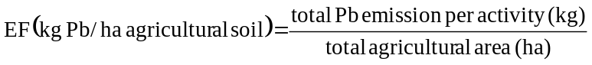

Taking into account a total utilised agricultural area in the EU-15 of 125 723 000 ha (Eurostat, 2002), a continental emission of 19 959 tons to soil and of 2 218 tons Pb to surface water from hunting and an emission from target shooting activities of 11 464 tons of Pb to soil, average Pb emissions can be calculated:
- hunting: 0.159 kg Pb shot/ha to soil and 0.018 kg Pb shot/ha to surface water;
- clay target shooting: 0.091 kg Pb shot/ha.

Emission factors per unit of agricultural area were also calculated for each EU Member State (EU-15). Therefore total emissions per country and activity, calculated based on the methodology given in scenario 1, were divided by the total agricultural area per country. The emission factors per country and activity are shown in Table 7. This table shows that the emission factors in countries like, Austria (0.02), Denmark (0.00), Finland (0.02), The Netherlands (0.01), Ireland (0.00) and Sweden (0.04) are low in comparison with the average EU-15 emission factor for hunting (0.16). For Denmark, Finland, The Netherlands and Sweden this corresponds with the fact that there is a ban or a restriction to use Pb ammunition in these countries. For Austria and Ireland, the author of this report is not aware of any ban or restriction of use of Pb ammunition. Table 7 also shows that, the Pb emission in the Netherlands is relatively lower than in most other EU-countries, so a correction of the Dutch data is necessary to be able to present emissions from the use of Pb ammunition for a “reasonable, representative EU region”.

Table 7: Overview of the emission factors (EF) of Pb shot (solid form) per country from use of Pb ammunition
COUNTRY | Hunting (kg Pb/ha) |  | Clay target (kg Pb/ha)
 | Soil | water | soil
EU-15 (weighted average) | 0.16 | 0.02 | 0.09
Austria | 0.02 | 0.00 | 0.07
Belgium | 0.11 | 0.01 | 0.17
Denmark | 0.004 | 0.00 | 0.00
Finland | 0.02 | 0.00 | 0.00
France | 0.15 | 0.02 | 0.07
Germany | 0.06 | 0.01 | 0.05
Greece | 0.52 | 0.06 | 0.02
Ireland | 0.0003 | 0.00 | 0.00
Italy | 0.39 | 0.04 | 0.18
Netherlands | 0.01 | 0.00 | 0.00
Portugal | 0.18 | 0.02 | 0.10
Spain | 0.13 | 0.01 | 0.05
Sweden | 0.04 | 0.00 | 0.08
UK | 0.19 | 0.02 | 0.30

Table 7 shows that Italy has the highest emission load per unit of agricultural area (0.39 kg/ha for hunting and 0.18 kg/ha for clay target) and The Netherlands has the lowest load ((0.01 kg/ha for hunting and 0.00 kg/ha for clay target).

Based on the calculation of emissions per country of country-specific consumption data and taking into account these averages and a utilised agricultural area in the Netherlands of 1 933 000 ha, the regional emissions can be calculated as:
- hunting: 307 tons of Pb shot to soil and 35 tons of Pb shot to surface water;
- clay target shooting: 176 tons of Pb shot to soil

TOTAL: 483 tons Pb shot to soil and 35 tons Pb shot to surface water per year.

Table 8: Yearly consumption of ammunition in the Netherlands (AFEMS, 2004)
TYPE OF CARTRIDGE | Number of Rounds fired in a year  10⁶ | Average Weight of lead per round  g | Total Amount of Lead  10³ tons | %  Target Shooting | %  Hunting and Practice in field | Lead per target shooting  10³ tons | Lead  per Hunting  10³ tons | Lead alternative  10³ tons | NOTE
Shot shell - lead | 0,50 | Sport 26g  Hunting 32g | 0,014 | 70 | 30 | 0,009 | 0,005 |  | Shot weight is different between sport and hunting ammunition
Shot shell - lead alternatives | 9,50 | 32 |  |  |  |  |  | 0,304
Rimfire | 25 | average 2,4 | 0,0600 | 100 | 0 | 0,0600 | 0
Centerfire rifle | 3 | average 7,0 | 0,021 | 60 | 40 | 0,013 | 0,008 |  | 1)
Pistol / Revolver (C) | 6 | average 7,0 | 0,042 | 99 | 1 | 0,042 | 0,000 |  | 1)
Flobert | 0 | average 4,0 | 0,000 | 100 | 0 | 0,000 | 0 |  | 1)
Air pellets | ?? | 0,5 |  | 100 | 0 | (d)
Total | 44 |  | 0,137 |  |  | 0,123 | 0,014

1) Average bullet weight is estimated between different cartridge types

3.1.3.4. Conclusion for the current estimation of the total load of Pb shot to the environment

An overview of Pb emissions from hunting and clay target shooting activities for a region, based on 4 different scenarios, and the EU15, is given in Table 9.

Table 9: Overview of yearly Pb shot load (solid form) for the use of Pb ammunition on a regional and EU15 scale
Activities and  environmental compartment | Regional emissions (in tonnes of Pb shot/yr) |  |  |  | EU scale emissions (in tonnes of Pb shot/yr)
Activities and  environmental compartment | Scenario 1A ⁽¹⁾ | Scenario 1B ⁽²⁾ | Scenario 2 ⁽³⁾ | Scenario 3 ⁽⁴⁾ | EU scale emissions (in tonnes of Pb shot/yr)
Hunting
Emission to soil | 13.14 | 5 998 | 1 998 | 307 | 19 979
Emission to water | 0.48 | 666 | 220 | 35 | 2 198
Clay target shooting
Emission to soil | 8.65 | 2 766 | 1 146 | 176 | 11 464
TOTAL emissions |  |  | 3 364 | 518 | 33 640
Soil | 21.79 | 8 764 | 3 144 | 483 | 31 443
Surface water | 0.48 | 666 | 220 | 35 | 2 198
(1) based on consumption data for The Netherlands (AFEMS, 2004) and Pb content of the shot, bullet.
(2) based on consumption data for Italy (AFEMS, 2004) and Pb content of the shot, bullet
(3) regional emission = 10% of continental emission
(4) based on an average emission factor (for the EU15) per unit of agricultural land

On a regional scale, it is proposed to use the emission data calculated based on scenario 3 for the following reasons:
- Total loads are calculated for a specific region The Netherlands (because the agricultural area of The Netherlands is used in the calculations), analogous to the RAR for Pb (Ecolas, draft 2004)
- In order to present reasonable emissions for a representative EU region, a correction is made on the Dutch emission data because of the fact the Netherlands is a special case (ban of use of Pb ammunition since 1993) and is not representative for the EU-15 and instead fictive consumption data, being an average for the different EU15 MS, are used;

To conclude, following total load data are taken forward in this report for calculation of emissions (taken into account a corrosion factor) and risk characterisation (cf data in bold in Table 9):
- Regional loads (solid frorm) calculated according to Scenario 3
- EU15 loads (solid form), calculated based on real EU15 consumption data.

3.1.3.5. Inclusion of current and future loads due to historical deposition of Pb in ammunition

The future Pb emissions arising from corrosion of Pb shot already in the environment caused by historic use of Pb shot need to be included. Information from two European countries and from industry is available.

Sweden

Anderberg et al. (1990) calculated the historical lead load in Sweden. Figure 8 presents the historical load from hunting and skeet. The consumption has varied considerably between different time periods, but the yearly fluctuations have been rather small. The five-year average values reached their lowest point in the 1930s and the highest points around 1950 and the middle of the 1970s. In the 1970s, the yearly fluctuations were greatest.

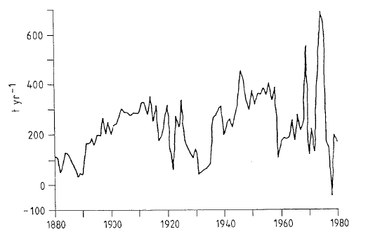
Figure 8: Calculated lead load from lead shot (tonnes/year) from hunting and skeet (Anderberg et al., 1990)

Figure 9 presents the historical load from cartridges (Anderberg et al., 1990). The consumption has varied a lot over the years. It reached its peak values with more than 1,000 tonnes some years at the beginning of the century, during the Second World War and in the 1970s. In between these peaks the variations from two years have normally been small with average values of 300-400 tonnes at the beginning of the century, of around 100 tonnes and even lower in the interwar period and from 100 to 400 tonnes from 1950 to 1970. In actual fact, the consumption has probably been much more stable than is indicated in these figures. Anderberg et al. (1990) suggest that the surpluses during the wars have probably been stored and used over a long time. It most also be underlined that no military consumption is included in these figures. The high figures for the 1970s can be explained by low prices on the world market, by stimulating imports that seem to have created this dramatic peak and by a normalization when old stores are running out. Figure 10 gives a lumped estimate.

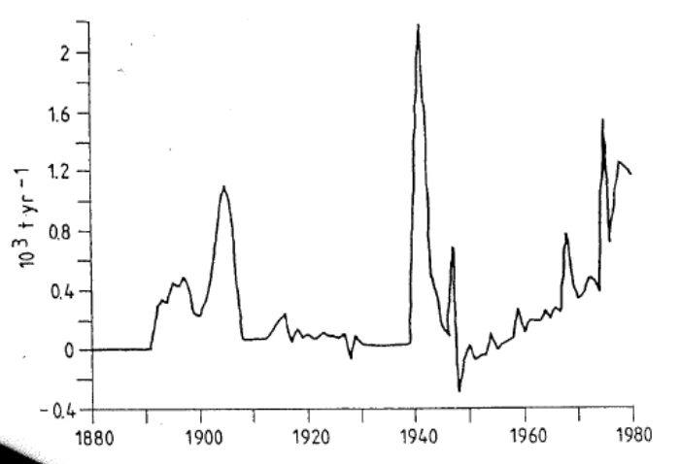
Figure 9: Calculated lead load from lead shot (tonnes/year) from cartrigdes (Anderberg et al., 1990)

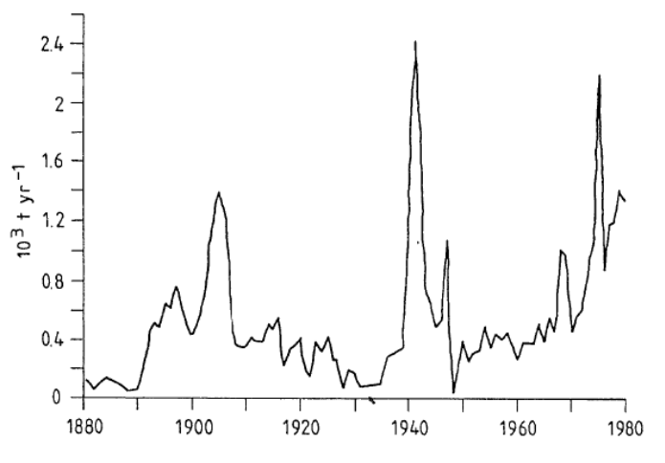
Figure 10: Calculated lead load from lead shot (tonnes/year) from hunting, skeet and cartridges (Anderberg et al., 1990)

Another source on historical emissions of Pb shot is a background document of a Swedish report on consequences of Swedish ban on lead in ammunition (Qvarfort, 2006). Different calculation methods are used to estimate the Pb shot deposition. The results are given from Figure 11 to Figure 13.

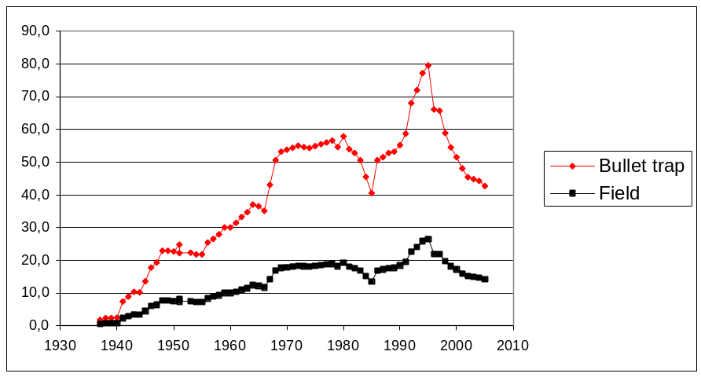
Figure 11: Distribution between shooting ranges (red) and field (black) (note that the amount in shooting ranges before recycling) (from pistol association (Qvarfort, 2006)

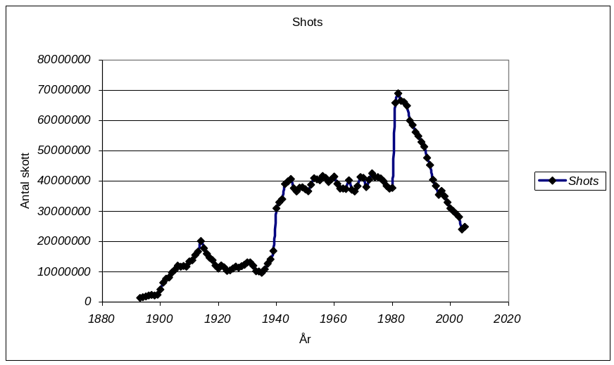
Figure 12: Time-series of the amount of lead shot for the period 1883 – 2005 (Note that from 1981 includes also airgun shooting).(from FSR voluntary association in Qvarfort, 2006)

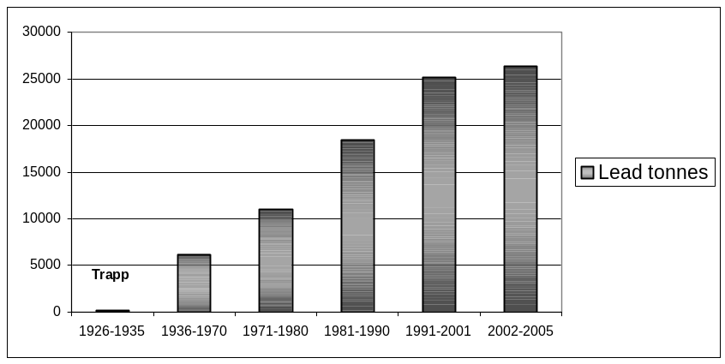
Figure 13: Time-series of amount of lead pellet in clay shooting ranges (from sport shooting association in Qvarfort, 2006)

The time-series of Qvarfort (2006) indicate a much more stable increasing Pb shot deposition rates, especially at the end of the first half of the century. From the 80-90s onwards, a decrease in Pb shot use is observed.

In conclusion, the Swedish data will not be used in this risk assessment because the two studies show significantly different patterns and interpretations indicating large uncertainties.

Denmark

The ban of leaded shots for hunting has been steadily decreasing in Denmark since the early eighties. The annual consumption in Denmark was in 1980-85 estimated to 25-30 million shots or approximately 800 - 1,000 tons lead per year with 75% used on land 25% over water (EPA, 1989). The use of leaded shots over wetlands was introduced in 1986, followed by a number of further restriction up to 1996 where a total ban of the use of leaded shots for hunting came into force. In 1994 the load of lead had therefore decreased to 200 tons and in 1993 further to 100-160. In 2000 the national consumption for leaded shots was less than 7 tons. These were not used for hunting, but on shooting range in connection with competitions.

In conclusion, there is a decreasing trend of Pb shot deposition in Denmark due to use restrictions. This situation is not representative for Europe and for worst-case reasons, these data will not be used in the determination of the time pattern of Pb shot deposition.

Europe (Industry)

After careful investigation by industry through historical statistics of the last century, it can be concluded that in Europe sport shooting activity is quite a young one. In particular, clay target has enjoyed a progressive development after the Second World War. This development is correlated to the GDP (Gross Domestic Product) per capita. Taking UK as a reference, there has been a marked contrast between the two halves of the Century. Between 1948 and 1998, the GDP per capita rose by 191% compared to a 37% increase between 1900 and 1948 (Research paper 99/11 – House of Commons). Sport shooting activities were rather limited before the Second World War. It can therefore be assumed that no clay target ranges have been in existence for one century. The average age should be estimated to be no more than 25 years and only 5 % could have been in existence for more than 50 years. Three main factors have had a negative impact on this leisure activity: the logistic and economic restrictions before, during and after the two World Wars and the economic depression in the late 1920. Growth in the real income of citizens has stimulated demand for leisure activity from 1945 to today.

In order to evaluate the differences in number of rounds fired over the last century, a historic picture related to clay target shooting in Italy can be used (see Figure 14). It shows the activity of the Italian Sport Shooting Federation (FITAV). The 6th column (“bersagli sparati”) shows that in the thirties, FITAV was shooting an average of 400,000 clay targets per year, while today the consumption in Italy is of about 50 million per year.

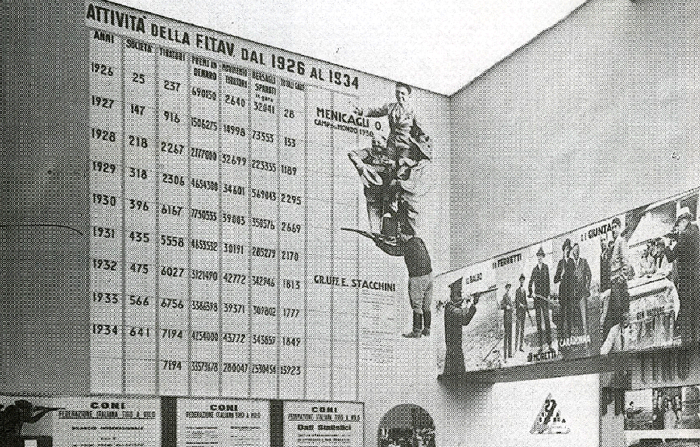
Figure 14: Historic picture related to clay target shooting in Italy

Another statistic that can be considered is the number of long arms tested by the National Proof House in Italy. In the first half of the 20th century, there were only about ten thousand firearms tested/year (for hunting and clay target), while at the end of the century the yearly tested long arms are about 300,000. The time-series on the number of rifles tested can be found in Figure 15. A significant increase is observed after the Second World War. Since 1980, a small but steady decrease is observed. In addition, it must be considered that the cost of ammunition compared to the GDP was much higher in the first half of the past century and therefore the actual consumption Pb in ammunition was much lower in the first half of the past century than the number of rifles tested would suggest.

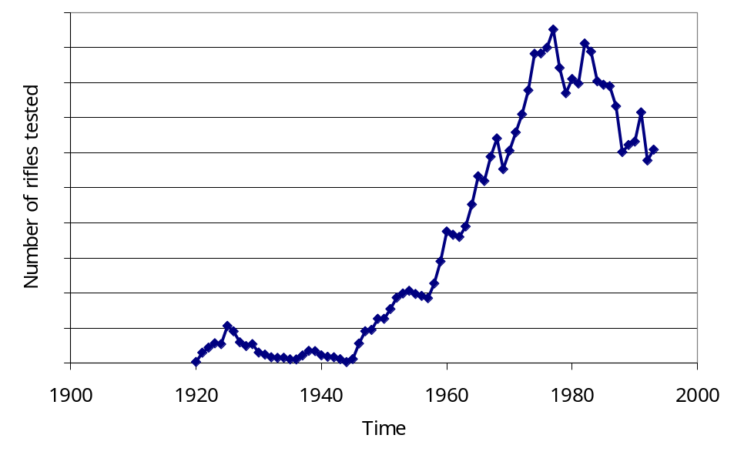
Figure 15: Time-series on the number of long arms tested by the National Proof House in Italy

According to industry, a similar pattern is expected for hunting. However, hunting activities have been more regular throughout the last century. Again the GDP has played an important role in keeping the consumption of ammunition much lower than today, due to the high cost of ammunition. The pattern for hunting is expected to have two downward peaks during and some years before and after the two World Wars. After all, men went to the army and lead was primarily destined for military use. Furthermore, for economic reasons (low GDP and relative cost of ammunition much higher that what it is nowadays) reasons, there was no money for leisure activities. In the first half of the century, Industry estimates that lead shot emission was not more than 25% of what it is today.

The information given by Industry was selected for the risk assessment. The time-series of the yearly regional Pb shot deposition for clay target shooting and hunting can be estimated as exemplified in Figure 16 for deposition on soil. The cumulative Pb shot deposition on soil time-series can be found in Figure 17.
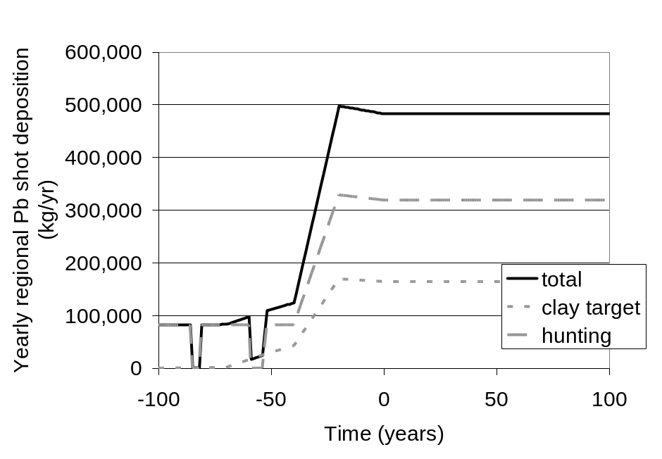
Figure 16: Yearly regional Pb shot deposition time-series for clay target shooting and hunting (on soil)

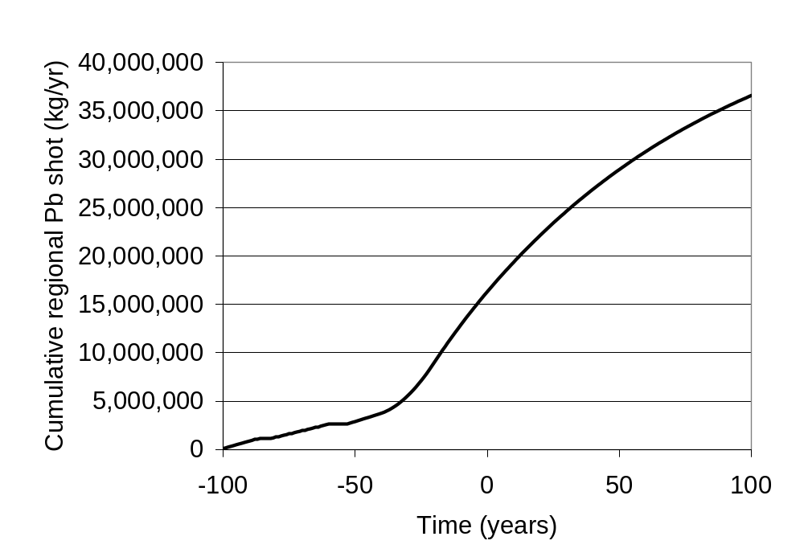
Figure 17: Cumulative regional Pb shot time-series for clay target shooting and hunting (on soil)

The EUSES model, in compliance with the TGD, calculates PECs and emissions after reaching steady state. This approach was originally developed for organic substances and has an important short-coming for metals. PEC steady-state conditions are only reached after a very long period (order of ten thousand years) partly due to conservative assumptions. The exposure assessment should be conducted over a surveyable time period (in analogy with the Zn and Cd risk assessments). For this reason, PECs were estimated after 100 years (1 century). This calculation was done using the integrator in SimpleBox of the EUSES 2.0 Excel version.

3.1.3.6. Parameters

Corrosion of Pb shot

Scheinost (2003) performed a literature review on the weathering rates of lead in soil and controlling factors (see Appendix E). His conclusions are the following. Based on the published studies, derivation of precise and accurate weathering rates is not possible. Observations range from almost no metallic Pb dissolved in hundreds of years to the transformation of 50% of deposited Pb bullets within a few years. The initial formation of a (thin) weathering layer due to oxidation is a very fast process. The further weathering weathering, however, depends on a range of factors, which are only partly understood. In very acidic and organic matter rich soils, the weathering continues until the whole metallic Pb core is dissolved and no visible weathering rind remains. In slightly acidic to carbonaceous soils, Pb weathering may be greatly reduced by the formation of a protective surface layer of weathering products. In other soils with similar pH, however, the formation of the weathering rind proceeds towards the core, until all of the metallic Pb is replaced by Pb carbonates. The factors responsible for the formation of a protective surface layer versus the formation of a non-protective weathering rind remain obscure. One possible explanation could be the presence of sufficiently soluble phosphates, which have been shown to induce the formation of pyromorphite with very low solubility. However, other factors like soil moisture may be of equal importance.
On a qualitative basis the influence of a wide range of soil and bullet properties on Pb weathering is fairly well understood, including pH, redox potential, soil organic matter, cation exchange capacity, moisture, temperature, composition of soil solution, soil texture, bullet composition, calibre and bullet jackets. However, Scheinost (2003) concludes at this moment, it appears that intrinsic bullet properties like alloy composition could be a major factor explaining why Pb artefacts remain intact for thousands of years while others corrode within a few years. This, however, has to be investigated.

Differences in corrosion rate between clay target shooting and hunting can occur. For this, it is important to understand how the bullet penetrates into the sand or other type of material. With the impact the bullet will usually split into different parts as a more or less intact bullet, and some relatively large and small fragments. All of these have a different corrosion rate. When you hunt the bullet will usually fall unaffected to the ground (Qvarfort Ulf, personal communication). However, differences in corrosion rate between clay target shooting and hunting were not quantified by Scheinost (2003).

Scheinost (2003) concludes that fast initial weathering rates can be considered to be in the range 0.2 to 2 % per year, corresponding to first order rate constants of 0.002 to 0.02 per annum. In this way, large amounts of the bullets and shotgun pellets deposited on shooting ranges and hunting areas would be transformed every year into Pb carbonates and sorbed species, and it would take between 50 and 500 years to completely weather from metallic Pb to other Pb species.

In a Swedish study, a reasonable upper limit for Pb corrosion of 1% per year is used (Anderberg et al., 1990). The Dutch emission inventory (VROM, 2002) also used a worst-case corrosion rate of 1% per year.

In this targeted risk assessment, a worst case corrosion rate of 1 % per year is taken for both soil and sediment on the emissions of Pb shot. This value is a worst-case assumption because it is assumed that the initial corrosion rate will not decrease in time but remains constant where in reality, it does decrease (Scheinost, 2003). For example, recent data in Linder (2004) show that the initial corrosion rate will decrease by about 50% after 2-3 years. Such studies suggest that additional research would be highly valuable in order to more accurately determine corrosion characteristic.

The corrosion rate in sediment is in reality likely lower (however not quantified in literature) than the corrosion rate in soil because massive metal would likely end up buried in sediment after a relatively short period of time. More information on corrosion rates in soil and sediment would lead to more realistic predictions. The resulting yearly emissions are found in Table 10.

Table 10: Yearly Pb emissions from use of Pb ammunition on a regional and continental scale after corrosion
 | Regional emission (kg Pb/yr) | Continental emission (kg Pb/yr) | EU scale emission (kg Pb/yr)
Soil | 4,830 | 309,600 | 314,430
Surface water | 350 | 21,630 | 21,980

There is no specific emission scenario for lead in ammunition in the EU-TGD (2003). Lead in ammunition remaining in the environment can be compared with ‘waste remaining in the environment’. On this aspect, it is written in the TGD: “Quantitative methods for estimating emissions from waste remaining in the environment are currently not available. Therefore such releases have to be considered on a case-by-case basis. As for substances in long-life articles, substances in ‘waste remaining in the environment’ will also accumulate. As a simplification the emissions at steady state can be assumed to be equal to the annually formed amount of ‘waste remaining in the environment’. If the degradation rate of the substance in the waste material is known, this should be taken into consideration. When the emission of a substance from waste remaining in the environment is very slow it will take a long time to reach steady state. In that case the calculated emission may reflect a future situation.”

Other distribution characteristics of the environmental compartments

The other distribution characteristics of the environmental compartments are summarised in Table 11 and Table 12. These parameters are default values from the TGD (EC, 2003). Because of their generic nature, these are difficult to be further refined. The partition coefficients were taken from the draft EU Pb RAR (2005).

Table 11: Physico-chemical properties of Pb
Parameter | Value | Unit
physical state | stable solid
melting point | 327.4-327.5 | °C
boiling point | 1,725-1,745 | °C
density | 11.34 | g/cm³
vapour pressure | 1.33  10 | mm Hg at 973 °C  mm Hg at 1,162 °C
surface tension | n.a.
solubility in water | insoluble
solubility in solvents | soluble in nitric acid and hot concentrated sulfuric acid
partition coefficient | n.a.
flash point | n.a.
flammability | n.d.
autoflammability temperature | n.a.
explosive properties | not explosive
oxidising properties | no oxidising properties
References | IUCLID datasheet

Differences in erosion rate can occur between and within rifle/pistol and clay target shooting ranges depending on the local topography, vegetation, climate and erosion management measures. Nevertheless, generic erosion parameters were used according to the TGD (EC, 1996).

Table 12: Other distribution characteristics of the environmental compartments
Parameter | Parameter abbreviation | Value | Unit
fraction of rain water infiltrating soil | Finfsoil | 0.25 | -
fraction of rain water running off soil | Frunsoil | 0.25 | -
mixing depth soil | DEPTHsoil | 0.1 | m
mixing depth sediment | DEPTHsediment | 0.03 | m
average precipitation | RAINrate | 0.001917808 | m/d
 |  | 700 | mm/yr
concentration of the suspended matter in the river | SUSPwater | 15 | mg/l
Soil erosion rate | EROSION | 8.21918E-08 | m/d
Flow rate of the river | FLOW | 18000 | m³/d
Density of solid phase | RHOsolid | 2500 | kg/m³
Bulk density of soil | RHOsoil | 1700 | kgwwt/m³
Bulk density of sediment | RHOsediment | 1300 | kgwwt/m³
Bulk density of suspended solids | RHOsusp | 1150 | kgwwt/m³
fraction water in compartment soil | Fwatersoil | 0.2 | m³/m³
fraction water in compartment sediment | Fwatersediment | 0.8 | m³/m³
fraction water in compartment susp matter | Fwatersusp | 0.9 | m³/m³
fraction solids in compartment soil | Fsolidsoil | 0.6 | m³/m³
fraction solids in compartment sediment | Fsolidsediment | 0.2 | m³/m³
fraction solids in compartment susp matter | Fsolidsusp | 0.9 | m³/m³
fraction air in compartment soil | Fairsoil | 0.2 | m³/m³
partition coefficient solid-water in soil | Kpsoil | 6400 | l/kg
soil-water partition coefficient | Ksoilwater | 9600.2 | m³/m³
partition coefficient solid-water in sediment | Kpsediment | 218776 | l/kg
sediment-water partition coefficient | Ksedimentwater | 109388.8 | m³/m³
partition coefficient solid-water in suspended matter | Kpsusp | 295121 | l/kg
suspended matter-water partition coefficient | Ksuspwater | 664023.15 | m³/m³

3.1.4. Estimation of cumulative Pb emissions

The regional, cumulative Pb emissions (from corroded Pb shot and including current emissions from historical contamination of Pb shot) can be calculated for soil and water. The emissions to soil is visualised in Figure 18.

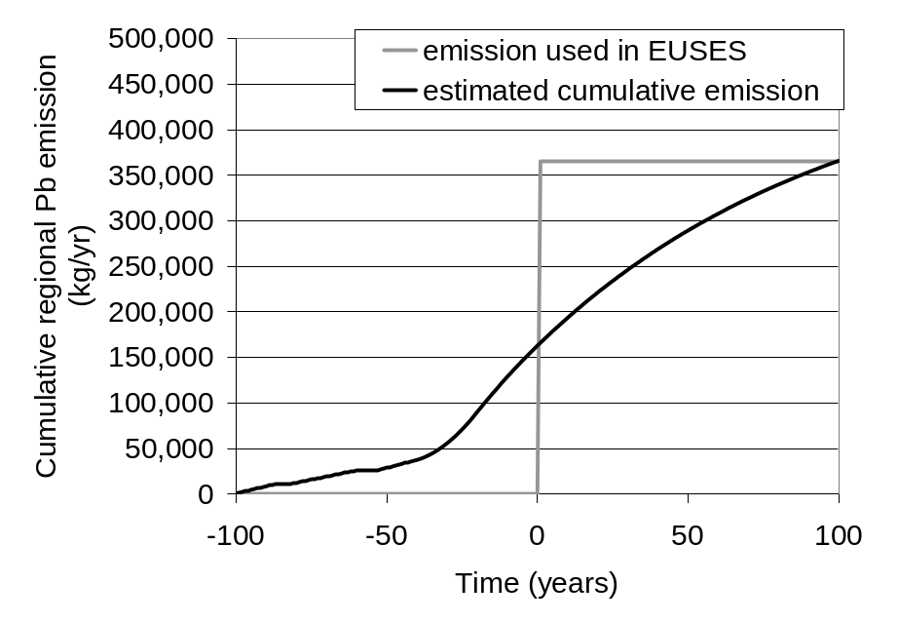
Figure 18: Cumulative regional Pb emission (on soil) for clay target shooting and hunting and the emission values used in EUSES

The resulting cumulative Pb emissions, to be inputted in EUSES, are found in Table 13.

Table 13: Cumulative Pb emissions from use of Pb ammunition on a regional and continental scale after corrosion
 | Regional emission (kg Pb/yr) | Continental emission (kg Pb/yr)
Soil | 365,848 | 23,450,657
Surface water | 26,678 | 1,648,760

The calculated future emissions in Table 13 are an overestimation, since:
- For the entire timeline, a corrosion rate of 1% is assumed, while the corrosion will be most important in the first years and will decrease to about 50% of the initial corrosion rate after 2-3 years (Linder, 2004); the corrosion rate will, in reality, then further gradually decrease in time.
- A constant yearly use of Pb in ammunition is assumed, while its emission could decrease in the future due to improved recovery and recycling programmes, future marketing or use restrictions.
- The emission inputted in EUSES is in fact a future emission (within 100 years). In reality, the emission starts from a lower value and gradually increases as time progresses (as demonstrated in Figure 18).

3.1.5. Prediction results based on cumulative emissions

Since the Technical Guidance Document (TGD, 2003) does not provide detailed information on how to deal with elements that have a natural background concentration in the environment, such as lead, the total risk approach was used in this risk assessment. In the “added risk approach” (according to Crommentuijn et al., 1997) approach, the "Predicted Environmental Concentration" (PEC) is expressed as Pb added by man, resulting in an “added Predicted Environmental Concentration” (PEC_{add}) and “added Predicted No Effect Concentration” (PNEC_{add}), respectively. The use of the added risk approach (a method that in principle can be used for all naturally occurring substances) implies that only the anthropogenic amount of a substance, i.e. the amount added to the natural background concentration, is considered to be relevant for the effects assessment of that substance. Thus, a possible contribution of the natural background concentration to toxic effects is ignored. Alternatively, the ‘total risk approach’ was used in which the PEC value include both the Pb background and Pb added by man.

The regional scale assesses the exposure levels due to all releases in a larger region (PEC_{regional}) and is therefore also representative for the contribution of the diffuse sources. The estimation of the regional releases is consequently based on gathered emission data and/or most adequate emission factors for each emission source (e.g. industry, public utilities, traffic, households, agriculture and natural sources) and not of Pb in ammunition alone.

The resulting cumulative emissions and the corresponding PECs are given Table 14.

Table 14: Overview of cumulative Pb emissions (100 years) and added/total PECs for the regional and continental environment determined after 100 years exposure (based on EU TGD 2003 Risk Assessment Spreadsheet Model 1.0 calculations).
input continental (anthropogenic): EU_{total} - input_{regional}
amount released to air |  | 848 t/y
amount released to surface water |  | 2,448 t/y
amount released to agricultural soil ⁽¹⁾ |  | 23,698 t/y (248 t/y (agricultural use) + 23,450 t/y (lead shot use))
amount released to natural soil⁽¹⁾ |  | 0 t/y
amount released to industrial soil⁽¹⁾ |  | 297 t/y
input regional (anthropogenic):
amount released to air |  | 43.7 t/y
amount released to surface water |  | 63 t/y (36 t/y (other) + 26 t/y (lead shot use))
amount released to agricultural soil⁽¹⁾ |  | 393.5 t/y (27.7 t/y (fertiliser) + 365 t/y (lead shot))
amount released to natural soil⁽¹⁾ |  | 0 t/y
amount released to industrial soil⁽¹⁾ |  | 10.4 t/y
PEC values (100 years of exposure) |  | PEC_{add} continental | PEC_{add} regional | PEC_{total} regional
PEC air | ng/m³ | 9.89x10-12 | 8.86x10-11 | 13.6
PEC agricultural soil | mg/kg_{dwt} | 3.69 | 5.66 | 32.68
PEC natural soil | mg/kg_{dwt} | 0.15 | 1.33 | 28.3
PEC industrial soil | mg/kg_{dwt} | 1.19 | 4.54 | 31.54
K_{p} sediment/suspended matter = 295,121 l/kg (median)
Kp sediment = 154,882 l/kg (median)
PEC surface water (dissolved fraction) | µg/l | 0.112 | 0.18 | 0.36
PEC sediment | mg/kg_{dwt} | 17.34 | 27.55 | 55.4
[Note that the regional PEC surface water and sediment are smaller compared to the previous RAR version. This is the net result of
- The emissions to all compartments are increased due to the inclusion of current releases from historical contamination. This results in an increase of the PECs
- There was a calculation error in the regional amount released to surface water (should be 63 t/y instead of 807 t/y). This results in a decrease of the PECs.
- A new SimpleBox version of the dynamic simulation (i.e. EU TGD 2003 Risk Assessment Spreadsheet Model 1.0 instead of SimpleBox 2.0) was used. This results in a decrease of the PECs (because steady-state is reached more slowly).
The net effect is a decrease of the regional PEC surface water and sediment]

The PEC_{add} regional_{, 100 years} for agricultural soil is 33 mg/kg dw. At this stage in time, 14.6% of the steady state is reached. The PEC_{add} regional_{, 100 years} for surface water and sediment is 0.18 µg/l and 27.55 mg/kg dw respectively. The PECs derived after 100 years for these compartments represent 41% of the steady state.

More information can be found in the main Pb RAR document (May 2007 version).

3.1.6. Measured data

An overview of measured data and a comparison between measured and modelled regional PECs can be found in the main Pb RAR (May 2007 version).

3.2. Local exposure assessment

3.2.1. Introduction

In order to perform the model calculations for Pb emissions to soil and surface water, a generic outdoor shooting range should be defined. Different typical local scenarios are defined in the section on use pattern.

After usage most Pb from ammunition will mainly enter the soil compartment. Depending on the condition at the shooting range (soil, vegetation, morphology, operation, ground water, climate etc.), the inputs of lead shot and clays material, will mainly accumulate in surface layers.

Indirect input of Pb from the soil into the surface water (through run-off and leaching) will be calculated based on the estimation of the water balance for these generic environments and the estimated/measured Pb concentration in the pore water. The sorption and the mobility of Pb having entered the soil matrix is mainly determined by the physicochemical soil conditions (together with climatic factors) and by the age of the inputs (corrosion, weathering). The potential contamination of the run-off/porewater by Pb in shooting ranges must therefore be assessed. Information on Pb concentration in the soil and groundwater as well as on the main factors (mainly the pH-value of the soil, lime content, iron and manganese contents, clay content and the content of organic substance of the soil) driving the mobility/availability in soils should be gathered.

In cases that there are surface waters present at or in the immediate surroundings of outdoor shooting sites, it is necessary to predict or compile data on Pb concentration in surface waters and sediments.

3.2.2. Methodology

3.2.2.1. Introduction

Local environmental exposure concentrations (i.e. air, water, sediment, soil) are usually calculated according to the EU Technical Guidance Document (EC, 1996) and revisions to the TGD (EC, 2003). Next to emission data, local environmental concentrations can be based on other information submitted by industry, e.g. monitoring data and/or information gathered from other non-industrial sources. Where measured data are lacking, PEC values are calculated according to the TGD methodology that is designed to make a reasonable worst case estimate of exposure. Generic local scenarios will be developed since it is not feasible to perform local risk assessments for every shooting range in the EU.

To assess the PEC_{local}, the local concentrations (C_{local}) have to be corrected for the regional anthropogenic background (PEC_{regional}), according to the TGD equation PEC_{local} = C_{local} + PEC_{regional}.

This section comprises a description of the TGD methodology used to calculate local concentrations (C_{add} values) in air, water, sediment and soil. Specific adjustments of the TGD methodology were made where needed in order to meet the objectives of this targeted risk assessment for lead ammunition. The local exposure data and calculated C_{add} values for environmental compartment of concern are reported in the tabular EU RAR format. Figure 19 illustrates the local emission and distribution routes for the environmental compartments under study according to the TGD (EC, 1996).

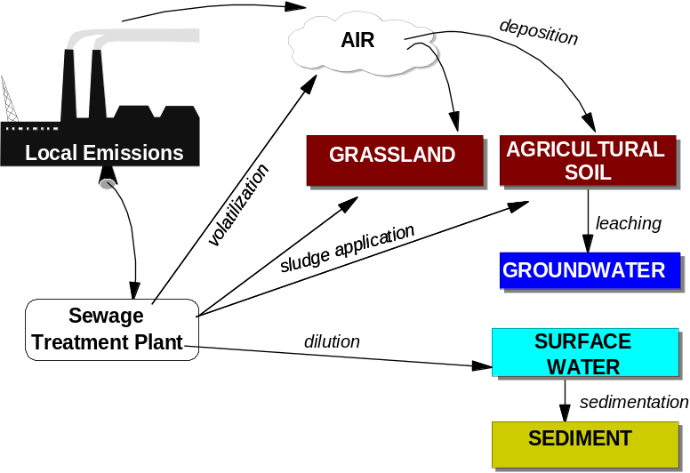
Figure 19: Local relevant emission and distribution routes (after EC, 1996)

However, these standard, generic local scenarios can not be used for shooting ranges. Therefore, targeted generic local scenarios were developed. Figure 20 shows the relationship between the local emission routes and the subsequent distribution processes, which may be relevant for the different environmental compartments of concern. For each compartment, specific fate and distribution models are applied. The compartments under consideration are soil, porewater, groundwater, surface water and sediment. In addition, two additional “compartments” or “boxes”, Pb shot in sediment and Pb shot in soil, were considered due to the different fate and ecotoxicity properties of Pb shot in soil and sediment compared with Pb in soil and sediment. In this way, cumulating emissions (i.e. cumulated emission from corroded Pb in an upcoming year and its preceding years) can be explicitly (dynamically) simulated in conjunction with other fate processes like erosion, runoff and leaching. Note that the regional exposure model EUSES does not allow simulating cumulative emissions. In that case, cumulative emissions need to be calculated a priori.

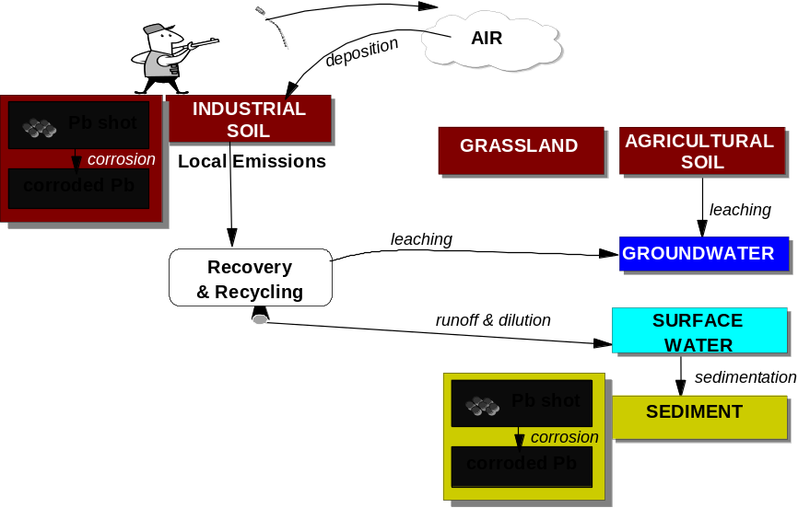

Figure 20: Modified local relevant emission and distribution routes for Pb shot

All flows of the substance between the different compartments (and with the outside world) are quantified. The most important processes are: corrosion, partitioning, runoff and leaching.

Mass balances and the corresponding differential equations are determined for the boxes “Pb shot on sediment”, “Pb shot on soil” and “soil”. This is visualised by the grey box in Figure 20. No mass balances were determined for the boxes “surface water” and “sediment” because these compartments are not considered for accumulation in the TGD and for the box “groundwater” because this compartment is not considered for environmental risk characterisation (TGD, 1996; 2003).

For local emissions in every environmental compartment, the emission rate is averaged per day (24 hours) in the TGD (EC, 1996). This implies that, even when an emission only takes place a few hours a day, the emission will be averaged over 24 hours. Emissions will be presented as release rates during an emission episode. PEClocal is consequently always calculated on the basis of a daily release rate, regardless of whether the deposition to soil or the discharge to surface water due to runoff from shooting range is intermittent or continuous. It represents the concentration expected at a certain distance from the source on a day when discharge occurs. The emission is always assumed to be continuous over the 24-hour period. For outdoor pistol/rifle and clay target shooting ranges (trap and skeet), continuous emission during the entire year is assumed.

3.2.2.2. Processes in compartments

Air
The firing of each bullet, especially if unjacketed, can release both lead vapours and particles as it leaves the barrel, to settle in front of the firing line. However, the amount of lead released when a bullet is fired is small (AFEMS, 2002). For this reason, emissions to air and transport and transformation processes in the air are not considered in this targeted risk assessment.

Pb shot on soil
According to the TGD, the local PEC_{soil} is calculated as an average concentration over a certain time period in agricultural soil, fertilised yearly with sludge from a STP and receiving continuous aerial deposition (dry and wet) from a nearby point source, for a period of 10 years. Here, emissions from sludge are not relevant. The main emission source is the load or “direct emission” of Pb shot. The main source of Pb ‘as such’ is the corrosion of deposited Pb shot.

Accumulation of the substance may occur when there is direct deposition of Pb shot over consecutive years. There are several extensive numerical soil and groundwater models available (mainly for pesticides). These models, however, require a detailed definition of soil and environmental characteristics. This makes this type of models less appropriate for a generic risk assessment at EU-level. For this generic local assessment, a simplified model is used. The top layer of the soil compartment is described as one compartment, with an average influx through direct deposition, and with several removal processes. The concentration in this soil box can now be described with a simple differential equation (EC, 1996).

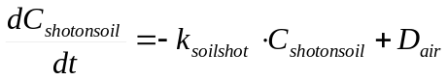

where
C_{shotonsoil}: concentration of Pb shot on soil [mg/kg]
k_{soilshot}: first order rate constant for removal from top soil for Pb shot [d⁻¹]
t: time
D_{air}: aerial deposition flux per kg of soil [kg/kg.d]

For Pb shot, the annual average total deposition flux and the deposition flux per kg soil are calculated as:
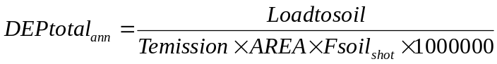
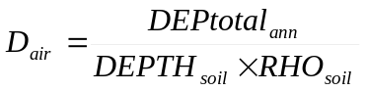

where:
DEPtotal_{ann}: annual average total deposition flux [mg/m².d]
Loadtosoil: emission to soil [kg/yr]
Temission: emission period (365 d/yr)
AREA: deposited area of the local system [km²]
Fsoil_{shot}: total area fraction of soil eligible for Pb shot [-]
D_{air}: aerial deposition flux per kg of soil [kg/kg.d]
DEPTH_{soil}: mixing depth of soil [m]
RHO_{soil}: bulk density of soil (1,700 kg/m³)

The removal processes for Pb shot on soil are corrosion, ingestion by animals and runoff. If rate constants are known for these processes, they may be added to the total removal. Removal through ingestion was assumed to be negligible compared to the corrosion rate in the soil. The overall removal rate constant is then given by:

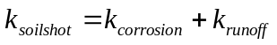

where
k_{soilshot}: first order rate constant for removal from top soil for Pb shot [d⁻¹]
k_{corrosion}: first order rate constant for corrosion of Pb shot on soil [d⁻¹]
k_{runoff}: first order rate constant for runoff of Pb shot on soil [d⁻¹]

The first order rate constant for removal from the top soil by runoff is given as:

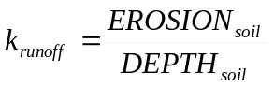

where
k_{runoff}: first order rate constant for runoff of Pb shot [d⁻¹]
DEPTH_{soil}: mixing depth of soil [m]
EROSION_{soil}: rate at which soil is washed from soil into surface water [m/d]

The differential equation can be solved to:

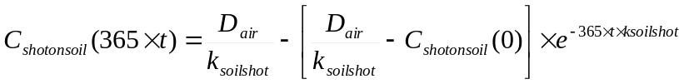

where
C_{shotonsoil}(365xt): initial concentration in soil after t years of continuous aerial deposition [mg/kg]
C_{shotonsoil}(0): initial concentration in soil [mg/kg]
D_{air}: aerial deposition flux per kg of soil [kg/kg.d]
k_{soilshot}: first order rate constant for removal from top soil for Pb shot [d⁻¹]
t: time [yr]

The initial concentration of Pb shot in soil is assumed to be zero.

With this equation, the concentration can be calculated at each moment in time, when the initial concentration in that year is known. In the TGD, it is assumed that sludge application takes place for 10 consecutive years (t = 10 years) as a realistic worst-case assumption for exposure. Similarly, 10 consecutive years was taken here for all scenarios. However, 10 consecutive years may not be sufficient to reach a steady-state situation. These substances may accumulate for hundreds of years. To indicate potential problems of persistency in soil, the fraction of the steady-state concentration can be derived:

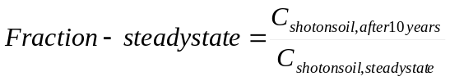

The concentration is not constant in time. The concentration increases as time progresses. Therefore, for exposure of endpoints, the concentration is averaged over a certain time period in the TGD (EC, 1996). Different averaging times are considered for these endpoints: for the ecosystem a period of 30 days is chosen. In order to determine biomagnification effects and indirect human exposure, it is more appropriate to use an extended period of 180 days because this averaging period is chosen as a representative growing period for crops. For grassland this period represents a reasonable assumption for the period that cattle are grazing on the field. For the ecosystem a period of 30 days is taken as a relevant time period with respect to chronic exposure of soil organisms (EC, 2003).

For sludge application, this averaging period is considered after the last application of sludge (see Figure 21 left). In this targeted risk assessment, deposition is assumed to be continuous and consequently soil concentrations are increasing over time. Similarly, an averaging period can be considered (see Figure 21 right).

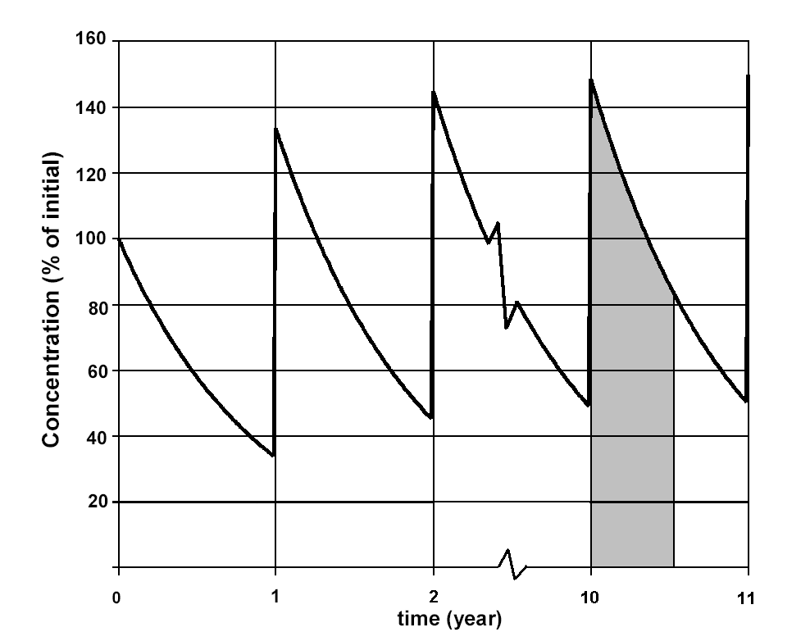 | 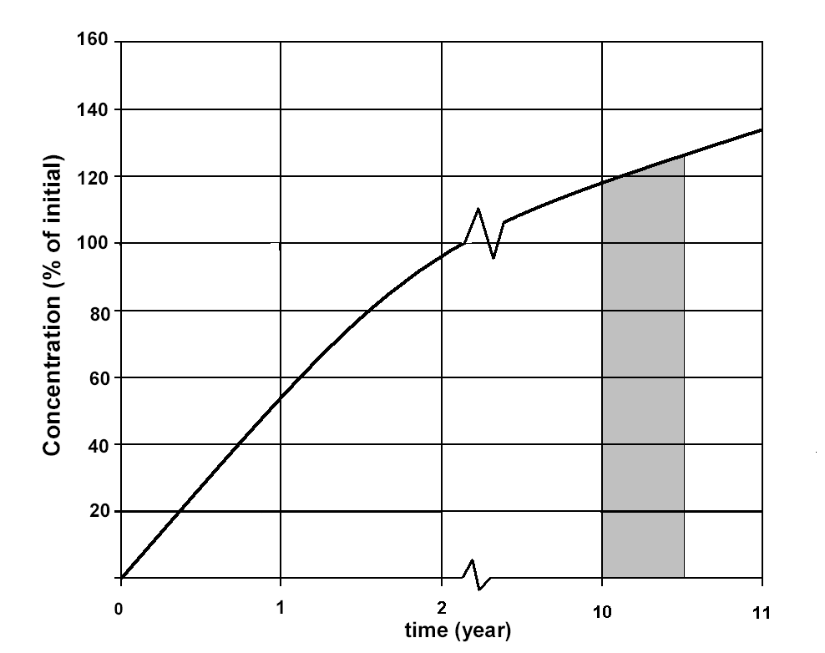
Figure 21: Left: accumulation in soil due to several years of sludge application, Right: accumulation in soil due to direct deposition of Pb shot, the shaded area is the integrated concentration over a period of 180 days

To be able to calculate the concentration in this year average over the time period T, an initial concentration in this year needs to be derived.

The concentration due to 10 years of continuous deposition only, is given by the following equations, with an initial concentration of zero and 10 years of input. The initial concentration is used to calculate the average concentration in soil over a certain time period (terrestrial ecosystem: 30 days).

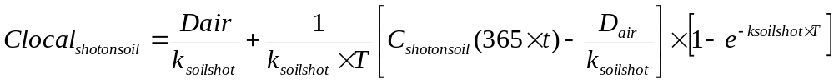

where
Clocal_{shotonsoil}: average concentration in soil over T days [mg/kg]
D_{air}: aerial deposition flux per kg of soil [mg/kg.d]
T: averaging time (30 d)
k_{soilshot}: first order rate constant for removal from top soil for Pb shot [d⁻¹]
C_{shotonsoil}(365xt): initial concentration in soil after t years of continuous aerial deposition [mg/kg]

Simulations show that the averaged concentration of Pb shot over 30 days is not different from the initial concentration in soil after t years. Therefore, averaging was not performed for this and the other compartments.

The local PEC value is obtained by adding the regional PEC value for (natural) soil to the calculated local concentration in soil.

where
PEClocal_{soil}: predicted environmental concentration in soil [mg/kg]
Clocal_{soil}: local concentration in soil [mg/kg]
PECregional_{naturalsoil}: regional concentration of Pb shot in natural soil

Soil
The main source of Pb in soil ‘as such’ is the corrosion of Pb shot. The top layer of the soil compartment is described as a separate compartment from the “Pb shot on soil” compartment, with an average influx through direct deposition, and with several removal processes. The concentration in this soil box can now be described with a simple differential equation.

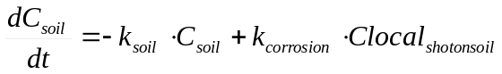

where
C_{soil}: concentration in soil [mg/kg]
k_{soil}: first order rate constant for removal from top soil for Pb [d⁻¹]
k_{corrosion}: first order rate constant for corrosion of Pb shot [d⁻¹]
Clocal_{shotonsoil}: average concentration in soil over T days [mg/kg]
t: time

The removal processes for Pb in soil are leaching, uptake by plants and runoff. If rate constants are known for these processes, they may be added to the total removal. The overall removal rate constant is given by:

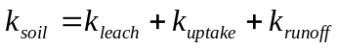

where
k_{soil}: first order rate constant for removal from top soil for Pb [d⁻¹]
k_{leach}: first order rate constant for leaching of Pb [d⁻¹]
k_{uptake}: first order rate constant for ingestion of Pb [d⁻¹]
k_{runoff}: first order rate constant for runoff of Pb [d⁻¹]

The first order rate constant for removal from the top soil by leaching is given as:

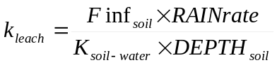

where
k_{leach}: first order rate constant for leaching of Pb [d⁻¹]
Finf_{soil}: fraction of rain water that infiltrates into soil (0.25)
RAINrate: rate of wet precipitation (700 mm/year) (1.92E⁻³ m/d)
K_{soil-water}: soil-water partitioning coefficient [m³/m³]
DEPTH_{soil}: mixing depth of soil [m]

Erosion is the movement and loss of surface layers of soil mainly by water but also wind and other factors. Soil type and structure, and slope of ground and its vegetation cover, are important determinants of soil erosion. Topsoil can be lost and deep runoff channels created. Water quality and aquatic habitats can be degraded and constituents of concern transported to other sites. Wind erosion is most likely in arid environments where the soil surface is friable and loose and was, for this reason, not considered in the exposure assessment. The first order rate constant for removal from the top soil by runoff is given as:

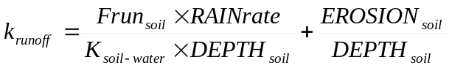

where
k_{runoff}: first order rate constant for runoff of Pb [d⁻¹]
Frun_{soil}: fraction of rain water that runs off from soil to water (0.25)
RAINrate: rate of wet precipitation (700 mm/year) (1.92E⁻³ m/d)
K_{soil-water}: soil-water partitioning coefficient [m³/m³]
DEPTH_{soil}: mixing depth of soil [m]
EROSION_{soil}: rate at which soil is washed from soil into surface water [m/d]

The local PEC value is obtained by adding the regional PEC value for (natural) soil to the calculated local concentration in soil. Note that this is an added concentration. The total concentration is afterwards calculated by adding the background concentration.

where
PEClocal_{soil}: predicted environmental concentration in soil [mg/kg]
Clocal_{soil}: local concentration in soil [mg/kg]
PECregional_{naturalsoil}: regional concentration in natural soil [mg/kg]

Pore water

The equation for the deriving the concentration in the porewater is (according to EC, 2003):

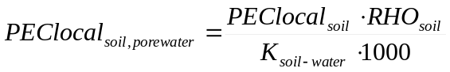

where
PEClocal_{soil}: predicted environmental concentration in soil [mg/kg]
PEClocal_{soil,porewater}: predicted environmental concentration in porewater [mg/l]
K_{soil-water}: soil-water partitioning coefficient [m³/m³]
RHO_{soil}: bulk density of soil (1,700 kg/m³)

Groundwater

The concentration in groundwater is calculated for indirect exposure of humans through drinking water (EC, 2003). For the calculation of groundwater levels, several numerical models are available (mainly for pesticides). These models, however, require a characterisation of the soil on a high level of detail. This makes these models less appropriate for the initial standard assessment. In the TGD, the concentration in porewater of agricultural soil is taken as groundwater level. It should be noted that this is a worst-case assumption, neglecting transformation and dilution in deeper soil layers (EC, 2003). This is an unrealistic worst-case assumption in case of Pb shot contamination (and metal contamination in general). Scheinost (2003) provides an overview of possible mechanisms of vertical distribution of Pb in the soil profile. He concluded that only in a few cases, a very small amount of Pb (<0.01%) was transported down the soils profile depths < 1 m. More information can be found in the section on measured data. Consequently, only pore water concentrations and no groundwater concentrations were calculated.

Pb shot on sediment
The main emission sources for Pb shot on sediment are the load or “direct emission” of Pb shot on surface water and the runoff of Pb shot from soil. This last process is unlikely to occur but is included as a worst-case assumption. The concentration in this box can be described following differential equation:

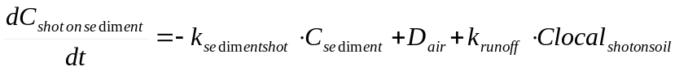

where
C_{shotonsediment}: concentration of Pb shot on sediment [mg/kg]
k_{sedimentshot}: first order rate constant for removal from sediment for Pb shot [d⁻¹]
t: time
D_{air}: aerial deposition flux per kg of sediment [kg/kg.d]
Clocal_{shotonsoil}: average concentration in soil over T days [mg/kg]
k_{runoff}: first order rate constant for runoff of Pb shot [d⁻¹]

The average total deposition flux and the deposition flux per kg sediment are calculated with the same formulas as for Pb shot on soil. Note that the AREA is now multiplied with the total area fraction of sediment eligible for Pb shot (instead of the total area fraction of soil eligible for Pb shot).

The removal processes for Pb shot on sediment are corrosion and ingestion by animals. If rate constants are known for these processes, they may be added to the total removal. Ingestion was not included because lead ammunition is easily corroded in birds (Scheuhammer & Norris, 1995) and may consequently enter the environment again. Transport to more downstream parts of the river was assumed to be zero (this is a worst-case assumption). The overall removal rate constant is given by:

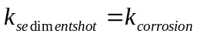

where
k_{sedimentshot}: first order rate constant for removal from sediment for Pb shot [d⁻¹]
k_{corrosion}: first order rate constant for corrosion of Pb shot on sediment [d⁻¹]

Surface water
No mass balance was determined on the surface water compartment. The local concentration in surface water (PEClocal_{water}) is in principle calculated according to TGD (EC, 2003) after complete mixing of the effluent outfall with the surface water. Dilution is then usually the dominant ‘removal’ process. To allow for sorption, a correction is made to take account of the fraction of chemical that is adsorbed to suspended matter. Similarly, a shooting range is considered as an industrial site and it is assumed that all emissions due to runoff of Pb from soil and corrosion of Pb shot from the sediment enter the surface water as a hypothetical effluent point discharge (see Figure 22). This is a realistic worst-case assumption as in reality runoff is a diffuse process.

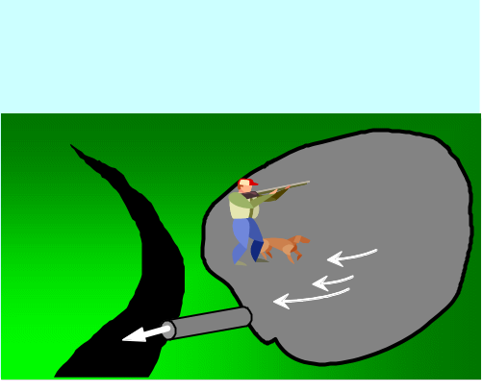
Figure 22: Emission to surface water due to runoff and erosion simplified as point source emission

The mass balance for dilution of effluent in a river can then be written as:

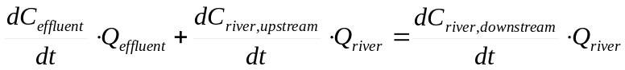

where
C_{effluent}: concentration in effluent water [mg/l]
Q_{effluent}: discharge rate of the effluent [m³/d]
C_{river,upstream}: concentration in river, upstream of hypothetical discharge point [mg/l]
Q_{river}: flow of the river [m³/d]
C_{river,downstream}: concentration in river, downstream of hypothetical discharge point [mg/l]

The upstream Pb concentration is considered to be zero as the specific impact of a shooting range is assessed. The concentration in the receiving surface water is then calculated. Complete mixing of the effluent with the receiving water is assumed. Dilution in the receiving surface water and sorption to suspended solids is taken into account.

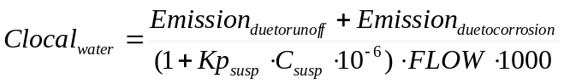
where
Clocal_{water}: local added concentration in receiving surface water [mg/l]
Kp_{susp}: solids-water partitioning coefficient of suspended matter [l/kg]
C_{susp}: concentration of suspended matter in the river (15 mg/l = default)
FLOW: (low) flow rate of receiving river (18000 m³/d)
Emission_{duetorunoff}: emission due to runoff of Pb from soil [mg/d]
Emission_{duetocorrosion}: emission due to corrosion of Pb from sediment [mg/d]

where
Emission_{duetorunoff}: emission due to runoff of Pb from soil [mg/d]
Emission_{duetocorrosion}: emission due to corrosion of Pb from sediment [mg/d]
AREA: deposited area of the local system [km²]
DEPTH_{soil}: mixing depth of soil [m]
Fsoil_{shot}: total area fraction of soil eligible for Pb shot [-]
k_{runoff}: first order rate constant for runoff of Pb [d⁻¹]
C_{shotonsediment}: concentration of Pb shot on sediment [mg/kg]
DEPTH_{sediment}: mixing depth of sediment [m]
Fwater: total area fraction of surface water [-]
RHO_{soil}: bulk density of soil (1,700 kg/m³)
RHO_{sediment}: bulk density of soil (1,300 kg/m³)

The local PECvalues are obtained by adding the regional PEC value for water to the calculated local concentration in surface water. Note that this is an added concentration. The total concentration is afterwards calculated by adding the background concentration.

where
PEClocal_{water}: predicted environmental concentration during emission episode [µg/l]
Clocal_{water}: local concentration in receiving surface water during emission episode [µg/l]
PECregional_{water}: regional concentration in surface water

Sediment

The concentration in sediment is calculated at the same location using an analogous ‘sorption’ approach from the water concentration. The local concentration in sediment (wet weight) during the emission episode can be estimated from the local values in water, the suspended matter-water partition coefficient and the bulk density of suspended matter (according to TGD).

The local concentrations in sediment during the emission episode are calculated according to the following equation:

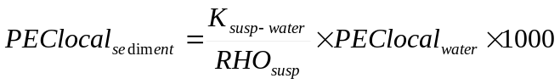
where:
PEClocal_{sediment}: predicted environmental concentration in sediment [mg/kgww]
K_{susp-water}: suspended matter-water partition coefficient
PEClocal_{water}: predicted environmental concentration during emission episode (mg/l)
RHO_{susp}: bulk density of suspended matter (1,150 kgww/m³)

where
Fwater_{susp}: fraction of water in suspended matter (0.9)
Fsolid_{susp}: fraction of solids in suspended matter (0.1)
Kp_{susp}: solids-water partition coefficient of suspended matter [l/kg]
RHOsolid: density of solid phase (2,500 kg/m³)

In this way, the Pb concentration in the sediment is, through the surface water compartment, dependent on the run-off from soil (including corrosion from shots in soil), the yearly corrosion rate of newly deposited shots as well as the shots already in the sediment. The local Pb concentration in the sediment does not account for erosion and sedimentation processes conform a local assessment in the TGD.

3.2.2.3. Dynamic simulation and steady-state conditions

Mass balances were considered for the boxes Pb shot on soil, Pb in soil and Pb shot on sediment. As in SimpleBox, the developed model produces two sorts of output: quasi-dynamic or “level 4” output and steady-state or “level 3” output (Brandes et al., 1996). The mass balances considered in this targeted risk assessment are:

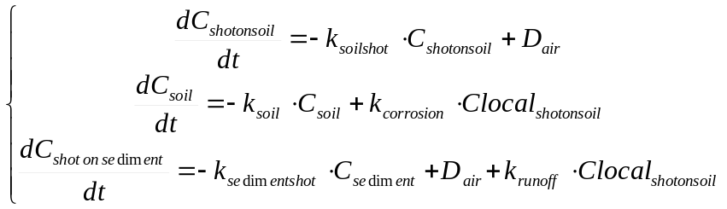

After a change in conditions (loadings or environmental conditions), mass flows and concentrations develop toward a new steady state, according to the mass balance equations. The “level 4” computation is done by numerical integration of the set of mass balance equations from time zero, with all concentrations set at their natural background level, to a specified time (e.g. 500 years). The mass balances are rewritten as:

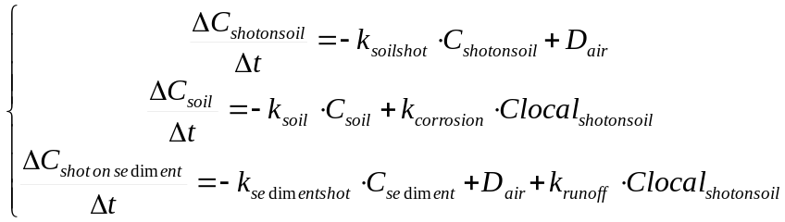

ΔC is the difference between the concentration at time t_{n} and the concentration of the previous time step t_{n-1}. Initial concentrations of Pb shot on soil and sediment (at time t = 0) were assumed to be zero. The initial concentration of Pb in soil was assumed to be 27 mg/kg (draft EU Pb RAR, 2005). A time-series can then be predicted.

The three considered mass balances can be put in the following matrix notation:

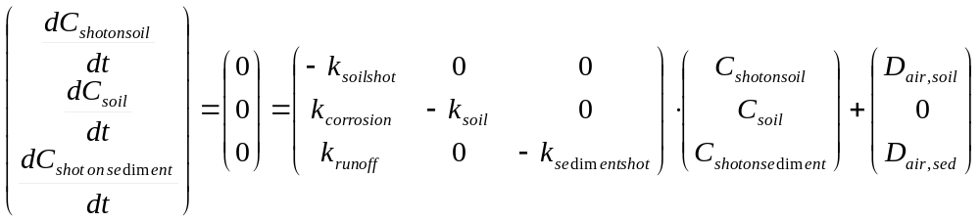

If the conditions (loadings and environmental conditions) remain constant in time for a sufficiently long period of time, eventually a steady state, in which all mass flows and concentrations are constant in time, will develop. At steady-state, the sum of the mass balance equation terms is equal to zero for all boxes and the steady-state concentrations can be solved from the 3 linear mass balance equations. This steady-state solution is obtained by means of a matrix inversion routine and is calculated as:

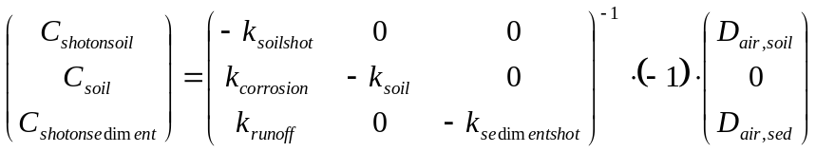

The steady-state concentrations and concentration after time t allow to calculate the percentage of steady-state situation (EC, 1996).

The time-series of Pb in ammunition resulted in steady-state concentrations above 1 kg Pb/kg soil, which is physically impossible. The concentrations are calculated (as in E-USES) according to following formulae:

However, this is a simplification of the more general formulae:

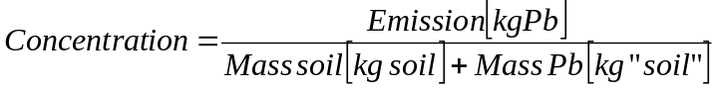

When Pb is continuously added for a long period of time in large amounts (as on shooting ranges) on a small surface (volume), the mass of the soil becomes significantly larger due to the contribution of the added Pb. Usually, the mass of the added chemical is insignificant compared to the mass of the receiving soil or

and the simplified formulae can be used without any significant error. However, in case of the local scenarios for Pb in ammunition, changes in the composition of the soil (density and volume) should be considered in trend analysis and steady-state calculations. For this, the differential equations discussed above are solved for fluxes (F expressed in kg/d) instead of concentrations because fluxes are independent of the volume and density of the receiving soil and sediment compartment. This results in next set of equations:

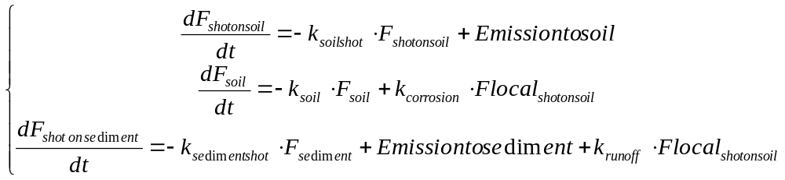

The subsequent calculation of the trend and the steady-state concentrations is analogous as for concentrations.

3.2.2.4. Initial sensitivity analysis

It is suggested by the CSTEE (Scientific committee on toxicity, ecotoxicity and the environment) that the uncertainties and assumptions should be identified and analysed so that a focused literature review and possible dedicated research can be performed to reduce uncertainties associated with the present calculations of regional Pb concentrations (CSTEE, 2003).

For this reason, it was also decided to perform a sensitivity analysis on the local exposure model in order to identify the most important parameters influencing the PECs in the environmental compartments considered. Different variants of the sensitivity analysis can be conducted (Frey and Patil, 2002; Cullen and Frey, 1999). In this targeted RAR, the following variant was used. The sensitivity of the model output to a small variation of all inputs was assessed. An infinitesimal variation (here 5%) was approximated by using uniform distributions with a maximum deviation of five percent for each parameter. This does not address the variance in the output due to the variance in the inputs, but it can assess the impact of a range of variation in the input values on the output. This method is very helpful in screening the most important inputs if no information on their uncertainty is available. This variant of sensitivity analysis is sometimes called “local sensitivity analysis”.

The values for the parameters used for the sensitivity analysis are given in Table 17. Note that not all parameters were considered for the sensitivity analysis. Generic parameters with TGD defaults (e.g. bulk density of sediment) were not considered.

A sensitivity analysis was carried out for the clay target shooting scenario only since the rifle/pistol and clay target shooting scenario only differ in the parameters emission and area of the local system.

Table 15: Settings for initial sensitivity analysis
Parameter | Parameter abbreviation | Scenario |  | Unit | Reference
Parameter | Parameter abbreviation | Rifle/pistol | Clay target | Unit | Reference
area (land+rivers) of local system | AREA | 0.005 | 0.02 | km² | Table 19
fraction of rain water infiltrating soil | Finfsoil | 0.25 | 0.25 | - | TGD
fraction of rain water running off soil | Frunsoil | 0.25 | 0.25 | - | TGD
mixing depth soil | DEPTHsoil | 0.2 | 0.2 | m | TGD
mixing depth sediment | DEPTHsediment | 0.03 | 0.03 | m | TGD
average precipitation |  | 700 | 700 | mm/yr | TGD
concentration of the suspended matter in the river | SUSPwater | 15 | 15 | mg/l | TGD
Soil erosion rate | EROSION | 8.218E-08 | 8.22E-08 | m/d | TGD
Flow rate of the river | FLOW | 18,000 | 18,000 | m³/d | TGD
partition coefficient solid-water in soil | Kpsoil | 6,400 | 6,400 | l/kg | Pb RAR
partition coefficient solid-water in sediment | Kpsediment | 218,776 | 218,776 | l/kg | Pb RAR
partition coefficient solid-water in suspended matter | Kpsusp | 295,121 | 295,121 | l/kg | Pb RAR
corrosion rate in soil |  | 2.75E-05 | 2.75E-05 | /d | Scheinost, 2003
corrosion rate in sediment |  | 2.75E-05 | 2.75E-05 | /d | Scheinost, 2003
Annual local load of lead shot: tonnage |  | 10,000 | 25,000 | kg/yr | Table 17
time horizon | t | 10 | 10 | yr | TGD
Natural background concentration soil |  | 0.000027 | 0.000027 | kg/kg dw | Pb RAR

The sensitivity analysis was performed using the @RISK Excel-addin software package (Palisade corporation, copyright 1997). The sensitivity analysis in @RISK uses either a multivariate stepwise regression analysis or a rank order correlation analysis. Regression is simply another term for fitting data to a theoretical equation. In the case of linear regression, the input data is fit to a line. Multiple regression tries to fit multiple input data sets to a planar equation that could produce the output data set. The sensitivity values returned by @RISK are normalized variations of the regression coefficients. Stepwise regression is a technique for calculating regression values with multiple input values. Other techniques exist for calculating multiple regressions, but the stepwise regression technique is preferable for large numbers of inputs since it removes all variables that provide an insignificant contribution from the model. The coefficients listed in Figure 23 are normalized regression coefficients associated with each input. A regression value of 0 indicates that there is no significant relationship between the input and the output, while a regression value of 1 or -1 indicates a 1 or -1 standard deviation change in the output for 1 standard deviation change in the input. Figure 23 summarizes the sensitivities of the considered input parameters towards 5 outputs: the Pb concentration in the surface water, the pore water and the soil, the Pb shot concentration on sediment and soil.

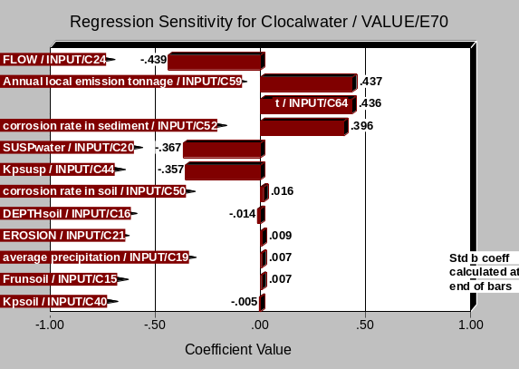 | 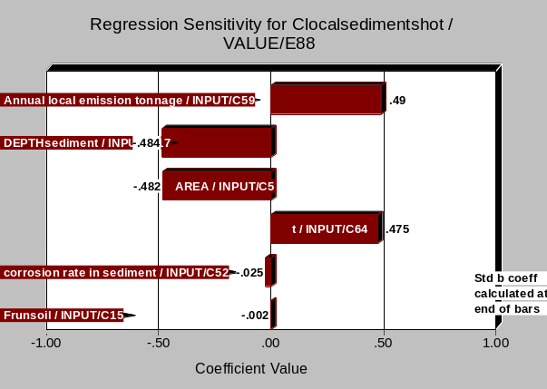
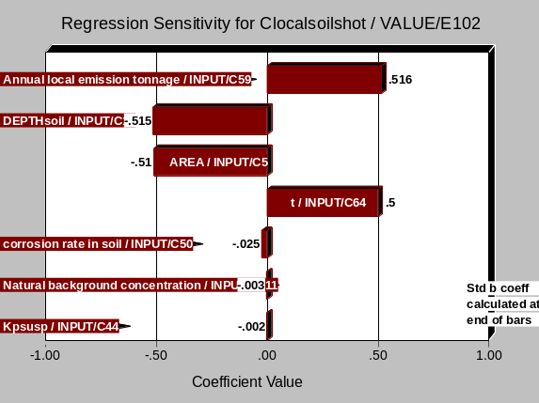 | 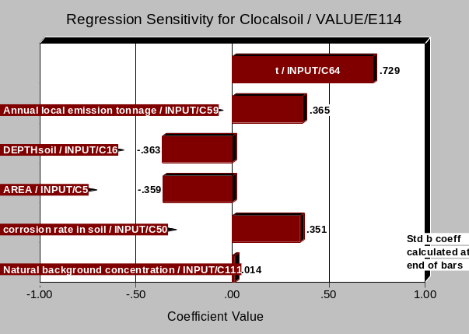
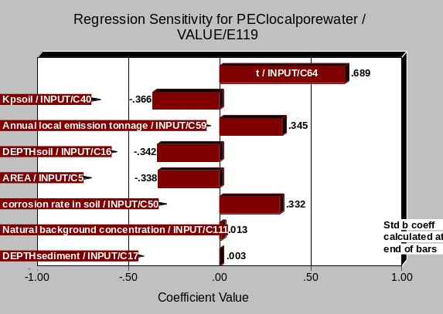
Figure 23: Initial sensitivity analysis for clay target shooting scenario

Following can be concluded:
- The annual local emission tonnage is very important for all predictions of exposure concentrations.
- The dimensions of the receiving environment (flow for PEClocal_{water}, area and depth soil/sediment for PEClocal_{soil}, PEClocal_{Pbshotonsoil}, PEClocal_{Pbshotonsediment}) are as important as the emission. Note that the soil depth and the area (deposited area) are not important for calculation of PEClocal_{water} and PEClocal_{sediment} (their regression sensitivity value is close to zero). This corresponds with the theoretical expectations that soil depth and the deposited area determine the “dilution” of Pb shot and Pb on soil whereas the flow determine the dilution of Pb in the receiving water environment. Consequently, in the shooting ranges scenarios, the estimation of the area and soil depth is less important as soil and groundwater risk is not assessed for those scenarios.
- The time (period of deposition) is sometimes equally, sometimes more important than the annual local emission tonnage or the dimensions of the receiving environment.
- The corrosion rate in soil or sediment is another important input parameter and is more important than the erosion or runoff rates (for the water and sediment compartment).
Based on these findings, resources were allocated to collect information on the most sensitive parameters (see next section).

3.2.2.5. Parameters

Local load of lead shot: regional to local transformation (prior to corrosion)

The local lead shot load is referred to as the input of Pb in ammunition to the technical area of the range, i.e. before any corrosion. The B-tables of Appendix I (EC, 1996) are normally used for the determination of the releases from point sources for the evaluation of PEClocal. They provide the fraction of the total volume released on a regional level that can be assumed to be released through a local, single point source, and the number of days during which the substance is released, thus allowing the daily release rate at a main point source to be calculated (EC, 1996). However, there is no guidance in the TGD on releases for the considered scenarios here. Alternatively, the local lead shot load can be estimated by dividing the regional lead shot load by the number of local sites (see Table 16) or reported local loads from literature can be used (see Table 17). The number of local rifle/pistol, trap/skeet and sporting clay sites were obtained from AFEMS (personal communication) and are only indicative (based on a limited survey).

Table 16: Regional and estimated local load of lead shot (based on the number of sites) for rifle/pistol and trap and skeet shooting ranges (bold: min – max values)
Scenario | Rifle/pistol (outdoor) |  |  | Trap/skeet |  |  | Sporting clay
Country | regional  lead shot load  (tonnes  /year) | # sites | local  lead shot load  (tonnes  /year) | regional  lead shot load  (tonnes  /year) | # sites | local  lead shot load  (tonnes  /year) | # sites
Austria | 182 | 369 | 0.49 | 251 | 43 | 5.84 | 5
Belgium | 49 | NA | NA | 248 | 25 | 9.92 | 20
Czech Republic | 332 | 25 | 13.26 | 218 | 50 | 4.36 | 10
Denmark | 104 | NA | NA | NA | NA | NA
Finland | 216 | NA | NA | NA | 524 | NA
France | 539 | 700 | 0.77 | 2,117 | 220 | 9.62 | 100
Germany | 1,107 | 2,000 | 0.55 | 917 | 440 | 2.08 | 30
Greece | 36 | 27 | 1.34 | 98 | 35 | 2.80 | 4
Ireland | 19 | NA | NA | NA | NA | NA
Hungary | NA | 650 | NA | NA | 63 | NA | 63
Italy | 350 | 30 | 11.67 | 2912 | 440 | 6.62 | 10
Norway | 133 | NA | NA | 71 | NA | NA
Portugal | 33 | NA | NA | 416 | NA | NA | 25
Spain | 56 | 18 | 3.12 | 1261 | 813 | 1.55 | 45
Sweden | 162 | 3,750 | 0.04 | 234 | 1,100 | 0.21 | 20
Switzerland | 276 | 600 | 0.46 | NA | 262 | NA | 40
The Netherlands | 114 | 25 | 4.56 | 9.1 | 20 | 0.46
United Kingdom | 123 | 1,500 | 0.08 | 3605 | 1,000 | 3.61 | 1,000
NA: Not Available

Lobb et al. (1997) estimated Pb shot deposition of 16 clay target shooting ranges in New Zealand conservatively based on average shooters and shots per shooter data. The lead shot load ranged from 210 to 9860 kg/year. Annual lead loadings of up to 6 tonnes were reported on three Danish shooting ranges (Jorgensen & Willems, 1987), and a Finnish range was reported to have an annual lead loading of 15 tonnes (Tanskanen et al., 1991). Laender ministers for the environment (1998) report a range of numbers from various sources. A global minimum maximum range of 32 – 32,000 kg/year was reported, however, the majority of the other data (with indication of their frequency) indicate that the reasonable worst-case load is not larger than 10,000 kg/year.

Table 17: Literature data on local lead shot load (i.e. quantities of lead used) for outdoor pistol/rifle ranges, clay target shooting ranges, sporting clay ranges and hunting areas
Location | Local lead shot load (kg/yr) | Reference
Type range unknown
Denmark | 6,000 | Jorgensen & Willems, 1987
Finland | 15,000 | Tanskanen et al., 1991
Finland | 500 (average)  120 – 15,000 | Sorvari et al., 2006
Outdoor pistol/rifle shooting ranges
EU countries | 40 – 13,260 | Derived from data provided by industry (see Table 16)
Switzerland | 40 – 800 | Knechtenhofer et al., 2003
SUMMARY | 10,000  40 – 13,260 | Realistic worst case  Minimum – maximum
Clay target shooting ranges (trap and skeet)
EU countries | 210 – 9,920 | Derived from data provided by industry (see Table 16)
New Zealand | 210 – 9,860 | Based on Lobb et al., 1997 (from Rooney, 2002)
240 shooting ranges from Bundesverband Schiessstaetten (Germany) | < 260 (50%)  260 - 2,600 (40%)  > 2,600 (10%) | Laender ministers for the environment, 1998
Baden-Wuerttemberg (Germany) | < 260 (13%)  260 - 2,600 (72%)  > 2,600 (11%) | Laender ministers for the environment, 1998
137 shooting ranges in Lower Saxony (Germany) | < 49 /ha (65%)  < 222 /ha (24%)  < 354 /ha (6%)  > 1,011 /ha (4%) | Laender ministers for the environment, 1998
Laender countries | 32 – 32,000 | Laender ministers for the environment, 1998
SUMMARY | 15,000  32 – 32,000 | Realistic worst case  Minimum – maximum

There is not enough information available to accurately calculate an average, a median or a percentile of the emission rates. Consequently, realistic worst case estimates (similar to ~ 90th percentiles) were determined based on expert judgement. A realistic worst case estimated local emission tonnage of 10,000 kg/yr and 15,000 kg/yr were taken respectively for outdoor pistol/rifle and clay target shooting ranges based on literature data and estimations.

For the local assessment, the accumulating emission due to Pb shot corrosion was considered. For each year, the corroded Pb of the newly deposited Pb ammunition was added to the corroded Pb of the previously deposited Pb ammunition.

Historical emissions

The future Pb emissions arising from corrosion of Pb shot already in the environment caused by historic use of Pb shot need to be included. For this, an average lifetime of a shooting range needs to be estimated. Table 18 gives a literature overview.

In Finland, one quarter of Finnish shooting ranges originate from the 1960s, the oldest dating back to the 19th century. Approximately 10% of the ranges were established in the 1990s (Sorvari et al., 2006).

According to Industry data, sport shooting activities were rather limited before the second World War. It is therefore correct to estimate that no clay target range has been in existence for one century. The average age should be estimated to be no more than 25 years and only 5 % could have been in existence for more than 50 years. Three main factors have got a negative impact onto this leisure activity: the logistic and economic restrictions before, during and after the two World Wars and the economic depression in the late 1920. A similar trend is observed for outdoor pistol/rifle shooting ranges.

Table 18: Lifetime of shooting ranges (in existence)
Scenario | Lifetime (years) | Reference
Outdoor pistol/rifle shooting ranges
European overview | >25  (some cases: >100) | Industry
Clay target shooting ranges (trap and skeet)
One closed range in Spain | 19 | Urzelai et al., 2003
Hollola, Finland (closed range) | 23 | Rantalainen et al., 2006
Cantebury, New Zealand  - closed ranges (4)  - active ranges | 35 (30 – 40)  > 34 (> 7 – > 70) | Rooney, 2002
240 shooting ranges from Bundesverband Schiessstaetten (Germany) | < 10 (15%)  10-20 (30%)  > 20 (55%) | Laender ministers for the environment, 1998
Baden-Wuerttemberg (Germany) | < 10 (6%)  10-20 (21%)  > 20 (70%) | Laender ministers for the environment, 1998
European overview | >25  (95th perc: >50) | Industry
SUMMARY | >50 | Reasonable worst-case

An average life-time for clay target shooting ranges in existence is estimated to be 25 years. A reasonable worst-case life-time for pistol/rifle and clay target shooting ranges in existence is estimated to be 50 years. A time-line of 60 years will be used in the risk assessment. This comprises of 50 years historical Pb shot deposition and 10 years of future Pb shot deposition (following the time-line used in the TGD for sludge application on agricultural soil in local assessment).

A similar trend is observed for outdoor pistol/rifle shooting ranges. In this last type of ranges, there are a couple of cases in which they are in existence since about a century. The same time-line of 60 years will be assumed.

The Laender ministers for the environment (1998) report an example of a shooting range, built 30 years ago, starting with a number of 10,000 rounds a year, growing continuously to 150,000 rounds today, approximately 70 tons of lead have been emitted during this period of operation.

The yearly, local Pb shot deposition is assumed to follow the trend in Figure 24 of which the current emission is 10,000 kg/yr for pistol/rifle shooting ranges and 15,000 kg/yr for clay target shooting ranges. This is visualised in Figure 24 for pistol/rifle shooting ranges. The Pb shot accumulates in the environment (visualised in Figure 25 for pistol/rifle shooting ranges). The Pb shot corrodes every year. This results in a Pb emission visualised in Figure 26 for pistol/rifle shooting ranges. As a worst-case scenario, it is assumed that there were no remediation activities. As the risk assessment does not include historical Pb emissions but includes future Pb emissions arising from corrosion of Pb shot already in the environment (caused by historic use of Pb shot), the Pb emissions in the past are set to zero.

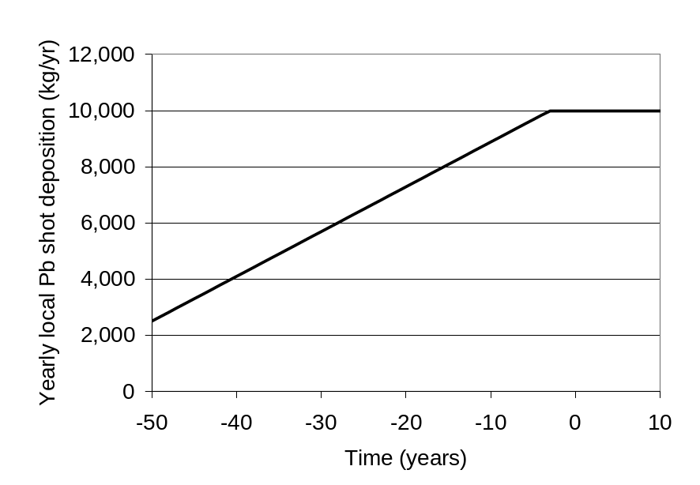
Figure 24: Yearly local Pb shot deposition time-series for a generic outdoor pistol/rifle range (on soil)

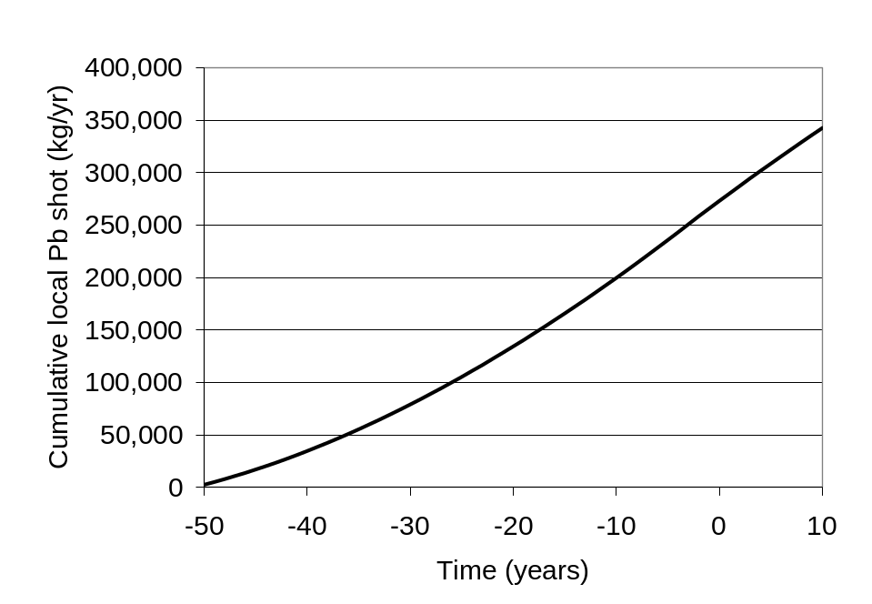
Figure 25: Cumulative local Pb shot time-series for a generic outdoor pistol/rifle range (on soil)

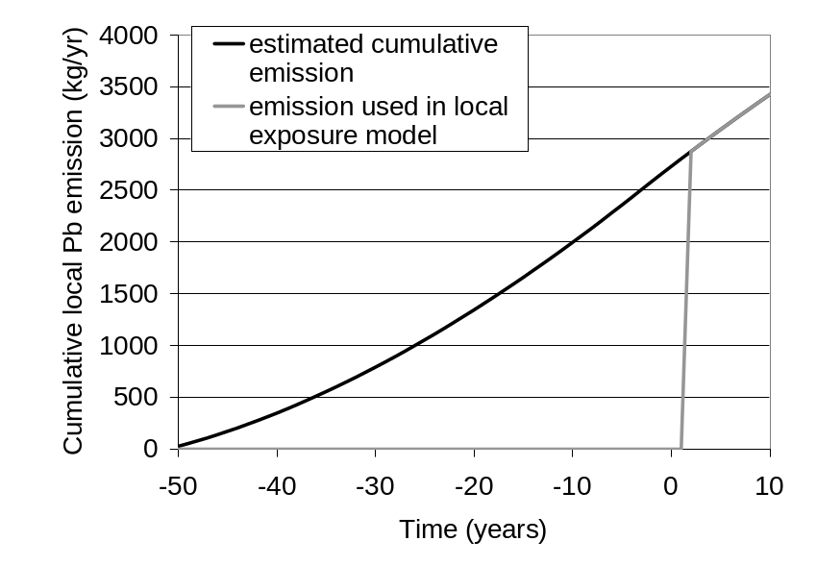
Figure 26: Cumulative local Pb emission for a local outdoor pistol/rifle range (on soil)

The area of the local system

Areas of a generic local environment are estimated in different regulations. In the TGD, the concentration in air is estimated at a distance of 100 meters from the source. This distance is chosen to represent the average distance between the emission source and the border of the industrial site. The deposition flux is averaged over a circular area around a source, with a radius of 1000 m to represent the local agricultural area. Consequently, the area of a generic local system is the surface of a circle with radius 1 km or 3.14 km² (for new and existing substances, EC, 2003). The standard environment for application of agricultural pesticides consists of a plot of target soil with a surface area of 1 hectare. Concentrations in soil and surface water (in this case a ditch surrounding the area) are calculated averaged over different time periods (RIVM, VROM, VWS, 1998). However, it is relevant to estimate more realistic areas for the considered scenarios.

AFEMS (2002) gives an overview of generic shooting ranges. The area of accumulation depends on the layout of the range and the clay target shooting disciplines used, but is likely to be several hectares. Shot deposition from trap and skeet layouts normally is from some 60m – 210m in front of each shooter, with maximum concentrations around 115m – 180m (see Figure 27). This is typically more variable at sporting layouts. Conventional layouts of trap, skeet, sporting and other clay target disciplines, typically disperse pellets over several hectares. Shooting ranges can re-site or re-align the shooting stands and the angles and trajectories of clay targets to concentrate the spent shot into a smaller area. This helps its future management and possible recovery. Pellet distribution can be greatly altered by local topography, vegetation and other surface features.

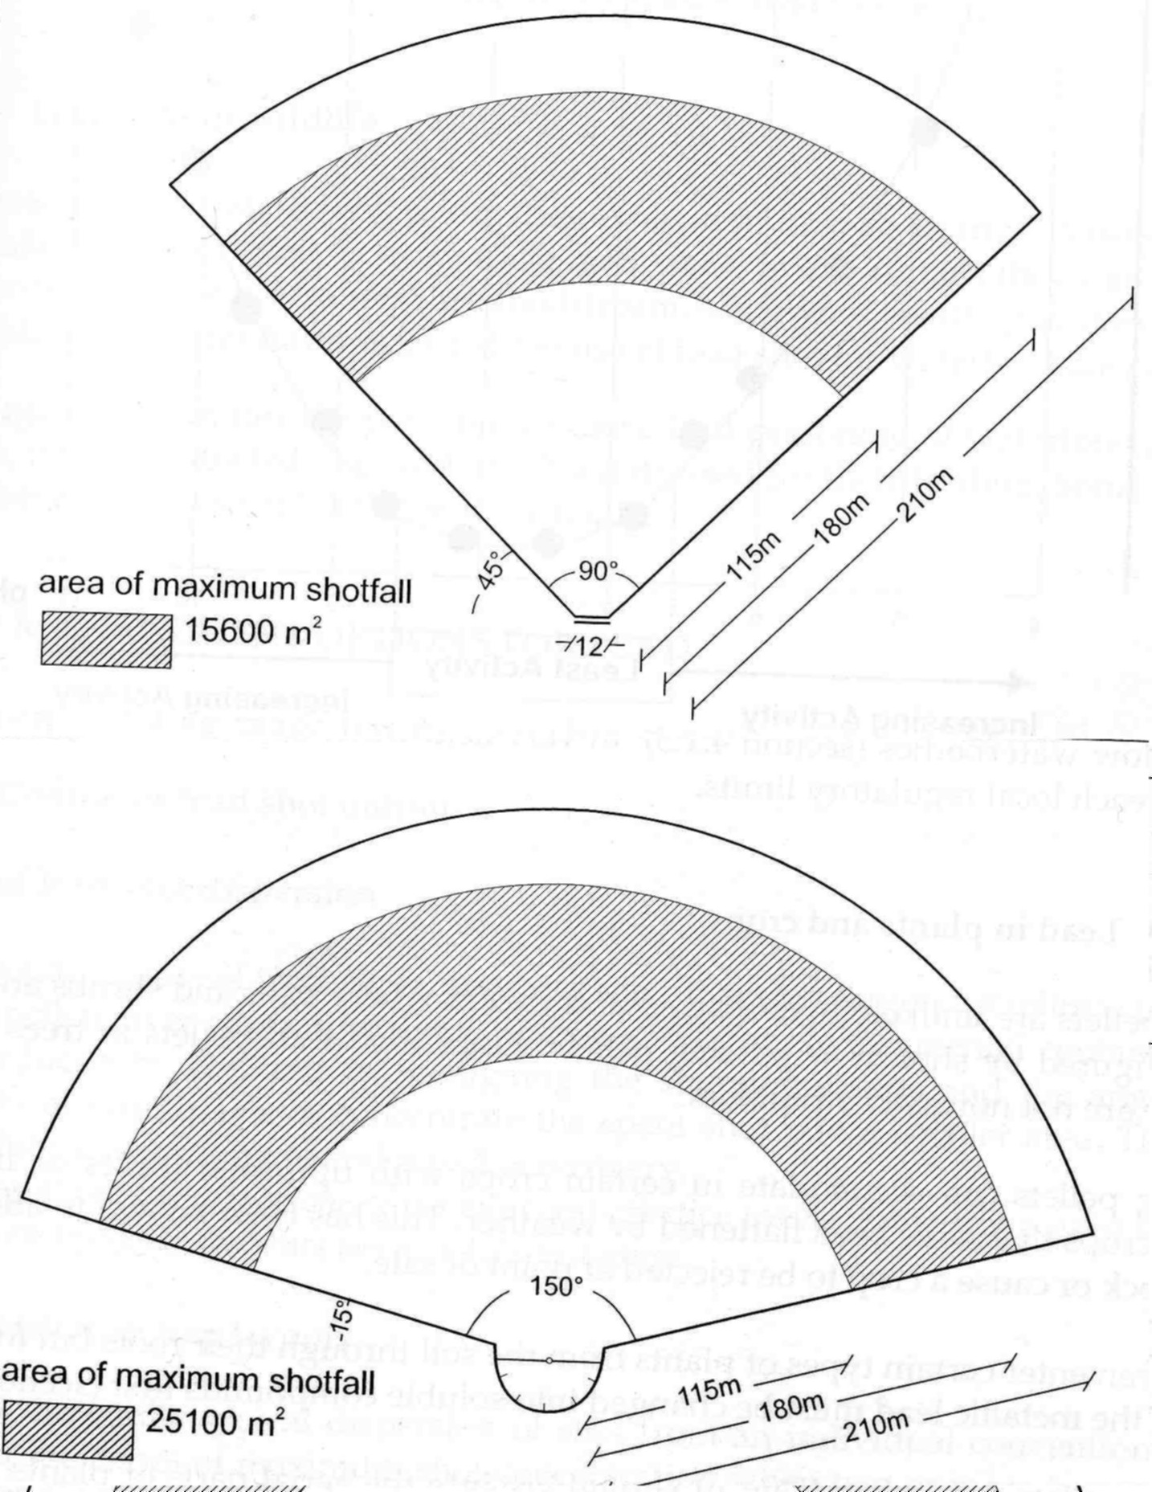

Figure 27: Shooting range layout and drop fall zone for trap (top) and skeet (bottom) (picture from AFEMS, 2002)

The area of land required for a rifle/pistol range can be much less than that for a shotgun range. Key factors are the length of the range (from under 100m to over 1000m) and the measures used to contain spent bullets. A 25-stand, 100m range, providing complete bullet containment, requires around 1ha of land, including the buildings and other infrastructure. For each 100m increase in length of the range the area increases by around 0.7ha. A 1000m range would cover some 8 ha of land. As the degree of bullet containment decreases the area of land required increases. These and other values found in literature are summarized in Table 19.

Table 19: Area of the local system and drop fall zone for outdoor pistol/rifle ranges, clay target shooting ranges, sporting clay ranges and hunting areas
Scenario + description | Area of the local system (ha) | Drop fall zone (ha) | Reference
Outdoor pistol/rifle shooting ranges
 | 0.7 – 8 |  | AFEMS, 2002
 | 1 |  | Cao et al., 2003a
rifle range | 0.6 |  | Craig et al., 1999
SUMMARY | 1  0.6 – 8 | 0.5 ^{z} | Realistic worst case  Minimum – maximum
Clay target shooting ranges (trap and skeet)
1 trap |  | 1.56 ª | AFEMS, 2002
1 skeet |  | 2.51 ^{b} | AFEMS, 2002
3 trap (overlapping) |  | 2.5 ^{c} | AFEMS, 2002
3 skeet (overlapping) |  | 4.33 ^{d} | AFEMS, 2002
1 trap | 2.8 | 1.2 ^{e} | Laender ministers for the environment, 1998
1 skeet | 5.2 | 2.3 ^{e} | Laender ministers for the environment, 1998
 | 4 |  | AFEMS, personal communication
3 trap, 2 skeet (overlapping) | 4 ^{f} |  | Based on Rooney, 2002
10 trap, 6 skeet (overlapping) | 17 ^{f} |  | Based on Rooney, 2002
6 trap, 3 skeet (overlapping) | 4 ^{f} |  | Based on Rooney, 2002
2 trap, 1 skeet (overlapping) | 3.6 ^{f} |  | Based on Rooney, 2002
 |  | 2 | Migliorini et al., 2004
shotgun range* | 0.6 |  | Craig et al., 1999
SUMMARY | 5.8  2 – 17 | 2  1.2 – 4.3 | Realistic worst case  Minimum – maximum
^{z} it is assumed that the deposition area is half of the area of the local system in a rifle/pistol range; ª based on 90°, 115-180m (worst case is 60-210m); ^{b} based on 150°, 115-180m; ^{c} based on 90°, 115-180m; ^{d} based on 150°, 115-180m; ^{e} distance = 75 to 200m; ^{f} Estimated based on maps
* the drop fall zone is larger than the shotgun range

According to a survey in Finland (Sorvari et al., 2006), most Finnish shooting ranges are relatively small and one-third of ranges cover an area of less than 1 ha. Only ca. 5% of ranges exceed 20 ha (see Figure 28).
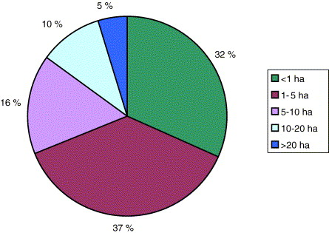
Figure 28: Estimated surface area covered by Finnish shooting ranges (Sorvari et al., 2006)

There is not enough information available to accurately calculate an average, a median or a percentile of the deposition areas. Consequently, realistic worst case estimates (~ 10th percentiles) were determined based on expert judgement. The area of maximum shot fall was taken in order to estimate the larger concentrations. For outdoor pistol/rifle ranges, 0.5 ha was taken as deposition area. For clay target shooting, 2 ha were taken as generic deposition area.

Fraction Pb shot deposition to soil and water

Following the assumptions in the use scenario, it is assumed that Pb shot is deposited 100% on the industrial soil. No direct emissions to neighbouring agricultural/natural soil or surface water are assumed for a well managed shooting range. The distance to surface water was estimated in Sorvari et al. (2006) for Finnish shooting ranges. 9% had a distance between 0 and 100 m, 43% had a distance between 101 and 1000 m and 18% had a distance between 1 and 3 km.

Mixing depth soil

The “soil depth” represents the depth range for the top soil layer which is of interest. In the TGD, the depth of 20 cm is taken because this depth usually has a high root density of crops, and represents the ploughing depth (EC, 2003). For grassland, the depth is less (10 cm) since grasslands are not ploughed. Depending on the condition at the shooting range (soil vegetation, morphology, operation, ground water, climate, etc.), the inputs of Pb shot, clays material and wads are mainly accumulated in surface-close layers, i.e. in a soil depth of up to approx. 0.3 m below the area’s surface, in individual cases also deeper. Vyas et al. (2000) found that 91% of the shot was present in the top 3 cm of the woodland soil surrounding a trap and skeet range. The number of shot found in the top 3 cm varied by location because of the abundance of shot fall, depth of litter horizon and topography. A soil depth of 10 cm was taken here as a realistic worst case since the soil at pistol/rifle and clay target shooting ranges are usually covered by vegetation and not ploughed.

Other distribution characteristics of the environmental compartments

The other distribution characteristics of the environmental compartments are summarised in Table 12 (in regional assessment section). These parameters are mostly default values from the TGD (EC, 2003) or taken from the draft EU Pb RAR (2005).

Pb shot properties

The corrosion rate of Pb shot is already discussed in section 3.1.3. Scheinost (2003) concludes in his study to consider initial fast weathering rates of 0.2 to 2 % per year. In this way, large amounts of the bullets and shotgun pellets deposited on shooting ranges would be transformed every year into Pb carbonates and sorbed species, and it would take between 50 and 500 years to completely weather from metallic Pb to other Pb species. In this targeted risk assessment, a worst case corrosion rate of 1 % per year is taken. The corrosion will be most important in the first year and will decrease to about 50% of the initial corrosion rate after 2-3 years (Linder B., 2004); the corrosion rate will then further gradually decrease in time. Nevertheless, the worst-case assumption of a constant (instead of a decreasing) corrosion rate of 1% was used for this assessment. The same corrosion rate was assumed for Pb shot on sediment even though it is likely that the corrosion rate in sediment is smaller than the corrosion rate in soil because massive metal would likely end up buried in sediment after a relatively short period of time. More information on corrosion rates in soil and sediment would lead to more realistic predictions. For the local exposure model, this corrosion rate was transformed into a first order removal rate constant of 0.0000275 /d. This corrosion rate is used for several years in the exposure assessment and therefore to be considered as worst case since Scheinost (2003) reports the range 0.2 to 2% per year as “initial” weathering rates. The initial formation of a (thin) weathering layer due to oxidation is a very fast process. The further weathering, however, depends on a range of factors, which are only partly understood. In slightly acidic to carbonaceous soils, Pb weathering may be greatly reduced by the formation of a protective surface layer of weathering products .

Uptake of Pb by plants

Several literature sources, of which some are reported here, describe Pb uptake by plants.

Samples of vegetation comprising violet (Viola sp.), black maple (Acer nigrum), and hawthorn (Crataegus sp.) were collected from the shooting range and shown to contain elevated lead concentrations (Emerson, 1993).

Grass samples taken from shooting ranges showed increased lead contents compared with uncontaminated matching samples. In the deposition centers of lead ammunition, the lead contents in the grass were indicated between 6 and 40 mg/kg dw (Coy and Schmid (1987) from Laender ministers for the environment, 1998). Uncontaminated samples contained 1.5 to 4 mg/kg. In an examination of ten selected shooting ranges in Baden-Wuerttemberg, the roots of wild plants showed systemically (via the soil solution) accumulated lead concentrations, which were 4,000 times higher than the samples of uncontaminated soils (Ministry for the Environment Baden-Wuerttemberg (1995) from Laender ministers for the environment, 1998). High lead accumulations were also found in the shoot of annual cultivated plants (rape: 500 mg Pb/kg dw) and spruces (400 mg/kg dw).

Tsuji & Karagatzides (1998) studied elemental distribution of lead shot in a tidal marsh that has been used heavily for hunting for generations. A direct correlation between soil Pb and plant biomass was not evident, and Pb contents of shoots (3.1 +- 0.8 µg/g) and rhizomes (2.8 +- 0.6 µg/g) were at background levels, suggesting minimal uptake of Pb from the soil.

Pb uptake by plants was not further considered here because plants on the technical area of a shooting range should not be considered.

3.2.2.6. Verification exposure model

Rooney (2002) assessed the magnitude and spatial distribution of Pb contamination at various clay and target shooting ranges in Canterbury (New Zealand). These site-specific data can be used to verify the generic, local exposure model developed above. The parameters that were used to run the local exposure model are given in Table 20. Default values, described above, were used for the remaining parameters. The years of operation and lead ammunition deposition are reported in Lobb et al. (1997) till 1997. Five years were added because measurements of Pb and Pb shot were reported in 2002. The Pb shot deposition was conservatively estimated based on average shooters and shots per shooter data by Rooney (2002). The area of the shot-fall zone was graphically estimated based on site plans from Rooney (2002). The soil depth with Pb shot concentration larger than 300 mg/kg was taken as the mixing soil depth. The shot-fall area of the Ashburton site has been ploughed periodically, which has caused the mixing of Pb shot into the top 20 cm of the profile and increases the fine earth Pb concentration to exist to this depth.

Table 20: Input parameters of 4 clay and target shooting ranges in New Zealand (after Rooney, 2002)
Site | Description* | Years of operation° | Estimated local lead shot load (kg/year) | Estimated shot-fall zone (ha) | Soil depth containing Pb shot (cm)
Ashburton | 3 trap, 2 skeet, pasture, ploughed | 30 | 600 | 1.5 | 20
Canterbury | 10 trap, 6 skeet, grazing | 12 | 9857 | 6 | 5
Timaru | 6 trap, 3 skeet, cropping | 30 | 2800 | 2 | 10
Waihora | 2 trap, 1 skeet, sporting field, grazing | 56 | 2490 | 1.2 | 15
* all trap and skeet are partly overlapping
° till 2002

Based on these input parameters, concentrations of Pb and Pb shot were predicted and are given in Table 21. Observed concentrations of Pb and Pb shot, found in Rooney (2002) are also given in Table 21. The Canterbury site is used intensively, and this is reflected in the data, which show that in a relative short period of time, the Canterbury site has accumulated a Pb loading approximately half of the Waihora site (Table 21), at which Pb shot has accumulated Pb for at least 50 years. At the Canterbury site, the continued oxidation of the rapidly accumulating Pb shot is likely to produce a rapid rise in potentially soluble Pb and fine earth Pb concentrations. This is of particular concern at the Canterbury site where there is a high rate of Pb shot deposition onto a sandy soil with low Pb-sorption capacity (due to few weathering products and low soil carbon) (Rooney, 2002).

Table 21: Predicted and measured environmental concentrations of 4 clay and target shooting ranges in New Zealand (after Rooney, 2002)
Site | Maximum observed concentration Pb shot (mg/kg) | Predicted concentration Pb shot (mg/kg wwt) | Range (min-max)  observed concentration Pb (mg/kg) | Predicted concentration Pb (mg/kg wwt)
Ashburton | 14,918 | 3,031 | 25 – 1,632 | 459
Canterbury | 101,392 | 21,308 | 0 – 719 | 1,309
Timaru | 11,526 | 20,796 | 47 – 576 | 3,190
Waihora | 198,029 | 33,509 | 20 – 55,958 | 9,658

A detailed comparison between observed and predicted concentrations of Pb and Pb shot in soil is hampered by their different meanings and interpretations. The observed concentrations are (minima and) maxima therefore indicating worst-case locations (so called hot spots) whereas in the generic, local exposure model, Pb shot loads are homogenously dispersed over the shot-fall zone and therefore indicating an average concentration for the entire shot-fall zone. Nevertheless, the range and order of magnitude of the observed and predicted concentrations can be compared as a rough indication for the performance of the local exposure model. The predicted Pb concentrations in soil are well within the observed range for the sites Ashburton and Waihora. For the sites Cantebury and Timaru, the predicted concentration was even larger than the largest observed Pb concentration. Consequently, the local exposure model was capable of predicting Pb concentrations in soil at clay target shooting ranges within a factor 3 to 6 and rather on the conservative side.

3.2.3. Prediction results

The predicted local Pb shot concentrations (added and total) after 10 years for all considered scenarios and compartments are reported in Table 22. The regional concentrations used are given in Table 14Error: Reference source not found. The steady-state level is also indicated. The PECtotal for Pb shot on soil is 309,221 mg/kg dwt for outdoor pistol/rifle range and 143,737 mg/kg dwt for clay target shooting range. The PECtotal for Pb in soil is 38,023 mg/kg dwt for outdoor pistol/rifle range and 14,623 mg/kg dwt for clay target shooting range. Estimated PECtotal values in water and sediment range respectively from 0.746 µg/l and 168 mg/kg dwt for outdoor pistol/rifle ranges and 0.95 µg/l and 227 mg/kg dwt for clay target shooting ranges. The water and sediment concentrations are higher in the clay target shooting scenario. This is largely due to the higher local emission for clay target shooting.

The predicted Pb concentration in soil will not be considered for the risk characterisation as it is assumed that all Pb shot is deposited within the range perimeters.

Table 22: Predicted Pb shot and Pb concentrations after 10 years (and cumulated emissions) based on PECregional,water of 0.36 µg/L (modelled), PECregional,sediment of 55.43 mg/kg dwt (modelled) and PECregional,naturalsoil of 28.3 mg/kg dwt (modelled)
Scenario | Clocal,added | PEClocal,added | PEClocal,total
Outdoor pistol/rifle shooting ranges
Pb shot on soil (mg/kg dwt) | 309,221 | 309,221 | 309,221
Pb shot on soil (% steady-state) | 53.1%
Soil compartment (mg/kg dwt) | 37,968 | 37,996 | 38,023
Soil compartment (% steady-state) | 4.8%
Pore water (µg/l) | 5,948 | Not calculated | Not calculated
Water compartment (µg/l) | 0.368 | 0.566 | 0.746
Sediment compartment (mg/kg dwt) | 112.6 | 142.2 | 168
Clay target shooting ranges (trap and skeet)
Pb shot on soil (mg/kg dwt) | 143,737 | 143,737 | 143,737
Pb shot on soil (% steady-state) | 43.1%
Soil compartment (mg/kg dwt) | 14,568 | 14,569 | 14,623
Soil compartment (% steady-state) | 2.8%
Pore water (µg/l) | 2,278 | Not calculated | Not calculated
Water compartment (µg/l) | 0.59 | 0.772 | 0.95
Sediment compartment (mg/kg dwt) | 172.56 | 202.36 | 227.96

Steady-state levels are not reached after 10 years. 43.1-53.1% of the steady-state level is reached for Pb shot concentration on soil. Only 2.8-4.8% of the steady-state level is reached for Pb concentration in soil. A possible decrease of the corrosion rate in time (due to control by the existing equilibrium Pb concentration) is currently not considered. Consequently, the steady-state levels should only be interpreted as indicative.

Bio-availability refinement for the sediment compartment

Assessing risks for the sediment compartment are quite often hampered by the fact that no clear relationship has been established between measured total concentrations of contaminants in sediments and their potential impact on aquatic life. As a result comparing predicted environmental concentrations expressed on a dry or wet weight basis with an established safety level (PNEC) has the potential to result in an under or overestimation of the associated risk. It is clear that for a risk assessment to reflect the current state of the science, procedures based solely based on total concentrations have to be improved by taking into account the bioavailable fraction of the contaminants present in the sediments. This involves assessing binding to reactive sulfides, organic carbon and potentially other reactive ligands and surfaces.

Attempts to address the inherent fundamental deficiencies of dry- or wet weight assessment approaches are the use of normalization procedures based on one of the factors of the bulk sediment matrix controlling the bioavailability of the chemicals of concern. Di Toro et al. (1991) identified organic carbon as a key element controlling the bioavailability of non-ionic organic chemicals and used this understanding in order to establish Sediment Quality Criteria for organic substances using the equilibrium partitioning theory. A similar approach can be applied to metal contaminated sediments where Acid Volatile Sulfides (AVS) have been demonstrated as being the predominant factor controlling metal toxicity. In this regard the difference of SEM (Simultaneous Extracted Metals) and AVS (SEM – AVS), referred to as excess SEM, does well at predicting the absence of toxicity (Di Toro et al., 1992, Ankley et al., 1994, Ankley et al., 1996). Common criticisms against the AVS approach, e.g. that it is only appropriate for use with anoxic sediments, appears to be unfounded since testing where this approach has been applied normally has both oxic and anoxic sediments present.

Under the current conclusion (i) programme, industry have initiated additional SEM/AVS measurements. The calculations below (yellow marked) will be revised based on the new information.

In case site specific SEM-AVS information is not readily available, a generic sediment bioavailability correction based on default AVS concentration can be applied based on the SEM/AVS database for Flanders (Belgium) (Vangheluwe et al., 2004). Flanders (Belgium) is assumed to be representative for Europe. Since SEM-AVS is multi-metallic in nature, any bioavailability correction should also take into account that some metals bind more preferentially with AVS than others. In case of lead it is known that it has a rather high affinity to bind with AVS. From the metals present in the sediment at concentrations levels sufficiently high to have a significant influence on the amount of AVS available to bind with lead only copper has a higher affinity. Therefore the regional ambient background of copper should be subtracted first from the total AVS value to calculate the amount of remaining AVS available to bind with lead. A ‘worst case’ setting of AVS (10th P AVS = 0.77 µmol/g dry wt) was used. It is stressed that it was observed from the regional dataset analysis that very low AVS-very high SEMPb combinations were not found in the real environment due to an observed co-variance between AVSPb and SEMPb (Vangheluwe et al., 2004). Therefore, this scenario can be regarded as less suitable to assess those local conditions where elevated lead levels are being measured.

The regional ambient concentration of copper is 64.4 mg/kg dry wt. expressed as a total concentration. Since even in the worst case scenario (AVS = 0.77 µmol/g dry wt) it can be assumed that the regional ambient copper concentration (64.4 mg/kg dry wt = 1 µmol/g dry wt) is completely bound with AVS only that fraction of the copper ambient background that really contributes to the overall measured AVS value should be subtracted in order to avoid an underestimation of the amount of AVS remaining to bind with lead. Indeed, the extractability efficiency of copper under the prevailing conditions (1 M HCl during 1 h) of the AVS extraction methodology used to derive the Flemish AVS data set is quite low. Under the current extraction conditions only a small fraction of the copper sulfides present in the sediment will be dissolved and contribute to the overall measured AVS value (being the sum of the sulfides released from all metals) and SEMCu value. Maximal extraction efficiencies of Cu(I)2S and Cu(II)S reported in the literature are ranging between 8% (efficiency of an extraction in 1M, but longer extraction time than in the present study, i.e. 24h) and 12% (efficiency of a 1 hour extraction, but at higher acid strength then in the present study, i.e. 6M) (Cooper and Morse, 1998). As a worst case scenario, it is assumed that the extraction efficiency is 12 % meaning that the amount of measured AVS needed to bind all the copper is 0.12 * total copper concentration (Table 23) or in other words that SEMCu equals 12 % of the total copper concentration measured in the sediment. For lead, it can be assumed as a conservative approach that the SEM fractions equal the total lead concentration.

Table 23: Bioavailability correction for lead using the SEM-AVS concept. Two set of scenarios have been developed. A worst case scenario in which the AVS concentration equals the 10th P: i.e. 0.77 µmol/g dry wt.
 | Ambient regional background (mg/kg dry wt) | Ambient regional background (µmol/g dry wt) | Amount of measured AVS needed to bind all copper (µmol/g dry wt) | AVS available (µmol/g dry wt) | Amount of lead that is bound by AVS  (mg/kg dry wt)
Cu | 64.4 | 1.01 | 0.12 | 0.77
Pb |  |  |  | 0.55 | 114

As such the incorporation of bioavailability into the local risk characterizations boils down to the subtraction of 114 mg Pb/kg dry wt (worst case estimate) from the total local PEC values.

This means that all Pb sediment is bound (and therefore not bio-available) both for the rifle/shotgun scenario and the clay target shooting scenario.

3.2.4. Measured data and comparison with predicted concentrations

When PECs have been derived from both measured data and calculation, they need to be compared (EC, 2003). If they are not of the same order of magnitude, analysis and critical discussion of divergences are important steps for developing an environmental risk assessment of existing substances. The following cases can be distinguished:
- Calculated PEC ~= PEC based on measured concentrations: The result indicates that the most relevant sources of exposure were taken into account.
- Calculated PEC > PEC based on measured concentrations: This result might indicate that relevant elimination processes were not considered in the PEC calculation or that the employed model was not suitable to simulate the real environmental conditions for the regarded substance. On the other hand measured data may not be reliable or represent only the background concentration or PECregional in the regarded environmental compartment. If the PEC based on measured data has been derived from a sufficient number of representative samples then they should override the model predictions. However if it cannot be demonstrated for the calculated PEC that the scenario is not unrealistically worst-case, the calculated PEC should be preferred.
- Calculated PEC < PEC based on measured concentrations: This relation between calculated PEC and PEC based on measured concentrations can be caused by the fact that relevant sources of emission were not taken into account when calculating the PEC, or that the used models were not suitable. Similarly, an overestimation of degradation of the compound may be the explanation. Alternative causes may be spillage, a recent change in use pattern or emission reducing measures that are not yet reflected in the samples.
Measured concentration of Pb shot on soil, Pb in soil, surface water and sediment were found in literature and are summarized from Table 25 till Table 26.

3.2.4.1. Pb ammunition on soil and Pb in soil

Unfortunately, it is not always clear from literature whether concentrations are expressed as total Pb (i.e. Pb ammunition and corroded Pb) or whether they are expressed as corroded Pb (i.e. Pb concentration when soil was sieved over a 2 mm sieve). The maximum measured Pb shot on soil and Pb concentrations (from Table 24) are largely smaller than the predicted concentrations (from Table 22). This can be explained by the worst-case character of the estimation of the predicted concentrations. For example, worst-case corrosion rates and local emissions were assumed. Some measured Pb concentrations are higher than the predicted. This is most probably due to the fact that measurements can be hot spots whereas predictions are averaged over the entire deposition zone. Moreover, PECs are predicted after 10 years of Pb shot emission whereas measurements can reflect shorter or longer periods. Note also that the measured data are a combination of shooting ranges and shooting areas whereas the predictions are related to shooting ranges.

Table 24: Measured concentrations of Pb shot on soil and Pb in soil for all considered scenarios (Note that it is not always clear from literature whether concentrations are expressed as total Pb (i.e. Pb ammunition and corroded Pb) or whether they are expressed as corroded Pb (i.e. Pb concentration when soil was sieved over a 2 mm sieve))
Scenario | Concentration (mg/kg) | Reference
Type area and range unknown
Denmark | 1,000  274  615 | Jorgensen & Willems, 1987
Finland | 27,000 (avg)  4,900 – 54,000 | Manninen & Tanskanen, 1993
The Netherlands | 360 – 70,000 | Ma, 1989
Outdoor shooting facility incl. pistol, trap and skeet in USA | 856.9 ** | Peddicord & LaKind, 2000
 | 5,000 (max) | Fahrenhorst & Renger, 1990
Sweden | 24,500 (max) | Lin, 1996
 | 2,256 (max) | Murray et al., 1997
 | 10,500 (max) | Tanskanen et al., 1991
 | 7,390 (max) | Merrington and Alloway, 1995
 | 31,200 (max) | Uren et al., 1995
 | 8,100 (max) | Merrington and Alloway, 1997
Ontario, Canada | 41 – 325 | Bisessar, 1992
Finland | 2,200 – 49,700 | Rantalainen et al., 2006
Outdoor pistol/rifle shooting areas and ranges
Five ranges in USA | 7.3 – 48,400 | Cao et al., 2003b
Switzerland | 60,000 (max) | AUKSG, 1994 (from Mozafar et al. 2002)
2 ranges in Switzerland  - in front of shooting house  - between backstop and house  - in the backstop | 164 – 322  44 – 3,110  26,000–33,600 | Mozafar et al., 2002
Range in USA | 875 – 4,448 | Chen & Daroub, 2002
Range in USA | 15,368 (max) | Chen et al., 2001
Switzerland | 4,462  (429 – 80,935) | Knechtenhofer et al., 2003
SUMMARY | 7.3 – 80,935 | Minimum - maximum
Clay target shooting areas and ranges (trap and skeet)
53 shooting ranges in Baden-Wuerttemberg in 1996 | 70,300 (max) | Laender ministers for the environment, 1998
12 soil samples from range in New Zealand | 45,000 | Rooney et al., 1999
4 ranges in New Zealand | 0 – 55,958 | Rooney, 2002
53 shooting ranges in Baden-Wuerttemberg in 1996 | 2,040 (max) | Laender ministers for the environment, 1998
150-210 m from shooters, Laurel, MD, USA | 110-27,000 * | Vyas et al., 2000
12 soil samples from range in New Zealand | 23 – 6,174 | Rooney et al., 1999
Northern England | 1,500 – 10,620 | Mellor and McCartney, 1994
Central Sweden | 3,400 (max) | Lin et al., 1995
In the shot fall-out zone, USA | 838 (max) | Stansly et al., 1992
9 sampling sites, Italy | 212 – 1,898 | Migliorini et al., 2004
 | 123 – 2,000 | Knigge & Köhler, 2000 (from: Migliorini et al., 2004)
Wetland skeet range in USA | 6.6 – 16,200 | Hui, 2002
2 ranges in Basque country (Spain) | 92 – 3,400 | Urzelai et al., 2003
SUMMARY | 0 – 70,300 | Minimum - maximum
(Intensively) hunting areas
Heavily hunted march of western James Bay region (Canada) | 7.4 (6.4 – 11.1) | Tsuji & Karagatzides, 1998
Canada | 9,000 – 180,000 pellets/ha | Beintema, 2001
Site extensively used by hunters in New Mexico (USA) | 167,593 – 860,185 pellets/ha | Best et al., 1992
Illinois (USA) | 51,643 – 180,875 pellets/ha | Anderson and Havera, 1989 (from: Kendall et al., 1996)
Indiana (USA) | 0 – 83,928 pellets/ha | Castrale, 1989
Hunting field in Tennesse (USA) with history of 8 years of dove shooting (pre- and post-hunt) | 27,225 – 108,900 pellets/ha | Lewis and Legler, 1968 (from: Best et al., 1992)
24 waterfowl hunting areas | 0 – 295,120 pellets/ha | Bellrose, 1959 (from: Best et al., 1992)
SUMMARY | 0 – 860,000 pellets/ha | Minimum – maximum
* 110-27000 ppm dry weight
** 95% upper confidence limit of exposure point concentrations

3.2.4.2. The aquatic compartment (surface water and sediment)

Measured Pb concentrations in surface water (summarized in Table 25) on-site are significantly higher than predicted Pb concentrations in receiving surface water outside the range. This can largely be explained by the fact that monitoring of Pb in surface water were made on the shooting range itself and the predictions are based on the assumption that there are no direct Pb shot emissions to surface water. Note also that all measured samples came from ranges in the USA.

In Peddicord & LaKind (2000), surface water Pb concentration is studied in a recreational outdoor shooting facility, including pistol, large-bore, and trap and skeet ranges. The ranges are located sequentially down the valley of a small stream in wooded hilly terrain and are interspersed with wooded and vegetated wetland areas on and between the ranges. In Cao et al. (2003b), samples were taken in retention ponds or ponds close to firing line. In Stansly et al. (1992), lead was measured close to the shot fall-out zone.

The rifle range in Craig et al. (1999) is traversed by two shallow drainage ditches which extend the length of the range. This drainage ditch terminates in an oval shaped shallow depression which generally contains water up to 1 meter in depth. Water drains out of the shallow depression into a shallow, apparently natural stream bed and passes then into a creek. During and for variable lengths of time after periods of rainfall, water up to several centimetres in depth is observed draining across the rifle range in the shallow ditches. On the shotgun range in Craig et al. (1999), water periodically stands in a shallow depression in the center of the range. The samples taken closest to the backstop gave values ranging from 36.6 – 473 µg/L. The samples taken in the central parts of the rifle and the shotgun shooting areas gave values ranging from 11.7 – 33.8 µg/L Pb, one sample taken in the runoff channel at the left margin of the rifle area gave a value of 64.6 µg//L Pb and the sample from the small collection pond to the left of the rifle area shooting boxes gave a value of 22.2 µg/L Pb. The sample taken at the margin of the shotgun shooting area where runoff drains into a natural drainage depression in the forest gave a value of 4.3 µg/L and the samples taken in the drainage streams approximately 300 meters down stream from the actual shooting areas gave values of 1.6 and 0.3 µg/L. A sample taken from the small forest drainage stream upstream from the site where it receives drainage from the shooting ranges, and thus presumably where it is unaffected by the shooting range gave a value of 0.5 µg/L. Craig et al. (1999) further concludes there is not a sufficient increase in the surface flow for dilution to account for a decline in the lead content of the waters. The decline in the lead concentration of the waters as they drain away from the backstop is significant and appears to result from a removal in lead from the waters. The decline in the lead contents of the surface water is important and encouraging because these data suggest that the dispersal of lead from the surface of the shooting range is very small.

In Urzelai et al. (2003), the monitored data show that lead mobility and migration to surface water is unlikely to be a serious problem in the investigated clay target shooting sites in the Basque country (Spain). Only the presence of surface water bodies directly affected by shot deposition can lead to higher Pb water concentrations.

Göteborgs Stad (2005) issued a report with results of the monitoring of metal concentrations in 29 streams and watercourses in the Gothenburg area in Sweden. Three out of these are streams draining shooting ranges. Metal concentrations were determined in water moss planted in the streams and harvested after 2 weeks exposure. In Otterbäcken, Pb concentrations of 18-100 mg/kg dw are measured. In two other sampling points, Pb concentrations of 8.1-229 and 39-283 mg/kg dw are measured in water moss. These measurements can not be compared to EUSES prediction results as water moss concentration is not considered as an endpoint. Moreover, it is not clear from the report whether the sampling points are located on-site or off-site shooting ranges or shooting areas.

Sundin (2005) presents some measurements of Pb on the area of a former shooting range (in use from beginning of 1900s-1968), where the gravel and sand from the backstop berms has been spread over the surrounding area. In summary, 9.79 – 20.9 µg/L was found in the water on-site, 3 g/kg Pb in the roots of the plants from the stream and 7-24 mg/kg in lingonberries growing in the area.

In this targeted risk assessment, it is assumed that all Pb shot deposition occurs within the range perimeters on the soil and there is consequently no direct emission to surface water or drainage ditches on the site. When drainage ditches or surface water is present at the shooting range, high Pb concentrations are measured. However, once the water drains to nearby creeks or rivers, measured concentrations are much smaller (0.3 – 1.6 µg/L (with upstream concentrations of 0.5 µg/L) as shown in Craig et al. (1999) and 5 µg/L as shown in Urzelai et al. (2003)). The predicted concentrations are of the same order of magnitude as the concentrations found downstream of shooting range.

Table 25: Measured concentrations of Pb in surface water for all considered scenarios
Scenario | On-site concentration (µg/L) | Off-site concentration (µg/L) | Reference
Type range unknown
Outdoor shooting facility incl. pistol, trap and skeet in USA | 49,100 * | NA | Peddicord & LaKind, 2000
Small ditches containing hydro-cerussite-coated bullets in USA | 11.7 – 473# | 0.3 – 4.3# | Craig et al., 1999
Former shooting area where backstop berms has been spread over the surrounding area | 9.79 – 20.9 | NA | Sundin, 1995
Outdoor pistol/rifle shooting ranges
Five ranges in USA | ND – 289 **  ND – 234 *** | NA | Cao et al., 2003b
In the shot fall-out zone, USA | 127 – 838 | NA | Stansley et al., 1992
SUMMARY | ND – 838 | NA | Minimum – maximum
Clay target shooting ranges (trap and skeet)
USA | 60 – 2,900 | NA | USEPA, 1994
2 ranges in Basque country (Spain) | 62 | 5 | Urzelai et al., 2003
SUMMARY | 60 – 2,900 | 5 | Minimum – maximum
* 95% upper confidence limit of exposure point concentrations
** total
*** dissolved
# pH ranged from 5.28 till 6.51

Similar conclusions can be given for the measurements of Pb in sediment (summarized in Table 26). The measured concentrations are larger than the predicted ones. However, sediments samples were taken on locations where direct Pb shot deposition is expected. Yurdin (1993) found off-site sediment concentrations of 129 mg/kg (ranging from 11-345 mg/kg).

Table 26: Measured concentrations of Pb in sediment for all considered scenarios
Scenario | On-site concentration (mg/kg) | Off-site concentration (mg/kg) | Reference
Type range unknown
Outdoor shooting facility incl. pistol, trap and skeet in USA | 7,051 * | NA | Peddicord & LaKind, 2000
Near shore lake sediments adjacent to shooting range in USA | NA | 129.5  (11 – 345) | Yurdin (1993)
(Intensively) hunting areas
Prime Hook National Wildlife Refuge in USA | 52  (st.dev. = 16) |  | Beyer et al., 1999
Popular lakes in Canada | Can reach more than 2,000,000 pellets/ha |  | Beintema, 2001
* 95% upper confidence limit of exposure point concentrations

3.2.4.3. The porewater/groundwater compartment

Although the porewater/groundwater compartment is not assessed in the environmental risk assessment, some Pb measurements from literature can be found in Table 28. No predictions for groundwater were made. The predicted pore water concentrations, however, are of the same order of magnitude as the measured concentrations.

Table 27: Measured concentrations of Pb in porewater
Scenario | Concentration  (µg/L) | Reference
Leach experiments on 3 three soils (New Zealand) | 1,600 – 3,400  400 – 500  200 – 1,100 | Rooney, 2002
Leach experiment in Canada | > 5,000 | Thomas, 1997

Mobilisation and migration of Pb downward through the soil profile has been recently documented at a clay target shooting range by Murray et al. (1997). The spatial distribution of Pb in subsurface soil horizons at a contaminated clay target shooting range correspond to the spatial distribution of Pb in surface soil, indicating that Pb was migrating downward through the profile. Soil Pb concentrations in the clay-rich profile were approximately 1000 mg/kg at the surface and >200 mg/kg at a depth of 1 m.

Scheinost (2003) provides an overview of possible mechanisms of vertical distribution of Pb in the soil profile. He concluded that only in a few cases, a very small amount of Pb (<0.01%) was transported down the soils profile to depths < 1 m. Mechanisms involved were transport of soluble Pb species along preferential water flow paths (root channels, cracks and other macropores), and perhaps also transport of Pb bound to mobile colloids (in carbonaceous soils). Due to the large amounts of Pb commonly present in shooting range soils, even the small amounts migrating down towards the groundwater may be in the order of kilograms per year and shooting range. However, few available studies show no elevated Pb concentrations in ground waters associated with shooting ranges.

The reader is referred to the Pb RAR (draft May 2007) for further and more extensive information on the fate of Pb in the soil.

Effects assessment

4.1. General

The effects assessment of Pb is extensively described in the draft EU Pb Risk Assessment Report (RAR) (June 2007). As mentioned earlier, the total and added risk approaches have both been used in this risk assessment report on lead in both the exposure assessment and effect assessment. With respect to the effects assessment the added risk approach implies that the Predicted No Effect Concentration (PNEC) is derived from toxicity data that are based on the added lead concentration in the tests. The calculation of the PNEC/PNEC_{add} values is in agreement with the calculation of PNEC values (for substances with no background concentration) as described in the TGD, i.e. the PNEC/PNEC_{add} values are derived from toxicity data (either NOEC values or LC₅₀ and EC₅₀ values from laboratory tests), using assessment factors or statistical extrapolation.

For lead as well as for other metals, it would be important to define the actual or bioavailable concentration, which is important for toxicity, both in the laboratory tests and in the real environment. Due to several physico-chemical processes, lead will exist in different chemical forms, some of which are more bioavailable than others. It is thus realised that the bioavailability of metals in both laboratory tests and in the environment may be affected by several physico-chemical parameters, such as pH, alkalinity and hardness.

Specific selection criteria have been developed for both the aquatic and the terrestrial effects data that pay attention to the relevancy aspect of the data. These criteria refer to the most relevant abiotic factors that may influence the toxicity such as pH, hardness, organic matter content and clay content.

PNEC/PNEC_{add} values were derived from the ecotoxicity data, using the two ecotoxicological extrapolation methods, both of which are described in the TGD:
- The PNEC/PNEC_{add} is calculated from the lowest acute LC₅₀ or EC₅₀ or, preferably, from the lowest chronic NOEC, using assessment factors that depend on the available toxicity data (TGD - Chapter 3).
- In case the chronic database is sufficiently large, the PNEC/PNEC_{add} is calculated by means of statistical extrapolation, using all available chronic NOEC values as input (TGD - Chapter 3, Appendix V).

In the TGD preference is given to the former extrapolation method and it is recommended to use statistical extrapolation as a “supplementary approach”. However, there is an increasing preference towards using statistical extrapolation for the derivation of PNEC values in the case of data-rich substances (such as lead).

All effects studies of Pb are extensively described and assessed in the draft EU Pb Risk Assessment Report (June 2007). Only specific effects studies on Pb shot are discussed here. However, no additional quantitative thresholds were derived for risk characterisation. The final resulting Predicted No Effect Concentrations (PNECs) can be found in Table 28.

Table 28: Derived PNECs for aquatic, sediment and terrestrial ecosystem and predators (From draft Pb risk assessment rapport, June 2007)
Ecosystem | PNEC
Aquatic ecosystem | 5.15 µg/L
Sediment ecosystem | 673 mg/kg dwt (not corrected for bio-availability)  225 mg/kg dw (corrected for bio-availability)
Terrestrial organisms | 308 mg/kg dw
Predators | 49.1 mg/kg ww

4.2. Aquatic compartment

The PNEC_{total}water is 5.15 µg/l (based on an assessment factor of 2). The PNEC_{total}sediment is 225 mg/kg_{dw} if corrected for bio-availability or 673 mg/kg dw (if not corrected for bio-availability).

4.3. Terrestrial compartment

The PNEC_{total}soil value is 308 mg/kg dw.

4.4. Non compartment specific effects relevant to the food chain

4.4.1. Effects of Pb

Toxicity of Pb through secondary poisoning is assessed based on laboratory studies where mammals or birds are exposed to variable Pb concentrations in their prey. A PNEC_{oral} can be calculated from such studies. This PNEC_{oral} can be combined with the bioconcentration factors (BCFs) or bioaccumulation factors (BAFs) of the prey to assess risks of secondary poisoning of the predator by Pb originating from soil. This protocol is suggested by the TGD (TGD, 1996).

The determination of PNECs for secondary poisoning and the subsequent risk characterisation is part of the voluntary Pb risk assessment (2007).

4.4.2. Effects of Pb ammunition

The purpose of this section of the risk assessment report is to assess the adequacy of the present scientific literature for risk assessment of direct and indirect ingestion of lead ammunition in the EU to populations of non-waterfowl birds. Lead shot is presently banned or strictly regulated for waterfowl hunting throughout much of the European Union (EU) with the intention of preventing adverse effects on waterfowl populations. Therefore, this document does not address waterfowl.

Many hundreds of technical publications address some aspect of the EU lead ammunition/terrestrial bird issue. This vast number makes a review of all potentially relevant publications impractical as part of the European Union Risk Assessment of Lead given current constraints.

A cursory overview of the scientific literature reveals that studies have been conducted for various purposes, and not with a unifying overall objective of providing data useful in assessing risks from lead ammunition to populations of terrestrial birds. The studies are fragmented by, among other things:
- species
- age
- sex
- geographic location
- habitat type
- effect studied
- measurement technique
- extrapolation from non-EU species

The available information consists primarily of reports on individual stand-alone studies conducted largely in isolation, or perhaps as part of a series of a few studies by the same authors on related aspects of the issue. While there is information on many topics, the lack of consistent purposes, approaches, sampling and analysis methods, reporting, etc. may render this more a large collection of separate observations than a data set adequate to support a broad, quantitative assessment of population-level risks.

While the available information is primarily individual studies, it also includes a few review papers that pull together the findings of a number of individual source documents addressing related topics. In this assessment, the impracticality of reviewing a large number of diverse source documents is circumvented by reviewing several review papers that collectively address several hundred source documents, rather than attempting the disproportionate task of reviewing such a number of individual source documents. This approach requires three important assumptions about these review papers that can be evaluated only to a limited extent during the review process. Those assumptions are that the review papers:

- collectively address an adequate number of appropriate source documents

- thoroughly and objectively extracted and summarized the essential information from each source document

- found quantitative means of unifying the fragmenting factors mentioned above, enabling broadly applicable conclusions to be drawn.

Although the subject literature reviews were not necessarily done with the objective of a quantitative assessment of population effects in mind, they have been evaluated for the robustness and relevance of their conclusions within the context of a quantitative risk assessment at the population level.

The scope of this assessment is:
- terrestrial birds
- lead shot and lead bullets
- lead ammunition used for hunting; use of lead ammunition at shooting ranges and for law enforcement and military purposes is not addressed because best management practices are available to minimize risks to birds at shooting ranges
- exposure to lead ammunition via
  - direct ingestion of lead shot mistaken for seed or as grit for the gizzard
  - secondary ingestion of lead shot or bullets in the digestive tract or embedded in the tissue of the prey of raptors and scavengers
- populations of terrestrial birds resident or migratory in the EU
- the review papers themselves; few original source documents were examined
- adequacy of the available data to support a robust, quantitative assessment of population-level risks
The focus on the adequacy of the available data to support robust, broadly applicable risk assessment includes consideration of both exposure and effects.

- Exposure. The concept of exposure in risk assessment involves more than mere co-occurrence of birds and lead ammunition in the same location and time. Exposure in a risk context occurs only if lead is internalized and becomes involved in a physiological process. Even if lead were to be ingested, pass through the digestive tract, and be eliminated without being absorbed and entering physiological processes, exposure in a risk context would not occur.

- Effects. Effects must be distinguished from mere phenomena. Ingestion of lead ammunition and even accumulation of lead in bones or other tissue are phenomena; although physiological or behavioural effects may derive directly from such ingestion or accumulation, it is such effects that must be measured and evaluated, not the mere phenomenon of ingestion or accumulation.

The format of this assessment is first a review of the key features of each review paper, followed by an assessment of the adequacy of the cumulative information they present for risk assessment of lead ammunition in the EU to populations of non-waterfowl birds.

EVALUATION OF REVIEW PAPERS

The papers reviewed in this document were selected to meet the conditions described above based on information provided by Member States as well as a separate literature search. This process identified three review papers that met the aforementioned conditions.

PAIN, D. J. AND C. AMIARD-TRIQUET (1993)

This paper provides a helpful concise summary of the history of concern and investigation of the presence and effects of lead in birds. The authors present and discuss original data on lead in the liver of wild raptors from eight locations in France. This is a substantial addition to the available information, including 222 samples from 16 species of diurnal and nocturnal raptors. The authors’ presentation and discussion of these data focus attention on diurnal raptors, which had statistically higher liver lead concentrations than the nocturnal raptors examined. The authors’ analyses of their data also help focus future attention by showing no statistical differences in liver lead concentrations between adult and juvenile buzzards (Buteo buteo), and no differences between the sexes of juvenile sparrowhawks (Accipiter nisus) from one site. Sparrowhawks (A. nisus) from three sites showed no statistical differences geographically, nor did kestrels (Falco tinnunculus) from two sites, although buzzards (B. buteo) did show geographical differences. At the only site with sufficient data for such comparisons, buzzards (B. buteo) had statistically higher median liver lead concentrations than kestrels (F. tinnunculus) and long-eared owls (Asio otus). No other statistical differences between species were identified at this site, or between buzzards (B. buteo) and sparrowhawks (A. nisus) at two other sites, and buzzards (B. buteo) and kestrels (F. tinnunculus) at one other site. When data for a species from all eight locations were pooled:
- Buzzards (B. buteo) had statistically higher liver lead concentrations than
  - Kestrels (F. tinnunculus)
  - Barn owls (Tyto albo)
  - Long-eared owls (A. otus)
  - Tawny owls (Strix aluco)
  - Eagle owls (Bubo bubo)
  - Hen harriers (Circus aeruginosus)
- Buzzards did not have statistically higher liver lead concentrations than sparrowhawks (A. nisus)
- Sparowhawks (A. nisus) had statistically higher liver lead concentrations than
  - Kestrels (F. tinnunculus)
  - Long-eared owls (A. otus)

This information is a substantial contribution to knowledge of the distribution of lead in raptors. However, the comments below identify concerns with some aspects of the interpretation and conclusions in Pain and Amiard-Triquet (1993) in relation to the adequacy of the present scientific literature for risk assessment of direct and indirect ingestion of lead ammunition in the EU to populations of non-waterfowl birds.

This review paper cites 39 source documents, including 5 papers whose title indicates they are unlikely to contain data directly relevant to risk assessment of direct and indirect ingestion of lead ammunition in the EU to populations of non-waterfowl birds, i.e. they are species descriptions, presentations of analytical, statistical, or other methods, etc. Of the 39 papers cited, 18 are duplicate citations of papers also cited by one or both the other two reviews.

Comments

The review comments are keyed to specific statements in the paper identified by the page number, paragraph number, and line number of the paragraph in the original publication. Paragraphs are numbered from the first full paragraph on each page; a paragraph that continues onto the next page is numbered as the last paragraph of the page on which it begins. The statement commented upon is then quoted (or summarized if the comment addresses a section of text). The comment follows the statement or summary. If the comment addresses more than one aspect of the statement or summary, distinct “bullets” address each aspect.

Page 183, Abstract, lines 6-7. “Of the 11 diurnal and 6 nocturnal raptor species investigated in this study, elevated liver lead concentrations, suggestive of shot ingestion, were found in 3.”
- This paper presents results of a study of 222 raptors collected throughout France and reviews other information (Abstract lines 4-5). Of the 17 species studied, three species (two of which were of the same genus) or 18% of the species studied had “elevated” lead concentrations in the liver. Pain and Amiard-Triquet considered this suggestive (not indicative or demonstrative) of lead shot ingestion.
- Even if “elevated” lead in the liver were due to shot ingestion, such elevation is merely a phenomenon without any demonstration of effect from those liver concentrations (see “Effects” in the Introduction to this document). The abstract does not comment on the implications, if any, of this lead in the liver for the viability of the populations of the three raptor species.

Page 184, paragraph 1, lines 7-9. “Lead poisoning is considered to have accounted for between 5.2% and 7.6% of total bald eagle mortality between the mid-1960s and early 1980s.”
- Pain and Amiard-Triquet do not state that the lead poisoning mentioned was due to ingestion of lead ammunition. Their context implies that the original sources so stated, but we have not verified this or evaluated the basis for the statement if it was made in the original sources.
- A ban on lead shot for waterfowl hunting had been in effect in the United States for about a decade when Pain and Amiard-Triquet was published, but the effect (if any) of this ban on bald eagle mortality is not mentioned.
- The geographical applicability of the stated mortality data is not presented, so it is impossible to know whether it refers to the whole of North America or to a limited geographical area and thus is of limited value.
- Pain and Amiard-Triquet give no context for the implications of the stated mortality for populations of eagles. In fact, the numbers of bald eagles throughout the Unite States have been steadily increasing since 1981 (12 years at the time Pain and Amiard-Triquet was published), and the species has not been classified as “endangered” in the United States since 1995 (http://www.eagles.org/vueaglewebcs/recov_status.htm), despite whatever mortality may or may not be occurring due to direct and indirect ingestion of lead ammunition.
- The bald eagle does not occur in the EU, and the quantitative relevance of this information to possible harm to EU populations of non-waterfowl birds from direct and indirect ingestion of lead ammunition is not clear.
- This mortality information might be useful for risk assessment of direct and indirect ingestion of lead ammunition in the EU to populations of non-waterfowl birds if it could be shown that:
- the mortality is demonstrably due to ingestion of lead ammunition
- the geographical applicability of the data is appropriate
- an appropriate quantitative extrapolation to EU to populations of non-waterfowl birds can be developed
- the uncertainties inherent in such extrapolations are appropriately considered

Page 184, paragraph 2, line 1. “Little information exists regarding raptors for any country outside North America.”
  - Presumably, but not stated, this refers to information on lead poisoning from ingestion of lead ammunition.
  - This appears to be an explicit acknowledgement that at the time of publication in 1993 there was not enough information to (1) conduct a robust, objective, quantitative assessment of population-level risks to EU populations of non-waterfowl birds from ingestion of lead ammunition. If this acknowledgement is correct, papers published since 1993 would have to provide the bulk of the information needed to conduct a risk assessment. This seems unlikely because:
- only two review papers on the topic published since 1993 could be identified for this document
- the three review papers evaluated for this document collectively cite only 79 source documents published in 1993 or later, not a large number considering the numerous fragmentations mentioned in the Introduction

Page 184, para. 3-7. These paragraphs comprise the entire Methods section of the paper.
- Nowhere do they mention any indication that the individual birds studied had ever been exposed to lead ammunition, however, ingestion of lead ammunition is implicitly assumed throughout the paper. The attempt to justify this assumption in the Discussion section is addressed in subsequent comments on specific points; suffice it to say here that this attempt is based on indirect evidence from other studies of other birds in other places and this paper provides no direct evidence that any of the individual birds studied here had ever ingested lead ammunition. Nor is evidence presented that the lead concentrations measured in the livers were not due to lead shot imbedded in the tissues of the individual birds themselves by ill-advised shooting.

Page 184, para. 6, lines 7-9. “Waterfowl and raptors with 2-6 ppm wet weight (ca. 6-18 ppm dry weight) liver lead may have been sublethally poisoned and birds with >6 ppm wet weight (>20 ppm dry weight) acutely poisoned (3 citations). These values were used for the interpretation of results in this paper.”
- The basis for considering these raptors sublethally poisoned is only that 2 to 6 ppm dry weight liver lead “may” have sublethally poisoned other birds, including waterfowl, in other studies. No evidence is presented that these liver lead concentrations actually produced sublethal poisoning even in the unspecified mix of “waterfowl and raptor” species that contained them.
- No evidence is provided that the lead concentrations that “may” have sublethally poisoned unspecified waterfowl and other raptor species would also cause lead poisoning in these raptor species.
- Page 189, paragraph 2 of this paper discusses a few of the variables that affect the susceptibility of a species to lead poisoning, for example:
  - waterfowl diet rich in calcium, phosphorus, and protein ameliorate lead poisoning (no evidence about these variables is presented for raptors)
  - lead poisoning is exacerbated in waterfowl by food shortages and in raptors is likely to be more severe in winter (whether related to temperature, food supply, or other factors is not clearly stated).
This paper makes no attempt to evaluate the possible effect of these (or other) variables on the validity of applying to this study liver lead concentrations that “may” have indicated sublethal poisoning in other studies.
    - The quoted sentence implies that the “may” also applies to the value used to indicate acute poisoning, although the sentence structure is somewhat ambiguous on this point. Even if the “may” does not apply to the acute poisoning value, all the concerns mentioned above about extrapolation from waterfowl and other unspecified raptors to these raptor species also apply to the acute value.

Page 185, para. 1, lines 3-5. “Due to the nature of the sample collection, however, the percentages of birds contaminated with lead cannot be extrapolated to represent wild populations.”
    - This statement is correct. However, in apparent contradiction to the implications of this statement, the Discussion section extrapolates from other studies of “wild populations” to infer that the liver lead concentrations in this study likely came from lead ammunition. If “the nature of the sample collection” means results of this study cannot be extrapolated to wild populations, it is not clear why results of studies of wild populations can be extrapolated to this study.
    - This statement means the Pain & Amiard-Triquet liver lead data cannot be used to draw conclusions of EU-wide relevance..

Pages 185-186, Tables 1 & 2. These tables classify the studied raptors as implicitly “uncontaminated” in Table 1 and explicitly “contaminated” in Table 2, based on the liver lead concentrations provided at page 184, para. 6, lines 7-9.
- Comments above on that point make it clear that these values are arbitrarily applied to the raptors in this study, and may or may not accurately indicate sublethal or acute poisoning. That is, some or all the raptors presented as “uncontaminated” in Table 1 may have actually been adversely affected by the lead in their livers, and some of the raptors presented as “contaminated” in Table 2 may have actually been unaffected by the lead in their livers.

Page 186, para 1, lines 1-6. “Elevated liver lead concentrations were found in 5 of 90 buzzards Buteo buteo (6%). Three of these had concentrations of 15-20 ppm dry weight, approaching the threshold for acute exposure (20 ppm). One additional bird had a concentration of 5.53 ppm dry weight, approaching the threshold used to indicate abnormal exposure. Elevated liver lead concentrations were also recorded in 2 of 32 sparrowhawks Accipiter nisus (6%), and one of these was indicative of acute poisoning (52 ppm dry weight). The only goshawk Accipiter gentilis sampled had an extremely elevated liver lead concentration of 711 ppm dry weight.”
- This is all based on the questionable values discussed at page 184, para. 6, lines 7-9.
- The three concentrations for the buzzard reported as “approaching the threshold for acute exposure” were 15.8, 16.6, and 19.6 ppm dry weight, which are below the “threshold” of 20 ppm by 27%, 20%, and 2%. Using Pain and Amiard-Triquet’s terminology, values 20% or more below the “threshold” might have been more objectively described as “abnormally exposed” than as “approaching the threshold for acute exposure”.
- When addressing the sparrowhawks, Pain and Amiard-Triquet tacitly acknowledge the previous comment: the value of 15.2 is not mentioned, although it is within the range of 15-20 that is said to “approach the threshold for acute exposure” for the buzzard.
- The single goshawk is clearly not an adequate sample. Although the following is purely speculative, the text presents no evidence that the appearance of only this single goshawk at the animal care centers indicates that goshawks with liver lead concentrations below the 711 ppm it carried are not sufficiently affected to be brought to the centers.
- The buzzard and sparrowhawk are the only two species in Tables 1 and 2 represented by substantial numbers of individuals; 11 of the 16 species in the two tables are represented by fewer than 10 individuals, and 8 are represented by 5 or fewer individuals. Six percent of both species represented by substantial numbers of individuals had lead-“contaminated” livers. It is possible that the other species simply are not represented by enough individuals to reliably indicate liver lead concentrations, and that this study really presents information on perhaps four or five species rather than the 16 indicated by Tables 1 and 2.
- Pain and Amiard-Triquet do not define “acute exposure” or “acute poisoning”. In environmental toxicology the term “acute” typically refers to events that occur relatively quickly, e.g., “acutely toxic concentrations” kill relatively quickly. If “acute” is used here in the typical environmental toxicology sense and liver lead >20 ppm dry weight indicates “acute poisoning” (page 184, para. 6, lines 7-9), it is noteworthy that the goshawk lived long enough after reaching 20 ppm lead in its liver to accumulate over 35 times the “acutely poisonous” level.

Page 188, para. 2, lines 5-6. “Nearly all cases of lead poisoning in avian species have resulted from the ingestion of lead objects, usually gunshot or fishing weights.”
- This is the last sentence in a subsection that discusses background tissue lead concentrations, and appears out of place. No citations are provided to support this statement, which appears to be simply Pain and Amiard-Triquet’s impression or opinion.
- The search for review papers to be considered in this document showed that the great majority of studies of ingestion of lead ammunition has focused on waterfowl. Pain and Amiard-Triquet’s impression or opinion might have been more supportable had they restricted it to “waterfowl” rather than the much broader “avian species”. However, had the statement had been restricted to waterfowl its relevance to raptors would have been questionable. As stated, it includes raptors with no justification for doing so.

Page 188, para. 3, lines 1-5. “In Denmark (citation) analyzed the livers from 51 raptors. Of 30 buzzards, 26 had values <2 ppm wet weight and 4 buzzards had concentrations of 2.2, 3.1, 4.9, and 6.1 ppm wet weight. … They considered that the 3 buzzards with concentrations above >3 ppm could have eaten lead shot embedded in the tissues of prey.”
- The substance that was analyzed in the livers is not specified; the context implies the data are liver lead concentrations, but this crucial information should not be left to speculation.
- The question of whether data from Denmark can be applied directly to France is not addressed, but direct applicability is implied without consideration of the possible influences of differences in climate, prey consumption, sources of lead, etc.
- The original authors “considered that the 3 buzzards with concentrations above >3 ppm could have eaten lead shot embedded in the tissues of prey.” This doubly qualified statement hardly constitutes evidence that the concentrations were associated with lead ammunition, but it appears that Pain and Amiard-Triquet accepted this “consideration” unquestioningly.
- Nothing is said about the source of these 30 buzzards. There is no indication that they were not collected from a local area near a lead smelter or other possible source of lead.
- No indication is presented that any of these 30 buzzards were adversely affected by the concentrations (presumably of lead) contained in their livers. Lacking such evidence of effect, these data merely report the phenomenon of some substance (presumably lead) in liver (see “Effects” in the Introduction to this document). The only indication of possible adverse effect is comparison to the values from page 184, para. 6, lines 7-9. Previous comments on these values show that they are questionable at best as indicators of adverse effect.

Page 188, para. 3, lines 5-8. “Liver lead concentrations of wild bald eagles that died of lead poisoning ranged from 11 to 61 ppm wet weight (citation) and two golden eagles Aquila chrysaetos in Sweden had 10 and 36 ppm wet weight in the liver (citation).”
- Here again is a statement about wild populations that page 185, para. 1, lines 3-5 imply cannot be compared to the findings of this study.
- A North American species and an EU species are addressed in the same sentence as if they were comparable, with no consideration of the possible influence of genetics, geography, prey, nutrition, general health, age, sex, or other variables on the validity of the comparison. The uncertainty inherent in any inter-species extrapolation is ignored.
- If liver lead >6 ppm wet weight indicates “acute poisoning” (page 184, para. 6, lines 7-9), it is noteworthy that one bald eagle lived long enough after reaching the “acutely poisonous” level to accumulate almost twice that level, and the other survived with “acute poisoning” long enough to accumulate over 10 times the “acutely poisonous” concentration. The golden eagles were even more noteworthy; as no indication is presented that they died after accumulating nearly 2 times and 6 times the “acutely poisonous” concentration of lead in their livers.

Page 188, para. 3, lines 8-9. “Captive raptors fed shot game died with liver lead concentrations from 36 to 204 ppm dry weight (citation).”
- No evidence is presented to justify the implication that the reported liver lead concentrations contributed to the deaths. These birds may have died from a variety of causes; the fact that the authors were interested in lead and measured it in the livers does not mean that lead caused, or even contributed, to the deaths. This appears to be an unjustified assumption that correlation implies causation.
- The species, age, sex, or general health of these raptors are not reported, implying without justification that these and other variables do not have an important influence on the effects of liver lead concentrations.
- The amount of lead in the shot game fed to these raptors is not reported; in fact, no evidence is presented to support the implication that the shot game contained lead, either incorporated into its tissues or as lead ammunition particles in its digestive tract or imbedded in its flesh.
- Again, it is noteworthy that an unspecified proportion of these unnamed raptors survived to accumulate over 10 times the “acutely poisonous” concentration of lead in their livers.

Page 188, para. 3, lines 11-12. “… levels indicative of acute poisoning were found in the sparrowhawk and goshawk.”
- These two species are mentioned here as if the data for each were equally strong, even though 32 sparrowhawks but only 1 goshawk were studied.
- It is not entirely clear just how “acute” the poisoning could have been, as the goshawk survived to accumulate over 35 times the “acutely poisonous” lead concentration in its liver.
- No mention is made of these sparrowhawks and goshawks exhibiting any signs of adverse effects, despite harbouring these lead concentrations in their livers. If no observable adverse effects were detectable, the importance of these liver lead concentrations is open to some question.

Page 188, para. 4, lines 1-6. “Kosters et al. (1979) fed a jay containing 43 lead shot to a captive buzzard that had been starved for 24 hours. The buzzard ingested 38 of the shot and eliminated all shot within 2 days, 33 in regurgitated pellets and 5 in feces. The authors suggested that shot ingestion should not normally result in mortality in buzzards, but that the ingestion of small particles of shot that has fragmented on hitting bone within prey species may result in poisoning.”
- This implies that even buzzards, which might be expected to be very thorough scavengers, do not always ingest all the shot in their prey.
- No mention is made of the concentrations of lead in the liver of this buzzard, so the direct relevance of this information to the data generated by Pain and Amiard-Triquet is not clear.
- It is extremely unlikely that in the wild a jay could contain 43 shot in its flesh, if for no other reason than the pattern density of a shotgun simply would not allow that many shot to hit a bird the size of a jay. It would also be rare for a jay to ingest that many shot as grit or mistakenly as seed.
- In the absence of any information on the subject, it is reasonable to presume that some of the shot were eliminated in less than 48 hours, and that in the process leading to elimination all reached a point that lead absorption into the buzzard’s body was minimal some time before actual elimination. For the 33 shot (87%) eliminated in regurgitated pellets, this point would have been reached relatively quickly. Therefore, “2 days” over-states the actual exposure time to an unknown degree.
- Kosters et al. suggested that the “ingestion of small particles of shot that has fragmented on hitting bone within prey species may result in poisoning”. However,
  - No information is provided here to indicate that lead pellets actually fragment in the body of shot prey. While this may occur in mammals, which have larger bones, it seems less likely in birds, whose typically delicate bones would seem more likely to break than to shatter a lead pellet, and especially unlikely in birds the size of jays.
  - No evidence is provided that ingestion of small particles of shot that has fragmented on hitting bone within prey species actually occurs, or results in poisoning.
  - If buzzards eliminate all intact shot ingested in prey, it is unclear why small fragments of shot in prey would not be eliminated just as readily.
  - Ingestion of “small particles of shot” would result in intake of much less lead than ingestion of intact shot. If this were the mechanism of intake, buzzards would be exposed to much less lead than if intact shot were ingested.

Page 188, para. 5, lines 1-3. “Although shot ingestion is not always fatal, the cumulative effects of regurgitation and subsequent ingestion of new shot have been shown experimentally to result in mortality in the bald eagle (citation).”
    - Insufficient information is presented for the reader to evaluate this statement. Theoretically, an eagle may absorb a small amount of lead each time a shot pellet is ingested and regurgitated. However, no information is presented on the frequency of ingestion/regurgitation in this lab experiment compared to that which actually occurs in the wild.
    - The proportion of bald eagles that repeatedly ingest and regurgitate lead shot is not specified.
    - The proportion of bald eagles that repeatedly ingest and regurgitate lead shot and subsequently die is not specified.
    - This information is for bald eagles, not an EU species. No information is presented about the uncertainties inherent in extrapolating this information to other species of raptors, and certainly not to the diversity of species that comprise EU non-waterfowl birds. Even if extrapolation information were available, there would still be a need to know the implications, if any, at the population level for EU non-waterfowl species.

Page 188, para. 6, through page 189, para. 2. These three paragraphs comprise 30% of the discussion of elevated tissue lead concentrations.
- These paragraphs consist of presentation of a series of factors that influence:
  - Ingestion of lead shot:
    - Prey items taken (page 188, para. 6, line 1)
    - Size of prey (page 188, para. 6, line 3)
    - Health of prey (page 188, para. 6, line 3)
    - Whether food is scavenged (page 188, para. 6, line 4)
    - Sex (page 189, para. 1, line 1)
    - Age (page 189, para. 1, lines 3-12)
  - Susceptibility to lead poisoning:
    - Time shot is retained (page 189, para. 2, line 1)
    - Production and regurgitation of pellets (page 189, para. 2, line 2)
    - Dietary factors such as calcium, phosphorus & protein (page 189, para. 2, lines 2-3)
    - Food shortages (page 189, para. 2, line 4)
    - Season of the year (page 189, para. 2, line 5)
Despite the acknowledged importance of these factors in determining the ingestion and effects of lead shot, none of them was quantitatively addressed in constructing Tables 1 and 2 or interpreting the data presented therein.

Page 188, para. 6, lines 9-12. “The only other diurnal raptor for which a large sample size was available, the kestrel, feeds mainly on small mammals and is therefore less likely to ingest gunshot. With the exception of the eagle owl Bubo bubo, the nocturnal raptors sampled do not take large mammals or birds and are unlikely to be exposed to shot.”
- Both raptor species addressed here are listed in Table 1, which consists of species whose liver lead concentrations were all below the “contaminated” level of the species listed in Table 2.
- These sentences are logically inconsistent in the context of the data presented in Table 1. The kestrel, which is said here to be “less likely to ingest gunshot”, had liver lead concentrations ranging from 0.08 to 3.74 ppm dry weight. However, the eagle owl, which takes “large mammals or birds” and is thus said here likely to be exposed to shot, had liver lead concentrations ranging from 0.21 to 0.55 ppm dry weight. This maximum is only 15% of the maximum value for the kestrel that is said to be “less likely to ingest gunshot” because it takes small prey. In addition, the median value for the eagle owl that takes larger prey and is thus supposedly more likely to be exposed to shot, is only 0.34 ppm, or 5% of the 6-7 ppm that is the upper threshold for “background liver lead concentrations” (page 184, para. 6, lines 1-2). The data in Table 1 for these species clearly contradicts the argument that “raptors selecting larger prey … will be more likely to ingest shot” (page 188, para. 6, lines 3-4).

Page 189, para. 3, lines 1-7. These lines present five papers whose authors reported lead poisoning in raptors. In no case do they present the basis for determining the birds were poisoned, or poisoned specifically by lead. Lead poisoning of raptors is one of the main subjects of the Pain and Amiard-Triquet paper, but these lines do not address their papers’ other main subject of lead poisoning specifically due to ingestion of lead shot (which is the focus of this document).

Page 189, para. 3, lines 7-10. These lines present two papers whose authors reported lead shot in the pellets regurgitated by raptors. However, effects on the raptors are not mentioned, and the species are not those reported upon in the seven preceding lines. If any inferences can be drawn from the buzzard that eliminated all ingested shot in two days (page 188, para. 4, lines 1-6), there may have been no effect on the raptors reported upon here.

Page 189, para. 3, lines 9-14. “Shot have also been recorded in the pellets of marsh harriers in France (citation), and preliminary results of a study currently underway in Charentex-Maritime, France, have shown more than half of 20 wild harriers had elevated blood lead concentrations (>20 µgPb/dl) and that 20% were probably clinically poisoned (>60 µg/dl) (citation).”
- No information is provided on the health of the marsh harriers that regurgitated shot in their pellets in one study, and no information is provided on the number of shot, if any, in the harriers that had “elevated” blood lead concentrations in the other study.
- No source or basis is provided for considering 20 and 60 µgPb/dl as indicating “elevated” or “clinical poisoning”. These numbers have been used for waterfowl and if they have been directly adopted for application to marsh harriers, this needs to be justified in light of the preceding comments on Page 188, para. 6, through page 189, para. 2.

Page 190, para. 1, lines 1-6. “In addition to lead poisoning in wild raptors, a range of captive species have died after being fed prey containing shot. These include the Egyptian vulture, in France (personal communication citation) the buzzard, sparrowhawk, peregrine, lugger falcon, goshawk, and the snowy owl in the United Kingdom and/or Germany (two citations).”
- No information is provided on the amount of lead shot in the prey fed the captive raptors, the period over which the feeding was continued, or any of the factors acknowledged in Page 188, para. 6, through page 189, para. 2 as important in determining the ingestion and effects of lead shot.
- Because the nature of the sample collection, the results of this paper cannot be extrapolated to represent wild populations (see statement and comment on page 185, para. 1, lines 3-5). No justification is presented here for implying that the results of the cited captive feeding studies are relevant to wild raptor populations.
- Lacking the information mentioned in the first point above and justification for extrapolating from captive to wild raptors, it is inappropriate to imply by the first clause of the sentence that wild raptors ingest shot and die in the same way as those fed prey containing shot in captivity.

Page 190, para. 2, lines 2-4. “However, the results of this and other published studies, and unpublished incidental records, have shown that many species of raptor are susceptible to lead poisoning wherever lead shot is used for hunting.”
- “Unpublished incidental records” are an inadequate basis for such a scientific assessment. Details of method and procedure are not available for “unpublished incidental records”, so independent verification, or even evaluation, is impossible.
- This study has not “shown that many species of raptor are susceptible to lead poisoning wherever lead shot is used for hunting.”
  - It does not show that the liver lead concentrations in the raptors studied were due to ingestion of lead shot.
  - It provides only circumstantial evidence and implication that ingestion of lead shot causes lead poisoning.
  - It presents no information on the raptors studied in relation to areas where lead shot is used for hunting.
  - Aside from the two preceding points, the raptors reported on were all collected only in France.

Page 190, para. 3, lines 3-5. “In Europe, these include the white-tailed eagle, spotted eagle, and marsh harrier, all of which are potentially susceptible as their diets contain waterfowl, other game species, and carrion.”
- Of the three species, no white-tailed eagles or spotted eagles, and only two marsh harriers, died in animal care centers “throughout France between the winters of 1988/89 and 1989/90” (page 184, para. 3, lines 2-3). Even the two marsh harriers were classified as not contaminated by their listing in Table 1 instead of Table 2 (see comment above at pages 185-186, Tables 1 & 2). Because the scope of this paper includes by its title “raptors in France and elsewhere”, surely any other birds of these species would have been included had they come to the centers. The data provided in this paper appears to indicate that these species are not actually as “susceptible” as stated here.

Summary and Conclusions

The review comments above point out questionable aspects of this paper and its conclusions. These cast doubt on the degree to which it actually demonstrates lead poisoning from ingestion of lead ammunition in raptors of France and elsewhere. Key questionable aspects are summarized here from the detailed comments above.

The criteria for classifying raptors as lead-“contaminated” are not defensible.
- The criteria were taken without qualification from sources that merely indicated they “may” have been associated with lead poisoning (page 184, para. 6, lines 7-9).
- The criteria, developed from waterfowl and other raptor species, were extrapolated directly to the species studied in this paper (page 184, para. 6, lines 7-9) without consideration of nearly a dozen variables acknowledged to affect such inter-species extrapolations at page 188, para. 6 through page 189, para. 2.
- The species studied in this paper and other species are shown to have survived with liver lead concentrations far higher than those used to identify “acute lead poisoning”.
  - The goshawk lived in the wild long enough after reaching the “acutely poisonous” concentration in its liver to accumulate over 35 times that level (page 186, para. 1, lines 1-6).
  - A bald eagle lived in the wild long enough after reaching the “acutely poisonous” level to accumulate almost twice that level in its liver (page 188, para. 3, lines 5-8).
  - Another bald eagle survived in the wild with “acute poisoning” long enough to accumulate over 10 times the “acutely poisonous” concentration (page 188, para. 3, lines 5-8).
  - There no indication that two golden eagles died after accumulating nearly 2 times and 6 times the “acutely poisonous” concentration of lead in their livers (page 188, para. 3, lines 5-8).
  - An unspecified number of unnamed raptors survived to accumulate over 10 times the “acutely poisonous” concentration of lead in their livers (page 188, para. 3, lines 8-9).
- The criteria were applied as if they were accurate to one decimal place (page 188, para. 6 through page 189, para. 2), when the preceding comments show this is clearly not correct.

No connection is established between ingestion of lead ammunition and lead concentrations in tissues purportedly indicative of lead poisoning.
- The Methods section makes no mention of such a connection (page 184, para. 3-7).
- Such a connection is implied at page 188, para. 3, lines 5-6, apparently as Pain and Amiard-Triquet’s opinion, without substantiation or citation.
- The authors of a source paper are reported to have “considered” that elevated lead in buzzards “could” have been associated with eating prey containing lead shot (page 188, para. 3, lines 3-5).
- A buzzard fed prey containing intact shot in the laboratory eliminated all ingested shot in 2 days with no reported adverse effect, but the authors of that study were reported as “suggesting” without providing any support that ingesting fragments of shot in prey “may” result in poisoning (page 188, para. 4, lines 1-6).
- Five source papers are cited as reporting lead poisoning in raptors, but in no case is this associated with ingestion of lead ammunition (page 189, para. 3, lines 1-7).
- Two source papers are cited as reporting lead shot ingestion by raptors, but in neither case are any effects on the raptors mentioned (page 189, para. 3, lines 7-10).
- Shot ingestion by some marsh harriers is reported from one study, and “elevated” blood lead concentrations in different harriers are reported from a different study (page 189, para. 3, lines 9-14), but ingestion and elevated concentrations in the same birds is not mentioned.
- Captive raptors are reported as having “died after being fed prey containing shot”. However:
  - No information is provided on any of the variables discussed at page 188, para. 6 through page 189, para. 2 as important in affecting lead shot ingestion and effects (page 190, para. 1, lines 1-6).
  - No justification is provided for assuming that the results of feeding captive raptors contaminated prey have implications for wild raptors (page 190, para. 1, lines 1-6).
- Despite the attempts cited above to imply associations, this paper does not provide a single documented case of:
  - Individual raptors adversely affected by ingestion of lead ammunition.
  - Adverse effects on raptor populations from ingestion of lead ammunition.

The text of the paper does not support its conclusions.
As shown by the preceding points in this section, and contrary to statements in its Conclusions section, the Pain and Amiard-Triquet paper:
- Does not show that “many species of raptors are susceptible to lead poisoning wherever lead shot is used for hunting” (page 190, para. 2, lines 2-4).
- Does not show that any rare or threatened raptor species are “susceptible to lead poisoning” (page 190, para. 2, lines 5-8).

The paper does not provide information useful for risk assessment of direct and indirect ingestion of lead ammunition in the EU to populations of non-waterfowl birds.
Again, this is not a comment on the paper, as this was not Pain and Amiard-Triquet’s purpose. Rather, this is a comment on the degree to which the paper provides information usable in quantitative risk assessment of direct and indirect ingestion of lead ammunition in the EU to populations of non-waterfowl birds as part of the broader EU risk assessment of lead. The paper does not provide information useful for this purpose.

KENDALL ET AL. (1996)

The authors selected the mourning dove (Zenaida macroura) as the model species for an ecological risk assessment of lead shot exposure in upland game birds and raptors. The problem formulation step presents an overview of the use of lead shot in hunting birds, primarily doves, and its effects on selected species. The conceptual model considered direct ingestion of shot (e.g. by doves as seed or grit) and secondary ingestion of shot (e.g. by raptors or scavengers ingesting shot in prey). The exposure assessment presents information showing large numbers of shot in some habitats, and indicating that up to approximately 6 percent of dove gizzards may contain lead shot. Evidence of secondary ingestion of lead shot in the prey of raptors or scavengers is presented. The authors discuss the difficulties and uncertainties in estimating the proportion of dove populations that may be exposed to, and affected by, lead shot ingestion in view of numerous important variables they discuss at some length. The authors build a case that direct ingestion of lead shot may be adverse to mourning dove populations, while acknowledging the difficulties and uncertainties in such an assessment. They then discuss management of the risk indicated by their assessment.

Kendall et al. (1996) is important as the first attempt to conduct an ecological risk assessment of lead ammunition and non-waterfowl birds. It is useful in assembling papers containing some relevant information, and in showing the difficulties in conducting such a risk assessment. However, the comments below identify concerns with some aspects of the procedures, interpretations and conclusions in Kendall et al. (1996) in relation to the adequacy of the present scientific literature for risk assessment of direct and indirect ingestion of lead ammunition in the EU to populations of non-waterfowl birds.

This review paper cites 108 source documents, including 9 papers whose title indicates they are unlikely to contain data directly relevant to risk assessment of direct and indirect ingestion of lead ammunition in the EU to populations of non-waterfowl birds, i.e., they are species descriptions, presentations of analytical, statistical, or other methods, etc. Of the 108 papers cited, 34 are duplicate citations of papers also cited by one or both the other two reviews.

Comments

The review comments are keyed to specific statements in the paper identified by the page number, L or R to denote left or right columns on the page, and the line numbered from the top to the bottom of the column in the original publication.

Page 4L, line 5: The linkage between waterfowl and terrestrial birds is not appropriate as they inhabit completely different environments and have very different feeding mechanisms that may make them differentially susceptible to lead shot exposure. There are also different physiological responses between the two groups.

Page 5L, line 27 through Page 5R, lines 1-15: This text deals almost exclusively with waterfowl and not terrestrial birds (see comment for Page 4L, Line 5).

Page 5R, line 56: Lead in surface waters may be a significant (and perhaps even important) source of exposure, but this is unlikely because the solubility of most forms of lead in water is extremely low. Even if it were important, it may have no relation to lead shot because the source of the lead in the water is unknown. To evaluate this one would need to know whether shot was the source of the lead, the consumption of contaminated water by the susceptible proportion of the population, and the effect(s) of such consumption, none of which is mentioned here.

Page 6L, Figure 2: This is not a model for tracking stress. It is a jumble of pathways for exposure and assorted effects at two trophic levels and consists almost entirely of adverse effects. For example, “increased predator mortality” could result in less predation on the lower trophic level. If mortality from predation is a limiting factor, increased predator mortality might be desirable but this is not an efficient way to attain it.

Page 6L, lines14 and 26: This is more extrapolation from waterfowl.

Page 6L, line 39: This section has nothing to do with “ecological effects”. Rather, it is a litany of exposure scenarios, phenomena associated with exposure, and potential effects of exposure for individual birds and not populations.

Page 6L, line 47: Mourning doves are probably the most widely hunted upland game birds in the world, are susceptible to lead exposure, exhibit lethal and sublethal effects, and are readily kept in captivity. Despite these favorable factors there appear to be no current population models that are adequate. The birds are highly adaptable and occupy, feed, and reproduce in a variety of habitats. Hence, it would be a major effort to assemble the scattered data needed to construct a population model. Reproductive success is greatly affected by climatic factors and the effects of lead are affected by such factors as gender, mass, diet, ambient temperature and age (Page 6R, line 16), all of which become uncontrolled variables under field conditions.

Page 7L, Table 1: This is an incomplete part of the exposure assessment and would have normally appeared earlier in the document. However, it merely presents pellet concentrations in various environments. Without knowing the proportion of the population that inhabits these environments and the number of pellets consumed and subsequent effects therefrom, it is of little use. However, with the missing information it would be an essential component in a population model.

Page 7L, line 5: Because of the resultant trauma: it does not seem likely that birds hit by more than a few shot would survive for any appreciable time.

Page 7L, line 10: Once again, reference is made to waterfowl. Moreover, the two references cited could not be found to verify the definition of “lead intoxication”, its severity, or how it was known that the source of lead intoxication was embedded shot in waterfowl.

Page 7R, Line20: This is only one of many references to shooting ranges. It should come as no surprise that the quantity of shot is greater than in agricultural areas. Without information on the species consuming the pellets, the number consumed by each bird, and the proportion of the population of interest that does this, the information is trivial.

Page 8R, line 13: No source is given for the information and the definition of “rates” is incorrect. A rate must carry a time component i.e., 10 pellets/day/bird. Only then may one determine the exposure over some time period to estimate total exposure.

Page 8R, lines 15-16: It is not clear where the values originate. Table 3 exhibits six mourning dove samples with >410 birds. Of these, the number of gizzards with shot ranged from 0.2% - 3.6%, not 0.3% - 3.6%. It is not known whether this is an error in the text or the table. With regard to Table 3, purported to document four instances of “lead shot poisoning” involving four species of birds in four different states, reference 105 could not be located. In reference 106 (partial abstract) the author apparently found a dead quail with 13 shot in the gizzard and attributed death to lead poisoning while commenting that information on lead poisoning in quail is very limited. Reference 107 cites the discovery of a dead bobwhite quail with four number 11 pellets in the gizzard. A “normal” quail was collected nearby. The dead quail had muscular discoloration, was emaciated and the gizzard was abnormal. No lead concentrations in tissue were reported for either bird. It was postulated that the bird died during an influx of cold weather that may have been a contributory cause. The authors cite deaths of quail with one or two lead pellets in the gizzard (the references for this could not be found.).

Page 9L, lines 30-39: The numerous references to “regurgitation” are of interest, as regurgitated shot probably do not contribute to lead exposure. Reference 45 cites an experiment in which a starved buzzard was fed a jay containing 43 shot pellets, of which only 38 were actually ingested. Within two days, 33 were regurgitated and five were eliminated in feces. Hence, the buzzard was only exposed to 5 pellets for two days or less. It is unknown how this relates to field conditions or other raptors. The same reference also found that raptorial scavengers had higher lead levels than predators. This is not surprising, as prey with high pellet loads are more apt to die than are those with lower pellet numbers.

Page 9R, line 3: Information on the consumption of mammals by marsh harriers could not be found in the reference.

Page 9R, line 17: Although the criteria were developed from a “variety” of avian species, all are raptors. This is hardly representative of upland birds in general.

Page 9R, line 18: The reference by Locke and Bagley could not be found so their proposed criteria are unknown so far as their protectiveness.

Page 9R, line 24: No liver lead values are given in Table 3.

Page 9R, line 28: No liver lead levels are given in Table 4. There is only a statement that they are “elevated.” This is a phenomenon, not an effect. In this table, data from marsh harriers are from regurgitates. It is not clear how pellets from these were apportioned among the 214 birds collected

Page 9R, line 39: This is not surprising as the number of shot in the gizzard is an instantaneous measurement while liver levels are representative of some unknown degree of exposure over some time.

Page 10L, lines13-16: This statement seems strange in that a relationship between ingestion of shot and liver lead levels is a constant theme throughout the paper.

Page 10L, line 50: If birds with lead intoxication are more susceptible to being shot, the proportion of such birds in the population should steadily decrease during hunting season. This also suggests a bias in hunter-collected birds, as they should have higher liver lead levels than the general population.

Page 10L, line 54: The business of counting pellets in gizzards and regurgitated material is a defect throughout the paper. The only meaningful dosage measurement is units of lead/units of bird, i.e. mg lead/kg bird. Depending on size, pellets have different surface areas (an important consideration in absorption). A far more acceptable procedure would be to administer lead under controlled conditions in a form known to be readily absorbed, measure liver concentrations, and then quantify any observed effects. As noted in the Introduction, the investigation of lead has been largely done without the thought of generating data suitable for a risk assessment.

Page 10R, line 27: Not only will the proportion of the mourning dove population at risk, if any, need to be known, so will the degree of risk. This will have to be done for all of the species of concern at risk.

Page 10L, line 43: This section presents an account of qualitative “effects” potentially attributable to “lead toxicity”, which, although of interest do not fit into a risk assessment without a dose-response relationship.

Page 11L, lines 41-61: This discussion highlights the difficulty of obtaining dose-response relationships because of variability and extrinsic factors.

Page 11R, line 1+: As with the previous comment, the entire column illustrates the difficulty of obtaining dose-response relationships without standardized laboratory animals and using lead pellets as a dosing mechanism. It is noteworthy that the standard errors in Table 3 are very large. The discussion continues on Page12L.

Page 12R, line 1 to “Characterization of a dose-response profile” on Page 13L: As with the previous Section concerning lethal effects, this discussion illustrates the even greater difficulty of dealing with sublethal effects.

Page 13L, lines 58-61: From this, it becomes clear why no dose-response relationships are presented in the document: none exist! The remainder of this section to its end on Page 14L is a compilation of confounding factors. Despite repetitious references to raptors throughout the document, it is concluded, “Data for making a general estimate of what constitutes a hazardous lead exposure in raptors are insufficient.” Other than waterfowl, mourning doves are perhaps the most studied avian species, yet there is not a credible risk assessment or population model for this very important species.

Page 14L, line 12: It is not clear why there is a “Sublethal effects” section here when there is a much more extensive section at Page 12R, Line 17... Perhaps there is confusion as to what constitutes a “sublethal effect”.

Page 14R, lines 38-48: It is not clear how the estimate that 3% of doves are in high risk areas was derived. Farther into the discussion this is qualified by the statement, “Depending on the population that occurs and feeds in high-risk habitats, several million birds could be potentially at risk.” In other words, not only is 3% incorrect, the actual percentage is not known.

Page 14R, line 50: Not only is similar information unavailable for upland birds other than doves: it is not available for doves other than as unfounded speculation.

Pages 15L, 15R and 16L: This section is not logically consistent. Although billed as seeking “cause and effect relationships” (presumably dose and response data that link specific responses to particular doses of lead), it does not accomplish this. It is a discussion of increases and decreases (most of which probably are not statistically significant) in mourning dove populations through time in various states, with notes as to which states allow or prohibit hunting. The basic conclusion is that there is no relationship with hunting. The birds are evidently able to cope with hunting mortality and any adverse effects from lead shot that may be an adjunct to hunting. This is not surprising as these are the most intensively managed upland game bird, with the management objective being the maintenance of a population that can support a suitable sustainable hunting harvest. Weather is invoked as a causative factor, which may or may not be correct. In order to make any sense of this type of trend data, there must first be a risk assessment and the data entered in a suitable population model to determine actual changes rather than “trends”; neither the risk assessment nor population model currently exist.

Page 17L, line 20: The fact that lead shot toxicity is broadly predictable but highly variable is the underlying reason that an effects assessment is difficult, thereby having precluded the development of a meaningful risk assessment.

Page 17L, line28: Not only are there no meaningful effects assessments, (see comment above), “Estimates of biologically significant exposure to lead in upland bird populations are currently unreliable.” Thus, both the effects and exposure components of a risk assessment do not exist or are questionable.

Page 17L, line 57: This is not a risk assessment. It is a collection of largely anecdotal information that cannot be readily divided into exposure and effects assessment. Hence, no risk assessment was actually conducted.

Page 17R, line 6: The relationship of lead fishing sinkers to upland birds is not clear, as there would not seem to be any reasonable routes of exposure.

Page 17R, line 41: It is not clear what these benefits are.

Page 18L, line 23: Once again, we see that the goal of regulations is to “maintain viable, healthy and sustained population of native species.” No evidence is presented that this condition does not currently exist. Although individuals may suffer some deleterious effects from lead shot ingestion, this has not been shown to have any effect at the population level.

Page 18L, line 26: This caution against the use of mortality data seems unusual as mortality data appear throughout the document.

Page 18L, line38: On the contrary, the data do not suggest substantial risks of widespread and repeated mortality in mourning doves because of exposure to lead shot. If this were occurring, the first manifestation would be a decrease in harvestable birds that would immediately be noticed by hunters and managers with an attendant outcry. The mourning dove population and the harvest have remained essentially stable for many years.

Page 18L, line 47: Having supposedly conducted a risk assessment on upland birds that emphasized mourning doves, it is now recommended to “determine the proportion of the mourning dove population that is at high risk and the identity of other upland species that may be at risk and whether the risk is large enough to reduce populations significantly.” Indeed, these are crucial needs that this sentence admits have not been resolved by the Kendall et al. paper.

Summary and Conclusions

Although Kendall et al. begin with a straightforward approach to risk assessment, no clear delineation of exposure and effects is made. Their conclusion is that they were not able to conduct a risk analysis because more research is needed. In other words, the data were inadequate. Although repeatedly mentioning that a population model is needed to put risks in perspective it soon becomes evident that no such model exists. Indeed, Kendall et al. failed to demonstrate that a measurable problem exists because of lead shot ingestion.

By not being selective in the choice of references, the paper is replete with inapplicable or questionable statements.

FISHER ET AL. (2006)

This paper provides a current summary of the concern and investigation of the effects of lead ammunition in non-waterfowl birds. Following a summary of sources of lead for non-waterfowl birds, the authors discuss the range of effects of lead on birds. Table 1 addresses lead shot, and identifies 27 species of birds for which the literature reports one or more individuals with “diagnosis of lead poisoning” and/or “tissue lead concentrations indicative of poisoning with the source of poisoning most likely to be gunshot”. It also identifies 27 species for which the literature reports “evidence of ingestion of shot, usually in the absence of tissue analysis”. The authors discuss a number of these incidences and the evidence that lead ammunition was involved, including several species for which lead poisoning or lead ammunition ingestion has been reported for only one individual. Table 2 addresses lead bullet fragments, and identifies 6 species of raptors for which the literature reports one or more individuals with “diagnosis of lead poisoning” and/or “tissue lead concentrations indicative of poisoning with the source of poisoning most likely to be lead bullet fragments”. The paper concludes with the authors’ assessment of (1) the conservation significance of lead poisoning, and (2) conservation measures to combat lead toxicosis from ammunition sources.

Fisher et al. (2006) makes a substantial contribution by providing an up-to-date review and citations for a large number of source documents addressing lead poisoning from ammunition sources in terrestrial birds. However, the comments below identify concerns with some aspects of the interpretation and conclusions in Fisher et al. (2006) in relation to the adequacy of the present scientific literature for risk assessment of direct and indirect ingestion of lead ammunition in the EU to populations of non-waterfowl birds.

This review paper cites 171 source documents, including 5 papers whose title indicates they are unlikely to contain data directly relevant to risk assessment of direct and indirect ingestion of lead ammunition in the EU to populations of non-waterfowl birds, i.e., they are species descriptions, presentations of analytical, statistical, or other methods, etc. Of the 171 papers cited, 43 are duplicate citations of papers also cited by one or both the other two reviews.

Comments

The review comments are keyed to specific statements in the paper identified by the page number, L or R to denote left or right columns on the page, and the line numbered from the top to the bottom of the column in the original publication.

Page 421, Abstract, Line 3: Poisoning of raptors has been addressed. See Page 427R, Line 31: Lead shot was banned in the U.S. for waterfowl hunting in 1991 to protect bald eagles, and Page 427L, Line 32, relative to the ban on lead bullets for deer hunting in Hokkaido to protect Steller’s sea eagles and white-tailed eagles.

Page 421, Line 8: The close juxtaposition of “ingesting lead” and “suffering lead poisoning” suggests that these are equally deleterious actions when they are not. Lead ingestion may be a precursor to lead poisoning, but the ingested lead may not be absorbed, or may be regurgitated and/or passed with feces without producing poisoning.

Page 422L, Line 8: It does not seem likely that upland game birds and mammals are the primary food source for many raptors. While their prey may well include upland game birds and mammals, for these organisms to constitute their “primary food source” the raptors would have to prey selectively on game rather than non-game species. “Game” and “non-game” are human classifications and raptors simply are not aware of them.

Page 422L, Line 30: No dose-response relationship between lead concentrations and specific effect(s) is identified. Without it, one cannot quantify what may be occurring at the individual or population level. If lead concentrations were a serious problem, determining the relationship would be the first investigative step.

Page 422L, Line 39: How do upland birds gain access to anglers’ weights such that they are primary sources of lead in tissues? This appears to be speculation.

Page 422R, Line 1: Values of hemoglobin and hematocrit will vary under normal circumstances. Without an error measurement and the presence of clinical findings, the reduction is a phenomenon or event and not an effect.

Page 422R, Line 8: The correlation does not necessarily indicate a cause-and-effect relationship. There may be a number of other confounding factors at work.

Page 422R, Line 20: “Detectable” and “high” are not defined. The importance of “detectable” will depend on the detection level. These are not effects; they are observations.

Page 423, Table 1: The utility of the table is greatly reduced by there being no definition of “poisoning.” According to the footnote, “poisoning indicates tissue concentrations indicative of lead poisoning (Franson et al. 1996) with the source of the poisoning most likely to be lead gunshot (how is this known?) and/or diagnosis of lead poisoning in one or more individuals.” According to the abstract, out of approximately 660 red-tailed hawks, lead and strychnine poisoning were each diagnosed in two birds, but twenty were diagnosed with agricultural pesticides. Hence, all of the instances of “poisoning” in the table are suspect pending examination of the text of the reference as they may or may not be due to lead, and especially not lead ammunition. Moreover, the raptors investigated in the reference were all red-tailed hawks, so any findings with regard to lead may not be applicable to other raptors. There are no red-tailed hawks in Table 1.

Page 424R, Line 2: Ten-fifteen percent of post-fledgling mortality from lead shot in prey seems rather high as it implies a large quantity of shot in prey species in addition to the difficulty of establishing the mortality levels and causative factors under field conditions.

Page 425L, Line 24: This is an unsupported statement in that the source of the lead is not known.

Page 425R, Line 36: The whooping crane is a very large bird: hence, the dose in mg Pb/kg/crane may not be of biological significance.

Page 426L, Table 2: This table suffers from the same defect as Table 1 in that there is no definition of the criteria used to classify birds as poisoned. See comment for Page 423, Table 1 above. As noted, the reference only concerns red-tailed hawks and extrapolation of poisoning based on tissue lead concentrations in red-tailed hawks to other birds is speculative. None of the birds in Table 2 is red-tailed hawks.

Page 426R, Line 17: This process would seem to attribute more intelligence to condors than is probably warranted. The statement implies condors know that they were calcium-deficient, that bone chips could cure the deficiency, that they recognize and “deliberately” ingest bone chips. The animals that they normally scavenge would not ordinarily have bone chips. Moreover, shiny or dull gray (oxidized) lead fragments do not resemble bone chips.

Page 426R, Line 22: Fisher et al. appear to have misinterpreted the reference. The reference deals with the evaluation of three frangible .22 caliber bullets fired from a short-barrelled pistol into a gelatin block to evaluate efficacy for self- protection. The investigators were primarily interested in penetration. “Varmint” hunters almost never use pistols. The intent of the sport is long-range accuracy. The shooter is equipped with an extremely accurate rifle firing high velocity and accurate bullets. Frangible bullets were developed for law enforcement use because of concern for collateral damage from ricochets and “over-penetration”. Hence, some law enforcement agencies specify frangible bullets. Frangible bullets cannot leave small lead particles in carcasses, as they contain no lead.

Page 426R, Line 29: Reasons usually given for the decline of the northern bobwhite quail are habitat loss and alteration, especially intensive agriculture, weed control on fencerows, and urbanization, not lead poisoning.

Page 427L, Line 23: Do the birds ingest regurgitated pellets? Perhaps there is confusion between shot pellets and regurgitation pellets?

Page 427L, Line 39: The use of computer models to show changes at the population level is precisely the science that is needed to assess the effects of ammunition lead. This is a strength of the Fisher et al. paper. The findings of the model were verified by empirical observations. Depending upon limiting factors, populations will decrease, increase, or remain stable over time. Obviously, they cannot increase infinitely and if a decrease is not reversed, they will ultimately become extinct and this is precisely what the model predicts.

Page 428L, Line 15: No evidence is presented that “large” numbers of birds will die from lead poisoning.

Page 428R, Line 18: Other than Steller’s sea eagles, no evidence has been presented of lead impacts at the population level.

Summary and Conclusions

Although Fisher et al. reviewed a great number of references their presentation makes it appear that most are anecdotal observations related to lead ammunition and birds rather than objective scientific investigations of the subject. Furthermore, Fisher et al. seriously misinterpreted one reference (Franson et al. 1966, see comment at page 423, Table 1), and appear not to have read at least one (Firearms Tactical Institute 1999, see comment at page 426R, Line 22). These errors cast doubt on the conclusions Fisher et al. draw from the other references. Therefore, a thorough review of their paper would require a review of each of the individual references. It appears that Fisher et al. includes “propagation of error” whereby erroneous information from an unverified source is accepted as fact.

ADEQUACY OF REVIEWS AND REFERENCES FOR RISK ASSESSMENT

GENERAL

The preceding review shows that the review papers examined appear to encompass most of the available information on the subject. The literature they review shows that under some circumstances lead ammunition can adversely affect individual birds, even large numbers in isolated events, but that literature does not show whether EU populations of non-waterfowl birds may be at risk from lead ammunition.

There are two basic routes by which non-waterfowl birds may ingest lead ammunition:
- direct ingestion, whereby birds ingest lead ammunition, especially lead shot, as food items or grit. After trituration of the shot in the gizzard, lead may be absorbed by the intestine and deposited in various body tissues.
- indirect ingestion, whereby predators and scavengers ingest lead incorporated in the tissues of prey, or ingest shot or bullet fragments in prey species or their remains such as offal and un-retrieved dead or crippled animals.

REVIEW PAPERS

The three review papers apparently comprise the extent to which the relevant source documents have been compiled and reviewed, and thus the cumulative information available to support quantitative risk assessment of direct and indirect ingestion of lead ammunition in the EU to populations of non-waterfowl birds. Collectively, these three papers cite a total of 318 source documents reviewed in their preparation. This 318 includes:
- 19 papers whose title indicates they are unlikely to contain data directly relevant to risk assessment of lead ammunition, i.e., they are species descriptions, presentations of analytical, statistical, or other methods, etc.
- 95 duplicate citations of papers also cited by one or more of the other two reviews

None of the review papers is particularly useful for the risk assessment process. This is not surprising, and is not intended as a criticism of the review papers, as review papers are usually done for specific purposes that, with the exception of Kendall et al. (1996), did not include risk assessment. In addition, reviews usually do not present new data, although extensive literature reviews may accompany research data as in the case of Pain and Amiard-Triquet (1993).

The reviewed papers present information useful for the Problem Formulation step of a risk assessment. None presents much information useful for quantitative assessment of exposure or effects, although it appears from the reviews that some useful data for both exposure and effects assessment may be contained in the original source documents. However, this information appears so scattered among species, location, age, sex, effect measured, and other variables that adequate information for quantitative assessment of risk of lead ammunition to any particular species is not available. This is particularly true in the context of risks to EU populations.

While the reviews are inadequate for quantitative risk assessment at the population level, they do present sufficient data to show that under some circumstances lead ammunition can adversely affect individual birds, even large numbers in isolated events.

CONCLUSIONS

Three review papers were evaluated for the accuracy and scientific validity of their reviews, and to determine whether they could serve as a database for a quantitative risk assessment of lead ammunition in the EU to populations of non-waterfowl birds. The fundamental conclusions of that evaluation are:

- Of 318 original source documents cited collectively by the three papers reviewed, only 204 were considered potentially to contain data relevant to a risk assessment. The remainder were:
  - duplicates cited in more than one review
  - species descriptions
  - presentations of analytical, statistical, or other methods, etc.
- None of the papers contains data suitable for risk assessment, even though the title of one indicated that it was intended to be a risk assessment.
- All three papers contain inconsistencies and conclusions that do not appear to be supported by the data available.
- Fisher et al. (2006) appear not to have read at least one of the references from which they reported data. This suggests that the source papers for all references cited would need to be checked.
- The three reviews collectively show that under some circumstances lead ammunition can adversely affect individual birds, even large numbers in isolated events, but they do not show whether EU populations of non-waterfowl birds may be at risk from lead ammunition.
- The review papers provide sufficient information to conduct an informal problem formulation (i.e. to scope out the requirement for a full risk assessment).
- Some useful data for both exposure assessment and effects assessment may be contained in the original source documents. However, this information appears so scattered among species, location, age, sex, effect measured, and other variables that adequate information for quantitative assessment of risk of lead ammunition in the EU to any particular species at the population level appears not to be available.

Risk Characterisation

5.1. General approach

In the risk characterisation, the Predicted Environmental Concentrations (PEC) in the various environmental compartments are compared with the corresponding added Predicted No Effect Concentrations (PNEC). In section 3.2, local concentrations are calculated for soil, water and sediment. These local concentrations resulting from emissions associated with a generic shooting range were corrected for the regional background (PEC_{regional}) which is effectively the ambient concentration of lead in the general environment from all sources excluding the local site being assessed. This correction is performed according to the TGD equation PEC_{local} = C_{local} + PEC_{regional}. The regional exposure assessment, including regional monitoring data is described in section 3.1. Measured environmental concentrations can also be used in the risk characterisation.

The simplest form of risk characterisation is a single quotient of single values representing exposure and effects, respectively i.e. deterministic approach. PEC/PNEC ratios > 1 indicate a potential risk to aquatic organisms, while PEC/PNEC ratios <1, indicate the absence of risks to the aquatic ecosystem (i.e. risk quotient approach).

Two ecological risk assessments of Pb shot (and not Pb) were found in literature.
- Kendall et al. (1996) performed an ecological risk assessment of lead shot exposure in non-waterfowl avian species: upland game birds and raptors. They concluded that their ecological risk assessment does not clearly define a significant risk of lead shot exposure to upland game birds, this issue merits continued scrutiny to protect upland game bird and raptor resources.
- Peddicord & LaKind (2000) performed a quantitative ecological (and human health) risk assessment at an outdoor recreational shooting range of Pb shot. They concluded that lead posed minimal risk to raptors, foxes, or deer. Lead in dietary items posed a small risk to individual birds. The only substantive risk was to individual small mammals and grit-ingesting birds from the incidental ingestion of lead shot within the shotfall zone at the trap and skeet range. Although effects associated with lead ingestion may occur at the level of individual organisms, ecological impacts are not expected at the population, community, or ecosystem level. This is because density-dependent compensation mechanisms would likely offset any site-related loss of a few individuals that might occur.

Only local risk characterisations of Pb are assessed below. Well managed rifle/shotgun and clay target shooting underwent a local risk characterisation.

5.2. Local risk characterisation

The risk characterisation of Pb is based on a comparison of the PEC with PNEC values. Overview tables are reported listing the local PEC values (based on modelled data) and the corresponding PEC/ PNEC values for all environmental compartments (surface water, sediment, soil). Note that accumulation of emissions of corroded Pb was considered in the exposure assessment.

5.2.1. Surface water

The local risk characterisation of Pb shooting ranges for the surface water compartment is given in Table 29.

Table 29: Local risk characterisation of Pb shooting ranges for water. RCR (Risk Characterisation Ratio) = PEC/PNEC.
Scenario | PEC_{total} | PNEC_{total} | RCR
Scenario | µg/L (diss) | µg/L (diss) | -
Rifle/shotgun shooting range | 0.746 | 5.15 | 0.15
Clay target shooting range | 0.95 | 5.15 | 0.18
Rifle/shotgun or clay target shooting area | Qualitative | 5.15 | Need for further information
Hunting area | Qualitative | 5.15 | Need for further information

All RCRs are smaller than one. No potential risks are predicted for both rifle/shotgun and clay target shooting scenario.

Regarding shooting and hunting areas, the complex nature of the challenge in assessing these scenarios precluded the development of meaningful default scenarios within the constraints of this risk assessment project and hence it is concluded that further information is required. This might involve an extensive exposure data collection exercise in order to determine and assess a manageable number of reasonable worst case scenarios representative of the wide range of actual use scenarios covered by shooting and hunting areas

5.2.2. Sediment

The local risk characterisation of Pb shooting ranges for the sediment compartment is given in Table 30. Under the current conclusion (i) programme, additional SEM/AVS measurements are being conducted. The calculations below (yellow marked) will be revised based on the new information.

Table 30: Local risk characterisation of Pb shooting ranges for sediment. RCR (Risk Characterisation Ratio) = PEC/PNEC.
Scenario | PEC_{total,} | PNEC_{total} | RCR
Scenario | mg/kg dw | mg/kg dw | -
Rifle/shotgun shooting range | 168 | 673 | 0.25
Clay target shooting range | 227.96 | 673 | 0.33
Rifle/shotgun or clay target shooting area | Qualitative | 673 | Need for further information
Hunting area | Qualitative | 673 | Need for further information

No potential risk is predicted for the local sediment compartment.

5.2.3. Soil

The local risk characterisation of Pb shooting ranges for the soil compartment is given in Table 31. Note that soil risks on-site are not assessed in the TGD. In addition, it is assumed in this scenario that clay target shooting ranges are properly managed according to guidelines from literature (AFEMS, 2002). In this assumption, the dropfall zone of Pb shot is considered to be within the range perimeters. Consequently, local risks for the soil compartment have not been assessed for shooting ranges. For shooting areas, the soil compartment is relevant for risk assessment. However, these were only qualitatively assessed.

Table 31: Local risk characterisation of Pb shooting ranges for soil. RCR (Risk Characterisation Ratio) = PEC/PNEC.
Scenario | PEC_{total} | PNEC_{total} | RCR
Scenario | mg/kg dw | mg/kg dw | -
Rifle/shotgun shooting range | 38,023 | 308 | Not relevant
Clay target shooting range | 14,623 | 308 | Not relevant
Rifle/shotgun or clay target shooting area | Qualitative | 308 | Need for further information
Hunting area | Qualitative | 308 | Need for further information

5.2.4. (In)direct ingestion

Three review papers were evaluated for the accuracy and scientific validity of their reviews, and to determine whether they could serve as a database for a quantitative risk assessment of lead ammunition in the EU to populations of non-waterfowl birds. The fundamental conclusions of that evaluation are:

- Of 318 original source documents cited collectively by the three papers reviewed, only 204 were considered potentially to contain data relevant to a risk assessment. The remainder were:
  - duplicates cited in more than one review
  - species descriptions
  - presentations of analytical, statistical, or other methods, etc.
- None of the papers contains data suitable for risk assessment, even though the title of one indicated that it was intended to be a risk assessment.
- All three papers contain inconsistencies and conclusions that do not appear to be supported by the data available.
- Fisher et al. (2006) appear not to have read at least one of the references from which they reported data. This suggests that the source papers for all references cited would need to be checked.
- The three reviews collectively show that under some circumstances lead ammunition can adversely affect individual birds, even large numbers in isolated events, but they do not show whether EU populations of non-waterfowl birds may be at risk from lead ammunition.
- The review papers provide sufficient information to conduct an informal problem formulation (i.e. to scope out the requirement for a full risk assessment).
- Some useful data for both exposure assessment and effects assessment may be contained in the original source documents. However, this information appears so scattered among species, location, age, sex, effect measured, and other variables that adequate information for quantitative assessment of risk of lead ammunition in the EU to any particular species at the population level appears not to be available.

Overall the current assessment does not allow robust conclusions to be drawn regarding population effects on terrestrial species. It must also be noted that the assessment does not cover waterfowl. Hence further information is required for both the terrestrial and waterfowl scenarios. A more detailed review of the source literature discussed in the review papers may provide greater clarity on whether relevant data exists at all. An attempt to identify literature not included in these reviews also merits consideration.

5.3. Uncertainty analysis local risk assessment

An overview of the main assumptions and uncertainties is given in Table 32.

Table 32: Overview of the input values and assumptions in local exposure assessment of lead in ammunition
Subject | Parameter | Value | Best case | Typi-cal | Realistic worst case | Worst case | Description
Scenario | No Pb shot deposition outside the range perimeters (clay target shooting: trap and skeet) |  |  | X |  |  | No recent EU statistics were found. Unclear to what extent this is covered in (future) EU or national laws or ordinances. However, recommendations are given by AFEMS (2002) and voluntary actions may be taken by range operators and industry. In EU, the shot fall zone is typically owned by a private person or company. The target shooting ranges are delimited, closed, and normally fenced areas.
 | Regional assessment of local clay target shooting ranges (trap and skeet) and small, local sporting clay shooting ranges |  |  |  |  | X | Pb emissions due to sporting clay (requiring regional assessment) could not unambiguously be separated from Pb emissions due to clay target shooting (typically local assessment)
Processes | No removal of Pb pellets due to ingestion by animals  No removal of Pb due to uptake by plants |  |  |  |  | X
 | No transport and transformation processes of Pb shot and Pb in the air compartment |  | X
 | Calculation of groundwater concentration according to EUSES |  |  |  |  | X
 | All emissions due to runoff of Pb from soil and corrosion of Pb shot from the sediment enter the surface water as a hypothetical effluent point discharge |  |  |  |  | X | Runoff is a diffuse process.
Emission | Outdoor pistol/rifle ranges  Clay target shooting ranges | 10000 kg/yr  25000 kg/yr |  |  | X |  | Estimates (similar to ~ 90th percentiles) were based on expert judgement
Environ-mental parameters | Area of the local system:  Outdoor pistol/rifle ranges  Clay target shooting ranges | 1 ha |  |  | X |  | Estimates (similar to ~ 90th percentiles) were based on expert judgement
 | Mixing soil depth | 10 cm |  |  | X |  | The soil at shooting ranges are usually covered by vegetation and not ploughed.
Fate parameters | Corrosion rate in soil |  |  |  | X |  | The initial formation of a (thin) weathering layer due to oxidation is a very fast process. The further weathering weathering, however, depends on a range of factors, which are only partly understood.
 | Corrosion rate in sediment |  |  |  | X |  | The corrosion rate in sediment is in reality different (likely lower) than the corrosion rate in soil because massive metal would likely end up buried in sediment after a relatively short period of time.
 | Infiltration rate, runoff rate, flow rate of the river and other environmental parameters |  |  |  | X |  | EUSES default values
 | Partition coefficients |  |  | X |  |  | Based on 50th percentiles
 | Time frame |  |  |  |  |  | Following TGD guidance
 | Bio-availability correction |  |  |  | X |  | The AVS concentration equals the 10th percentile

Conclusions

Lead ammunition accounted for 30% of the total Pb-emissions to soil in the European Union. As a result, it was deemed appropriate to (1) initiate a more detailed study (targeted risk assessment) on the emissions due to the use of lead ammunition in order to assess the potential impact of shooting and hunting and (2) to assess the potential local risks of shooting ranges.

Following conclusions are reached for the local environmental risk assessment:

Table 33: Overview of considered local scenarios
Scenario | Local risk
Scenario | RCR | Concl
Outdoor pistol/rifle shooting range | Aquatic: 0.15  Sediment: 0.25 | (ii)
Outdoor pistol/rifle shooting area | Qual. | (i)
Clay target shooting shooting range (trap and skeet) | Aquatic: 0.18  Sediment: 0.33 | (ii)
Clay target shooting area (trap and skeet) | Qual. | (i)
Sporting clay shooting range | Qual. | (ii)
Hunting area | Qual. | (i)
NR: Not relevant

Pistol/rifle and clay target shooting range scenario (based on provisional effects data from Pb RAR (April 2007):
- Aquatic compartment (surface water and sediment): Conclusion (ii): There is at present no need for further information and/or testing and no need for risk reduction measures beyond those, which are being applied already.
- Terrestrial compartment: Conclusion (ii): There is at present no need for further information and/or testing and no need for risk reduction measures beyond those, which are being applied already.

Pistol/rifle, clay target shooting and hunting area scenario:
- Aquatic compartment (surface water and sediment): Conclusion (i): There is need for further information and/or testing
- Terrestrial compartment: Conclusion (i): There is need for further information and/or testing
- Secondary poisoning: Conclusion (i): There is need for further information and/or testing
- (In)direct ingestion by aquatic (such as waterfowl) and terrestrial predators: Conclusion (i): There is need for further information and/or testing

References

AFEMS. 2002. Shooting ranges and the environment. A handbook for European range managers. Association of European manufacturers of sporting ammunition.

AFEMS. 2004. Lead yearly consumption in ammunition in EU countries. Based on statistics 2002. Personal Communication.

Anderberg S, Bergbäck B, Lohm U. 1990. Pattern of lead emissions in Sweden 1880-1980. Swedish Chemicals Inspectorate Report 13/90.

Anderson WL, Havera SP. 1989. Lead poisoning in Illinois waterfowl (1977-1988) and implementation of non-toxic shot regulations. Ill. Nat. Hist. Surv. Biol. Notes 133.

Ankley G.T., N.A. Thomas, D.M. Di Toro, D.J. Hansen, J.D. Mahony, W.J. Berry, R.C. Swartz and R.A. Hoke, 1994. Assessing potential bioavailability of metals in sediments : a proposed approach., Environmental Management, 18 (3):331-337.

Ankley G.T., D.M. Di Toro, D.J. Hansen and W.J. Berry, 1996. Technical basis and proposal for deriving sediment quality criteria for metals. Environmental Toxicology and Chemistry, 15 (2): 2056-2066.

Astrup T, Boddum JK and Christensen TH. 1999. Lead distribution and mobility in a soil embankment used as bullet stop at a shooting range. Journal of Soil Contamination 8, 653-665.

AUKSG (Amt für Umweltschutz des Kanton St. Gallen). 1994. Die schwermetallbelastung des bodens bei schiessanlagen im Kanton St. Gallen, Amt für Umweltschutz, St. Gallen, CH-9001 Switzerland (From Mozafar et al., 2002).

Bäckström M., Karlsson S. and Allard B. 2000. Mobilisation of lead – field measurements at a trap range compared to solubility experiments. Proceedings International Conference on Heavy Metals in the Environment. Michigan, USA. (From Rooney, 2002).

Beintema N. 2001. Lead poisoning in waterbirds. International update report 2000. Wetlands International supported by the UK Joint Nature Conservation Committee and the African – Eurasian Migratory Waterbird Agreement, AEWA.

Bellrose FC. 1959. Lead poisoning as a mortality factor in waterfowl populations. Illionis Nat. Hist. Surv. Bull. 27:235-288.

Beyer W.N., Spann J., Day D. 1999. Metal and sediment ingestion by dabbling ducks. The science of the total environment 231, 235-239.

Best TL, Garrison TE, Schmitt CG. 1992. Availability and ingestion of lead shot by mourning doves (Zenaida macroura) in southeastern New Mexico. The Southwestern Naturalist, 37:287-292.

Bisessar S. 1992. Phytotoxicological survey report: Scarborough Rod and Gun Club – Uxbridge 1992. Phytotoxicology Section, Ontario Ministry of Environment and Energy, Toronto, ON, Canada. Report No. SDB-051-3512-93 (From Tsuji & Karagatzides, 1998).

Brandes L.J., den Hollander H., van de Meent D. 1996. SimpleBox 2.0: a nested multimedia fate model for evaluating the environmental fate of chemicals. RIVM Report no. 719101029, Bilthoven, The Netherlands.

Braun U., Pusterla N., Ossent P. 1997. Lead poisoning of calves pastured in the target area of a military shooting range. Schweizer Archiv fur Tierheilkunde 139, 403-407.

Brewer L, Fairbrother A., Clark J. and Amick D. 2003. Acute toxicity of lead, steel, and an iron-tungsten-nickel shot to mallard ducks (ANAS PLATYRHYNCHOS). Journal of wildlife diseases, 39 (3), 638-648.

Bricka RM, Rivera YB and Deliman PN. 1998. Vertical migration potential of metal contaminants at small arms firing ranges, Camp Edwards Military Reservation, Massachusetts. US Army Corps of engineers, IRRP-98-3, Vicksburg, MS. (From Rooney, 2002).

Cao X., Ma L.Q., Chen M., Hardison D.W. and Harris W.G. 2003a. Lead transformation and distribution in the soils of shooting ranges in Florida, USA. The Science of the Total Environment 307, 179-189.

Cao X., Ma L.Q., Chen M., Hardison D.W. and Harris W.G. 2003b. Weathering of lead bullets and their environmental effects at outdoor shooting ranges. J. Environ. Qual. 32, 526-534.

Castrale JS. 1989. Availability of spent lead shot in fields managed for mourning dove hunting. Wildl. Soc. Bull. 17: 184-189.

Chen M., Ma L.Q. and Harris W.G. 2001. Distribution of Pb and As in soils at a shooting facility in Central Florida. Soil and Crop Sciences Society of Florida, Proceedings 60, 15-20.

Chen M., Daroub S.H. 2002. Characterisation of lead in soils of a rifle/pistol shooting range in Central Florida, USA. Soil and sediment contamination, 11, 1, 1-17.

Commission of the European Communities (EC), 1996. Technical guidance document in support of Commission Directive 93/67/EEC on risk assessment for new notified substances and Commission Regulation (EC) No 1488/94 on risk assessment for existing substances. Part II: Environment. Office for Official Publications of the European Communities, Luxembourg.

Commission of the European Communities (EC), 2003. Draft revised Technical guidance document in support of Commission Directive 93/67/EEC on risk assessment for new notified substances and Commission Regulation (EC) No 1488/94 on risk assessment for existing substances. Part II: Environment. Office for Official Publications of the European Communities, Luxembourg.

Cooper D.C. and J.W. Morse, 1998. Extractability of metal sulfide minerals in acidic solutions: application to environmental studies of trace metal contamination within anoxic sediments., 32, 1076-1078.

Craig JR, Rimstidt JD, Bonnafon CA, Collins TK and Scanlon PF. 1999. Surface water transport of lead at a shooting range. Bulletin of Environmental Contamination and Toxicology, 63, 312-319.

Craig JR, Edwards D, Rimstidt JD, Scanlon PF, Collins TK, Schabenberger O & Brich JB. 2002. Lead distribution on a public shooting range. Environmental geology, 41, 873-882.

Crommentuijn T., Polder M.D. and van de Plassche E.J. 1997. Maximum Permissible Concentrations and Negligible Concentrations for metals, taking background concentrations into account. National Institute of Public Health and Environmental Protection, Bilthoven, The Netherlands. Report N° 601501 001.

Crössmann G. and Paetz A. 2004. Umwelt und schiessen. Beuth Verlag GmbH, Berlin, Germany.

CSTEE. 2003. Opinion on the report on “risks to heath and the environment related to the use of lead in products” (TNO report, STB-01-39 final). European commission, Brussels, Belgium.

Cullen A.C. and Frey H.C. 1999. Probabilistic techniques in exposure assessments. A handbook for dealing with variability and uncertainty in models and inputs. Plenum, New York, 335 p.

Custer T.W., Franson J.C., Pattee O.H. 1984. Tissue lead distribution and hematologic effects in American kestrels (Falco sparverius) fed biologically incorporated lead. J. Wildl. Dis 20, 39-43.

CUWVO. 1997. Handreiking regionale aanpak diffuse bronnen: werkgroep VI. (Manual on regional approach towards diffuse sources: working group VI).

CUWVO. 1999. Handreiking regionale aanpak diffuse bronnen: werkgroep VI. Bijwerking voor 1999. (Manual on regional approach towards diffuse sources: working group VI. Update for 1999).

Darling C.T.R. & Thomas V.G. 2003. The distribution of outdoor shooting ranges in Ontario and the potential for lead pollution of soil and water. The Science of the Total Environment, 313, 235-243.

Delahaye et al. 2003. Emissie van zeven zware metalen naar landbouwgrond. (emissions of seven heavy metals to agricultural soil). Centraal Bureau voor de Statistiek. Voorburg/Heerelen.

Di Toro D.M., J.D. Mahony, D.J. Hansen, K.J. Scott, A.R., Carlson and C.E. Pesch, 1991. Acid volatile sulfides predicts the acute toxicity of cadmium and nickel in sediments. Environmental Sci. Technol., 26, 96-101.

Di Toro D.M., J.D. Mahony, D.J. Hansen, K.J. Scott, A.R. Carlson and G.T. Ankley 1992. Acid volatile sulfide predicts the acute toxicity of cadmium and nickel in sediments. Environmental Science and Technology, 26, 96-101.

ECETOC. 1994. Environmental Exposure Assessment. European Centre for Ecotoxicology and Toxicology of Chemicals (ECETOC), Technical Report No. 61, Brussels.

Ecolas (draft 2004). Assessment of point and diffuse environmental sources of lead and lead compounds as a basis for regional exposure assessment under European Council Regulation (EEC)N°793/93.

Emerson R. 1993. Contamination of soil from gun shot: St. Thomas Gun Club. Technical memorandum, Report number SDB 052-4304-94TM. Ministry of environment and energy, standards development branch, phytotoxicology section, Bramption, Ontario.

Eurostat. 2002. Agriculture Statistical yearbook. Data 1992-2001. Detailed tables.

Fahrenhorst, C. and Renger, M. 1990. The effects of very large amounts of lead, antimony and arsenic on agricultural soils in the vicinity of shooting ranges. Verband Deutscher Landwirtschaftlicher Untersuchngs und Forschungsanstalten, Reihe Kongressberichte 32, 827-830.

Fisher, I.J., D.J. Pain, and V.G. Thomas. 2006. A review of lead poisoning from ammunition sources in terrestrial birds. Biological Conservation, 131, 421-432.

Frey H.C. and Patil S.R. 2002. Identification and review of sensitivity analysis methods. Risk Analysis 22, 553-578.

Göteborgs Stad. 2005. Metaller i vattendrag. En undersökning av metallhalter i vattenmossa i Göteborg 2005. ISSN 1401-243X.

Heyman J, Smout L. 2005. Vlarem I Bijlage 1 Indelingsrubriek 32.7.2. Kluwer Publisher, Mechelen, Belgium.

Hockin CD. 1989. Spent shotgun shots in the countryside – an evaluation of the environmental conditions of a number of clay pigeon shooting schools in the United Kingdom and Sweden. Final report of stage one studies to British Association for Shooting and Conservation. RPS Environmental Sciences LTD.

Hui C.A. 2002. Lead distribution throughout soil, flora and an invertebrate at a wetland skeet range. Journal of Toxicology and Environmental Health, Part A, 65, 1093-1107.

Jorgensen S.S. & Willems M. 1987. The fate of lead in soils: the transformation of lead pellets in shooting-range soils. Ambio, 16, 11-15.

Keel M.K., Davidson W.R., Doster G.L. & Lewis L.A. 2002. Nothern Bobwhite and lead shot deposition in an upland habitat. Arch. Environ. Contam. Toxicol. 43, 318-322.

Kendall R.J., Lacher T.E., Bunck C., Daniel B., Driver C., Grue C., Leighton F., Stansly W., Watanabe P.G. & Whitworth M. 1996. An ecological risk assessment of lead shot exposure in non-waterfowl avian species: upland game birds and raptors. Environmental Toxicology and Chemistry 15, 1, 4-20.

Knechtenhofer L.A., Xifra I.O., Scheinost A.C., Flühler H. and Kretzschmar R. 2003. Fate of heavy metals in a strongly acidic shooting-range soil: small scale metal distribution and its relation to preferential water flow. Journal of Plant Nutrition and Soil Science, 166, 84-92.

Knigge T., Köhler H-R. 2000. Lead impact on nutrition, energy reserves, respiration and stress protein (hps 70) level in Porcellio scaber (Isopoda) population differently preconditioned in their habitats. Environmental pollution 108, 209-217 (From: Migliorini et al., 2004).

Laender ministers for the environment. 1998. Soil contaminations at shooting ranges. Report by the workgroup of the conference of the (Laender) ministers for the environment. 19-20 November 1998, Stuttgart, Germany. URL: http://www.wfsa.net/SoilReport.pdf

Lassen C. and Hansen E. 2000. Paradigm for Substance Flow Analyses: Guide for SFAs carried out for the Danish EPA. Environmental Project No. 577.

Lewis JC and Legler E. 1968. Lead shot ingestion by mourning doves and incidence in soil. Journal of Wildlife Management, 32:476-482.

Lin Z. 1996. Secondary mineral phases of metallic lead in soils of shooting ranges from Orebro County, Sweden. Environmental Geology, 370-375.

Lin Z., Comet B., Qvarfort U. and Herbert R. 1995. The chemical and mineralogical behaviour of Pb in shooting range soils from central Sweden. Environmental Pollution 89, 303-309.

Linder. 2004. Corrosion of lead in soil – Results of research in Sweden. World symposium on lead in ammunition, 9-10 September 2004, Rome, Italy.

Lobb A..J., Rooney C.P., Main M. 1997. Initial investigation into lead contamination at clay target clubs and wetlands in Canterbury. Canterbury Regional Council, R97(6), Christchurch, New Zealand (From Rooney, 2002).

Ma W. 1989. Effect of soil pollution with metallic lead pellets on lead bioaccumulation and organ/body weight alterations in small mammals. Arch. Environ. Contam. Toxicol. 18, 617-622.

Mackay D, Paterson S, Shiu WY. 1992. Generic models for evaluating the regional fate of chemicals; Chemosphere 24 (6), 695-717.

Manninen S. & Tanskanen N. 1993. Transfer of lead from shotgun pellets to humus and three plant species in a Finnish shooting range. Arch. Environ. Contam. Toxicol. 11, 269-272.

Mateo R., Cadenas R., Mañez M. and Guitart R. 2001. Lead shot ingestion in two raptor species from Doñana, Spain. Ecotoxicology and Environmental Safety, 48, 6-10.

Mellor A. and McCartney C. 1994. The effects of lead shot deposition on soils and crops at a clay pigeon shooting site in northern England. Soil Use and Management 10, 124-129.

Merrington G. and Alloway B.J. 1995. Soils contaminated with lead and antimony from sports shooting. In Fifth International Conference on Contaminated Soil. Maastricht, The Netherlands. (Eds van der Brink, Bosman and Arendt) pp. 631-632. (Kluwer Academic Publishers).

Merrington G. and Alloway B.J. 1997. Determination of the residual metal binding characteristics of soils polluted by Cd and Pb. Water, Air, and Soil Pollution 100, 49-62.

Migliorini M., Pigino G., Bianchi N., Bernini F., Leonzio C. 2004. The effects of heavy metal contamination on the soil arthropod community of a shooting range. Environmental pollution 129, 331-340.

Mozafar A., Ruh R., Klingel P., Gamper H., Egli S. & Frossard E. 2002. Effect of heavy metal contaminated shooting range soils on mycorrhizal colonization of roots and metal uptake by leek. Environmental monitoring and assessment 79, 177-191.

Murray K., Bazzi A., Carter C., Ehlert A., Harris A., Kopac M., Richardson J. and Sokol H. 1997. Distribution and mobility of lead in soils at an outdoor shooting range. Journal of Soil Contamination 6, 79-93.

NSSF. 1997. Environmental aspects of construction and management of outdoor shooting ranges. National Shooting Sports Foundation, Newton, USA.

Pain, D. J. and C. Amiard-Triquet. 1993. Lead poisoningof raptors in France and elsewhere.
Ecotoxicology and Environmental Safety, 25, 183-192.

Peddicord R.K. and LaKind J.S. 2000. Ecological and human health risks at an outdoor firing range. Environmental Toxicology and Chemistry, 19, 10: 2602-2613.

Peryea and Creger, 1994. Vertical distribution of lead and arsenic in soils contaminated with lead arsenate pesticide residues. Water, Air and Soil pollution 78, 297-306.

Qvarfort. 2006. Spridning av bly från finkalibrig ammunition i olika miljöer (exklusive bly i krut och tändsatser). Background document (in Swedish) for the report: Consequences of Swedish ban on lead in ammunition. Environmental Protection Agency and the Swedish Chemical Inspectorate.

Rantalainen M.-L., Torkkeli M., Strömmer R., Setälä H. 2006. Lead contamination of an old shooting range affecting the local ecosystem – a case study with a holistic approach. Science of the total environment, 369, 99 – 108.

Rice D.A., McLoughlin M.F., Blanchflower W.J., Thompson T.E. 1987. Chronic lead poisoning in steers eating silage contaminated with lead shot – diagnostic criteria. Bulletin of Environmental Contamination and Toxicology 39, 622-629.

RIVM, VROM, VWS 1998. Uniform system for evaluation of substances (USES 2.0). National Institute of Public Health and the Environment (RIVM), Ministry of Housing, Spatial Planning and the Environment (VROM), Ministry of Health, Welfare and Sport (VWS), The Netherlands. RIVM report 679102044.

Rooney C.P., McLaren R.G. and Cresswell R.J. 1999. Distribution and phytoavailability of lead in a soil contaminated with lead shot. Water, Air and Soil Pollution 116, 535-548.

Rooney C.P. 2002. Fate of lead in soils contaminated with lead shot. PhD Thesis. Lincoln University, New Zealand.

Scheinost A..C. 2003. Literature review: weathering rates of lead in soil and controlling factors. Report by Andreas Scheinost for LDAI (Version 20 July 2004).

Scheuhammer A.M. and Norris S.L. 1995. A review of the environmental impacts of lead shotshell ammunition and lead fishing weights in Canada. Rep. 88. Minister of Environ., Canadian Wildlife Service, Ottawa, Canada.

Sorvari J., Antikainen R., Pyy O. 2006. Environmental contamination at Finnish shooting ranges – the scope of the problem and managment options. Science of the total environment, 366, 21-31.

Stansly W., Kosenak M.A., Huffman J.E. and Roscoe D.E. 1997. Effects of lead-contaminated surface water from a trap and skeet range on frog hatching and development. Environmental Pollution, 96 (1), 69-74.

Stansley W. and Roscoe D.E. 1996. The uptake and effects of lead in small mammals and frogs at a trap and skeet range. Archives of Environmental Contamination and Toxicology, 220-226.

Stansley W., Widjeskog L., Roscoe D.E. 1992. Lead contamination and mobility in surface water at trap and skeet ranges. Bull Environ Contam Toxicol 49, 640-647.

Sundin O. Marksanering av nedlagd skjutbana vid trumtorp i eskilstuna kommun. Technical Report in Swedish, obtained through KEMI, Stockholm, Sweden.

Tanskanen H., Kukkonen I, Kaija J. 1991. Heavy metal pollution in the environment of a shooting range, Autio, S. Geological survey of Finland special paper 12, 187-193.

Tsuji LJS & Karagatzides JD. 1998. Spent lead shot in the Western James Bay region of northern Ontario, Canada: soil and plant chemistry of a heavily hunted wetland. Wetlands, 18 (2), 266-271.

Uren N.C., Ma Y. and Forse J. 1995. The reactions of metallic lead with soils. In 4th Environmental Chemistry Conference - Chemistry in Tropical and Temperate Environments. Darwin, Australia. (Eds Dundas and Salter-Duke) pp. EO10.1-EO10.3. (Royal Australian Chemical Institute - Environment Division).

Urzelai A., Ciprián E., Roldán A., Cagigal E., Bonilla A. 2003. Environmental impact and risks associated to clay target shooting ranges. Proceedings of ConSoil 2003, 8th International FZK/TNO Conference on Contaminated Soil in coorperation with OVAM, 12-16 May 2003, Gent, Belgium, 618-626.

US EPA. 1994. Proceeding under section 7003 of the solid waste disposal act. Westchester County Sportsmen’s Center. Administrative Order of Consent. Docket no II RCRA-94-7003-0204. USEPA, Washington, DC, USA.

US EPA. 2001. Best management practices for lead at outdoor shooting ranges. Report No. EPA-902-B-01-001. US Environmental Protection Agency, New York, USA.

Van de Meent D. 1993. Simplebox: a Generic Multimedia Fate Evaluation Model. National Institute of Public Health and the Environment (RIVM), RIVM Report No. 672720 001, Bilthoven, The Netherlands.

Van Bon J and Boersema JJ. 1988. Sources, effects and management of metallic lead pollution: the contribution of hunting, shooting and angling. Contam. Soil 3, 269-271.

Vangheluwe M, Heijerick D & Verdonck F. 2004. Probabilistic assessment of lead bioavailability in sediments. Final report. EURAS, Gent, Belgium.

VLAREBO. 1996. Besluit van de Vlaamse regering houdende vaststelling van het Vlaams reglement betreffende de bodemsanering (VLAREBO) - Bijlagen (datum inwerking treding: Thursday, March 28, 1996) BIJLAGE 1. Lijst van inrichtingen en activiteiten die bodemverontreiniging kunnen veroorzaken. http://www.emis.vito.be/navigator/Scripts/item.asp?id_boek=1051&volgnr=1&id_inhoud=314&AddInfo=False

VROM. 2002. Datawarehouse Emission Inventory. The Pollutant Emission Register (PER), established under the auspices of "Inspectorate for Environmental Protection of the Ministry of Housing, Spatial Planning and the Environment (VROM/HIMH).

Vyas N.B., Spann J.W. & Heinz G.H. 2001. Lead shot toxicity to passerines. Environmental pollution 111, 135-138.

Wiemeyer S.N., Schmeling S.K., Anderson A. 1987. Environmental pollutant and necropsy data for ospreys from the eastern United States, 1975-1982. J. Wildl. Dis. 23, 438-442.

WHO. 1989. Lead – environmental impacts. Environmental Health Criteria 85. World Health Organisation, International Programme on Chemical Safety (IPCS), Geneva, Switzerland.

Yurdin BJ. 1993. An investigation of Lake Michigan sediment at the Lincoln Park Gun Club, Chicago, Illinois. Illinois Environmental Protection Agency, Springfield, IL, USA.

Zentralstelle Österreichischer Landesjagdverbände. 2002. Hunting in Austria. From: FACE, http://www.face-europe.org

Appendix C Background report – Pb emission inventory – draft 02/2007 - ECOLAS

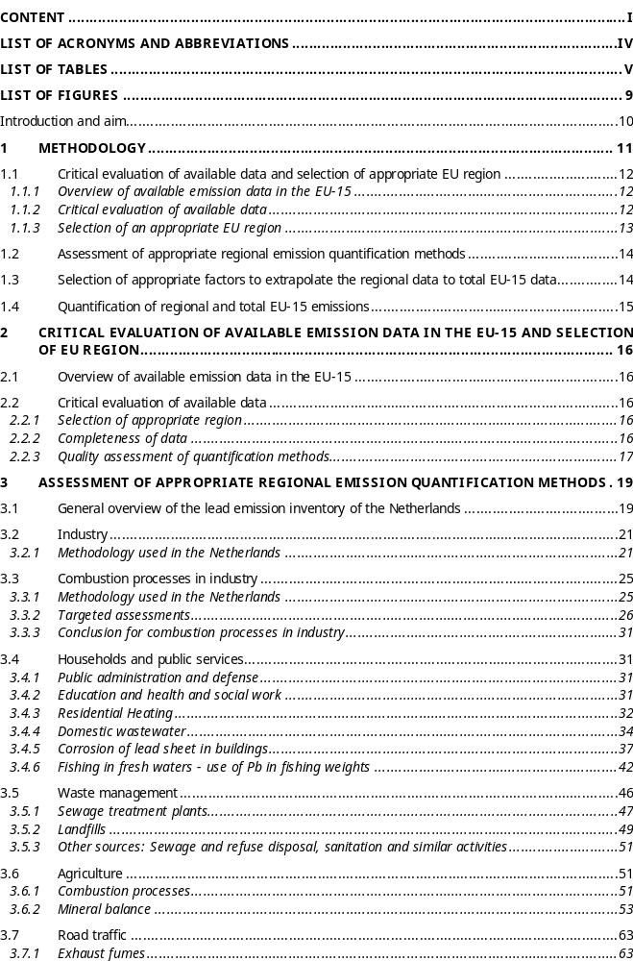

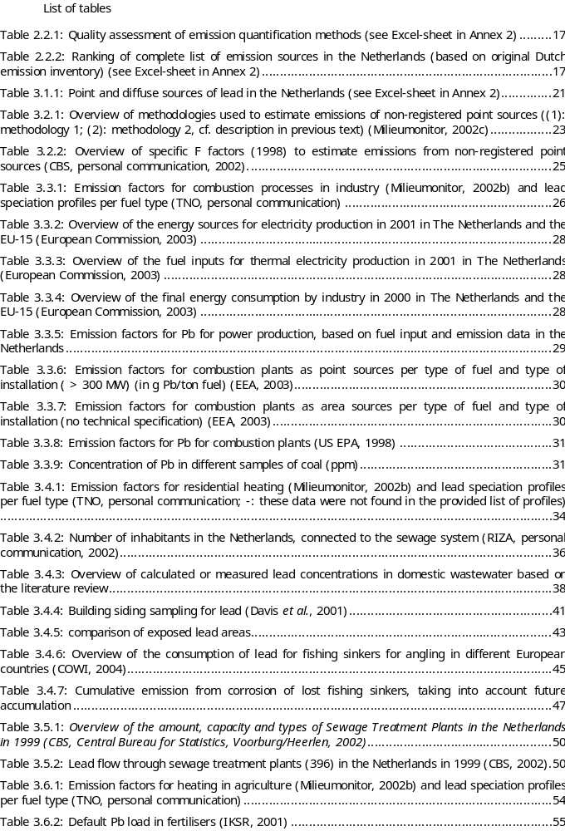

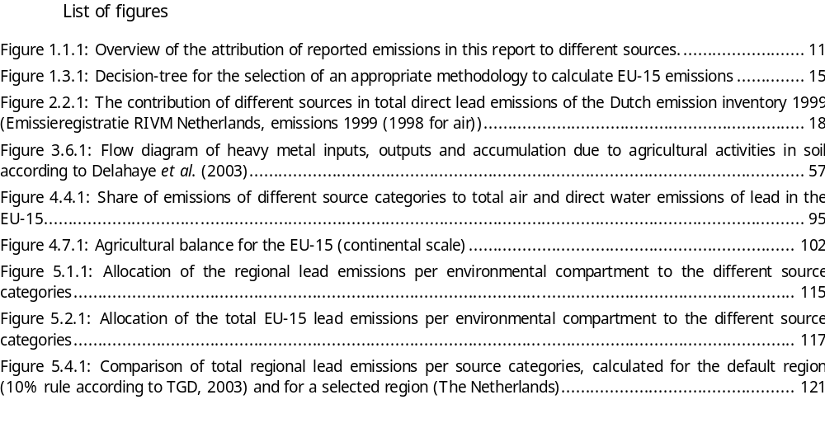

List of acronyms and abbreviations

AWV Administratie Waterwegen en Zeewezen (Administration of the Flemish Ministry for Waterways and Ports)
BCR Brussels Capital Region Bruxelloise (Organisation for the burning of domestic waste of the Brussels Capital Region)
CBS Central Bureau for Statistics in The Netherlands
COPERT Computer Programme to calculate Emissions from Road Transport
DGRNE Direction générale des Ressources naturelles et de l'Environnement
du Ministère de la Région wallonne (Administration of the Walloon Ministry of Natural Resources and the Environment)
EEA European Environmental Agency
EMEP-CORINAIR Co-operative programme for Monitoring and Evaluation of the Long Range Transmission of Air Pollutants in Europe – Core Inventory of Air Emissions in Europe
FER Flemish Emission Registry
FR Flemish Region
ISSEP Institut Scientifique de Service Public (Public Scientific Institute)
SIOMAB Société d'Incinération d'Ordures Ménagères de l'Agglomération
SS Sewage System
sSS separate Sewage System
STP Sewage Treatment Plant
SWO Sewage Water Overflow
VMM Vlaamse Milieumaatschappij (Flemish Environmental Agency)
WR Walloon Region

Introduction and aim

The European Union Council Regulation (EEC) No. 793/93, on the evaluation and control of existing substances, requires under Article 10 the assessment of the real or potential risk for man and environment of priority substances, using principles which have been laid down in the Commission Regulation No. 1488/94 on risk assessment of existing substances. This risk assessment entails a sequence of actions comprising assessment of effects, exposure assessment and finally risk characterisation.

The aim of the present study is to assess point and diffuse environmental sources of lead and lead compounds as a basis for regional exposure assessment under European Council Regulation (EEC)N°793/93.

Methodology
To achieve the results, described in the aim of this study, four actions are distinguished:
- critical evaluation of available data on point and diffuse sources of lead for different EU-15 countries and the selection of a representative EU region;
- assessment of appropriate regional emission quantification methodologies;
- selection of methods to quantify lead emissions on a European (EU-15) scale;
- quantification of regional and total EU-15 lead emissions.

The several actions are briefly described below.
In order to understand correctly the quantified emissions it is important to state that the word ‘emissions’ used in the current document always refers to direct emissions from the source to the compartments air, water and soil. Especially for emissions to water a more detailed description is necessary. Emissions to water allocated to a specific source, e.g. households, are always direct emissions from that source to the water compartment. This means that emissions from households, first going to a sewage system and possible through a sewage treatment plant before entering the surface water, are attributed to the sewage system (SS) resp. sewage treatment plant (STP) and not to ‘households’. Figure 1.1.29 illustrates this.
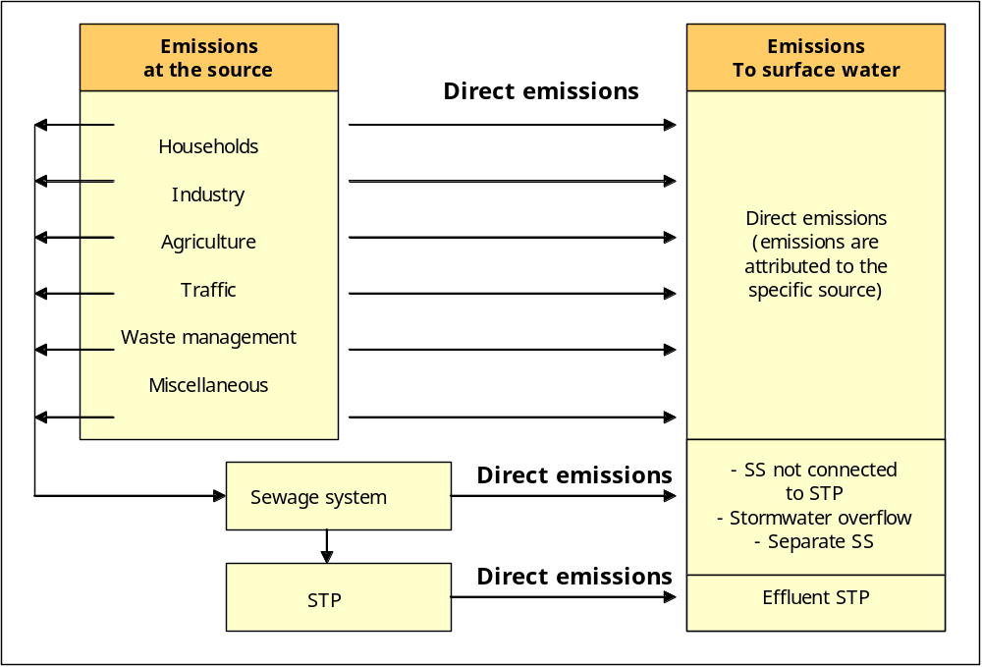
Figure 1.1.29: Overview of the attribution of reported emissions in this report to different sources.

1.1 Critical evaluation of available data and selection of appropriate EU region
The evaluation of the available emission data in the EU was performed in three steps:
- Overview of available emission data in the EU-15;
- Critical evaluation of available data;
- Selection of an appropriate EU region.

Overview of available emission data in the EU-15
All European countries were contacted in order to gather the most recent available lead emission data and their quantification methods. The reference date focussed on was 2000. For most Member States however, only the 1999 data were available at the time of the questionnaire was sent out. It was assumed that the 1999 data are representative for 2000 also. If possible, these data were completed with information from international organisations such as the European Commission (Directive 76/464/EEC, Water Framework Directive,…), North Sea Conferences, OSPAR, HELCOM, ICPR (International Conference for the Protection of the Rhine) and the Lead Development Association International (LDAI). The emissions from point and diffuse sources are assigned to the different environmental compartments (air, surface water and soil).

Critical evaluation of available data

Completeness of data
It is the aim of this part of the study to create the most extensive qualitative inventory as possible of lead emission sources. Therefore, the first step in this study is to compare the data, received from different EU-15 countries, and to select the most extensive country-individual emission inventory as a starting point. This selected inventory is completed with lead emission sources mentioned by other EU-countries and in international literature. As a result, a complete qualitative list of lead emission sources is created. This format includes emissions to air, direct emissions to the surface water and emissions to soil.
Together with the identification of lead emission sources, the methods, used to quantify the emissions for each individual source are, as a first step, taken over from the reporting country.

Quality assessment of quantification methods
In order to efficiently optimise the quantification methods and emission data, priorities are set based on:
- The relative importance of the source;
- the actual quality of the data (uncertainty of data).
In order to assess the importance of the individual sources, the emission data are ranked in decreasing order. This list is based on the emission data of the selected country and sources that are added from the inventories of other EU-countries or from literature. A zero emission is attributed to these added sources.
The quality of the quantification methods used, were assessed, in order to evaluate the quality of the calculated emissions. The quality of the emissions can depend on:
- the emission factor: specific value of an emission, mostly given in physical terms, related to the respective sectoral or process activity rate (e.g. for energy related emissions (Mg/GJ) (EEA, 2003)
- the activity data: quantitative representation of the variable that “explains” the emissions in a source category, preferably in physical dimensions (e.g. produced mass of cement [tons/year] or otherwise in monetary dimensions (e.g. value of glass production [ECU/year], either in emission inventories or in emission projections (EEA, 2003).
- the distribution factor: the partitioning of total emissions to the environmental compartments.
As a first step the quality code, allocated to the emission pathway, was not taken into account, since in the context of a source-orientated approach it is of minor importance, compared to the emission factor and activity data.
The method of defining quality codes to assess the quality of the used data was taken over from EPA (1995) and EMEP/Corinair (EEA, 2003). The definitions were adjusted based on the overall quality of the gathered data. The following codes were defined to assess the quality of these three variables:
A = an estimate based on emission measurements;
B = an estimate based on emission measurements and possibly on an engineering calculation derived from relevant facts;
C = an estimate based on an engineering calculation derived from relevant facts and some assumptions;
D = an estimate based on engineering calculation derived assumptions only; or when no information on the quantification methodology was available but evidence of a scientific study is provided;
E = an estimate based on non-specified background information.
The overall assessment is determined by the lowest quality score. Based on this assessment, sources and quantification methodologies, which have to be studied by a targeted assessment, because of their importance and/or low quality quantification method, were identified. Eventually the quantification method with the highest quality score is selected for each source.

Selection of an appropriate EU region
“Regional” emissions are needed as an input for the regional exposure assessment (carried out by Euras) in the EUSES-model. By default, it is assumed that 10% of the European production and use of a substance takes place within the regional area. Therefore:
regional emission = 10% of total European emission = emission of a generic region
Alternatively, regional emissions can be calculated for a selected region also. According to the TGD (2003), a general standard region is represented by a typical densely populated area with an area of 200 x 200 km² and 20 million inhabitants, located in the margin of Western Europe. A country may also represent this area if it has similar characteristics (TGD, 2003). Therefore:
regional emission = emission of a selected region
Based on the definition of a region as described in the TGD (2003) and based on the degree of detail of the emission inventory per country, one country will be selected as “EU region” in this report. In this framework also the experience with other Risk Assessment studies (e.g. Zn-, Cu- and Ni-RARs) will be used.

1.2 Assessment of appropriate regional emission quantification methods
For the complete list of emission sources, as a result of the previous actions, an appropriate quantification method needs to be selected. The quality assessment of the quantification methods already shows the need to perform targeted assessments for some sources. An evaluation of:
- the quantification methodology used by the country, selected as an EU-region, and,
- the quantification methods described in the targeted assessment,
enable to select the most appropriate quantification method per source. The emissions of lead to the compartments air, water and soil in the selected region will be calculated based on these selected methods in order to quantify the lead emissions on a regional scale.

1.3 Selection of appropriate factors to extrapolate the regional data to total EU-15 data
“Continental” emissions are needed as a background for the regional exposure assessment (cf. Pb-RAR (Euras, KUL, Ecolas, April 2005)) in the EUSES 2.0-model. Emission estimation on the continental scale should be based on a EU-wide production volume of the substance. Therefore, the EU-15 emissions will be used to calculate continental emissions. By default, it is assumed that 10% of the European production and use of a substance takes place within the regional area. Therefore:
- regional emission = 10% of total European emission
- continental emission = 90% of total European emission
Based on these assumptions, continental releases can be calculated according to the following default TGD equation (2003):
Continental emission = 10 x regional emission - regional emission
In the present report, continental emissions, as a background for regional exposure assessment (EUSES), will be estimated by following equation:
Continental emission = Total EU-15 emission – regional emission
The methodologies to quantify regional emissions are described in previous sections. Initially, total EU-15 emissions could be quantified as the sum of the lead emissions of all EU-15 countries, as reported through the sent-out questionnaires. Due to lack of detailed and homogeneous emission data from all 15 EU-countries (cf. Annex 1 to this report), it is rather difficult -in most cases impossible- to calculate the total EU-15 emissions by summarising the country-specific emission data for each emission source. As an alternative, other appropriate methodologies to estimate EU-15 emissions have to be selected. This selection is based on the decision-tree shown in Figure 1.3.30. If the selected region is representative for the EU, in analogy with the default TGD equation (2003), total EU-15 emissions will be quantified based on regional emissions. One important remark here is that, instead of using the default TGD factor “10”, source-specific extrapolation factors will be used to extrapolate regional emissions to total EU-15 emissions. This methodology can be summarised by the following equation:
Continental emission = (Source-specific regional to total EU-15 extrapolation factor x regional
emissions) - regional emissions
Consequently, for each identified source, a source-specific extrapolation factor has to be determined.
If the region is not representative for the EU-situation, country-specific parameters or more average parameters, representative for the EU, will be selected.
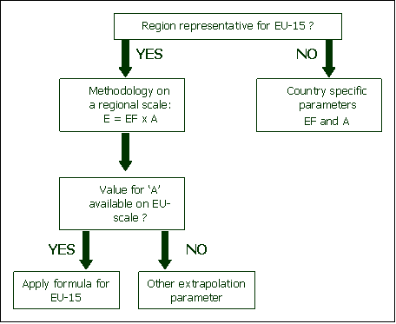
Figure 1.3.30: Decision-tree for the selection of an appropriate methodology to calculate EU-15 emissions

1.4 Quantification of regional and total EU-15 emissions

Based on the methods described in previous sections total regional (for a selected and a generic region) and EU-15 emissions are quantified.

Critical evaluation of available emission data in the EU-15 and selection of EU region

2.1 Overview of available emission data in the EU-15
This chapter discusses the available information on lead emissions in the EU-15 countries. The emission data from most Member States refer to the year 1999 or 2000. Emission data from the following countries were processed: the Netherlands, Belgium, the UK, Austria, Luxembourg, Spain, Ireland, Denmark, Finland, France, Sweden and Germany. Italy, Portugal and Greece provided no information. The difference in nomenclature, classification and source definition in these country-specific inventories complicates the processing of these data. A description of the available emission data per country is given in Annex 1. The sources, provided by the countries, were redefined (cf. Annex 1). Lead producers and manufacturers are being considered as point sources, all other sources of lead are being considered as diffuse sources.

2.2 Critical evaluation of available data
This chapter assesses the accuracy and completeness of the available data in order to identify the most accurate quantification methodology for each source as a basis for a regional quantification.

Selection of appropriate region
According to the TGD (2003) calculations on a regional level need to be performed for a highly industrialised, densely populated area of 200 x 200 km² with about 20 million inhabitants. Unless specific information on use or emission per capita is available, it is assumed that 10% of the European production and use takes place within this area, i.e. 10% of the estimated emissions are used as input for the region. As already explained in chapter , total EU-15 emissions for most sources need to be estimated based on regional emissions. As a result an appropriate region needs to be defined first. Looking at the total surface of the Netherlands of 41 526 km² and a number of inhabitants of about 16 million and taking into account that the Netherlands is an industrialised country, it was concluded that the Netherlands most closely resemble the definition of a region. Since the final aim of this study is to assess the emission situation on a regional scale, it was decided to take the Netherlands as an appropriate region to calculate the PEC_{regional}. The emissions of the generic region (10% of EU-15 emissions, TGD (2003)) are also calculated and added at the end of this document to compare with the emissions of the selected region and to illustrate this different approach.

Completeness of data
From the overview, given in Annex 1, it is clear that the Netherlands and Belgium provided the most detailed information. Based on that and the fact that the Netherlands were selected as “a region” in the framework of this RAR, the data and methodologies from the Dutch emission inventory were taken over as a starting point for the current lead emission inventory. The Dutch inventory was completed with lead emission sources mentioned by other EU-countries and in international literature. A complete list of lead emission sources was created, the so-called quantification format. These data include emissions to air, direct emissions to the surface water and emissions to soil. The sources, reported by other countries and found in literature should be quantified for the Netherlands, in order to complete the emission inventory. The following paragraph indicates the reason for not quantifying some of these sources:
- Industry (‘production of mineral fibres’ and ‘laundries’): on a regional scale it was assumed that, if they are present in the Netherlands they are accounted for in the Dutch emission inventory, possibly using another nomenclature; on a continental scale, the available emission data of all EU-15 countries were taken into account, meaning that also these sources are accounted for (cf. chapter Error: Reference source not found);
- Households (cigarette smoke, household products (tea mugs) and fireworks): emissions from the use of household products are taken into account within the sector ‘domestic wastewater; emissions from cigarette smoke and fireworks are assumed to be negligible;
- Waste management (scrap handling, waste recovery processes and left cable sheets): since the sources were only mentioned by one country and there is no information available on the quantification methods used for these sources and the emissions seem negligible they were not quantified for the regional and continental scale;
- Agriculture (aquaculture): based on a one-time mentioning of this source without giving information on a possible quantification method, it is acceptable not to quantify this source;
- Traffic (use of Pb in vehicles): it was assumed that the most important uses of Pb in vehicles (in brakes, tyres, motoroil) were already accounted for;
- Natural sources are generally not taken into account in the RAR;
- Miscellaneous (use of paint, use of building materials): the most important use of Pb in building materials (e.g. sheet) is already accounted for; the Pb-content in paint and other building materials in not quantified by any of the EU-15 Member States and is therefore assumed to be negligible.

Quality assessment of quantification methods
The quality of the quantification methods, present in the emission inventory were assessed, in order to evaluate the accuracy of the calculated emissions as described in the methodology description (chapter ) of this report.
For the Netherlands, the quality of the calculation methods was already assessed in the original documents. These codes were ‘translated’ to the codes, defined in this report. The quality of methods, reported by other countries and found in literature, were assessed according to the above mentioned definitions. The result of the quality assessment is given in Table 2.2.34.
Table 2.2.34: Quality assessment of emission quantification methods (see Excel-sheet in Annex 2)
In order to efficiently optimise these quantification methods and emission data, priorities need to be set, based on:
- the importance of the source;
- the actual quality of the data.
In order to assess the importance of the individual sources, the total emission data per source (air+water+soil) were ranked in decreasing order (Table 2.2.35). A zero emission was attributed to the sources, which were not reported by the Netherlands but taken from the reporting of other countries or from literature.
Table 2.2.35: Ranking of complete list of emission sources in the Netherlands (based on original Dutch emission inventory) (see Excel-sheet in Annex 2)
The share of the different source sources per environmental compartment in total lead emissions in the Netherlands is given in Figure 2.2.31.

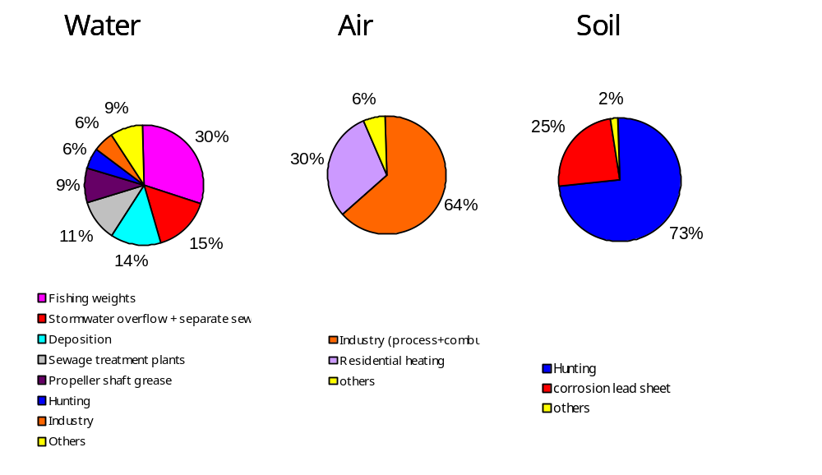
Figure 2.2.31: The contribution of different sources in total direct lead emissions of the Dutch emission inventory 1999 (Emissieregistratie RIVM Netherlands, emissions 1999 (1998 for air))

Based on this assessment and the experience with diffuse source analysis of other risk assessment studies (Cu, Ni, cf. ECOLAS, 2005a and 2005b), it was decided to carry out a targeted assessment for the following sources:
- industry – combustion processes;
- households - domestic wastewater;
- households - use of lead sheets in buildings;
- households - use of fishing weights.
- waste management – waste incineration and landfills;
- agriculture - balance sheet for minerals
- miscellaneous – use of Pb-containing ammunition;
- navigation – use of propeller shaft grease.
It was aimed to use the year 2000 as a reference year for the point and diffuse emissions assessment. At the time of the start of this project, the 1999 emission inventory was the most recent available in the Netherlands, therefore 1999 is used as reference year throughout this whole document. It can be assumed that the emissions in 1999 are representative for the year 2000 also. The emission quantification methods for all identified sources are assessed in the following chapter.

Assessment of appropriate regional emission quantification methods
For the complete list of emission sources, as a result of the previous actions, an appropriate quantification method needs to be selected as described in chapter of this report. As a result the most appropriate quantification method per source will be selected based on an evaluation of:
- the quantification methodology used in the Netherlands, and,
- the quantification methods described in the targeted assessments per source,
At the time of the start of this project, the 1999 emission inventory was the most recent available in the Netherlands, therefore 1999 is used as reference year throughout this whole document. To correctly understand the Dutch emission inventory, first, a general description of this inventory is given.

3.1 General overview of the lead emission inventory of the Netherlands
The methodology, used to quantify emissions of lead in the Netherlands, is explained below per individual source. Emissions to the compartments air, water and soil are quantified. First, a short description is given on how the accomplishment of the emission inventory in the Netherlands is organised.
The Pollutant Emission Register (PER), also called the Emission Inventory System (EIS) has been established under the auspices of "Inspectorate for Environmental Protection of the Ministry of Housing, Spatial Planning and the Environment (VROM/HIMH) by the co-operation of several institutions:
- Statistics Netherlands (CBS);
- National Institute of Public Health and Environment (RIVM);
- Ministry of Agriculture, Nature, Conservation and Fishery (LNV); through representation by the National Reference Centre for Agriculture (IKC-L);
- Ministry of Transport, Public Works and Water Management (V&W) through representation by the National Institute of Water Management and Waste Water Treatment (RWS/RIZA)
- The Netherlands Organisation for Applied Scientific Research (TNO).
All of these institutions are represented in the Co-ordination Committee for the Monitoring of Target Sectors (CCDM), monitoring the overall reporting methodology.
The PER reports on emissions of 170 substances, which are registered by the Central Datawarehouse Emission Registration (ER-C). The data gathered in the ER-C can be subdivided into two main groups:
- Data from individual registered point sources (ER-I);
- Emission data of small and medium enterprises (SME), as well as non-industrial diffuse sources, calculated collectively by several task groups, being:
- Energy industry and waste treatment (ENINA)
- Waste
- Traffic and transport
- Development of methodologies for emissions to water (MEWAT)
- Agriculture
- Remaining sources (WESP)
The combination of point source emissions and emissions, calculated by these task groups, is performed by TNO.
The general methodology, used to quantify the emissions of lead in the Netherlands, are shown in Table 3.1.36.
Table 3.1.36: Point and diffuse sources of lead in the Netherlands (see Excel-sheet in Annex 2)
Some country-specific assumptions are explained below. When no specification is made regarding the emission pathway (air/water/soil), the remark applies to all compartments. Emissions to water from each reported source, presented Table 3.1.36, refer to direct emissions. This implies that emissions caught by the sewage system at the source are not included in the emission data of each specific source. Only the amount of emissions, discharged to the surface water directly (at the place were the emission originates) are reported in Table 3.1.36 as emissions to the water compartment. Emissions, caught by the sewage system are emitted to the surface water as 'indirect emissions' through several pathways:
- The emissions of Sewage Treatment Plants (STP) (after treatment);
- The overflow of mixed sewage systems;
- Storm water overflow of separate sewage systems:
- Sewage systems not connected to an STP.
Consequently, indirect emissions to the water compartment, originating at the different sources, were reported collectively for the four above mentioned sectors. Since the separation between direct and indirect emissions is dependent of, among others, the degree of connection of households or industries to a sewage system, the degree of connection of sewage systems to an STP, … the amount of direct emissions is highly country-specific. For the Netherlands, the most important sources of indirect emissions are:
- Corrosion of lead sheets in residential and utility buildings (79.5%)
- Discharge of domestic wastewater (13.1%);
- Industry (6.2%) of which:
- Metal and electrotechnical industry (3.1%);
- Surface treatment (1.6%);
- Other (0.5%)
- All other sources (0.2%)
Table 5.2.93 gives the regional emissions of lead (in the Netherlands), including the results from the Dutch report and the targeted assessments. This table is given at the end of this report since the total EU-15 emissions are also included. The methods followed to estimate total EU-15 emissions are given in chapter 4.

3.2 Industry

Methodology used in the Netherlands

Process emissions to water
Source outlining: the industrial sources, defined by SBI-codes (e.g. in Table 3.2.37).
Methodology: - individual registration for several point sources (ER-I);
- collective registration for non-registered point sources, mainly SME's.
Compartments: water
Methodology description (van der Most et.al., 1998):
ER-I data are collected through, on the one hand, data from the Environmental Year Reports (required since 2000) and, on the other hand, voluntarily delivered data by some companies.
The methodology to estimate emissions from non-registered point sources depends on the industrial source category. For the extrapolation only indirect emissions to water from non-registered point sources are estimated. These represent the emissions from non-registered point sources, which enter the sewage system. Nevertheless, the total direct emission to surface waters from industry is rather complete, since direct emitters to water are limited and are, in general, individual registered point sources.
Two methodologies are used:
- Methodology 1: based on activity data
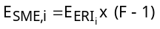
where | E_{SME,i} = | indirect emissions from non-registered industrial sources within category i;
 | E_{ERI, i} = | indirect emissions from individual registered companies (non direct emitters) within category i
 | F =

- Methodology 2: based on component-specific emission factors
The estimation is based on following equation:
where | E_{SME,i} = | indirect emissions of non-registered industrial sources within category i;
 | EF_{i} = | emission factor for category i (kg Pb/activity unit); this EF is calculated as the ratio of Pb-emissions and production data per ER-I company
 | ERI _{i} = | individual registered companies within category i
The industrial source categories, based on SBI-codes, are strongly related to the NACE codes, used on a European level. Table 3.2.37 gives an overview of all industrial source categories for which emissions to the water compartment from non-registered point sources are estimated and an indication of the methodology used to carry out the extrapolation. Note that this Table gives a general overview of the extrapolation methodologies for all parameters. This implies that some industrial sectors (SBI-codes) will not be relevant for lead.

Table 3.2.37: Overview of methodologies used to estimate emissions of non-registered point sources ((1): methodology 1; (2): methodology 2, cf. description in previous text) (Milieumonitor, 2002c)
SBI-code | Process description – category i | Extrapolation unit (1)/  Emission factor (2)
10 - 14 | Minerals, mining, … | No extrapolation
151 | Production, processing of meat and meat products | Production (tons)
152 | Processing of fish | Production (tons)
1531 | Processing of potatoes | Production (tons)
1533 | Processing of vegetables | Production (tons)
154 | Manufacture of vegetable and animal oils and fats | Production (tons)
155 | Manufacture of dairy products | Production (tons)
156 | Processing of Meal and starch | No (~ 100 % in ERI)
157 | Processing of Animal feed | No (relevant companies in ERI)
1583 | Manufacture of sugar | No (100 % in ERI)
1584 | Manufacture of chocolate, candy | Production (tons)
158 (rest) | Manufacture of several food products | Production (tons)
1595 | Malting | No (~ 100 % in ERI)
1596 | Brewery | No (~ 100 % in ERI)
159 (rest) | Manufacture of beverages | Production (tons)
16 | Tobacco industry | No, not relevant, few companies
17 (rest) | Manufacture of textiles | Production value + Emission factor
173 | Finishing of textiles | Production (m²) + Emission factor
191 | Tannery | Production (m²)
19 (rest) | Processing of leather | No (no relevant emissions)
211 | Paper and cardboard | No (100% in ERI)
212 | Manufacture of paper and cardboard articles | Production (tons)
23 | Processing of oils, oil refineries | No (100% in ERI)
2411 | Gases | No, not relevant, few companies
2412 | Manufacture of dyes and pigments | Production (tons)
2413 | Manufacture of other inorganic basic chemicals | Production (tons)
2414 | Manufacture of organic basic chemicals | No (~ 100 % in ERI)
2415 | Manufacture of mineral fertilisers | No (100 % in ERI)
2416 | Manufacture of plastics in primary form | Production (tons)
242 | Manufacture of chemical pesticides | Production (tons)
243 | Manufacture of paint, varnish and ink | Production (tons)
244 | Pharmaceutical industry | No (~ 100 % in ERI)
245 | Manufacture of soap, cosmetics | Production (tons)
2462 | Manufacture of glues and gelatines | Production (tons)
2466 | Manufacture of other chemical products | Production (tons)
246 (rest) | Manufacture of other chemical products | No (sometimes 100% in ERI, to divers)
251 | Manufacture of rubber products | Production (tons)
252 | Manufacture of plastic products | Production (tons)
261 | Manufacture of glass and glass products | Production (m²)
26 (rest) | Manufacture of other building materials | No (to divers)
271 - 273 | Steel industry, blast furnaces | No (~ 100 % in ERI)
274 | Manufacture of basic precious and non-ferrous metals | Production (tons)
275 | Casting of metals | Production (tons)
2851 | Galvanising industry | Production (value)
28, ex 2851 | Manufacture of fabricated metal products, except machinery and equipment | Production (value) + emission factor
29, 31 en 32 | Manufacture of metal products, (electrical) machinery and equipment | Production (value) + emission factor
30 | Computer industry | No (few companies in ERI)
33 | Instruments, precision instruments | No (few companies in ERI)
34 | Manufacture of motor vehicle, trailers and semi-trailers | Production (pieces)
354 | Manufacture of motor cycles, bicycles | Production (pieces)
36 | Other industry | No (sector to divers)
37 | Preparation for recycling activities | No (few companies)

Process emissions to air
Source outlining: air emissions, not related to combustion processes from industrial sources,
defined by SBI-codes.
Methodology: - individual registration for several point sources (ER-I);
- collective registration for non-registered point sources, mainly SME's.
Compartments: air
Methodology description (van der Most et.al., 1998):
ER-I data are collected through data from the Environmental Year Reports. Reported emissions can be the result of measurements or estimations, based on emission factors.
Process emissions of heavy metals to air (ERC metadata, 2001)
from non-registered point sources are in general calculated based on following equation:
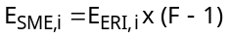
where | E_{SME,i} = | emissions from non-registered industrial sources, within category i;
 | E_{ERI, i} = | emissions from individual registered companies (non direct emitters) within category c (also emissions from ERI in previous years, adjusted with recent production data, are added here)
 | F = | 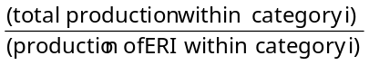

Table 3.2.38 gives an overview of the specific F factors (1998) used to estimate air emissions from non-registered point sources. Emissions from companies who reported their emissions in previous years, were added to the ER-I data before the (F-1)-factor was used to estimate emissions from non-registered point sources.

Table 3.2.38: Overview of specific F factors (1998) to estimate emissions from non-registered point sources (CBS, personal communication, 2002).
Industrial sector - category i | F-factor (1998)
Manufacture of basic chemical products (SBI 241) | 1.05
Manufacture of petrochemical products (SBI 2414) | 1.00
Manufacture of paint, dyes and ink (SBI 243) | 3.34
Manufacture of glues, gelatines and other chemical products (SBI 246) | 1.06
Manufacture of glass and glass products (SBI 261) | 1.04
Manufacture of ceramic goods (SBI 262) | 1.00
Manufacture of iron and steel and ferro-alloys (SBI 271) | 1.00
Manufacture of basic precious and non-ferro metals (SBI 274) | 1.03
Casting of metals (SBI 275) | 1.15
Public service activities, waste removal (SBI 751) | 1.00

3.3 Combustion processes in industry

Methodology used in the Netherlands
Source outlining: air emissions, related to combustion processes from all industrial
sources, defined by SBI-codes.
Methodology:
- individual registration for several point sources (ER-I);
- collective registration for non-registered point sources, mainly SME's.
- waste incineration plants are not included in this sector but are categorised in the sector 'Waste Management'
Compartments: air
Methodology description (van der Most et.al., 1998):
ER-I data are collected through, on the one hand, data from the Environmental Year Reports (required since 2000) and, on the other hand, voluntarily delivered data by some companies.
Emissions from non-registered point sources are estimated per source category, based on following equation:
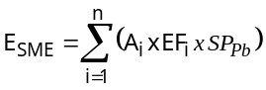
where
E_{SME} = emissions to air from non-registered point sources (kg dust);
A_{f,i}= consumption of fuel f by non-registered point sources in category i (kg)
EF_{i}= emission factor (kg dust or soot/kg fuel)
SP_{Pb} = Speciation profile of dust for lead (kg Pb/kg dust)
The industrial source categories, based on SBI-codes, are strongly related to the NACE codes, used on a European level. The emission factors for dust or soot used in the above mentioned equation are shown in Table 3.3.39. To calculate emissions of lead, based on the emission of total dust or soot, heavy metal speciation profiles of dust per fuel type were used.
Table 3.3.39: Emission factors for combustion processes in industry (Milieumonitor, 2002b) and lead speciation profiles per fuel type (TNO, personal communication)
Fuel type | Dust type | Emission factor (g/GJ) | Lead speciation profile
Domestic fuel oil | Soot, burning of oil | 5 | 0.00037
 | Fine dust | 4.5 | 0.00037
 | Coarse dust | 0.5 | -
Petroleum | Soot, burning of oil | 2 | 0.00037
 | Fine dust | 1.8 | -
 | Coarse dust | 0.2 | -
Fuel oil | Soot, burning of oil | 25 | 0.00037
charcoal | Fly ash | 12 | 0.0007
 | Fine dust | 60 | 0.0007
 | Coarse dust | 40 | -
Cokes | Fly ash | 8.81 | -
 | Fine dust | 6 | -
 | Coarse dust | 4 | -
Natural gas | Fine dust | 0.15 | -
Biogas | Fine dust | 2 | -
LPG | Fine dust | 2 | -

It is unclear, whether an EF for soot or fine dust was used in the Dutch methodology. Based on the emission data, reported in the Dutch emission inventory of 1999, we can conclude that, for 'domestic fuel oil' and 'petroleum', EF for soot were used, while for 'hard coal', an EF for fly ash was used.

Targeted assessments
The reliability of the emission factors used in the Dutch emission inventory is uncertain and therefore it is deemed necessary to look for a more reliable emission estimation method. Lead emissions from industry are important due to combustion processes in industry. Emissions of metals from combustion processes are dependent on:
- The fuel consumption;
- The combustion conditions;
- The downstream cleanup.
Taking into account these parameters, total emissions can be calculated based on:
- Total consumption per type of fuel
- An average emission factor per type of fuel (taking into account the average combustion conditions and the downstream cleanup)
Two important fuel consumption sources can be distinguished leading to lead emissions from combustion processes (Eurostat, 2003): power production plants and the final energy consumption in industry. These consumption streams will be taken into account to estimate total Pb-emissions from combustion processes in industry.

Fuel consumption
Electricity is produced ("generated") in many ways, using different fuel sources and very different technologies. The atypical allocation of energy sources for electricity production in The Netherlands compared to the EU-15 is twofold. On the one hand, the share of fossil fuel based power production is much higher in the Netherlands (91%) than in the EU-15 (50%). On the other hand, the input of solid fuels and oil for power production is about 32% of the total fuel input in the Netherlands, while in the EU-15 the input of solid fuels and oil is about 63.5% of the total fuel input for power production. Table 3.3.40 gives an overview of the energy sources for electricity production in 2001 in the Netherlands compared to the EU-15. Table 3.3.41 gives an overview of the fuel input for thermal electricity production in the Netherlands, which are important to estimate Pb-emissions.
Table 3.3.40: Overview of the energy sources for electricity production in 2001 in The Netherlands and the EU-15 (European Commission, 2003)
Electricity Generation | The Netherlands |  | EU-15
Electricity Generation | TWh | % | TWh | %
Nuclear Power | 3.98 | 4.3 | 891.39 | 33.4
Renewable | 4.40 | 4.7 | 436.68 | 16.4
Conventional Thermal | 85.37 | 91 | 1343.31 | 50.3
TOTAL | 93.75 |  | 2671.37

Table 3.3.41: Overview of the fuel inputs for thermal electricity production in 2001 in The Netherlands (European Commission, 2003)
 | Mtoe ⁽¹⁾ | in TJ (10¹² J) ⁽¹⁾ | in ktons ⁽²⁾ | % of total
Solid fuels | 5.37 | 224 831 | 14 052 | 28.4
Oil | 0.65 | 27 214 | 680 | 3.4
Gas | 11.37 | 476 039 |  | 60.2
Biomass and geothermal | 1.51 | 63 220 |  | 8.0
TOTAL | 18.9 | 791 305
(1) 1 toe = 1 ton of oil equivalent = 41868 MJ
(2) 1 ton heavy fuel oil = 40000 MJ; 1 ton hard coal = 24000 MJ; 1 ton brown coal = 8000 MJ

The final energy consumption in industry is also reported by Eurostat (2003). An overview of the final energy consumption in industry per type of fuel in The Netherlands is given in Table 3.3.42.
Table 3.3.42: Overview of the final energy consumption by industry in 2000 in The Netherlands and the EU-15 (European Commission, 2003)
 | Mtoe ¹ | kton
Solid fuels | 1.293 | 3 383
Oil | 0.037 | 39
Gas (TJ) | 267 167
Biomass and geothermal | 0.069
(1) 1 toe = 1 ton of oil equivalent = 41868 MJ

Emission factors
As already mentioned, emission from combustion processes is also dependent of the combustion conditions and the downstream cleanup. Different technologies are used to burn fossil fuels for electricity production (fossil fuel-fired plants, including fuels such as gas, coal, oil, lignite, peat), notably:
- steam cycles (superheated and pressurised steam is pumped from a combustion boiler to a steam turbine which drives a generator; in the turbine the substantial heat energy in the steam is translated into mechanical rotational energy. In driving the generator, this rotational energy is in turn transformed into electrical energy)
- gas turbines require a clean gas source (particle- and abrasive- free) such as natural gas. There is no combustion boiler, gas is burned directly in a rotating gas combustion turbine that directly drives an electrical generator. The very hot exhaust gases from the gas turbine retain significant amounts of heat energy that can be utilised in a number of ways.
- combined cycle plants comprise a gas turbine driving one generator directly; the hot exhaust gases from the gas turbine are used to boil steam in a heat recovery steam generator. This steam is then fed to a steam turbine driving a second generator, meaning that the overall efficiency of electricity production is very high.
- cogeneration or CHP. In these plants, steam turbines and/or gas turbines can be used, and the fuel source could be any fossil, biomass or nuclear technology. CHP plants are distinguished by one feature: heat is produced, some of which is used to produce electricity, and rather than waste the rest, as much as possible is directed to some significant heat load, such as a district heating network or an industrial process. Where a real heat load exists, the overall energy efficiency can be very high.
In the following paragraph an overview is given of the available literature sources, indicating emission factors from fuel combustion in general or power production in particular. Before reviewing publicly available literature, emission factors were calculated from the total lead emissions reported by The Netherlands and the fuel consumption.

[a] Emission factors calculated from emission data in the Netherlands
The emission data reported in the Dutch emission inventory are for 98% reported by the individual power production plants and are not calculated based on the emission factors used for a collective estimation for non-reporting facilities. Based on the total emission of lead, reported from the power production plants and the total fossil fuel input for electricity generation, emission factors can be calculated. The same can be done for emissions from combustion processes in industry and the total final consumption of fuel in industry. These calculated emission factors, given in Table 3.3.43, are only indications.
Table 3.3.43: Emission factors for Pb for power production, based on fuel input and emission data in the Netherlands
Fuel type | Fuel input (kton) ¹ | Emission (kg Pb) ² | EF (g Pb/ton fuel)
Power production
- Solid fuels | 8 590 | 309 | 0.036
- fuel oil | 3 | 0.4 | 0.133
Combustion in industry
- Solid fuels | 727 | 16 | 0.022
- fuel oil | 291 | 951 | 3.268
(1) fuel input for thermal power generation in 2000 (Eurostat,2003) – it is assumed that this input is representative for 1998
(2) based on Dutch emission inventory of 1998 (no emission data from fuel combustion since then are available)

[b] EMEP/CORINAIR emission inventory guidebook (EEA, 2003)
In the EMEP/Corinair Guidebook (EEA, 2003), emission factors of heavy metals from ‘Combustion in energy and transformation industries’ are given for combustion of hard coal, brown coal, heavy fuel oil and gas. The emission factors mentioned in Table 3.3.44 show general emission factors for combustion plants as point sources, with a thermal capacity of more than 300 MW, while Table 3.3.45 gives emission factors for combustion plants as area sources with no technical specification.
Table 3.3.44: Emission factors for combustion plants as point sources per type of fuel and type of installation ( > 300 MW) (in g Pb/ton fuel) (EEA, 2003)
Fuel category | Emission factor (g Pb/ton)
 | Dry bottom boiler |  | Wet bottom boiler
 | Dust control ⁽¹⁾ | Dust control + FGD ⁽²⁾ | Dust control ⁽¹⁾ | Dust control + FGD ⁽²⁾
Hard coal | 0.02 - 1.1 | 0.007 - 0.5 | 0.3 - 3.0 | 0.1 - 1.2
Brown coal | 0.003 – 0.06 | 0 001 – 0.02 | - | -
Heavy fuel oil | 1.3
Gas | - | - | - | -
- Clean gas particle concentration 50 mg/m³
- FGD = Flue gas desulphurisation, clean gas particle concentration 20 mg/m³

Table 3.3.45: Emission factors for combustion plants as area sources per type of fuel and type of installation (no technical specification) (EEA, 2003)
Fuel category | Emission factor for Pb
Hard coal | 6.0 g/TJ (=0.144 g/ton)
Brown coal | 3.9 g/TJ (=0.031 g/ton)
Heavy fuel oil | 0.6 – 1.3 g/ton
Gas | -

[c] US EPA (1998)
The US Environmental Protection Agency published a compilation of air pollutant emission factors (AP-42). The emission factors for combustion processes, proposed in this compilation are given in Table 3.3.46.
Table 3.3.46: Emission factors for Pb for combustion plants (US EPA, 1998)
Fuel | Emission factor (g Pb emitted per ton of fuel burned) | Comments
Coal combustion | 0.21 | Uncontrolled emission factor (measured)
Residual oil No.6 | 0.19 | Uncontrolled emission factor (measured)
The chapter on combustion processes is revised in 1998, but the emission factors cited are sometimes taken from much older sources. It is not clear whether these emission factors are representative and/or reliable.

[d] Van der Sloot H.A., Zonderhuis J. and Meij R. (1983)
This Dutch publication gives an overview of the concentrations of several trace elements in coal samples. The samples were analysed by ECN for several purposes and show diversity in their origin. Although the diversity in samples also is shown in the concentration of trace elements, these samples are considered to be representative for the types of coal used for energy production in the Netherlands.

Table 3.3.47: Concentration of Pb in different samples of coal (ppm)
Sample | Concentration of Pb (ppm) | Sample | Concentration of Pb (ppm)
1 | 23 | 6 | 6
2 | 6 | 7 | 19
3 | 9 | 8 | 16
4 | 11 | 9 | 4.7
5 | 11 | Range | 4.7 - 23

The publication gives a weighed average concentration of 15 ppm Pb of in the Netherlands imported types of coal. Heavy metal concentrations of coal cannot be used as such as an emission factor, since they do not take into account combustion conditions and flue gas cleaning technologies. Moreover it must be noted that these data are rather old.

[e] CONCAWE (personal communication, P. Lourens, 2005)
CONCAWE (Conservation of Clean Air and Water in Europe) was established in 1963 by a small group of leading oil companies to carry out research on environmental issues relevant to the oil industry. Its membership has broadened to include most oil companies operating in Europe. The main objectives of CONCAWE are:
- To acquire pertinent scientific, economic, technical and legal information on environmental, health and safety issues relating to the refining of crude oil and the distribution and use of petroleum products.
- To communicate the findings in order to improve understanding of these issues by all stakeholders including the industry, authorities and the public at large.
CONCAWE does not have specific data on emissions factors for metals in refinery combustion or on metal contents in the fuels. For own use CONCAWE applies the emission factors as given by US EPA AP-42 (cf. Table 3.3.46).

[f] Discussion on literature review
The different literature sources show that only scarce information is available on emission of Pb from fuel combustion. The EMEP/Corinair Emission inventory Guidebook (EEA, 2003) and the US EPA Compilation of emission factors (US EPA, 1998) seemed to be the only available sources. It was concluded, since on the one hand the emission factors from US EPA originate from old sources and on the other hand the EMEP/Corinair Guidebook is generally accepted on a European level, to select the latter to estimate the Pb-emissions from combustion processes. The emission factors per type of fuel are then:
- solid fuels: 0.0875 g Pb/ton
- oils: 1.25 g Pb/ton
Based on these emission factors, total emissions from combustion processes in the Netherlands can be estimated at:
- Emission from power plants: 2080 kg Pb
- Emission from combustion processes in industry: 213 kg Pb
- Total emissions: 2293 kg Pb
Based on this literature overview it must be concluded that the reliability of the emissions, calculated with these EF, is also uncertain. It must be stressed that this calculation only gives a general indication of the emissions.

Conclusion for combustion processes in industry
Since 98% of the emissions from combustion processes in industry in the Dutch emission inventory are based on plant-individual reported data and it is unclear whether the calculation based on emission factors and fuel consumption is reliable, it is concluded to use these data in the current regional emission inventory.

3.4 Households and public services

Public administration and defense

Methodology used in the Netherlands
Source outlining: emission from waste treatment activities within this public sector
Methodology: individual registration (ER-I)
Compartments: air
Methodology description: ER-I data are collected through data from the Environmental Year Reports. Reported emissions originate from measurements or estimations based on emission factors of the company itself.

Conclusion
Since no targeted assessment was considered to be necessary, based on the critical evaluation of the data, these data are taken over in the regional emission quantification.

Education and health and social work

Methodology used in the Netherlands
Source outlining: Emissions from the combustion of fossil fuels within these sectors (SBI 80
and SBI 85)
Methodology: collective estimation
Compartments: air
Methodology description: cf. Section "3.3 Combustion processes in industry", p. 143.

Conclusion
Since no targeted assessment was considered to be necessary, based on the critical evaluation of the data, these data are taken over in the regional emission quantification.

Residential Heating

Methodology used in the Netherlands
Source outlining: Emissions from the combustion of fossil fuels (central heating) , wood and waste
(sphere heating) in order to heat residential buildings
Methodology: collective estimation
Compartments: air
Methodology description:
The emission estimation is based on following equation:
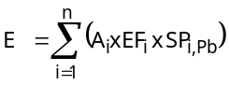
Where E = Total emission from residential heating (in kg Pb/year)
A_{i} = Consumption of fuel type i for residential heating (kg fuel)
EF_{i} = Emission factor for fuel type i (kg dust/kg fuel)
SP_{i},_{Pb} = Speciation Profile for Pb per fuel type i (kg Pb/kg dust)
Emission factors for dust were taken from literature. To calculate emissions of lead based on total dust emission, heavy metal profiles of dust were used (Table 3.4.48)
Table 3.4.48: Emission factors for residential heating (Milieumonitor, 2002b) and lead speciation profiles per fuel type (TNO, personal communication; -: these data were not found in the provided list of profiles)
Fuel type | Dust type | Emission factor (g/GJ) | Lead speciation profile
Domestic fuel oil | Soot, burning of oil | 5 | 0.00037
 | Fine dust | 4.5 | 0.00037
 | Coarse dust | 0.5 | -
Petroleum | Soot, burning of oil | 2 | 0.00037
 | Fine dust | 1.8 | -
 | Coarse dust | 0.2 | -
Hard coal | Fly ash | 200 | 0.0007
 | Fine dust | 120 | -
 | Coarse dust | 80 | -
Natural gas | Fine dust | 0.3 | -
LPG | Fine dust | 2 | -

It is unclear, whether EF for soot or fine dust were used in the Dutch emission estimation methodology. Based on the emission data, reported in the Dutch emission inventory of 1999, we can conclude that, for 'domestic fuel oil' and 'petroleum', EF for soot were used, while for 'hard coal', an EF for fly ash was used.
For sphere heating, the task group WESP, involved in the Dutch emission registration, initiated a specific study to review the quantification methodology used in the Netherlands to estimate emissions from residential heating (Hulskotte et al., 1999). The study was based on two questionnaires: one, yearly sent-out to the users of wood stoves and fireplaces and a general questionnaire on the comfort of houses in the Netherlands. The results of these questionnaires enabled the authors to estimate the total amount of wood stoves and fireplaces in the Netherlands. The estimation of total emission is based on:
- An estimation of the amount of fuel used per type of installation and type of fuel;
- A calculation of the total amount of fuel per type of installation by multiplying the average fuel consumption per hour with the average duration of the use of an installation and the fraction of a specific fuel used to the total use of the installation;
- The identification of emission factors for several priority substances related to the type of installation and fuel type;
- The multiplication of total fuel use and emission factors.
Emission factors for lead are estimated per type of fuel:
- Wood: 0.15 mg Pb/kg wood (BUWAL, 1995);
- Coal: based on an EF for dust and the lead content in fly ash of coal: 0.35 mg Pb/kg (Veldt, 1993);
- Waste: based on the assumption that 50% of the lead in the burned waste (wood) is emitted: 250 mg Pb/kg waste.
In the abovementioned study, total lead emissions of 94 kg for wood burning, 2.7 kg for coal and 2323 kg for waste is estimated for the Netherlands, resulting in total regional air emissions of 2420 kg lead.

Conclusion
Especially, lead emissions from wood and waste burning in wood stoves and fireplaces in the Netherlands, are important. They account for about 99% of total emissions from residential heating. Since the Dutch emission registration continuously tries to update the emission inventory with new information and the emissions from residential heating were reviewed recently (1999), we assume that the emissions from residential heating from the Dutch emission inventory are reliable. As a result the data from the Dutch emission inventory (reviewed by Hulskotte et al., 1999) are taken over in the regional emission quantification.

Domestic wastewater

Methodology used in the Netherlands
Source outlining: Emissions due to the discharge of wastewater by households; emissions due to corrosion of construction materials, like gutters, are not included in the EF; corrosion of water conduits of houses is included.
Methodology: collective estimation per year
Compartments: water
Methodology description:
The estimation is based on following equation:
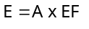
Where
E = Total emission to water from wastewater discharge in households (in kg/year)
A = the number of inhabitants (/year)
EF = Total emission factor (0.9 g Pb/inhabitant.year (Stora, 1985 in Haskoning, 2000))
The EF was determined based on a large number of measurements at representative locations in the Netherlands in 1985. Since this emission factor is still used in Dutch emission inventory, apparently this emission factor is still assessed to be reliable for the current situation in the Netherlands.
Correction factor:
- soil: 0.68% x [(75% x 50%) + (25% x 100%)]
based on the number of inhabitants, not connected to a sewage system in the Netherlands in 1999 and discharging directly to soil (0.68%), taking into account that 75% of these households dispose of an individual wastewater treatment installation (IWTI) with a retention factor of 50%;
- water: 1.37% x [(75% x 50%) + (25% x 100%)]
based on the number of inhabitants, not connected to a sewage system in the Netherlands in 1999 and discharging directly to the surface water (1.37%) and taking into account that 75% of these dispose of an individual wastewater treatment installation (IWTI) with a retention factor of 50%.
These correction factors are country-specific as well as year-specific, since they depend on the degree of connection to an STP.
Table 3.4.49 gives an overview of the number of inhabitants in 1999, connected to different types of sewage systems (RIZA, personal communication, 2002)
Table 3.4.49: Number of inhabitants in the Netherlands, connected to the sewage system (RIZA, personal communication, 2002)
Reference year: 1999 | Share of total number of inhabitants (%) | number of inhabitants
Total number | 100 | 15760200
Not connected, emitting to soil | 0.68 | 107169
Not connected, emitting to surface water | 1.37 | 215915
Mixed sewage system | 77.50 | 12213984
Separate sewage system | 9.45 | 1489510
Improved Separate sewage system | 11.00 | 1733622

Targeted assessment
In the Netherlands an emission factor of 0.9 g of Pb per inhabitant (Stora, 1985 in Haskoning, 2000) is used. In order to verify the accuracy of this emission factor, a literature study was performed. It should be noted that domestic wastewater consists of a natural part (urine, faeces) and an anthropogenic part (use of washing powders, cleaning agents, drinking water,…).

[a] Methodologies used in other countries
The Flemish Region in Belgium uses the same emission factor as mentioned in the Dutch emission inventory (0.9 g Pb/inhabitant.year (Stora, 1985 in Haskoning, 2000)). The difference with the Dutch emission inventory can be found in the fact that an additional emission factor is used for the natural part (faeces, urine) of the Pb emissions (0.06 g Pb/inhabitant.year (Stora, 1985 in Haskoning, 2000))
In Germany an emission estimation is performed for the households neither connected to wastewater treatment plants nor sewers (Fuchs et al., 2002). For these sources it was assumed that only the dissolved portion of heavy metals of human load reaches water bodies after percolating through the soil. The fraction of heavy metals retained during the passage in the soil was estimated as 95 %. Emissions are calculated with following formula:
E_{UN} = (A_{AUN} + E_{EWN} x AG_{EG}) x a where:
E_{UN} | = heavy metal input via inhabitants and impervious urban areas connected neither to sewers nor to wastewater treatment plants [kg/year]
E_{AUN} | = heavy metal input from paved urban areas connected neither to sewers nor to wastewater treatment plants [kg/year]
AG_{EG} | = inhabitant specific load of dissolved heavy metals [1.6 g Pb/(inhabitant.year)]
E_{EWN} | = inhabitants connected neither to sewers nor to wastewater treatment plants
a | = load share entering the surface water bodies after percolation through the soil (=0.05)

[b] Desmet H. et al., 2001
The aim of this study was to determine average heavy metal concentrations in the emitted wastewater of households. Therefore a spot check of 10 residential districts in Flanders was drawn up. The number of inhabitants within this spot check was 4947, spread over about 1958 houses. 95% of the inhabitants was connected to a sewage system. In 12% of the cases the sanitary water was not connected to the sewage system. Measurements were taken in the sewage system. This implies that part of the load could not be detected. However, according to the authors this lack was assumed to be 3% of the average, which can be interpreted as a systematic fault (acceptable deviation) of the methodology.
An average wastewater flow of 136±3 litre per inhabitant per day and an average lead load 23±2 µg Pb/l, an average emission of 3.1±0.3 mg Pb per inhabitant per day were measured. Based on these data an annual lead load of 1.1 g Pb/inhabitant can be calculated. This emission factor is comparable with the Dutch emission factor.
Quality assessment: A

[c] Jönsson H. et al., 1997
Human urine was analysed in a sewage system which served 44 apartments, 160 persons of the Understen eco-village, located within the city of Stockholm. The urine was separated from the faeces using a special type of toilets. The urine solution (urine and flush water) from all apartments was piped to two large collection tanks (40 m³ each). The average lead content of the analysed urine (+ flushing water) was <0.01 mg Pb/l. Per inhabitant and per day an average of 1.34 litre has been flushed, which results in a discharge of lead through urine solution of <0.013 mg Pb/inhabitant.day. Consequently, the annual lead emission equals 4.9 mg Pb/inhabitant.
Quality assessment: B (since a specific low water using flushing system is used, we assumed that these data cannot be generalised)

[d] Jenkins D., 1998
In a study to assess the effect of the reformulation of powder laundry detergents on the heavy metal contributions to wastewater (USA), a mixture of eleven different brands of laundry detergents (in proportion to the market share of each individual brand) was analysed on its heavy metal content. Based on this heavy metal content and the average laundry detergent consumption per capita (total consumption in 1994 divided by total population in 1994), the average heavy metal contributions of powder laundry detergents were calculated. The average Pb load is 0.01 mg Pb/inhabitant.day. In order to be able to compare this flux with other sources mentioned in the underlying study, a yearly emission of 3.65 mg Pb/inhabitant.year was calculated.
Quality assessment: D (the methodology of the determination of total STP influent heavy metal contribution was not explained)

[e] Discussion on literature review
To be able to have an idea of the average lead concentrations in domestic wastewater in different countries in Europe, the total emissions and emission factors per inhabitant were recalculated to average lead concentrations based on the total amount of water consumed in households per country. This recalculation is given in Table 3.4.50.
Table 3.4.50: Overview of calculated or measured lead concentrations in domestic wastewater based on the literature review
Source of information | Total emission at the source (tons) | Water consumption (in Mm³) | Average Pb-conc (mg/l)
Dutch emission inventory (1999) | 14.22 ⁽¹⁾ | 948 (IWSA, 1999) | 0.015
Desmet et al. (2001) |  |  | 0.023 ⁽²⁾
Fuchs et al. (2002) - Germany |  | 3946 (IWSA, 1999) | 0.033 ⁽³⁾
Average |  |  | 0.024
(1) based on emission factor of 0.9 g/inhabitant x 15 800 000 inhabitants in the Netherlands
(2) based on measurements in wastewater
(3) based on emission factor of 1.6 g/inhabitant x 82 200 000 inhabitants in Germany

The Pb-concentrations found, based on the literature review (cf. Table 3.4.50) show a reasonable consistency. Therefore, an average Pb-concentration in domestic wastewater of 24 µg Pb/l is calculated.
Some commercial progressive hair colouring marketed within the EU has contained lead acetate, with the lead content of commercial preparations being on the order of 0.3-0.4% (w/w) (Cohen and Roe 1991). Regulatory approval was granted for the use of such products as an exemption from 76/768/EEC Cosmetics Directive following the submission of data that documented product safety.
Neither the tonnage of lead acetate used in hair dyes during 2000, the base year for this Risk Assessment, or the proportion of hair dye sold within the EU that contained lead acetate in 2000 could be determined. The only known manufacturer of the hair dyes in question has since discontinued the use of lead acetate in hair dyes (personal communication). Subsequent to 2000, the EU Scientific Committee on Consumer Products (SCCP) has recommended against the use of CMR category 1 classified substances in hair dyes and further initiated a process whereby safety dossiers would be required for any substance intended for use in hair dyes. Any substance for which a safety dossier has not been submitted was banned effective 1 December, 2006.
In the absence of information indicating that lead acetate is still used in hair dyes, this application has not specifically been considered. However it must be noted that these emissions would anyway be covered by data on emissions from domestic wastewater.

Conclusion for discharge of wastewater
Based on this literature review, an average Pb-concentration in domestic wastewater of 24 µg/l is taken into account. On a regional scale (total water use of 948 Mm³) this results in a Pb-emission at the source of 22540 kg. In the Netherlands 98% of the households are connected to an urban wastewater treatment plant, resulting in direct emissions at the source of 462 kg. According to the Dutch emission inventory, 68,5% of this 462 kg will be emitted to the surface water, while 31,5% will be emitted to the soil directly.
- emissions to surface water: 309 kg Pb
- emissions to soil: 153 kg Pb
Of the total discharge at the source of 22540 kg Pb, 22078 kg Pb will enter the UWWTP and based on a lead removal efficiency of 84% in the Netherlands, an indirect emission of domestic wastewater to surface water through the STP is 3533 kg. The rest, 18546 kg, will end up in sewage sludge.

Corrosion of lead sheet in buildings

Methodology used in the Netherlands

Corrosion of lead sheet in residential buildings
Methodology: collective estimation per year
Compartments: water, soil
Description of methodology:
The estimation is based on following equation:
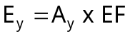
Where E_{y} = total emission of Pb (in kg Pb/year)
A_{y} = the number of houses
EF = total emission factor for Pb (0.0133 kg Pb/house)

Correction factor:
- emissions to soil: 0.30
- emissions to surface water: 0.0137
This correction factor is based on the fact that in 1999, 1.37% of the total number of Dutch inhabitants, were not connected to a sewage system and that part of the emission will be directly to the surface water; another 68.63% (=70%-1.37%) is emitted to the sewage system.
Determination of the exposed area (van Bentum et al., 1996):
The total exposed area of lead in residential buildings (15.7E6 m² ) is drawn up from:
- connection between roof and vertical wall: 2.1x10⁶ m²
- connection between chimney and roof: 7.2x10⁶ m²
- dormer: 1.5x10⁶ m²
- dormer window: 1.8x10⁶ m²
- other applications in residential building: 3.1x10⁶ m²
The data on total area of lead sheet used, are in general based on objective data on e.g. the amount of houses with a dormer, a dormer window, … It was assumed (de Graaf en Eleveld, 1993) that the exposed area is about 25% of total inventoried areas in these applications.
Determination of the emission factor:
An emission was estimated for the reference year 1990 as follows:
- the exposed area of lead in residential buildings is 15.7E6 m² (van Bentum et al., 1996)
- the corrosion factor is estimated at 5 g/m² per year (Annema et al., 1991)
This brings us to 78500 tons of lead in 1990. Since the emission of Pb from the corrosion of lead sheet at residential buildings can be related to the number of houses, an emission factor is calculated based on the number of houses (5892000) and the calculated emission of Pb in 1990. This results in an emission factor of (78500 tons/5892000 houses) = 0.0133 kg Pb per house.

Corrosion of lead sheet in utility buildings
Methodology: collective estimation per year
Compartments: water, soil
Description of methodology:
The estimation is based on following equation:
Where E_{y} = total emission (in kg Pb/year)
A_{y} = the total industrial area (m²)
EF = total emission factor (kg Pb/m²)

Correction factor (personal communication, van den Roovaart, RIZA):
- emissions to soil: 0.80
- emissions to sewage system: 0.20; none of the emissions to the water compartment will reach the surface water directly.
Determination of the exposed area (van Bentum et al., 1996)
Based on sales of lead sheet applications in the residential and utility building industry it was calculated (de Graaf en Eleveld, 1993) that about 50% of the lead sheet was used in utility buildings. Due to the difference in type of roofs in utility and residential buildings, the exposed area of lead (in comparison with the total lead sheet used) in utility buildings will be smaller. Based on these facts it was assumed that the exposed area of lead sheet is utility buildings is about 80% of the exposed area of lead sheet in residential buildings (80% of 15.7E6 m² = 12.5E6 m²)
Determination of the emission factor:
An emission was estimated for the reference year 1990 as follows:
- the exposed area of lead in residential buildings is 12.5E6 m² (van Bentum et al., 1996)
- the corrosion factor is estimated at 5 g/m² per year (Annema et al., 1991)
This brings us to 62500 tons of lead in 1990. The emission of Pb from the corrosion of lead sheet in utility buildings has been related to the industrial area. An emission factor is calculated based on the total industrial area (503860000) and the calculated emission of Pb in 1990. This results in an emission factor of (62500 tons/503860000 m²) = 0.124 g Pb per m² industrial area.

Targeted assessment
The Dutch methodology was reviewed by means of a literature study and a specific study by the LDAI.

(a) Thornton, I., Rautiu, R. & Brush, S. (2001)
The authors consider that the approximate corrosion rate of 5g/m² of exposed area per year, used in a Life Cycle Analysis performed in the Netherlands, may be above the actual rate, as it is based on measurements taken some time ago (Roorda and van der Ven, 1998). The actual emission factors, which are used in the Dutch emission inventory to estimate lead emissions from industrial and residential buildings, are based on this corrosion rate. This implies that the actual Dutch emission factors for lead from utility and residential buildings might be overestimated.
According to Thornton et al. (2001), different factors can influence the lead corrosion rate:
- lead sheet, on exposure to air, rapidly forms a layer of oxide on its surface. Further reaction with carbon dioxide in air results in the formation of lead carbonate, which has an extremely low solubility and gives good protection from further attack. Leaded roofs in areas subject to high levels of sulphur dioxide (the main component of "acid rain") have very good stability, because a superficial layer of lead sulphate can form, which has a very low solubility in both water and dilute sulphuric acid;
- if the design of a roof allows condensation to occur underneath, this can result in corrosion. The condensed water is very pure, having not been exposed to atmospheric carbon dioxide, and a protective patina of lead carbonate does not form on the metal surface, thus any attack on the lead tends to continue. This can be much more serious if the condense passes over timbers, as it can dissolve chemicals from the wood which can further attack the lead;
- further potential for accelerated lead loss from roofing materials may result from lichens on tiled roofs. Water, in contact with lichens, can contain organic acids, which can dissolve lead from guttering etc. (Blaskett and Boxall, 1990);
- the combined use of lead and aluminium in roofing materials is not recommended when materials are exposed to a marine environment. Here corrosion of lead has been noted which in turn has caused accelerated corrosion of aluminium (Blaskett and Boxall, 1990).
Unfortunately, Thornton et al. (2001) do not suggest any emission factor for lead from building material.

(b) Davis et al., 2001
Corrosion of building siding materials was measured, based on the analysis of synthetic water samples. Usually 120 to 160 ml of synthetic rain water was sprayed at a medium intensity on building walls and then collected using sheets of aluminium foil. Table 3.4.51 gives an overview of the measured metal concentrations, based on building siding sampling.
Table 3.4.51: Building siding sampling for lead (Davis et al., 2001)
Building siding material | Lead concentrations (µg/m²)
Building siding material | Geometric mean | median | Mean
Brick | 94 | 76 | 300
Painted wood | 73 | 110 | 520
Concrete | 14 | 20 | 26
Metal | 2.7 | 4.0 | 9.8
Unpainted wood | 9.0 | 8.9 | 93
Vinyl | 11 | 7.6 | 11

Quality assessment: A. The emission factors are only valid for specific siding materials and cannot be used to estimate lead emissions from building materials in general.

(c) Stotz et al. (1999)
In this publication, specific heavy metal loads from roof run-off were given, based on a literature study. Specific lead loads in roof run-off were cited between 20 and 7000 mg per m² roof area per year. The roof material was not specified, only for the highest load of 7000 mg it was indicated that it was a metal roof. Since there is too little specification on the used material and the used methodology, these data are not useful to quantify emissions from corrosion of lead sheets.
Quality assessment: D (no information is given on the manner in which emission factors were identified).

(d) Lead Development Association International
A specific targeted assessment was performed by The Lead Development Association (LDA). In this study the lead runoff calculation for the Netherlands were revised. Total exposed area of lead sheet as well as the corrosion rate was revised.

Revision of Exposed lead sheet area
The total exposed area of lead sheet was estimated by:
- assuming a life span for lead sheet of 50 years, it is possible to sum the lead sheet consumption figures for the Netherlands for 1951-2000 and estimate this to be the tonnage of lead sheet that is present on buildings in the Netherlands in 2000;
- the consumption data are derived from (1) industry lead sheet and pipe consumption figures for 1970-2000, and (2) ILZSG (International Lead and Zinc Study Group) lead sheet and pipe production figures for 1960-1969. Production for 1951-1959 is assumed to be constant at 1960 production levels;
- it is estimated that lead sheet for exterior building application comprises 75% of sheet and pipe consumption 1951-1974 (remainder is 20% pipe, 5% other sheet) and 95% of sheet and pipe consumption 1975-2000 (remainder is 5% other sheet);
- the average mass per unit area of lead sheet is estimated to be 13.6 kg/m² (code 3) for 1951-1994, and 18.1 kg/m² (code 4) for 1995-2000. By dividing the tonnage of lead sheet by the average mass per unit area the total area of lead sheet the total area of lead sheet is obtained.
Using the Dutch government's estimations that:
- 25% of lead sheet on residential buildings and 20% of lead sheet on utility buildings is exposed;
- 50% of the sheet is used on residential buildings and 50% is used on utility buildings;
a total exposed area of lead sheet in the Netherlands in 2000 is calculated to be 12.8 x 10⁶ m². In Table 3.4.52 the reviewed surfaces are compared to the surfaces which were used to estimate emissions for the Netherlands.
Table 3.4.52: comparison of exposed lead areas
Exposed lead area | Actual value (CUWVO, 1999) for the year 1990 | Reviewed value (LDA, pers. comm.) for the year 2000
Residential | 15 700 000 m² | 7 096 811 m²
Utility | 12 500 000 m² | 5 677 449 m²

Table 3.4.52 shows a substantial overestimation in the Dutch government's calculations (CUWVO, 1999).

Revision of run-off rates
In the Wilson report (2003), run-off rates as found in literature were compared with laboratory and real-life studies. The above mentioned experiments were performed by The Independent Netherlands Organisation for Applied Scientific Research (TNO) on behalf of the European Lead Sheet Industry Association in 2001 to verify the run-off rates found in literature.
The one year programme of testing at the TNO research facilities in Delft enables a number of conclusions to be drawn about the corrosion of lead sheet under normal atmospheric exposure conditions:
- on exposure to the atmosphere, the surface of lead sheet reacts rapidly to form a tightly adherent and stable patina of virtually insoluble lead compounds,
- because rainfall is mildly acidic, slight dissolution of the corrosion products can occur,
- the rate of run-off varies with the amount of rainfall, temperature and pH,
- the average annual run-off rate of just under 5 g/m² corroborates the limited evidence available in previously published literature,
- the precise alloy composition of lead sheet has an influence on run-off rates,
- run-off from lead flashings installed on roofs is much lower than from lead sheet test samples because of the orientation of the sheet (less rain can run over vertical sections), the effects of shelter and evaporation rates, and because of the alkalinity of building materials which increases the pH of the rain and reduces its aggressiveness towards lead compounds.
In the Wilson report (2003), the following run-off rates were given:
- Lead flashings: a run-off rate of 0.88 g/m² seems appropriate to apply in general;
- Lead sheets (roof): a run-off rate of 5 g/m² seem reasonable based on literature and experimental studies.

Conclusion
Because of the recently performed (2001) extensive literature review and experimental study by the LDAI and the specific gathering of information on the exposed area of lead sheets, these specific findings are used in the current study to calculate lead emissions from the run-off of lead sheets and flashings. Based on these reviewed data, a total emission at the source of 13873 kg can be estimated. Only 106 kg will be emitted directly to surface water and 7245 kg will be emitted to soil, the remaining part will enter the sewage system.

Fishing in fresh waters - use of Pb in fishing weights

Methodology used in the Netherlands
Methodology: collective estimation per year
Compartments: water
Description of methodology:
The estimation is based on following equation:
Where E_{y} = Total emission of Pb (kg Pb/year)
A_{y} = The number of inhabitants
EF = Total emission factor for Pb (1.84 g Pb/inhabitant (CUWVO, 1999))
The emission factor is based on a single emission calculation for 1993. The expert group 'Fishlead' in the Netherlands estimated a total load of surface waters from the use of fishlead of 28 tons in 1993. This total emission was related to the total number of inhabitants in 1993, 15.24 millions. This resulted in an emission factor of 1.84 g of lead per inhabitant from the use of fishlead.
Correction factor: /
Since the Pb is directly emitted to the surface water, no correction factor is necessary. It must be noted that the Pb is emitted in solid form. It is assumed that about 1% op the Pb will dissolute each year.

Targeted assessment
Recreational anglers (people who fish using a hook and line) often attach lead weights to their fishing line to sink the hook and bait or lure in the water. They may also use lead jigs, which are weighted fish hooks. Fishing sinkers come in all shapes and sizes. Sometimes people accidentally drop loose fishing sinkers or jigs into the water. Sinkers and jigs may also be lost in the water if the hook or line gets tangled and the line breaks or is cut. Scientists estimate that about 500 tonnes of lead sinkers and jigs are lost in Canadian waters every year. Only scarce information is available on the loss of lead in European waters from the use of fishing sinkers. The information found is listed and described hereafter.

(a) COWI (2004)
A study from COWI in authorisation of the European Commission aimed at assessing the impact of potential restrictions of lead ammunition, fishing sinkers and candle wicks containing lead on business and private users. More specific and for the current study relevant objectives of the COWI-study are:
- To provide a quantitative up-to-date assessment of the various uses in the Member States and the Candidate Countries.
- To identify and analyse the regulations and rules on hunting, shooting and fishing at national or regional level which may have an influence on the use of products in question.
In this study, statistics were gathered in several European countries (EU-25) on the consumption of lead for fishing sinkers for angling. Table 3.4.53 gives an overview of these statistics.
Table 3.4.53: Overview of the consumption of lead for fishing sinkers for angling in different European countries (COWI, 2004)
Country | Consumption  (tons Pb/year) | Total Population (million) | Number of active anglers (million) ⁽¹⁾ | Consumption  (kg Pb/angler/year) | Year of study | Source
Czech republic | 400-800 | 10.3 | 0.23 | 1.7-3.5 |  | COWI
Denmark | 97-170 | 5.3 | 0.45 | 0.2-0.4 | 2000 | Lassen et al., 2003
France | - | 59.2 | 4 |  |  | COWI
Hungary | 80-100 | 10.2 | 0.325 | 0.2-0.3 |  | COWI
Netherlands | 28 | 15.9 | 1.5 | 0.02 | 1993 | Annema et al., 1995
Poland | 1,020-1,530 | 38.6 | 0.6 | 1.7-2.6 |  | COWI
Sweden | 200 | 9.0 | 2.02 | 0.1 | 1992 | Gustafsson et al., 1993
UK | 500-1,000 | 59.6 | 4 | 0.1-0.3 |  | COWI
(1) Source: website of European Anglers Association, 2004.

Based on this publication, Ecolas calculated an average Pb-consumption per angler per year of 0.8 kg Pb. It is assumed that an average consumption of 8 European countries (EU-25) is representative for all EU-15 countries and therefore also for the selected region, the Netherlands. About the application and consumption of lead in commercial fishing, the Netherlands have responded to the questionnaire, sent out to all EU-25 Member States in the framework of this COWI-study, that the type of equipment used in the Netherlands are trawl, seines and beamtrawl nets and it is reported that lead is not used in any of the equipment. It is further reported that there is no domestic production of lead weights and lead-containing ropes or lines.

(b) Scheuhammer A.M. et al. (2003)
Next to an estimation of the amount of anglers, the magnitude of lead sinkers and jig use in Canada, this study also describes lead sinker ingestion and poisoning in wildlife. Especially the first part of this study was found to be important for the underlying study, aiming at estimating the amount of lead sinkers lost in European fresh waters. The study states that the mass of lead sold as fishing sinkers annually in Canada is estimated to be about 559 tons. An undetermined additional amount of lead is sold in the form of jigs. The majority of this annual purchase of lead is destined to be deposited in the environment, with virtually no chance of recovery or recycling. In this study also the lead deposition is estimated from the annual loss of sinkers and jigs. Fishing sinkers and jigs may be accidentally dropped into the water or may be lost if the hook or line becomes entangled and the line breaks or is cut. It is assumed that the majority of sinkers purchased annually are to replace those lost while fishing, thus, the magnitude of lead deposition from the loss of lead fishing weights can be estimated by monitoring annual production and sale. Researchers from the University of Arizona interviewed about 850 anglers from 12 U.S. states. For all study sites combined, anglers each reported losing, on average, 0.18 sinkers per hour, 0.14 pieces of fishing line per hour, and 0.23 hooks and lures per hour. About 2% of anglers reported releasing or losing fish with tackle attached. At this rate, each angler would have lost about 1 sinker for every 6 hours of fishing. Similarly, British anglers were reported to have lost or discarded an average of two or three sinkers per angling day (Bell et al., 1985 in Scheuhammer et al., 2003).

(c) Discussion on literature review
Based on the limited information found, it was concluded that:
- The use of a consumption factor of 0.8 kg Pb per angler per year is more reliable than the Dutch methodology (described in ) since it is the average of 8 independent calculations in 8 EU-countries.
- Since this calculated consumption factor is based on yearly consumption data, it is assumed based on the Canadian study (Scheuhammer et al., 2003) that the yearly consumption is equal to the yearly loss of fishing sinkers.
As a result, total loss of fishing sinkers and jigs can be estimated based on the total amount of anglers in the Netherlands (1 500 000) and taking into account a loss factor of 0.8 kg Pb/angler/year. It must be stressed that:
- this loss factor indicates the total loss of Pb in solid form to the environment and,
- this estimation has a high level of uncertainty, since it is based on only two literature references.
This total loss indicates the total weight of solid lead lost in the surface water. In the Pb-RAR however we do not take into account the toxicity related to the direct ingestion of Pb-particles. Therefore the corroded Pb-fraction needs to be estimated. Little is known about the corrosion of Pb sinkers in fresh water. In the “Targeted risk assessment on lead in ammunition” (Verdonck et al., 2005), a worst-case corrosion factor of 1% per year was taken into account to estimate the yearly corrosion/emission of lead from the use of ammunition. Through lack of specific information on the corrosion of Pb from fishing sinkers in surface water, also a worst-case yearly corrosion factor of 1% is taken into account. The selection of a 1% corrosion factor is an important uncertainty in this estimation since corrosion is dependent of the characteristics of the environment (e.g. pH) and in reality will probably vary between 0.2 and 2% per year (Scheinost, 2003).
In the general scenario for PEC calculation, the cumulative corrosion of lead from lead sinkers, lost in surface water prior to the reference emission year (prior to 1999) is not taken into account, because:
- the corrosion of lead sinkers lost in previous years is a historical pollution and is not a subject of the risk assessment;
- the corrosion will be most important in the first year and will decrease in time; Linder B. (2004) states that the corrosion rate will decrease to about 50% of the initial corrosion rate after 2-3 years (Linder B., 2004) and will then further gradually decrease in time;
- it is imaginable that lead fishing sinkers, due to their weight, will almost immediately sink to the bottom of the river and will quite fast be swamped with sediment; as a result, it could be assumed that corroded Pb will not be emitted to the surface water after the first year; no specific information on this subject is however available.
Nevertheless, due to the high uncertainties in this estimation, additional scenario’s for PEC calculation will be included, to take cumulative emissions into account. The input data for these scenario’s (to predict future accumulation) are given in chapter .

Conclusion
Based on the targeted assessment, a yearly emission of 12 tons of Pb (=1 500 000 anglers x 0.8 kg Pb/angler/year x 1% corrosion/year) is used in the regional emission inventory. This estimation is significantly lower than the calculation in the Dutch emission inventory. Since the data used in the Dutch emission inventory originate from estimations referring to 1994 and the data mentioned in the targeted assessment are based on a recent report (COWI, December 2004) it is decided to use these data in the regional emission inventory. The use of a corrosion factor of 1% is only an assumption. It must be stressed that the calculated emission to surface water from the loss of fishing sinkers is highly uncertain. The estimated emission is a yearly emission and does not take into account cumulative emission of Pb, from the corrosion of fishing weights lost in previous years. Historical emissions however are not a subject of the Risk Assessment (TGD, 2003). In the following chapter cumulative emissions are calculated to predict future accumulation of Pb in surface water and soil.

Future accumulation
The PEC for fresh water is calculated with the EUSES 2.0-model. This model predicts the concentrations in fresh water after reaching a steady state concentration. One should realise however, that this calculation is based on a number of assumptions. An important assumption is that the calculation focuses on the added amounts of lead in the environment, e.g. added to the present natural and ambient concentrations in the fresh water. So only the added amount of Pb through the loss of lead sinkers from one year is taken into account. It is questionable, whether Pb in fishing weights will keep corroding after the first year (cf. chapter (c) Discussion on literature review). To assess all possible options, in this chapter, it is assumed that, in the coming years, a same amount of Pb sinkers will be used every year, and that above that, sinkers, which were lost this year, will keep corroding during the next years. The future PEC needs therefore to be estimated based on an accumulation model. This accumulation model takes into account, not only yearly added emissions from the yearly use of fishing sinkers, but also the fact that sinkers, lost in year t, will keep corroding in year t+1, t+2, t+3, … The calculated emissions per year, taking into account a cumulative corrosion of 1% per year, are shown in Table 3.4.54.
Table 3.4.54: Cumulative emission from corrosion of lost fishing sinkers, taking into account future accumulation
Year | Cumulative emission to surface water (kg Pb)
1 | 12 000
2 | 23 880
3 | 35 641
4 | 47 285
5 | 58 812
10 | 114 742
20 | 218 512
50 | 543 412
100 | 760 761
200 | 1 039 224

The cumulative future emissions in Table 3.4.54 are probably an overestimation, since:
- In all cases, a corrosion rate of 1% is assumed, while the corrosion will be most important in the first year and will decrease to about 50% of the initial corrosion rate after 2-3 years (Linder B., 2004); the corrosion rate will then further gradually decrease in time. Moreover, massive lead would likely end up buried in sediment after a relatively short period of time, resulting in lower corrosion rates and no direct emission to surface water.
- A constant use of Pb fishing sinkers is assumed, while this consumption could decrease in the future due to future marketing and use restrictions. In Denmark and the UK, already a ban on lead in fishing weights is in practice (Nordic Council of Ministers, 2003)
The PEC derivation for fresh water, based on a future accumulation model, calculated with Simple-box and taking into account the emissions in Table 3.4.54, is described in detail in the Pb RAR (Euras, KUL and Ecolas, 2005). The Simple-box model takes into account a yearly emission over a certain period of time, equal to the calculated cumulative emission after 10 or 100 years in Table 3.4.54, meaning that e.g. it is assumed that the yearly emission is 114.7 tons of Pb (emission after 10 year) for 10, 100 years.

3.5 Waste management
In order to fully understand the used Dutch terminology, an overview is given of the separate activities comprised in this section:
- Sewage treatment plants (STP): all emissions directly to the surface water from the Dutch sewage treatment plants
- Waste incineration plants (WIP): process and combustion emissions from waste incineration plants
- Sewage and refuse disposal, sanitation and similar activities: all activities within waste treatment not included in previous mentioned sources (STP and WIP);
- Sanitation of environmental pollution: this includes air emissions from the use of fuels within these activities
- Landfills: emissions to water and soil from leaching of landfills
- Public service activities, waste removal: waste removal plants, under the authority of municipalities
- Wastewater treatment from remediation activities: specific water emissions from specific activities
The different "waste management" sectors are split in such a way that no overlapping of emissions can occur.

Sewage treatment plants

Methodology used in the Netherlands
Methodology: individual and collective estimation
Compartments: water
Methodology description:
The estimation is based on following equation:
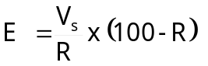
where
E = emission to water (kg/year)
V_{s} = load in sewage sludge (kg/year)
R = efficiency for lead of WWTP (84 % (Milieumonitor, 2002a))
The CBS makes an inventory of the emissions of all STP (400) in the Netherlands. The following methodology is used to calculate all heavy metal emissions to surface waters from STP:
- individual: at approximately 100 STP, the heavy metal concentrations and the flow are measured at the influent and at the effluent. For another 100 STP only concentrations in the effluent are measured. Yearly emissions of heavy metals are calculated by multiplying average daily emissions by 365 days.
- Collective: based on the measurements in the influent and the effluent, an average emission retention efficiency for lead is calculated. These efficiencies are used to calculate emissions of the other STP (~200), based on the amount of metals in the produced sewage sludge. The average retention efficiency of STP for lead in 1999 is 84%.
The emissions to the surface water from sewage treatment plants in the Netherlands, are estimated with the PROMISE model. In order to better understand the assumptions, made in this model, a more detailed description is given here. The calculations within PROMISE start with a calculation of all emissions to air and water at the source with the process model PROMO (taking into account all sources). Process emissions to surface water are separated in (Elzenga et al., 1998):
- Direct discharge to surface water
- Discharges to sewage systems and eventually sewage treatment plants (STP)
The sewage system is divided into mixed and separate systems:
- Mixed systems: wastewater is transported to a STP. The treated wastewater is discharged to surface waters. In case of heavy rain, the mixed sewage system cannot transport all wastewater and as a result a part of the untreated wastewater can be emitted to the surface water (storm water overflow);
- Separate systems: wastewater and rainwater are transported separately. Industrial and municipal wastewater are transported to a STP en are treated before discharge to the surface water. Rainwater is transported separately and is discharged to the surface water directly (emissions from separate sewage systems).
- Emissions to air and soil: emissions to air can spread and deposit on the earth’s surface. PROMISE takes into account deposition on paved areas and direct deposition on surface water. Emissions on paved areas can be emitted to the surface water through run-off. Emissions on unpaved areas are not taken into account in PROMISE.
A drain scheme is linked to each process, entered in PROMO. This allows for a distinction between the direct discharge to surface waters and the discharges from mixed/separate sewage systems per Dutch PAWN-district. The distinction between these drain systems is dependant of the processes itself. Some processes are rainwater related e.g. wear of roads, corrosion of roofs, …, others are not rainwater related e.g. corrosion of conduit systems, industrial emissions, … Following assumptions are made in the process:
- For rainwater related processes:
- To separate sewage system → discharge to surface water
- To mixed sewage system → 22% of the wastewater will be emitted to the surface water through overflow (this percentage is based on an average overflow of 177 mm/year, an average precipitation of 796 mm/year and a run-off coefficient of 100% for paved areas)
- For not rainwater related processes:
- To separate sewage system → connected to STP
- To mixed sewage system → 1% of the wastewater will be emitted to the surface water through overflow
Table 3.5.55 gives an overview of the number, the capacity and the types of sewage treatment plants in the Netherlands in 1999.
Table 3.5.55: Overview of the amount, capacity and types of Sewage Treatment Plants in the Netherlands in 1999 (CBS, Central Bureau for Statistics, Voorburg/Heerlen, 2002)
 | Number of installations |  |  | Design Capacity (inhabitant equivalents)
1999 | total | with defosforing | without defosforing | total | with defosforing | without defosforing
Total | 396 | 205 | 191 | 25230 | 19583 | 5647
Mechanical installation | 0 | 0 | 0 | 0 | 0 | 0
Oxidation Bed | 13 | 10 | 3 | 549 | 516 | 33
Aeration Tank | 53 | 39 | 14 | 9403 | 8253 | 1150
Oxidation Tank | 62 | 34 | 28 | 2314 | 1757 | 557
Oxidation Ditch | 92 | 26 | 66 | 1278 | 714 | 564
Carrousel | 120 | 72 | 48 | 7341 | 5302 | 2039
Discontinu system | 8 | 0 | 8 | 14 | 0 | 14
Parallel Installation | 12 | 5 | 7 | 656 | 421 | 235
Two-step installation | 35 | 18 | 17 | 3667 | 2612 | 1055
Compact Installation | 1 | 1 | 0 | 8 | 8 | 0

Table 3.5.56 gives an overview of the material flow of lead through STPs in the Netherlands in 1999.
Table 3.5.56: Lead flow through sewage treatment plants (396) in the Netherlands in 1999 (CBS, 2002)
 | Influent | Effluent | Sewage sludge
Total flow | 2014 x 10⁶ m³/year | 2014 x 10⁶ m³/year | 374 x 10³ tons DM
Pb load | 56 tons | 8.6 tons | 57 tons

In Table 3.5.56 a total amount of 374 ktons (DM) of sewage sludge was produced by the sewage treatment plants. According to the CBS (2002) this sludge had following destination in 1999:
- 16 ktons are treated with a wet oxidation process
- 34 ktons are composted
- 119 ktons are landfilled
- 194 ktons are incinerated
- since 1995, a strict regulation excludes the use of sewage sludge on agricultural land

Conclusion
Since the Dutch emission quantification is based on site-specific measurements and calculations, these data are taken over in the regional emission quantification (8908 kg Pb emitted directly to surface water).

Landfills

Methodology used in the Netherlands
Methodology: individual calculation of emissions per landfill
Compartments: water, soil
Methodology description:
The emission estimation is based on following equation:
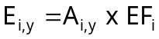
where
E_{i,y} =total emission per landfill per year (kg Pb)
EF = total emission factor (90 µg Pb/l percolate (Coops et.al., 1995))
A_{i,y}= total amount of percolate produced per landfill (l), where,
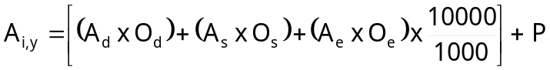
where, O_{d}= area covered with vegetation (ha) = A_{t} - A_{e} - A_{s}
O_{t} = total area (ha)
O_{e}= sealed area (ha) O_{s}= unsealed area and dumping front (ha) A_{d} = surplus water from O_{d} (300 mm/year)
A_{e} = surplus water from O_{e} (5 mm/year)
A_{s} = surplus water from O_{e} (450 mm/year)
Surplus water = rainfall - evaporation
P = production of water in the waste (assumed 0)
10000/1000 = conversion from (mm x ha) to m³
The emission factor, taken from literature, depends on the quality of the waste dumped and the presence of a STP at the landfill. Through a questionnaire, sent on a yearly basis to several landfills, these specific characteristics become available.
Correction factor
The effluents of all landfills in the Netherlands will be emitted as follows:
- 30% uncontrolled emission to surface water e.g. when the landfill is not provided with a sealing underneath;
- 10% controlled emission to the surface water (normally only allowed when a WTP is present on site);
- 60% is emitted to a sewage system (this type of emission occurs with or without a WTP present on site).
Since this methodology description does not clarify the partitioning of total emissions to the different environmental compartments, Ecolas calculated the partitioning factors based on the emission data reported in the Dutch emission inventory:
- 435 kg Pb to soil
- 71 kg Pb direct to the surface water
- 337 kg Pb indirect to the surface water, meaning, caught by the sewage system
These data show a distribution of 52% to soil and 48% to water of which only 8% will reach the surface water directly and 40% will be caught by the sewage system.

Targeted assessment
The “Waste stream analysis and emission assessment” background report (Vangheluwe M., 2005) tackles the emission from landfills. In this report an emission to surface water from leachate of 199 kg Pb is calculated.

Conclusion
The emissions calculated by Vangheluwe M. (2005) are taken over in the emission inventory.

Other sources: Sewage and refuse disposal, sanitation and similar activities
Methodology: individual registration and collective estimation
Compartments: air, water
Methodology description:
In this section, following sources are included:
- Waste incineration plants;
- Sewage and refuse disposal, sanitation and similar activities;
- Sanitation of environmental pollution;
- Public service activities, waste removal;
- Wastewater treatment from soil remediation activities.
For process emissions to water and soil, emission data are entirely based on individual registrations of plant specific data.
For combustion emissions from use of domestic fuel oil (meaning only emissions from combustion processes for heating of buildings in on of these activities) a small amount was estimated (cf. 3.3 Combustion processes in industry, p.143).

Targeted assessment
The “Waste stream analysis and emission assessment” background report (Vangheluwe M., 2004) tackles the emission from waste incineration plants. This analysis results in an emission from waste incineration plants of 97 kg Pb to air and 1186 kg Pb to surface water. The study indicates that these emissions are probably highly overestimated.

Conclusion
The emissions calculated by Vangheluwe M. (background report, 2005) are taken over in the emission inventory.

3.6 Agriculture

Combustion processes

Methodology used in the Netherlands
Methodology: collective estimation per source category c (agriculture, horticulture…)
Compartments: air
Description of methodology:
The emission estimation is based on following equation:
Where | E = | Emission from combustion processes in agriculture (in kg Pb/year)
 | A_{i} = | Consumption per fuel type i (kg fuel)
 | EF_{i} = | Emission factor for fuel type i (kg dust/kg fuel)
 | SP_{i},_{Pb} = | Speciation Profile per fuel type i for Pb (kg Pb/kg dust)
Emission factors of dust were taken from literature. To calculate emission of lead based on total dust emission, heavy metal profiles of dust were applied (Table 3.6.57).
Table 3.6.57: Emission factors for heating in agriculture (Milieumonitor, 2002b) and lead speciation profiles per fuel type (TNO, personal communication)
Fuel type | Dust type | Emission factor (g/GJ) | Lead speciation profile
Domestic fuel oil | Soot, burning of oil | 5 | 0.00037
 | Fine dust | 4.5 | 0.00037
 | Coarse dust | 0.5 | -
Fuel oil | Soot, burning of oil | 50 | 0.00037
 | Fine dust | 45 | 0.00037
 | Coarse dust | 5 | -
Petroleum | Soot, burning of oil | 2 | 0.00037
 | Fine dust | 1.8 | -
 | Coarse dust | 0.2 | -
Hard coal | Fly ash | 100 | 0.0007
 | Fine dust | 2 | -
 | Coarse dust | 80 | -
Natural gas | Fine dust | 0.15 | -
LPG | Fine dust | 2 | -

Conclusion
Based on the critical evaluation of available data, no targeted assessment needed to be performed for this source. The data from the Dutch emission inventory were selected for the regional emission quantification.

Mineral balance

Methodology used in the Netherlands
This source is not taken into account in the 1999 Dutch emission inventory.

Targeted assessment
Since the emission of lead as a result of the use of fertilisers on agricultural soil was not quantified in the Dutch emission inventory, a literature review is needed in order to select an appropriate emission quantification method.

[a] International Commission for the Protection of the Rhine (ICPR)
A method to quantify the emissions to water and soil from input of fertilisers to agricultural land, was solely reported by Belgium. The described methods were assessed as follows:
Flemish region:
- drift and run-off of fertilisers: E (D for EF; B for activity code and E for distribution);
- soil erosion: E (E for EF and A for activity code).
- This emission estimation is based on the model proposed by the ICPR (1996).
- Walloon region:
- drift and run-off of fertilisers: D (A for EF; B for activity code and D for distribution).
It is important to note that in the regional modelling, the EUSES model, already takes run-off and leaching into account. Therefore only drift of fertilisers to the surface water should be calculated here in order to prevent double counting. The ICPR-model (1996) is a widely used model and specific emission factors for the use of manure in the Netherlands are indicated in this model (IKC-landbouw, 1997). Emissions could be quantified based on:
Drift of fertilisers = (quantity of fertilisers used x percentage drift to surface waters x lead load in fertiliser)

Where (RIVM, personal communication)
percentage drift manure = 0.2%;
percentage drift mineral fertiliser = 0.6%;
Default lead loads for fertilisers are shown in Table 3.6.58.
Table 3.6.58: Default Pb load in fertilisers (IKSR, 2001)
Type of fertiliser | Lead load (mg/kg DM)
Bovine manure | 12
Pig manure | 13
Fowl manure | 9
P-fertiliser (incl. NP and NPD) | 9
N-fertiliser | 6
K-fertiliser | 6

Since drift to the surface water is calculated separately, this amount is distracted from the emission to soil, calculated in the Dutch emission inventory based on a “balance sheet for minerals”. As a result, emissions to soil from use of fertilisers is:
Emission to soil = input from use of fertilisers – uptake by crops – drift to surface water.

[b] Use of sewage sludge on agricultural land
In the Netherlands it is not allowed to use sewage sludge on agricultural soil. The Central Bureau for Statistics (CBS, 2002) states that the use of sewage sludge on agricultural soil in the Netherlands is impossible since 1995 due to strict regulations on the metal content of sewage sludge for use on agricultural land. Therefore this emission source is not taken into account in the source category ‘agriculture’ in the Dutch emission inventory.

[c] Delahaye et al. (2003)
Estimating emissions of Pb to agricultural soil implies the calculation of a net emission, being the difference between total input and total output of Pb. A recent report of Delahaye et al. (2003) aims at estimating emissions from 7 metals, including Pb, to Dutch agricultural soils based on a mass balance model. Net emission to soil is calculated as follows:
Net emission = Input – Output, where:
- Input is the result of use of mineral fertilisers, animal manure and air deposition (and other various sources)
- Output results from crop removal
All input and output parameters taken into account in the model are shown in Figure 3.6.32.
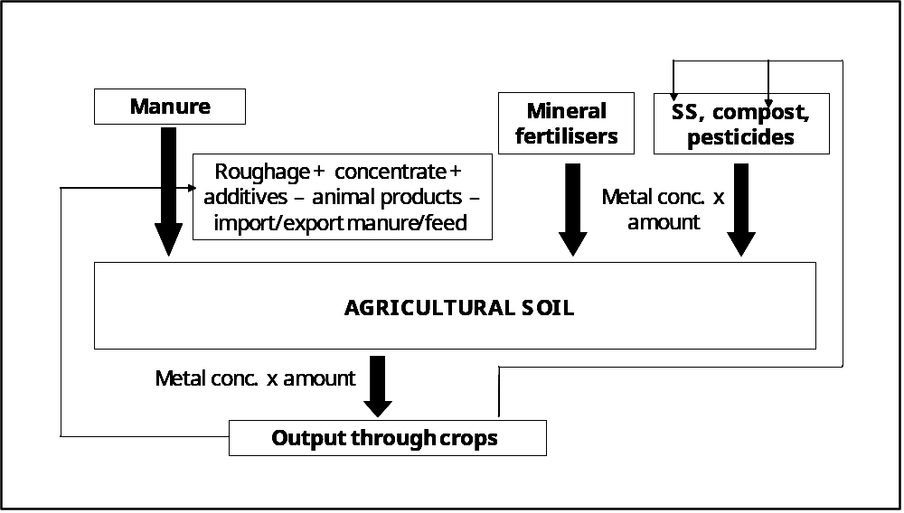
Figure 3.6.32: Flow diagram of heavy metal inputs, outputs and accumulation due to agricultural activities in soil according to Delahaye et al. (2003)

Input to agricultural soil

Mineral fertilisers
According to Delahaye et al. (2003), some fertilisers contain appreciable amounts of lead. Input of metals from mineral fertilisers is taken into account in the mass balance model by taken the product of the average metal content of fertilisers and the amount of fertilisers used on agricultural soil. The background data to estimate a total input to Dutch agricultural soils of 4.89 tons of Pb are given in Table 3.6.59.
Table 3.6.59: Overview of the amount of fertilisers used in the Netherlands, the average Pb-concentrations per type of fertiliser and the total Pb-load (tons)
Type of fertiliser | Amount (tons) | Range of Pb-concentration (mg/kg) | Pb-load (tons)
N-fertiliser (as N) | 285109 | 2.7 – 5.9 | 0.88
P-fertiliser (as P₂O₅) | 62240 | 5.5 - 236.5 | 2.26
K-fertiliser (as K₂O) | 31578 | 1.2 – 20.0 | 0.07
Ca-fertilisers | 170754 | 1.4 – 39.0 | 1.69
TOTAL FOR ALL FERTILISERS |  |  | 4.89

Manure
The input of metals through the use of manure on agricultural soil is the sum of the metal content in roughage (in most cases feed produced at the farm) and the concentrate, used as a supplement, taking into account removal of metals through animal products, feed for dogs and cats and the net export of concentrate and manure.
The total metal loads through roughage and concentrates are estimated based on the total amount of feed, given to the animals and the average lead concentrations in the feed. These data lead to a total input of 18.66 tons Pb from roughage and 10.33 tons from concentrate. The detailed data leading to these estimations are given in Table 3.6.60 and Table 3.6.61.
Some impurities of Pb occur in phosphate-feed (40% P₂O₅). Taking into account a consumption of 33650 ktons P-feed in the Netherlands and a Pb-concentration of 30 mg/kg P₂O₅ leads to a total input of 0.8 tons.
Table 3.6.60: Overview of amounts of roughage given to the animals (in ktons) and the average Pb-concentrations (mg Pb/kg) in the Netherlands
 | Amount (in ktons) | Pb-concentration (mg/kg) | Pb-load (in tons)
MOISTURE RICH FODDER
Grain processing industry | 1961.5 | 0.04 | 0.078
Potato processing industry | 1395 | 0.04 | 0.056
Sugar processing industry (pulp) | 610 | 0.15 – 0.36 | 0.220
Fermentation industry | 145.6 | 0.01 | 0.001
Dairy products | 570 | 0.01 | 0.003
OTHER ROUGHAGE
Beet, turnip | 79 | 0.15 | 0.012
Potato peel | 1718 | 0.03 | 0.052
Roots of endive | 129 | 0.15 | 0.02
Others | 232 | 0.10 – 0.15 | 0.28
Hay | 395 | 2.25 | 0.889
Grass (pit) | 4264 | 2.25 | 9.594
Fresh grass | 3299 | 8.40 | 7.423
TOTAL ROUGHAGE | 17868 |  | 18.66

Table 3.6.61: Overview of amounts of concentrate feeds given to the animals (in ktons) and the average Pb-concentrations (mg Pb/kg) in the Netherlands
 | Amount (in ktons) | Pb-concentration (mg/kg) | Pb-load (in tons)
Cereals | 3396 | 0.05 – 1.30 | 2.1
Seeds and kernels (sunflower, palm, …) | 5995 | 0.1 – 1.7 | 2.1
Others (fats, meals, …) | 6766 | 0.15 – 2.10 | 6.2
TOTAL |  |  | 10.33

The removal of Pb from manure through net export of concentrate is estimated by Delahaye et al. (2003) based on a total export of 1200 ktons and an average concentration of 0.6 mg Pb per kg concentrate feed. For output through net export of manure, Delahaye et al. (2003) estimated that net export of manure is about 7% of total consumption (based on total phosphate). Therefore the Pb-output from net export of manure is estimate as 7% of total input through manure diminished with net export of concentrate feed and feed for dogs and cats.
The Pb-load in feed for dogs and cats is estimated at 0.35 tons, while the removal through animal products is assumed to be 5% of the total input through animal feed.

Air deposition
Air deposition is not an input from agricultural activities but a secondary source, but the input through air deposition is important to estimate the accumulation of Pb in agricultural soil and will therefore not be reported in the final emission inventory as a source from agricultural activities. Delahaye et al. (2003) reports an air deposition of 18.2 tons Pb on agricultural soil.

Hunting
Delahaye et al. (2003) also reports the use of lead shot for hunting as an input of lead to agricultural soil. An input of 28.96 tons Pb is taken into account. How this amount was derived was already explained in detail in chapter . This amount was revised based on the “targeted risk assessment of lead in ammunition (Verdonck et al., 2005)”. The result of this study is a yearly emission of Pb to soil (after corrosion) of 4.8 tons Pb. In the Pb-RAR, we want to estimate emissions per specific source and thus, emissions from specific agricultural activities only, as identified in the RAR, need to be estimated. Therefore, we exclude input from hunting (identified as a miscellaneous source) and air deposition (which is in fact the result of many sources, like traffic, industry, …) from the total input calculated by Delahaye et al. (2003). The total input to soil from agricultural activities on a regional scale (The Netherlands) is 50.5 tons of Pb (52% of total input, being 98 tons).

Output from agricultural soil
Removal through crops has already been estimated by the Central Bureau of Statistics (Delahaye et al., 2003) and is based on the metal concentrations of the harvested products (production of 33369 ktons in the Netherlands) and results in a total removal of 22.8 tons. There are uncertainties in these metal concentrations, but, since the same concentrations are used for roughage and the harvest is mainly used for roughage, these errors largely compensate. Pasture eaten by cattle on the field is automatically incorporated since its metal content stays in the field (van Tilborg, 2003). Emissions from the use of Pb-containing ammunition is estimated in a separate section () and therefore the Pb-removal through crops is subtracted entirely from the total input of the other sources, excluding hunting.
Based on the total input and output through crops, not taken into account hunting, a net input from agricultural activities to agricultural soil of 27.68 tons of Pb can be calculated. An overview of all input and output data is given in Table 3.6.62.
Table 3.6.62: Input of Pb (tonnes per year) into agricultural soil according to Delahaye et al. (2003)
Source | Pb
 | 1 000 kg
Input to agricultural soil
Manure input
Concentrate | 10.33
Roughage | 18.66
Fodder phosphates | 0.07
Total input (manure) (a) | 29.06
Manure output
Net export compound feed | 0.77
Dog feed etc. | 0.35
Animal products | 1.40
Net export manure | 1.90
Total output (manure) (b) | 4.42
Manure (a-b) | 24.64
Fertilisers | 4.89
Gft-compost | 11.42
Champost | 2.50
Other compost ¹⁾ | 6.63
STP-sludge | 0.45
Pesticides | -
Corrosion green houses | -
Hunting ²⁾ | 28.96
Input agricultural soil | 79.48
Input agricultural soil minus hunting ²⁾ | 50.52
Removal through crops | 22.84
Net Emission to soil (not taken into account hunting) ²⁾ | 27.68
Air deposition | 18.2
- bulb culture waste, greenhouse waste and heather turf
- the Pb-input from hunting activities will not be taken into account as an agricultural source in the current emission inventory
Table 3.6.62 shows that about 11% (fertilisers + STP-sludge) of the Pb-input to agricultural soil (excl. hunting and deposition) come from anthropogenic lead sources.

[d] Leaching to groundwater or surface water
Another process that may remove metals from the soil is the leaching to surface and ground water. This removal process is not taken into account in Delahaye et al. (2003). Leaching is for Dutch agricultural soils estimated by Römkens et al. (2004) and Bonten and Römkens (2004). Leaching is the result of horizontal movement of the pore water to surface water or vertical transfer of pore water into deeper soil.
Römkens et al. (2004) and Bonten and Römkens (2004) estimate the leaching of metals from agricultural soil based on the hydrological model STONE in combination with measured and estimated ground water concentrations and a derived empirical partition model for metals. The approach focuses on the horizontal water mass streams in the upper 50 cm of the soil since it was aimed to derive the metal load to surface water in The Netherlands. However, the vertical mass transport at 5 m depth has also been calculated. The model used 16 different soil types from STONE in combination with soil properties to differentiate for the soil character. Each soil type is subdivided according to ground water type into 7 subclasses. Horizontal and vertical ground water flow, in combination with metal content is calculated for each 5 cm of depth, consolidated per soil type and subsequently for the whole of The Netherlands to arrive at a total leaching figure. Van Tilborg (2003) states that the horizontal leaching from sandy soils may be underestimated in Römkens et al. (2004) Bonten and Römkens (2004) optimised the calculation of the lateral leach by summarizing the actual leaching data for all units in the Netherlands in stead of extrapolating the estimations for some representative units in the Netherlands to the whole region. Table 3.6.63 gives an overview of the lateral and vertical leach, calculated by Bonten and Römkens (2004).

Table 3.6.63: Leaching of lead (kg/year) from agricultural soils of the Netherlands according to Bonten and Römkens (2004) and Römkens et al. (2004)
 | Pb
Total lateral leach (Bonten and Römkens (2004)) | 39 000
Total vertical leach (Römkens et al. (2004)) | 12 915
Total lateral and vertical leach (Römkens et al. (2004)) | 51 915

Taking into account a total leach (lateral and vertical) of 51 915 kg Pb, the data in Table 3.6.62 and Table 3.6.63 show that for lead, a net accumulation occurs in agricultural soil (here all sources, also hunting and deposition, need to be taken into account). In general, emissions, calculated in the current emission inventory (Pb-RAR) are used to calculate Pb-concentrations in the soil. Pb-concentrations in the different environmental compartments are calculated based on the EUSES-model. For agricultural soil, the EUSES-model takes into account a leaching factor based on a K_{d}-value of 6400 l/kg (Sauvé et al, 2000). In the EUSES model it is possible to avoid the calculation of leaching by putting the leaching factor to zero. There is no option or it is irrelevant to use the leaching data, calculated by Bonten and Römkens (2004) as input data to surface water in the EUSES model, next to the net-input to agricultural soil. So there are only two options:
- concentrations in soil can be estimated based on a net-input, where EUSES takes into account leaching (based on a K_{d}-value of 6400 l/kg) and runoff;
- concentrations in soil (accumulation) are not calculated with EUSES, meaning that no input data to agricultural soil and taken into account; choosing this option, accumulation in agricultural soil needs to be estimated based on a separate mass balance model.
Currently, Pb-concentrations in agricultural soil will be calculated with EUSES, based on a yearly total net input from agricultural activities to the soil of 50.52 tons of Pb (input from hunting activities of 4.8 tons will also be taken into account to calculate soil concentrations).

[e] Accumulation of lead in agricultural soils
As already mentioned in the previous section, Pb-concentrations in agricultural soil are in general calculated with the EUSES-model (EURAS). To try to give an indication on the accumulation of lead in agricultural soils, some different approaches were used: [E1] calculations taken over from literature and [E2] an own calculation based on a mass balance model.

[E1] Literature data

Nicholson et al. (2003)
In this publication, an inventory of metal inputs (under which lead) to agricultural soils in England and Wales in 2000 is presented, accounting for major sources including atmospheric deposition, sewage sludge, livestock manures, inorganic fertilisers and lime, agrochemicals, irrigation water, industrial by-product ‘wastes’ and composts. Across the whole agricultural land area, atmospheric deposition was responsible for 55-77% of total lead input. Livestock manures were responsible for an estimated 6-27% of total Pb inputs. However, on the individual field scale sewage sludge, livestock manures and industrial wastes could be the major source of many metals where these materials are applied.
Total input of lead through the use of sewage sludge is calculated based on detailed statistics on the quantities of sewage sludge applied to agricultural land and the weighted average lead concentrations for sludge used in agriculture.
Lead inputs to agricultural land from livestock manures were estimated from the livestock numbers, excreta production quantities and mean manure lead concentrations for each livestock class (cattle, pigs, poultry) and manure type (slurry, farmyard manure, broiler litter, layer manure).
Lead inputs from the use of fertilizers and lime are estimated based on detailed statistics on fertiliser use on farms in the UK and the lead contents in fertilizers used in the UK.
The loading rates of lead from sewage sludge and livestock manures were determined at a rate of application equivalent to 250 kg total N/ha. An average N concentration in sludge of 4.4% dry weight was assumed and typical N contents of livestock manures. Existing regulatory limit values for metal loading on agricultural soils were not taken into account. Table 3.6.64 shows the annual lead input and the lead addition rates to agricultural land in England and Wales from different sources. No accumulation rates, nor output flows however were estimated in this study.

Table 3.6.64: Annual lead input (tons Pb) and lead addition rates (g Pb/ha/year) to agricultural land in England and Wales from different sources
Source | Annual lead input  (tons Pb) | Lead addition rates (g/ha/year)
Sewage sludge ⁽¹⁾ | 106 | 1256
Livestock manures ⁽¹⁾ | 48
- dairy cattle slurry | - | 44
- beef cattle slurry | - | 50
- pig slurry | - | 29
- cattle FYM ⁽²⁾ | - | 27
- pig FYM | - | 27
- layer manure | - | 42
- broiler litter ⁽³⁾ | - | 18
Inorganic fertilizers | 16
- nitrogen | 6 | 0.7
- phosphate | 3 | 0.5
- potash | 1 | 0.2
- lime ⁽⁴⁾ | 6 | 10
(1) rate of metal addition assuming an application rate equivalent to 250 kg N/ha/year
(2) includes sheep FYM
(3) includes broilers, pullets, other hens and other poultry
(4) typically applied every 5 years to non-calcareaous soils

This study provides a detailed overview of the loading of Pb from different fertilizers and shows the significant influence of the limit values of N on agricultural soils and the Pb/N ratios. This study can however not be used as such to assess accumulation of lead in agricultural soils as removal through leaching, erosion and crop offtake have not been considered.

[E2] Calculation based on mass balance model
The used model is a soil mass balance model, where the lead concentration in the soil in a specific year y is calculated based on following formula:
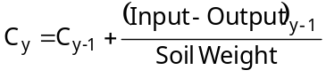
Where: C_{y} (mg/kg) = lead concentration in soil in year y (in mg/kg)
Soil weight (ton/ha) = depth of mixing zone (0.2 m) x soil density (1.7 ton/m³) x 10.000 Input (g/ha.y) = the yearly input of lead from use of fertilisers, manure, … (in g/ha.y)
Output₁ (g/ha.y) = Leaching + removal through crops
Output_{y} (g/ha.y) = [(Output_{y-1} – removal through crops) x (C_{y}/C_{y-1})] + removal through
crops
Different calculations were performed, based on different input and output data:
- Scenario 1: based on abovementioned model
- Scenario 2: an alternative of the abovementioned model where all input and output data were recalculated to g Pb per ha per year, based on the ratio of total input and output and the total amount of utilised agricultural area on a regional scale, so leaching was not estimated based on K_{d}-value
- Scenario 3: total load changes (input – output) per ha are available for several animal farms and crop farms across the European countries from literature study were given.

Scenario 1
Concentrations in agricultural soil are calculated based on the abovementioned formula. The yearly input and the removal through crops per ha are estimated based on the total input, the total removal through crops (calculated in previous sections, Table 3.6.65) and the total amount of agricultural area in the Netherlands. The used input data in g/ha/year are given in Table 3.6.65.
Table 3.6.65: Input and output of Pb (in tons and in kg/ha) into agricultural soil on a regional scale
Source | Scenario 1 | Scenario 2
Total input to agricultural soil (tons Pb) | 73.55 (= 50.52 + 18.2 + 4.8)
Total output from agricultural soil (tons Pb)
Removal through crops (tons Pb) | 22.84
Leaching (tons Pb) | 51.92
Total utilised agricultural area (1000 ha) | 1933
Input to agricultural soil (g Pb/ha) | 38.05
Output from agricultural soil (g Pb/ha) | 20.26 | 38.68
Removal through crops (g Pb/ha) | 11.82 | 11.82
Leaching (g Pb/ha) | 8.44 | 26.86
(1) this is the leaching calculated for the first year, leaching will increase yearly with the Pb-concentration in the soil.

Leaching however is in scenario 1 not calculated based on total leaching but based on the following formula:
Leaching (g/ha.y)= 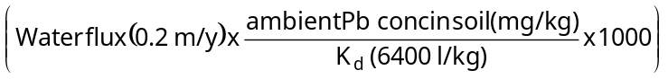
Using this model, an added lead concentration of about 0.5 mg Pb/kg after 100 years can be calculated. This shows an almost steady-state situation for Pb-concentrations in soil.

Scenario 2
Instead of calculating leaching based on the abovementioned formula, leaching was estimated here also based on the total leaching on a regional scale, divided by the total regional agricultural area of 1933 x 10³ ha. The result is more or less the same as in scenario 1. Lead concentrations increase with about 0.3 mg Pb/kg soil after 100 years and again a steady-state situation occurs.

Scenario 3
For the third scenario, literature data were used to estimate lead accumulation in other European agricultural soils.
Römkens (2004) shows some interesting data on the results of heavy metals balances (load change) in animal (21) and crop (15) farms from EU countries. For animal farms, load changes range from -153.1 g/ha.year (output is larger than input) to 1611 g/ha.year, with an average load change of 191.9 g/ha.year. For crop farms, load changes range from -62.8 g/ha.year (output is larger than input) to 13923.1 g/ha.year, with an average load change of 79.97 g/ha.year. These data show that the load change can differ significantly from one farm to the other. Negative load changes can be related either to high leaching losses in combination with low input systems. Even for different farms within one country, the data show that large differences can be found. These data show that a Pb-accumulation in agricultural soil can occur.

[F] Conclusion
The methodology used by Delahaye et al. (2003) is based on a very detailed diagram of input and output data. The quality of these data are assessed as being very high since:
- the Delahaye et al. (2003) report was specifically written to update the Dutch emission inventory and we can assume that the aim of such updates is to improve the emission inventory;
- the report contains the most recent data available at this moment.
Therefore these data are used in the current lead emission inventory (except for hunting data which are taken from the “targeted risk assessment for lead in ammunition”) and for the moment, leaching data from Bonten and Römkens (2004) are only mentioned here informatively. Leaching is estimated with the EUSES model based on a total net input to agricultural soil.

3.7 Road traffic

Exhaust fumes

Methodology used in the Netherlands (Klein et al., 2004)
Source outlining: exhaust fumes from the combustion of fuel and motor oil in road traffic vehicles
Methodology: collective estimation per type of vehicle "c" (passenger car, bus, truck, …) and type of road "r" (highway, densely populated areas, rural road)
Compartments: air
Description of methodology:
The methodologies used in the Netherlands to estimate road traffic emissions to be incorporated in the Dutch emission inventory are explained in detail in specific report, published in the “Milieumonitor” series. In this document this publication is referred to as “Klein et al., 2004”.
The estimation is based on following equation:
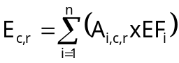
where E_{c} = emission (kg Pb/year) from vehicle type "c" and type of road "r"
A_{i} = consumption of fuel type "i" by category "c" and road type "r" (kg
fuel)
EF_{i} = emission factor for fuel type "i" (kg Pb/kg fuel)
Emissions of heavy metals due to exhaust fumes, are directly related to the fuel consumption and the type of fuel. Annual changes of the heavy metal content of fuel may arise from regulations and/or evolved refining methodologies.
Emission factors are determined, based on measurements of the lead content of the several fuel types (Table 3.7.66). Fuel consumption is related to vehicle type and fuel type and the estimation of the fuel consumption is based on the amount of kilometres travelled per year per vehicle. Allocation of fuel consumption to several road types is based on the total length of these specific roads.
Table 3.7.66: Content of lead in several fuel types and motor oil (Klein et al., 2004)
Fuel type | Lead content (mg/kg fuel)
Gasoline / unleaded gasoline | 0 ⁽¹⁾
Diesel oil | -
LPG | -
Motor oil | 0.0148
(1) The emission inventory still reports a very small emission from road traffic through exhaust fumes
because it is assumed that still traces of Pb are present in gasoline (TNO, personal communication, 2002)
It is assumed that all heavy metal emissions from exhaust fumes are emitted to the air. This assumption is based on measurements, performed by TNO in 1996 (Klein et al., 2004).

Conclusion
Since no targeted assessment was considered to be necessary, these data are taken over in the regional emission quantification.

Tire wear

Methodology used in the Netherlands (Klein et al., 2004)
Methodology: collective estimation per type of vehicle c (passenger car, bus, truck, …) and type of road r (highway, densely populated areas, rural road)
Compartments: air, water, soil
Description of methodology:
The estimation is based on following equation:
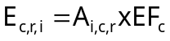
where,
E_{c,r,i} | = emission of dust from vehicle type c, road type r and fuel type i (kg/year)
A_{i,c,r} | = amount of kilometres travelled per vehicle type c, road type r and fuel type i (km)
EF_{c} | = emission factor for dust per vehicle type c (mg dust/km)
The EF of dust are based on a study performed by TNO in 1992. The lead content of the dust, emitted from tire wear, is considered to be 0.016%. No distinction is made between the lead content of fine dust and coarse dust.
Correction factor:
As shown by the equation, emission factors are expressed in mg of total dust per travelled km per vehicle for specific types of vehicles. The EF for tire wear is calculated based on total emissions of dust per tire and the number of tires per vehicle. To calculate the allocation of lead to the different environmental compartments, the following assumptions were made:
- the share of fine dust (PM-10) in total dust is 5%; the share of coarse dust in total dust is 95%;
- in densely populated areas it is considered that run-off to water or soil will enter the sewer system and will not be emitted to soil or surface water. After sewage treatment a part of these heavy metals can be emitted to surface water;
Table 3.7.67 shows the basic emission factors and the assumptions made to calculate the emissions of dust to air, water and soil.
Table 3.7.67: Overview of basic emission factors and assumptions made to calculate emissions due to tire, road and brake wear
Vehicle type | Area | EF tire wear (mg dust/km) | EF road wear (mg dust/km) | EF brake wear (mg dust/km) | Emission of coarse dust (%) |  | Emission of fine dust (%)
 |  |  |  |  | water | soil | air
Passenger cars | Built up | 92 | 145 | 8 | 100 | 0 | 100
Passenger cars | Rural road | 92 | 145 | 8 | 20 | 80 | 100
Passenger cars | Highway | 92 | 145 | 8 | 20 x 0.5 | 80 x 0.5 | 100
Motorcycle | Built up | 46 | 73 | 4 | 100 | 0 | 100
Motorcycle | Rural road | 46 | 73 | 4 | 20 | 80 | 100
Motorcycle | Highway | 46 | 73 | 4 | 20 x 0.5 | 80 x 0.5 | 100
Moped | Built up | 23 | 36 | 0 | 100 | 0 | 100
Moped | Rural road | 23 | 36 | 0 | 20 | 80 | 100
Delivery truck | Built up | 120 | 190 | 10 | 100 | 0 | 100
Delivery truck | Rural road | 120 | 190 | 10 | 20 | 80 | 100
Delivery truck | Highway | 120 | 190 | 10 | 20 x 0.5 | 80 x 0.5 | 100
(Articulated)  Truck | Built up | 495 | 783 | 43 | 100 | 0 | 100
(Articulated)  Truck | Rural road | 495 | 783 | 43 | 20 | 80 | 100
(Articulated)  Truck | Highway | 495 | 783 | 43 | 20 x 0.5 | 80 x 0.5 | 100
Bus | Built up | 360 | 569 | 31 | 100 | 0 | 100
Bus | Rural road | 360 | 569 | 31 | 20 | 80 | 100
Bus | Highway | 360 | 569 | 31 | 20 x 0.5 | 80 x 0.5 | 100

Targeted assessment

[A] Methods used in other countries
Emissions from the wear of tyres are only reported by Belgium:
- Flemish Region: VROM (1992) in van der Most & Veldt (1992);
- Walloon & Brussels Capital Region: Berdowski (1996) in CUWVO (1999).
The methods, used to quantify emissions from tyre wear in Belgium, are based on Dutch publications. Considering that:
- van der Most & Veldt (1992) was used to estimate emissions for the Dutch emission inventory of 1992;
- Berdowski (1996) in CUWVO (1999) is used to estimate the emissions for the Dutch emission inventory of 1994/1995;
- we assume that the method, used to estimate the emissions for the Dutch emission inventory of 1999 (described in Klein et al., 2002) is more accurate.

[B] Baekken, T (1993) in Lindgren A. (1996)
In this study the wear of tyres is estimated to be 0.2 g/km per vehicle.
Quality assessment: D.

[C] Pagotto C. (1999)
In this study an overview is given of tyre wear rates for lead and the lead contents of tyres, based on international literature (Table 3.7.68).
Table 3.7.68: Overview of literature study on tyre wear rate and lead content of tyres (Pagotto, 1999)
Reference | Tyre wear rate (mg/vehicle.km) | Lead content of tyres (µg/g)
Brunner et.al. (1975) | 120 | -
Shaheen (1975) | - | 1110
Brinkmann (1985) | 80 | 900 - 1100
Sadiq et.al. (1989) | - | 2 - 519
Muschack (1990) | 120 | 1100
Hildeman et.al. (1991) | - | 160
Gabet (1991) | 60 | -
Baekken (1993) | 200 | -
Rogge et.al. (1993) | 24-360 | -
Wada and Miura (1996) | Highway light vehicle: 550  Highway heavy vehicle: 948  Road light vehicle: 275  Road heavy vehicle: 586 | -
Pereira (1997) | Light vehicle: 64  Heavy vehicle: 140 | -

Pereira (1997, in Pagotto (1999)) suggests that 95% of the particles from tyres are deposited and that 5% remains in suspension in the air. This confirms the assumption, made by TNO (1992). Pagotto (1999) bases her emission estimation on specific measurement campaigns for tyre wear and Pb concentration in tyres and not on the literature data given in Table 3.7.68). The following methodology was used to estimate lead emissions from tyre wear (Pagotto, 1999):
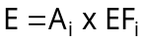
where
E | = total emission from wear of tyres (kg Pb/year);
A | = the total mileage from vehicles from category i (km);
EF | = emission factor per unit of mileage (mg Pb/km), where
 | EF | = BW x C (mg/km road), where
 |  | BW | = average tyre wear (mg Pb/vehicle km (Table 3.7.69));
 |  | C | = average lead concentration of tyres (7.2 µg Pb/g, based on measurements on two different tyre brands (Pagotto (1999))

Table 3.7.69 gives an overview of the average tyre wear for different vehicle categories. These data are based on specific measurements.
Table 3.7.69: Average tyre wear per vehicle type (µg/vehicle km) (Pagotto, 1999)
 | Passenger cars | Light duty | Heavy duty
Tyre wear (mg/veh.km) | 0.5 | 0.5 | 1
Quality assessment: B

[D] Davis et.al. (2001)
Results were obtained from four different brands of automobile tyres. Lead concentration in tire dust was analysed by means of atomic absorption spectrophotometry (detection limit lead: 1 µg/l). The mean lead levels found were 17 µg Pb/g. In one tyre even a content of 65 µg Pb/g was detected. Sadiq et.al. (1989), cited in this study, gives an average lead content of 57 µg Pb/g, based on 29 tyre samples.
Quality assessment: A

[E] Blok (Revision in the framework of Zn-RAR)
In the framework of the European Zn Risk Assessment, BLIC studied in detail the average tyre wear per vehicle type (BLIC, pers. comm.). These new data were included in the calculation methodology formerly used by RIVM, the average Pb-concentration in tyre wear was taken over from Klein et al. (2003) since this was not reviewed by BLIC. The calculation is based on the following formula:
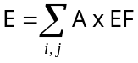
where
E = total emission from wear of tyres (kg Pb/year);
A_{i,j} = the total yearly mileage per type of vehicle i and road type j (km);
EF_{i,j} = emission factor per type of vehicle i and type of road j (mg Pb/km)
= tyre wear per vehicle type i and road type j x Pb concentration in wear (0.016%)
Table 3.7.70 gives an overview of the parameters used to calculate lead emission factors per vehicle type and road type.
Quality assessment: B.
Table 3.7.70: Emission factors for tyre wear suggested by BLIC (personal comm.)
Vehicle type v | Road type r | EF tyre wear (mg dust/km)
Passenger cars | Urban | 124
Passenger cars | Rural | 72
Passenger cars | Highway | 21
Motorcycle | Urban | 46
Motorcycle | Rural | 46
Motorcycle | Highway | 46
Moped | Urban | 23
Moped | Rural | 23
Delivery truck | Urban | 120
Delivery truck | Rural | 120
Delivery truck | Highway | 120
(Articulated)Truck | Urban | 1583.4
(Articulated)Truck | Rural | 590.3
(Articulated)Truck | Highway | 212
Bus | Urban | 863.7
Bus | Rural | 371.7
Bus | Highway | 115.6
Special vehicles | Urban | 92 - 495
Special vehicles | Rural | 92 - 495
Special vehicles | Highway | 92 - 495

Conclusion
The emission factor currently used in the Netherlands is based on an emission factor for dust and a lead speciation profile. The lead concentration in tyres, as described in international literature, varies from 2 µg Pb/g to 1100 µg Pb/g. The lead concentration used in the Dutch emission inventory (160 µg/g) lies within that range. Because of the fact that none of the literature source, cited in the targeted assessment are really conclusive, it is suggested to calculate the lead emissions from tyre wear according to BLIC revision of the wear rates and the lead concentration of 0.016% (Klein et al., 2004).

Road wear

Methodology used in the Netherlands (Klein et al., 2004)
For "road wear" the same methodology is used as for "tire wear". The EF for road wear is estimated as being 1.6 times the EF for tire wear. The lead content of dust (fine and coarse dust) from road wear is assumed to be 0.0015%. The EF of dust is based on measurement, performed by TNO in 1996.
Table 3.7.67 shows the basic emission factors and the assumptions made to calculate the emissions of dust to air, water and soil. These assumptions were made by experts within the task group 'Traffic and Transport' in the Netherlands. For road wear of highways one has to take into account the influence of "Very open textured asphalt concrete" (ZOAB), gripping a part of the dust emitted to soil or water. Due to cleaning of roads this part will not be emitted to water or soil. This is taken into account by the use of a correction factor of 0.5 for the emission of coarse dust to soil or water on highways.

Conclusion
Since no targeted assessment was considered to be necessary, these data are taken over in the regional emission quantification.

Brake wear

Methodology used in the Netherlands (Klein et al., 2004)
For "brake wear" the same methodology is used as for "tire wear" and “road wear". The lead content of dust (fine and coarse dust) from brake wear is assumed to be 0.005%. The EF were taken from national and foreign literature.
Table 3.7.67 shows the emission factors and the assumptions made to calculate the emissions of dust to air, water and soil. These assumptions were made by experts within the task group 'Traffic and Transport' in the Netherlands. Since it is assumed that only fine dust (PM-10) is emitted from brake wear, heavy metals will only be emitted to the air.

Conclusion
Since no targeted assessment was considered to be necessary, these data are taken over in the regional emission quantification.

Motor oil leakage

Methodology used in the Netherlands (Klein et al., 2004)
Methodology: collective estimation for all vehicles
Compartments: water, soil
Description of methodology:
The estimation is based on following equation:
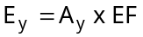
where, E_{y} = total emission from “motor oil leakage” (in kg oil/year)
A_{y} = number of kilometres travelled by all vehicles in year y (km)
EF = emission factor for motor oil leakage (10 mg oil/km, Klein et al. (2002))
The average motor oil leakage per vehicle and per kilometre is based on a single calculation of the total motor oil leakage and the total amount of kilometres travelled in one particular year in the Netherlands.
Correction factor:
- Lead content of motor oil is assumed to be 0.0148 mg Pb/kg oil
- From total emissions for all vehicle types, emissions, due to specific vehicle types, specific road types and fuel types, are estimated. This estimation is based on the amount of travelled kilometres per vehicle, road and fuel type.

Balance weights in vehicles

Methodology used in the Netherlands
Emissions from the corrosion of Pb-containing balance weights in vehicles is not included in the emission inventory.

Targeted assessment
A German report (Hillenbrand et al. , 2005) estimates the emissions to water and soil from the corrosion of balance weights (containing Pb) in vehicles. In the past, the vast majority of balance weights contained lead. If the balance weights were lost and then pulverised by traffic and distributed as fine lead dust, these quantities of lead could end up in the environment. In addition, lead emissions occurred due to the surface corrosion of the balance weights. According to the standards set by the Directive 2000/53/EC of the European Parliament and the Council on end-of-life vehicles, this use of lead will be phased out in the future. Calculating the emissions is done by using an average number of balance weights for the various types of vehicle, an estimation of the share of lost weights and the corrosion rate.

Loss of wheel weights
It is assumed that for 1% of the vehicles, replacing their tyres, the weights on one of the four wheels are lost. For trucks, replacing the 2 front tyres, it is also assumed that 1 of the 2 weights is lost. The average weight of balance weights is 163 g for passenger cars and 367 g for trucks.
Taking into account the number of new tyres per year in Germany for passenger cars (4 per car) and trucks (2 per truck) of 55.3 and 1.4 million respectively and the loss rate of 1% of one tyre new tyres per year for cars and trucks, the emission from loss of balance weights in Germany is estimated to be 5.65 tons Pb for cars and 1.32 tons Pb for trucks. Emission factors per vehicle in use are then calculated as the ratio between the total emission for cars and trucks and the amount of cars and trucks in use in Germany, giving emission factors of 107.2 mg/car.year and 286.3 mg/truck.year. Based on these emission factors for cars and trucks, EF for other types of vehicles are estimated based on the amount of tyres (e.g. EF for motor bikes half of the EF for passenger cars since motor bikes only have 2 tyres).

Corrosion of wheel weights
Next to the loss also a corrosion rate is considered of 7.3 g/m²/year. The surface area of balance weights is assumed to be 30 cm² for passenger cars and 83 cm² for trucks. Based on this information, EF of 21.9 mg/year for cars and 60.59 mg/year for trucks are calculated. Again EF for other types of vehicles are estimated based on the amount of tyres (e.g. EF for motor bikes half of the EF for passenger cars since motor bikes only have 2 tyres).

Total emissions for Germany
The combination of number of vehicles in use in Germany with the respective EF results in total emissions in Germany from loss and corrosion of wheel weights of 7.28 and 1.50 tons Pb respectively.

Total emissions for The Netherlands (selected region)
The emissions for the selected region (The Netherlands) are calculated from the German data, based on the ration of the amount of vehicles in use in Germany and The Netherlands (ACEA, 2000). The ratio of the amount of vehicles in use in Germany (47.1 million) and in The Netherlands (7.5 million) is 6.3. It is assumed that this ratio is representative for all type of vehicles (trucks, mopeds, busses, …). This results in a total emission of 1.39 tons Pb from loss and corrosion of lead weights in The Netherlands.
In Hillenbrand et al (2005), 87% of these emissions are allocated to the soil and 13% to the surface water. This distribution factor is taken over in the underlying document.

Conclusion
Based on the above mentioned estimations, an emission of Pb from the loss and corrosion of Pb-containing balance weights for The Netherlands can be estimated at 1.2 tons to soil and 0.2 tons to water.

3.8 Navigation

Exhaust fumes

Methodology used in the Netherlands (Klein et al., 2004)
Methodology: collective estimation per type of navigation (on oceans, recreational (boats), ships at
berth)
Compartments: air, water
Description of methodology:
The estimation is based on following equation:
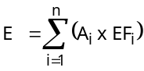
where E = emission from navigation (in kg Pb/year)
A_{i} = consumption per fuel type i kg fuel)
EF_{i} = emission factor for fuel type i (kg Pb/kg fuel, Table 3.8.71)
As already mentioned, emissions of heavy metals due to exhaust fumes, are directly related to the fuel consumption and type of fuel. As a result, emission factors are determined, based on measurements of the lead content of the several fuel types.
Table 3.8.71: Content of lead in several fuel types (TNO, personal communication, 2002)
Type of navigation | Fuel type | Lead content (mg/l fuel)⁽¹⁾
Marine navigation | - | 0.01
Ships at berth | - | 0.01
Navigation on inland waterways | Diesel oil | -
Boats | Gasoline | 0.01
Boats | Diesel oil | -
(1) although under regulation, traces of Pb will still be present in the fuel
Fuel consumption is related to the source category and fuel type. Fuel consumption, by several types of navigation, is estimated as follows:
- Ships - navigation on inland waterways: a combination of the amount of kilometres navigated on inland waterways and a rough estimation of a consumption of 10 kg of gasoil per kilometre. A distinction is made between 'navigation' and 'push towing'.
- Ships - marine navigation: estimated based on the intensity of ship movements. It is assumed that 70% of the fuel used by ships is heavy fuel oil, while 30% is light fuel oil. Emissions due to marine navigation in harbours is based on a study on the air quality in the harbour of Rotterdam, performed by TNO in 1996.
- Ships at berth: fuel consumption of the enterprise providing energy to ships at berth was calculated based on a standard consumption per visit. It is assumed that 50% of the used fuel is light fuel oil and 50% is heavy fuel oil. After 1994, fuel consumption was adjusted based on the amount of transhipments and storage in the harbour.
- Boats: based on the inventarisation of the number of pleasure crafts and some assumptions concerning the fuel consumption per hour for several types of craft (Table 3.8.72).
Correction factor:
For ships, emissions are entirely allocated to the air compartment.
For boats it is assumed that a percentage of total emissions of heavy metals due to exhaust fumes will be emitted to the surface water directly:
- diesel-powered boats: 5%;
- gasoline-powered boats: 75%.

Table 3.8.72: Fuel consumption per type of craft (Dutch Research institute for Recreation and Tourism, 1988 in Klein et al., 2004).
Type of craft | Fuel consumption (litre/year)
Cabin sailboat with gasoline engine | 10
Cabin sailboat with diesel oil engine | 80
Cabin motorboat with gasoline engine | 45
Cabin motorboat with diesel oil engine | 390
Open motorboat with gasoline engine | 60
Open motorboat with diesel oil engine | 120

Propeller shaft grease

Methodology used in the Netherlands
Methodology: collective estimation for all boats
Compartments: water
Description of methodology:
The estimation is based on following equation:
where | E = | Total emission (kg Pb/year)
 | A = | Number of active boats on Dutch inland waterways per year (4577 boats in 2000)
 | EF = | Emission factor for Pb in year y (1.28 kg Pb/boat)
In the Dutch emission inventory it is assumed that a boat with a greased sterntube gland, uses about 152.2 kg grease per year. About 40% of that grease will leave the stern tube at the site of the machine room were the grease can be collected and removed. About 60% of the used grease will be emitted in the surface water, meaning about 91.3 kg grease per boat per year. The Pb-content of the grease is about 1.7 % (weight). As a result an emission factor of 1.6 kg Pb per boat with greased sterntube gland can be used. In 1994 about 5792 boats (with or without greased sterntube gland) were active in the Netherlands. For the emission inventory an emission factor of 1.28 kg per boat per year was calculated in order to avoid the knowledge of the amount of boats with greased sterntube gland. Based on a total amount of boats of about 4577 in 1999 in the Netherlands, a total emission of about 6 tons of Pb was calculated.
Correction factor: /
Since the lead is directly emitted to the surface water, no correction factor is used.

Targeted assessment
A targeted assessment was performed aiming at the verification of the Pb-content of the propeller shaft grease as well as the total use of Pb-containing propeller shaft grease. Several producers of propeller shaft and grease as well as relevant institutions were contacted: Jooren Propellers, IVAM (Research and Consultancy on Sustainability Section Chemical Risks), Kramer Scheepsschroeven, Bakker Ijlst, TotalfinaElf. No quantitative information is available on the consumption nor on the content of propeller shaft greases.

[A] The LLINCWA-project (2001)
In this framework the “Lubrication in Inland and Coastal Water Activities (LLINCWA)”-project is important. This project is focussed on prevention and diminishing pollution of the environmental compartment with the highest hazard potential, surface water. LLINCWA is a technology transfer project sponsored by the European DG Enterprise within the framework of the EU 5th innovation framework programme. The general objectives of the LLINCWA project are: reduction of diffuse water pollution with lubricants and greases, increased use of non-toxic biodegradable lubricants, and protection of sweet water reserves. To achieve these goals important changes in the lubricant market have to be initiated. The following substitution oriented objectives are formulated. Increase of the number of users to add to the critical mass needed for market acceptance of bio-lubricants, stimulation of self-organising and self-regulating processes on the lubricant market and increasing the transparency of the lubricant market and environmental methodologies. To ensure co-operation throughout the whole working field an advice group has been established in each LLINCWA member country, consisting of e.g. representatives of national and local governments, lubricant supplier and shipping organisations, and water quality management organisations. An instrument to judge the environmental compatibility of lubricants has been developed. On the non-technical side the market structure, decision making structures, important actors and their interrelations, and business economical aspects has been identified.
Educated guesses estimate a total yearly use of 5 million tons of lubricants in all applications: land and water in Europe. Suppliers do not distinguish between land and aquatic use, which makes it impossible to make a clear estimation of the yearly lubricants use in the aquatic area. Around 45% of these lubricants is being spilled somewhere in the environment: deliberately or accidentally, showing the enormous need to stimulate the use of biodegradable, non-toxic lubricants. In the water-connected areas only an extreme minority of the actually used lubricants can be identified as biolubricants, a use of generally lower that 1-5% even after the 3 years of LLINCWA activities. As a consequence inland and coastal water activities remain responsible for an enormous aquatic pollution with mineral oils and their additives. Measurements show a total load on mineral oil of 1032 tons/year (1997) entering the Netherlands as pollution in Rhine water, on a total pollutant load of more than 5.000 tons/year. This means a load of more than 20% due to mineral oil originating from all sources fuels, machine oils, spills from metal working fluids, lubricants etc. Added to this are emissions in the Netherlands itself. A calculation of the actual spill caused by inland shipping in the Netherlands shows a significant contribution to the total mineral oil load. (Loss) lubrication of the screw axe and rudder system of the Dutch inland fleet does contribute annually around 300 ton to the actual aquatic pollution with mineral oils. In the past the total oil spill of the inland fleet was considerably larger. With the separate collection of bilge water a strong reduction could be realised. The recreational sailing activities in the Netherlands, with their screw axes and still a high amount of 2-stroke outboard engines, yearly contribute a significant amount of 83 tons mineral oils, mainly emitted in the more environmentally sensitive areas. As a general statement one can say that the additives used determine the toxicity of (bio)lubricants, while the base fluids determine the biodegradability. The main environmental problems with mineral oil used in lubricants are highlighted in its physical effect of staining essential organs and its low biodegradation (both aerobic and anaerobic). According to the EU criteria its acute aquatic toxicity is too low to classify many mineral oil distillates as hazardous for the (aquatic) environment. In contrast to mineral oil lubricants biolubricants, like vegetable oils, synthetic esters and some polyglycols show ready biodegradability under aerobic as well as anaerobic conditions. The toxicity of the oils and esters is low. Due to their ready biodegradability staining effects due to biolubricants are not likely to occur and long-term effects can be ruled out.
It can be concluded that biolubricants are not generally used and still need to broaden their market. No information on the specific Pb-content of greases could be found.

[B] Appelman et al., 2005
A recent publication on emissions from the use of propeller shaft grease in inland navigation in the Netherlands (Appelman et al., 2005) shows however that since 1997 no Pb from the use of propeller shaft grease is emitted in fresh waters in the Netherlands. This statement is based on the following:
- There are 3 types of sealings for propeller shafts in use: research (Ministerie van V&W DGG, personal communication in Appelman et al., 2005) shows that since 1996 less traditional grease based propeller shaft sealings are used in favour of oil and water based systems;
- Since a part of the grease will be emitted to the surface water, grease suppliers are trying to reduce the content of harmful substances in their greases. That’s how Pb is nearly totally disappeared from the grease and also a number of biological degradable products are put on the market;
- More and more water- and oil based systems are installed in new boats (ships), while in old boats (ships), grease based systems are being replaced by water and oil based systems:
- Oil based systems tend to provide a better sealing and they loose hardly any oil in the water;
- Water based systems are ecologically sound; only a small amount of the water will leak out of the system. This water can contain corrosion inhibitors and glycols, but only in very small amounts.
- Propeller shaft grease contains about 80% of mineral oil.
Emissions from the use of propeller shaft grease are in Appelman et al. (2005) estimated based on following formula:
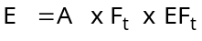
where | E = | Total emission of lead from the use of propeller shaft sealing oils and/or greases, (kg Pb/year)
 | A = | Travel intensity on Dutch waters (in million ton km/year)
 | F_{t} = | Implementation of use of grease/oil of type t (%)
 | EF = | emission factor for type t (kg/million ton km)

For deriving the emission factor per type of used grease/oil following facts are taken into account:
- Grease is composed mainly from mineral oil (80%); the remaining 20% consists of additives and soaps;
- The two major suppliers state that no Pb is used anymore in their grease; one supplier states to use Pb in one batch of grease for car motors;
As a result, Pb emissions will be insignificant compared to the estimations in the current emission inventory (Emissieregistratie Nederland, emissies 1999). Lead is replaced mainly (probably before 1996) by zinc (naphtenate) and other components. No metals are used, except for lithium for example, as a thickener in the soap component of the grease.
To link the emission factor for grease with the travel intensity on Dutch inland waters, data of the collection of waste grease from inland navigation is used (123 tons in 2001 (SAB, 2001 in Appelmans et al., 2005). Since not all these grease originates from propeller shaft and next to open propeller shaft grease systems, also closed systems are used, it is estimated (Weekhout, 1997 in Appelmans et al., 2005) that 35% of the propeller shaft grease is emitted in the surface water (in previous calculations 60% was assumed, Emissieregistratie, emissies 1999).
For Pb, an emission factor of 0.20 kg Pb/million ton km is used for 1985, decreasing to 0.12 kg Pb/million ton km in 1996 and 0 kg Pb/million ton km since 1997. As a result, no emission of Pb occur from the use of propeller shaft grease.

Conclusion
Since it is the aim of the “Appelmans et al. study” (2005) to optimise the current Dutch emission inventory, this publication is assessed as being more reliable than the method proposed in the current Dutch emission inventory (Emissieregistratie, emissies 1999, cf. section ), Therefore a zero emission of Pb from the use of propeller shaft grease is taken over in the current regional emission inventory.

3.9 Rail transport

Wear of collector shoes

Methodology used in the Netherlands (Klein et al., 2004)
Methodology: collective estimation for all collector shoes
Compartments: air, water, soil
Description of methodology:
The emission estimation is based on following equation:
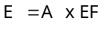
where | E = | Total emission per rail transport type (kg dust/year)
 | A = | Consumption of electricity per transport type (train, subway/trolley) (in Kwh/year)
 | EF = | emission factor (10 mg dust/kWh)
The emission factor was deduced from data, published in a Dutch technical study report on the wear of collector shoes and overhead wires in 1992, the use of electricity by trains in that year and the lead content of collector shoes and overhead wires.
Correction factors:
- for air: 0.2 (share of fine dust in total dust is 20%, which remains airborne);
- for water: 0.05;
- for soil: 0.65;
- another 10% of the dust will not reach the environment but will attach to the train surface and will be cached by the washing system;
- the collector shoe contains 10% of lead.

Conclusion
Since no targeted assessment was considered to be necessary, based on the critical evaluation of the data, these data are taken over in the regional emission quantification.

3.10 Aviation

Methodology used in the Netherlands
Methodology: collective estimation of emissions from several types of aeroplanes.
Compartments: air
Methodology description:
The Dutch inventory system includes emission estimations for the following sources:
- Aeroplane emissions during landing and take-off cycles;
- Emissions from the use of Auxiliary Power Units and General Power Units (APU/GPU);
Landing and take-off cycle (LTO cycle)
Emissions are estimated by using the EMASA-model. This model is derived from the generally used methodology of the EPA. The model is based on following assumptions:
- a LTO-cycle can be separated into 4 different phases: idle, take-off, climb-out to 3000 foot and approach from 3000 foot. Emissions taking place above 3000 foot are not taken into account;
- fuel consumption is related to the power settings within these specific phases, the type of engine and the duration of each phase.
The emission factors for dust are determined in the framework of the certification of planes, with a propulsion above 30 kN. In the calculation for Schiphol airport, about 100 types of aeroplanes are taken into account. For other airports in the Netherlands the same methodology was used until 1994. For following years the emission data are adjusted based on the specific number of movements per airport per year. Emissions from military airports are roughly estimated based on the number of squadrons present at the airport and the linked number of aeroplanes and helicopters, assuming an average number of movements per plane.
Auxiliary Power Units and General Power Units
The emission estimation is based on following equation:
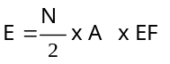
where E= Total emission (kg Pb/year)
N= Number of passengers per year
A = Fuel consumption for power generation (~500 g fuel/passenger)
EF = emission factor (0.0104 mg Pb/kg fuel (Klein et al., 2002))
Emission factors are determined, based on measurements of the lead content of the diesel. Emissions due to platform traffic are not considered, since it was already included in the source category "mobile machinery".

Conclusion
Since no targeted assessment was considered to be necessary, based on the critical evaluation of the data, these data are taken over in the regional emission quantification.

3.11 Miscellaneous
The use of Pb-containing ammunition

Methodology used in the Netherlands

Hunting
Methodology: collective estimation per year
Compartments: water
Description of methodology:
The estimation is based on following equation:
Where E_{y} = Total emission of Pb (kg Pb/year)
A_{y} = The amount of used shot cartridges
EF = Total emission factor for Pb (6.86 g Pb/cartridge (CUWVO, 1999))
Determination of EF:
A Dutch study (Van Bon en Boersema) estimated the emission of lead from the use of lead shot cartridges to be 230 tons/year. In 1993, a ban of the use of lead shot for hunting activities was introduced. Based on import data en expert judgement (RIVM) the number of used lead shot cartridges in 1995 was estimated at about 1.5 million cartridges. This amount corresponds with 48 tons of lead. As an alternative for lead cartridges, also zinc, iron and bismuth were used. The yearly total amount of cartridges, used for hunting in the Netherlands, is estimated at 7 million cartridges. Based on these data, for 1995 an emission factor of 0.00686 kg Pb/cartridge was calculated (= 48 tons of Pb/7x10⁶ cartridges).
In 1999 a study was performed on the emission of lead from the use of cartridges (De Straat, 1999 in CUWVO, 1999). In this report, a emission of total metals of 190 tons was estimated for 1997, of which 20% was emission of lead (= 38 tons). In order to estimate the Pb emissions from use of lead shot in 1998, is was supposed that the amount of Pb used in cartridges still decreases but that this decrease levels off. For 1998 - 1999 - 2000 and 2001 therefore an emission of 36 tons of lead was estimated.
Correction factor :
- emissions to soil: 0.85 (estimation made by Bon en Boersema, 1988 in CUWVO, 1999)
- emissions to water: 0.15 (directly emitted to the surface water, estimation made by Bon en Boersema, 1988). It must be noted that the Pb is emitted in solid form. It is assumed that about 1% op the Pb will dissolute each year.

shooting as a sport or recreative activity
Methodology: collective estimation per year
Compartments: soil
Description of methodology:
The Dutch inventory system includes emission estimations for the following sources:
- folkloristic shooting
- clay pigeon shooting
For folkloristic shooting emission data are based on a questionnaire, held in 1988, showing an emission of 14 tons of Pb to the soil. Since 1999, emission estimations take into account the obliged use of butts. For the year 1999 an emission of 8 tons is assumed.
For clay pigeon shooting emission data are based on the number of shot cartridges used and the Pb-content of this ammunition in 1996. These data were derived from a questionnaire, held among 21 firing ranges in the Netherlands. It is assumed that the popularity of clay pigeon shooting did not decrease over the last years. As a consequence, emission data are held constant.
Correction factor: /

Targeted assessment
The Review Panel recommended that uncertainties and assumptions on Pb shot/ammunition emissions and corrosion rates are further examined and analysed through a focused literature review and possible dedicated research in order to reduce uncertainties associated with the present calculation in the Dutch emission inventory (VROM, 2002). Therefore, a targeted risk assessment study on lead in ammunition was performed (Appendix A, Verdonck et al., 2005). This targeted risk assessment aimed at a more accurate estimation of Pb-emissions on a regional and continental scale from the use of Pb in ammunition. The activities using ammunition, included in the regional assessment are:
- Hunting (over dry land and over wetlands);
- Clay target shooting (used here as umbrella term for trap and skeet shooting and sporting clays).
Based on country-specific consumption data and agricultural area, total yearly regional lead emissions were calculated based on three scenario’s: (1) based on consumption data and Pb-content per type of ammunition; (2) as 10% of total EU-15 emissions; (3) based on an emission factor per unit of agricultural area. These emission factors were calculated as an average EF, based on country-specific consumption data and country specific agricultural area for each EU-15 Member State. Although, emissions from the use of Pb-containing ammunition are not categorised within the source category ‘Agriculture’ due to the fact that it is not really an agricultural activity, most of the hunting activities take place within agricultural area.
Total emissions for the selected region (The Netherlands) were estimated in the “Targeted risk assessment on lead in ammunition” (Annex A, Verdonck et al., 2007). The emissions were based on:
- Total consumption of lead containing ammunition for hunting and clay pigeon shooting in The Netherlands;
- A corrosion rate of 1% per year;
- Current emissions of historic use.
Details on the methodology can be found in the full report (Annex A, Verdonck et al., 2007). The calculated emissions per year, taking into account a cumulative corrosion of 1% per year, are then after 100 years (including current emissions from historical use of Pb in ammunition): 26,678 kg Pb to surface water and 365,848 kg to soil.

Sources related to the sewage system
Sewage system related emissions from e.g. storm water overflow, separate sewage systems and systems not connected to a STP can contain emissions originating from several sources (households, road run-off, agriculture, industry, …). Therefore these sources cannot be attributed to one of the previous emission categories and are categorised within the miscellaneous sources.

Methodology used in the Netherlands
Methodology: collective estimation
Compartments: water
Methodology:
The several sources quantified here can be distinguished in:
- Storm water overflow (SWO): includes overflow of mixed sewage systems, being wastewater and rainwater, entering the sewage system. In case of overflow, untreated wastewater can reach the surface water in times of heavy rainfall. Since this source assembles emissions from several target groups (households, industry, …) it is categorised under "Miscellaneous sources". Furthermore it should be noted that it is no primary source of lead.
- Separate sewage systems (sSS): this source represents direct emissions of rainwater to the surface water. Since this is a secondary emission, resulting from primary emissions such as run-off from roads and paved areas, corrosion processes and street dirt, this source is categorised under "Miscellaneous sources".
- Sewage systems (SS) not entering an STP: this kind of emission does not occur in the Netherlands
Calculations of these emissions are performed with the model "PROMISE". This model contains emission factors and calculation rules in order to determine the emissions. Deposition is not included in this source.

Targeted assessment
The emissions from SWO, sSS and SS not connected to an STP are estimated in the Dutch emission inventory based on the total load of indirect emissions from all kinds of sources. Emissions from the abovementioned sources are the result of:
- emissions from sources, of which a part will be enter the sewage system, e.g. discharge of wastewater, urban road traffic, …;
- rainfall dependent emissions, e.g. lead sheet corrosion, run-off from roads, …
The Dutch emission inventory reports for all years within the period 1990-2002, an emission of 27000 kg from SWO, sSS and not connected SS. Two sources are very important in the determination of this 27 tons: emissions from lead sheet and emissions from traffic. Since emissions from lead sheet were revised in the current report and emissions from traffic decreased during the past decade, also the indirect emissions from these sources through SWO, sSS and not connected SS were revised. The difference between emissions at the source from lead sheet and traffic, reported in 1990, and in the current report is given in Table 3.11.73.
Table 3.11.73: The difference of emissions at the source from lead sheet and traffic in 1990 and in the current report
Source | 1990 Dutch emission inventory | Current report | Share of emissions in current report to 1990 Dutch emission inventory
Traffic | 9708 | 7330
Lead sheet corrosion | 68362 | 13873
Total | 78070 | 21203 | 27 %

The data in Table 3.11.73 show that the total emissions from two important sources (corrosion of lead sheet and traffic) were estimated significantly lower in the current report than in the emission inventory of the Netherlands in 1990. Since the emissions from SWO, sSS and SS not connected to an STP were kept constant in the Dutch emission inventory since 1990 but these emissions are directly related to the total direct emissions from these sources, which decreased to 27% of the direct emissions in 1990, the emissions from SWO, sSS and not connected SS were adjusted accordingly. It must be noted that the total lead input to STP’s in 1999 accounted for 58% of the total input in 1990 (CBS, 2004). Since emissions from SWO are being limited in the Netherlands during that period, it is assumed that they decreased to 27% of the emissions in 1990.
This is only an estimation based on changes in direct emissions. If we look at the total inflow of Pb to STP’s, this input is in 1999 decreased to 58% of the emissions in 1990. On the other hand, it must be kept in mind that the overflow rate as such is decreased over the past years (Hulskotte J. (TNO Netherlands), personal communication, 2004) which will be responsible for lowering the emissions from overflow and separate sewage systems. Therefore the decrease with only 58% will probably be an underestimation, and a decrease with 27% is used in the underlying report.

Conclusion
Based on the targeted assessment, and especially based on the data in Table 3.11.73, the emissions from SWO, sSS and SS not connected to an STP of 27000 kg were corrected to 7290 kg, being 27% of 27000 kg.

Selection of methodology to quantify total EU-15 emissions

4.1 Introduction
Total emissions on a EU-15 scale were quantified. The EU-15 scale covers all current EU Member States: Austria, Belgium, Denmark, Finland, France, Germany, Greece, Ireland, Italy, Luxembourg, Portugal, Spain, Sweden, the Netherlands and the UK. The EU-15 emissions will be used to calculate continental emissions. The latter were used in the EUSES-model as a background for the regional exposure assessment (carried out by Euras) as described in chapter 1 of this report.
Initially, total EU-15 emissions could be quantified as the sum of the lead emissions of all EU-15 countries, as reported through the sent-out questionnaires. Due to lack of detailed and homogeneous emission data from all 15 EU-countries it is rather difficult -in most cases impossible- to calculate the total EU-15 emissions by summarising the country-specific emission data for each emission source. As an alternative, other appropriate methodologies to estimate EU-15 emissions have to be selected. This selection is based on the decision-tree shown in Figure 1.3.30. As shown in Figure 1.3.30, if the region is representative for the EU-15 for a specific source, the regional emissions are extrapolated to the total EU-15 emissions, based on an appropriate extrapolation factor, preferably the parameter used as the activity in the regional emission quantification method. For example, if emissions on a regional scale are estimated based on the total mileage in the Netherlands, the extrapolation factor will be the ratio between the total mileage in the EU-15 and the total mileage in the Netherlands. If the region is not representative for the EU-15, an alternative methodology is used. A general overview of the methodologies used to estimate total EU-15 emissions is given in Table 4.1.74.
The quantification methods used for estimating total EU-15 emissions are explained more in detail per source in the following sections. If the method is based on an extrapolation from regional emissions, only the extrapolation parameter and factor is given, else, the methodology is explained

Table 4.1.74: Overview of the methodologies to quantify total EU-15 lead emissions
Source | Methodology ⁽¹⁾ | Methodology description  (in case of T) | Extrapolation parameter  (in case of E) | Extrapolation factor  (in case of E)
Industry
- Process emissons | T | Extrapolation of emissions of 11 Member States to 15 MS | - | -
- Combustion processes | T | fuel consumption x emission factor | - | -
Households
- Residential heating | E | - | Number of inhabitants | 24
- Domestic wastewater | T | Water consumption (23,471x10⁶ m³ x Pb-concentration (24 µg Pb/l) x connection rate to STP (79%) | - | -
- Corrosion of lead sheet in buildings | T | Amount of lead sheet exposed x runoff rate and 5 g Pb/m² for roofs)  - for flashings: 217x10⁶ m² and 0.88 g Pb/m²  - for roofs: 22x10⁶ m² and 5 g Pb/m² | - | -
- Fishing in fresh waters  - recreational  - commercial fishing | E  T | -  Estimation based on questionnaire (COWI, 2004) | Number of anglers  - | 12.5
Waste management
- Sewage treatment plants | T | E = Vs / R x [100-R])  Vs = total Pb load in sewage sludge = 715 tons Pb  R = average Pb removal efficiency = 84% | - | -
- Landfills/waste incineration | T | Vangheluwe M. (background report on Waste stream analysis, 2005) | - | -
Agriculture
- Heating (greenhouses) | E | - | Livestock/Production of animal/crop farms | 10/13
- Mineral balance | T | Emission = total input – removal through crops | - | -
Traffic - road
Exhaust fumes/road, brake, tyre wear/leakage motoroil | E | - | - Passenger cars/busses: person km  - trucks: haulage on national territory | 25 / 32  27
Traffic – navigation
Exhaust fumes | E | - | - Inland waterways: transport equipment  - ships: port traffic  - boats: inhabitants | 3  4  24
Propeller shaft grease | E | - | inhabitants | 24
Traffic – air transport/rail transport
- air transport  - rail transport | E  E | -  - | - Movements of aircrafts  - total length of lines | 16  56
Miscellaneous sources
Use of Pb-containing ammunition  - hunting  - clay target shooting | T | Consumption of ammunition x Pb-content x corrosion rate | - | --
Stormwater overflow/separate sewage system | E | - | Number of inhabitants connected to STP | 20.8
(1) E=based on extrapolation from regional emissions; T = Based on a total EU-15 estimation

4.2 Industry
Emissions from industry depend on the size and the type of industrial activity. In order to justify the extrapolation from Dutch (regional) to EU (continental) releases, two important questions have to be answered:
- Which parameter can give an indication of the size of the industry and can be of practical use to extrapolate emission data?
- Is the pattern of the industrial activity in the Netherlands representative for Europe?

A parameter indicating the size of the industry

[1] Default TGD factor
The continental emissions can be calculated according to the default TGD equation:
Continental emission = 10 x regional emission - regional emission
In this equation it is assumed that regional emissions represent 10% of the total European emissions, with a general standard region represented by a typical densely populated area of 200x200 km² and 20 million inhabitants, located in the margin of Western Europe.

[2] Zinc Risk Assessment
In the Zn-RAR a factor of 22 is used to extrapolate the Dutch industrial emission data to the EU. This extrapolation factor of 22 is based on the ratio of Dutch inhabitants (16 million) versus EU inhabitants (350 million). The assumption is that there is a relation between the number of inhabitants and the industrial activities. The rapporteur is aware that this is an arbitrary choice, but the standard TGD factor of 10 is considered to be to low for zinc.

[3] Value of production in the industry
The extrapolation is based on the assumption that emissions from industry are related to the total production from industry. Total production from industry is expressed here in value of production. The value of production is defined as the value of the goods and services actually produced by the enterprises of a sector during the reference year (1999). It must be noted that the data used here and provided by Eurostat:
- only cover enterprises with 20 persons employed or more;
- are not corrected for price inflation;
- are not limited to the production value of industrial sectors of which emission data are reported in the Dutch emission inventory. The value of production (Eurostat, 2003a) refers to a production value for the industry as a whole (NACE codes D: manufacturing). As a consequence the extrapolation for Europe could be,
- overestimated if their market share is larger in the Netherlands, compared to the EU
- underestimated if their market share is smaller in the Netherlands, compared to the EU
Nevertheless, the total production value gives a general indication of the industrial activity in Europe compared to the industrial activity in the Netherlands. We assumed that emissions from industry are more related to the total industrial production than the number of inhabitants.
The value of production (Eurostat, 2003a) refers to a production value for the industry as a whole (NACE codes D: manufacturing). This parameter will be representative for the lead emitting industries if the production value of this subgroup covers a significant part of the total production value. Nevertheless, the total production value could give a better indication of the size of the industrial activity in Europe compared to the industrial activity in the Netherlands than the default TGD factor of 10 or the number of inhabitants. Using the value of production as an extrapolation factor, this factor can be estimated as follows:
Extrapolation factor: 23 (= 4 029 867 x 10⁶ for EU-15/177 748 x 10⁶ for the Netherlands (Eurostat, 2003a))

[4] Number of employees in domestic industry
Production values are not easily available for each individual EU-country. In order to have an idea of the country-specific industrial activity, the number of employees in domestic industry per country, which is available for all EU-15 countries, was chosen as an alternative. Table 4.2.75 shows that the ratio of the number of employees in the domestic industry correlates with the production value. This justifies the use of the number of employees in domestic industry instead of the production value for industry as in general indication of the size of industrial activity.
Table 4.2.75: Production value (Eurostat, 2003a) and number of employees in industry for EU-15 and the Netherlands
 | Production value for industry (10⁶ EURO) | Number of employees in domestic industry (x1000) | Correlation number of employees in domestic industry/production value
EU-15 | 4 029 867 | 250 676 | 62,5
The Netherlands | 177 748 | 10 740 | 60

It was proposed to use the number of employees in the domestic industrial sector in the EU as an extrapolation factor since:
- it is assume that the number of employees in the domestic industrial sector gives an indication of the size of the industrial activity and the corresponding emissions;
- this parameter is available on a country-specific level, which is important in the following step of the emission calculation.

Representativeness of the industry in the Netherlands
When using the Dutch emission data as a basis for extrapolation from regional to continental industrial emissions, it is assumed that the pattern of the industrial activity in the Netherlands is representative for the EU. The local risk assessment (Euras, personal communication, 2003) revealed that the primary and secondary lead production is much higher in a number of EU Member States (e.g. Belgium, UK, Germany) than in the Netherlands. Therefore the representativeness of the Netherlands can be questioned. Two scenarios are checked. The underlying figures are given in Table 4.2.76.

[1] Scenario 1: the industrial activity mix of the Netherlands is representative for the EU-15
It was assumed that the industrial emissions depend on the size of the industry and the mix of the industrial activities. This scenario assumes that the industrial activity mix in the Netherlands is representative for the EU-15. Under 2.1.1. it was shown that the size of the industry is correlated to the number of employees in the domestic industrial sector. Consequently, the extrapolation can be carried out, based on the ratio of the number of employees in the EU-15 and in the Netherlands, being 23 (250679/10740). Assuming an equal industrial mix in the Netherlands and in the EU-15, the emission pattern to air and water is assumed to be the same:
- total emissions to water in the EU-15: 23*4 767 = 109 634 tons;
- total emissions to air in the EU-15: 23*38 703 = 890 084 tons.

[2] Scenario 2: the industrial activity mix of the Netherlands is not representative for the EU-15
In this scenario, the aim is to define an area for which the mix of industrial activities is representative for the EU-15. It can be assumed that increasing the coverage of the EU-15 will fulfil this condition. This implies that the more countries of the EU-15 are taken into account, the more representative this area will be for the EU-15. Based on the available data, the area defined above will include all countries which have reported both their emissions to air and to water in the framework of this study.
Since it was assumed that the mix of industrial activities in the EU-reported area is representative for the EU-15, the extrapolation to the EU-15 only depends on the size of the total industrial activity. It was shown that the number of employees is representative for this parameter. Since the number of countries, which reported their emissions, differs extremely for emissions to air and to water, an extrapolation factor is calculated separately, being 1.28 (250 679/195 137) for air emissions and 1.64 (250679/153050) for water emissions:
- Air emissions in the EU-15: 1.28 x 550385 kg = 704493 kg;
- Water emissions in the EU-15: 1.60 x 109 286 kg = 174 858 kg.
Following scenario 2, total industrial emissions for the EU-15 region of 854 743 kg of Pb were estimated. Since the emissions of the EU-reported cover a larger part of the EU-15, we assume that these emissions are a more representative basis for extrapolation. Consequently, we propose to extrapolate the industrial emissions according to scenario 2.The disadvantage of this extrapolation method is that no split up between individual industrial sectors is possible due to the fact that most countries only report total industrial emissions.
Table 4.2.76: Country-specific emission data from the entire sector “industry” and extrapolation scenarios
Country | Emissions (kg/year) |  | Number of employees in domestic industry (x 1000)
 | Water | Air | Number of employees in domestic industry (x 1000)
Austria | NA | 5510 | 5471
Belgium | 7980 | 103699 | 6715
Denmark | 100 | 589 | 3557
Finland | 100 | 3500 | 3456
France | 49300 | 154600 | 38195
Germany | 22193 | 81000 ⁽¹⁾ | 55952
Greece | NA | NA | 7124
Ireland | NA | NA | 2494
Italy | NA | NA | 39028
Luxembourg | NA | 884 | 289
Portugal | NA | NA | 6896
Spain | NA | 68000 ⁽²⁾ | 27091
Sweden | NA | 2600 | 5679
The Netherlands | 4767 | 38 859 ⁽³⁾ | 10740
UK | 24 846 | 91144 | 37992
Total emissions for EU-reported | 109 286 | 550385 | 156 607 (water)/  195 137 (air)
Total emissions for EU-15, according to scenario 1 | 109 634 | 907012 | 250 679
Total emissions for EU-15, according to scenario 2 | 174 858 | 704493 | 250 679
(1) most recent air emission data of Germany are from the reference year 1995
(2) emission data reported to EMEP for 1999 were used here
(3) note that the sum ot total industrial emissions also includes emissions from oil refineries (160 kg) explicitly

[3] Iron and steel production
Table 2 in Annex shows that on a regional scale (the Netherlands), emissions from the production of iron and steel (Dutch nomenclature “manufacture of iron and steel and ferro-alloys (SBI 27) and manufacture of wires out of iron and steel (SBI 273)” represent 85% of total industrial emissions to air (32930 kg compared to total industrial air emissions of 38699 kg). In this part of the report an attempt was made to verify if this situation in the Netherlands is representative for the continental scale (EU-15 region). Therefore total emissions from the iron and steel sector for the theoretical EU-region were estimated based on a methodology, analogous to the method used in scenario 2 (cf. section ) for total industrial emissions. Therefore:
- The representativeness of emissions from the “iron and steel sector” was increased by increasing the coverage of the area (all data available on emissions from the “iron and steel sector” in different EU-15 countries were summed);
- The size of the industry in the EU-15 region was shown by using production data from the International Iron and Steel Institute (IISI, 2001)
Table 4.2.77: Country-specific emission data from the sector “iron and steel” and extrapolation scenario 3
Country | Emissions (kg/year) |  | Crude steel production in 1999 (IISI) in ktons
 | Water | Air
Austria | NA | NA | 5202
Belgium | 1 433 | 79 576 | 10931
Denmark | NA | 440 | 729
Finland | 135 | 7261 | 3956
France | 11000 | 28600 | 20200
Germany | NA | NA | 42062
Greece | NA | NA | 951
Ireland | NA | NA | 335
Italy | NA | NA | 24738
Luxembourg | NA | NA | 2 600
Portugal | NA | NA | 1044
Spain | NA | NA | 14882
Sweden | NA | 1387 | 5066
The Netherlands | 0 | 32 642 | 6075
UK | 3732 | 60000 | 16298
Total emissions for EU-reported | 16300 | 209906 | 57460 (water)/  63255 (air)
Total emissions for EU-15, according to scenario 3 | 44010 | 514270 | 155,069

Based on the data in Table 4.2.77, an extrapolation factor is calculated separately, being 2.7 (155069/63255) for water emissions and 2.45 (155069/57460) for air emissions:
- Air emissions in the EU-15: 2.454 x 209906 kg = 514270 kg;
- Water emissions in the EU-15: 2.7 x 16300 kg = 44010 kg.
Following this scenario, total emissions from the sector “iron and steel” for the EU-15 region of 558280 kg of Pb were estimated. Compared with total industrial emissions for the EU-15 of 879350 kg Pb (scenario 2), the share of emissions of the sector “iron and steel” in total industrial emission in the EU-15 is 64%.

4.3 Industrial combustion processes
As already indicated in chapter , especially the atypical allocation of energy sources for electricity production in The Netherlands and the EU-15 makes it difficult to simply extrapolate regional to continental emissions. The atypical allocation is twofold. On the one hand, the share of fossil fuel based power production is much higher in the Netherlands (91%) than in the EU-15 (50%). On the other hand, the input of solid fuels and oil for power production is about 32% of the total fuel input in the Netherlands, while in the EU-15 the input of solid fuels and oil is about 63.5% of the total fuel input for power production. As an alternative, as indicated on a regional scale, emissions from combustion processes can be estimated based on the fuel consumption in industry and representative emission factors for lead.
An overview of the total fossil fuel consumption for electricity production in the EU-15 is given in Table 4.3.78. Table 4.3.79 gives an overview of the total final energy consumption in industry.

Table 4.3.78: Overview of the fuel inputs for thermal electricity production in 2001 in The Netherlands and the EU-15 (European Commission, 2003)
 | Mtoe | % | in TJ (10¹² J) ⁽¹⁾ | in ktons ⁽¹⁾
Solid fuels | 157.45 | 52.7 | 6 592 116 | 412 007
Oil | 32.39 | 10.8 | 1 356 104 | 33 903
Gas | 91.46 | 30.6 | 3 829 247
Biomass and geothermal | 17.77 | 5.9 | 743 994
TOTAL | 299.07 |  | 12 521 462
(1) 1 toe = 1 ton of oil equivalent = 41868 MJ
(2) 1 ton heavy fuel oil = 40000 MJ; 1 ton hard coal = 24000 MJ; 1 ton brown coal = 8000 MJ

Table 4.3.79: Overview of the final energy consumption by industry in 2000 in the EU-15 (European Commission, 2003)
 | Consumption (Mtoe) ¹ | Consumption (kton)
Solid fuels | 32.527 | 51 488
Oil | 15.016 | 15 717
Gas (TJ) | 4 097 748
Biomass and geothermal | 15
(1) 1 toe = 1 ton of oil equivalent = 41868 MJ
The emission factors, used on a regional level were distracted from the EMEP/Corinair Emission inventory Guidebook (EEA, 2003), which can be assessed as being representative for the EU-15. Therefore the same emission factors as on a regional scale will be use. Combining these total fuel consumptions for Europe with the average emission factors per fuel type, brings us to a estimation of total Pb-emissions from combustion processes in industry of:
- For power production: 78.4 tons Pb
- For other combustion processes in industry: 24.2 tons Pb
- Total Pb-emissions: 102.6 tons Pb

4.4 Comparison of industry and industrial combustion processes with EPER
EPER is the European Pollutant Emission Register, which was established by a Commission Decision of 17 July 2000. The EPER Decision is based on Article 15(3) of Council Directive 96/61/EC concerning integrated pollution prevention and control.
According to the EPER Decision, Member States have to produce a triennial report on the emissions of industrial facilities into the air and waters. The report covers 50 pollutants which must be included if the threshold values indicated in Annex A1 of the EPER Decision are exceeded. The threshold value for lead are 200 kg to air and 20 kg to water. The threshold values have been chosen in order to include about 90% of the emissions of the industrial facilities looked at, so as to prevent an unnecessarily high burden on all industrial facilities. The first reporting year was 2001. This information had to be reported June 2003 at the latest. The second reporting year will be 2004. The share of reported air and direct water emissions in the EU-15 from different industrial sectors to total lead emissions is shown in Figure 4.4.33. This figure shows that the metals industry is responsible for 82% of total industrial air and 39% of total industrial direct water emissions in the EU-15. In the case air, the majority of these emissions relate to the production of iron and steel. The EPER database includes data on all EU-15 Member States. The reported lead emissions from Austria, Denmark, Greece, Ireland and Luxemburg are scarce. We can conclude that the emissions from the biggest industrial countries are included.

Emissions to air 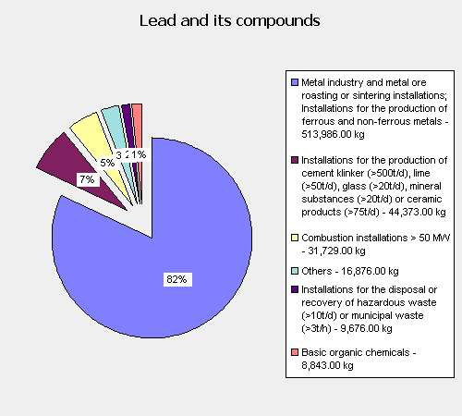 | Emissions to water 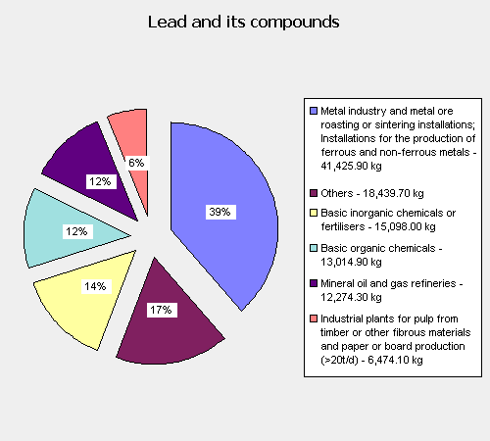
Figure 4.4.33: Share of emissions of different source categories to total air and direct water emissions of lead in the EU-15
Total emissions reported in EPER are compared with the emissions estimated in the current report (see section and ). This comparison is shown in Table 4.4.80.
Table 4.4.80: Total lead emissions from industrial sources on EU-15 level
Reference | Emission to air (kg/year) | Emission to water (kg/year)
EPER | 625 483 | 106 726.9
Ecolas | 781 885 (= 679 885 + 102000) | 174 858

Table 4.4.80 shows that the data from EPER are quite comparable with the data estimated in this report. It is logical that emissions estimated in this report are larger since not all industrial plants existing are considered for EPER reporting – only those activities which are listed in Annex A3 of the EPER Decision are included. Moreover, it can be expected that the EPER database does not include lead emissions from small and medium enterprises (SME). Therefore emission data will be taken over in the continental emission inventory as they were estimated in sections and . As a result emissions from industry (combustion and process emissions) in the EU-15 are:
- 781.9 tons to air;
- 174.9 tons to water.

4.5 Households and public services

Residential heating – combustion of wood in stoves
Extrapolation parameter: consumption of wood energy in households
Extrapolation factor: 57
No recent data could be found on the consumption of wood for residential heating in different EU-15 countries. In 1990 the consumption of wood energy in households was (Eurostat):
- 75 204 000 m³ in the EU-15;
- 1 308 000 m³ in the Netherlands.
Assuming that the evolution in wood consumption for residential heating is the same in all European countries, it is assumed that the relation between wood consumption in the EU-15 and the Netherlands will be the same in 1999 as in 1990. As a result, an extrapolation factor, based on data of 1990 will be used (57 = 75204/1308)

Residential heating – other fuels
Extrapolation parameter: number of inhabitants;
Extrapolation factor: 24 (377.1 x 10⁶ for EU-15 / 15.8 x 10⁶ for the Netherlands (Eurostat, 2003d)).

Domestic wastewater
Extrapolation parameter: / (emissions are estimated on a country-specific basis);
Since the literature review, performed in section of this report, is based on studies performed throughout Europe, an average Pb-concentration in domestic wastewater of 24 µg/l is taken into account. In the Netherlands 98% of the households is connected to an urban wastewater treatment plant. On an EU-15 level country specific connection rates need to be used. In the TGD in support of the Commission Directive 93/67/EEC on risk assessment for new notified substances and the Commission Regulation (EC) No 1488/94 on risk assessment for existing substances it is assumed that, across the Community (Europe) about 80% of the municipal waste water volume is treated at least in a primary purification plant. Taking into account this average connection rate, 20% of the total number of inhabitants will discharge their wastewater directly to the surface water.
Instead of using a default connection rate, more recent data on the country-specific connections rates are available (OECD, 2004) and will be used. These connection rate are given in Table 4.5.81
Table 4.5.81: Connection rate of the EU-15 countries to an STP and number of inhabitants
 | STP connection rate (%)  (OECD, 2004) | Water consumption (Mm³)  (IWSA, 1999)
Australia | 85 | 424
Belgium | 40 | 428
Germany | 93 | 3946
Denmark | 95 | 250
Ireland | 75 | 232
Finland | 82 | 258
France | 80 | 3210
Greece | 93 | 658
Italy | 70 | 4700
Luxembourg | 90 | 27
The Netherlands | 98 | 948
Portugal | 45 | 626
Spain | 55 | 2037
Sweden | 85 | 526
UK | 95 | 5201
Average/Total | 79 | 23471

Emission data from discharge of domestic wastewater are estimated based on:
- An average Pb-concentration of 24 µg Pb/l (based on literature review);
- A country-specific water consumption (total in the EU-15 of 23471 x 10⁶ m³ (IWSA, 1999));
- A county-specific connection rate to sewage treatment plants (OECD, 2004): average for EU-15 of 79%.
Since no information is available on the share of households in the EU-15 emitting directly to surface water and to soil, the same share as on a regional scale are taken into account (34% to soil (=0.68% of 2%) and 66% to surface water). Based on these data, direct emissions at the source are about 35 tons to water and 71 tons to soil.

Corrosion of lead sheet in residential and utility buildings
As already mentioned in section of this study, a targeted assessment was performed by the Lead Development Association on this specific topic. This study also included emission estimation on a EU level.
The total exposed lead area (m²) for 2000 was estimated based on following sources:
- production data from ILZSG (International Lead and Zinc Study Group) for rolled and extruded products and sheet and strip
- consumption data from ELSIA (European Lead Sheet Industry Association)
- UK - LSA consumption
- Belgium - consumption estimates from Belgian industry
- Ireland - production estimates from Irish industry
- Netherlands - consumption data from Uzimet
A distinction was made between exposed area from flashings (between 85% and 95% of total area) and from roofings (between 5% and 15% of total area).
Emissions were calculated based on following run-off rates:
- Lead flashings: a run-off rate of 0.88 g/m² seems appropriate to apply in general;
- Lead sheets: a run-off rate of 5 g/m² seem reasonable based on literature and experimental studies
Table 4.5.82: Overview of data used to estimate total lead emissions from lead sheet run-off in the EU.
 | Data for EU-15
Estimated exposed area (m²) | 239 414 107
Percentage flashings | 91%
Exposed area flashings (m²) | 217 385 012
Run-off rate flashings (g/m².y) | 0.88
Lead emissions from flashings (kg/y) | 191 299
Percentage roofing | 9%
Exposed area roofing (m²) | 22 029 095
Run-off rate roofing (g/m².y) | 5.00
Lead emissions from roofing (kg/y) | 110 145
Total lead emissions (kg/y) | 301 444

In analogy with the emissions on a regional scale, a distinction is made between the lead sheet run-off from residential and utility buildings. Since no specific information is available according this distinction in the EU-15, the industry estimated this on each 50% of the total exposed area. For utility buildings, in analogy with the regional scale, it is assumed that all emissions to water will enter the sewage system and that 80% of total emissions are emitted to the soil compartment directly at the source. The direct emissions to water from residential buildings depend on the connection rate from households to the sewage system, being in average 85% in the EU-15. As a result 15% of total emissions will enter the surface water directly. It is assumed that 30% will be emitted to the soil compartment. These assumptions bring us to total emissions to water of 22459 kg and emissions to soil of 164703 kg.

Fishing in fresh waters – use of Pb in fishing weights
The methodology used on a regional scale is derived from European data and is therefore found to be representative for the EU-15. Based on the methodology described in chapter , a yearly emission of 149.640 tons of Pb (=18.7 million anglers x 0.8 kg Pb/angler/year x 1% corrosion/year) is used in the regional emission inventory.
The fact that no lead is used in the Netherlands in the equipment for commercial fishing is not representative for the EU-15. For commercial and ‘small-scale semi-commercial and recreational fishing using nets’, lead is used in other countries in the EU-15 in at least three different ways dependent on the specific fishing nets:
- Seine ropes are used for large nets, mainly used for fishing benthic fish on relatively shallow water. The seine rope is typically designed as a woven rope with a thin lead wire woven into the filaments of polypropylene or polyester, which is sewn to the net. Seine ropes are typically used in Denmark, Scotland, Norway and Iceland.
- Lead lines are used all over Europe for pound nets. A line is made of small pieces of lead beads threaded on a plastic rope. The string of lead beads is covered by a woven plastic stocking of polypropylene, polyester or other plastics and the stocking is sewn or woven on the net.
- Sinkers/weights are used all over Europe for large ring nets or seines for pelagic fish, some type of trawls, fykes, hoop nets and other types of net fishing.
Based on a questionnaire to all European Member States (EU-25), the lead consumption for commercial fishing in the EU-15 is, in the COWI-study (December 2004) estimated between 1921 and 8666 tons of Pb. Assuming that the loss of Pb in commercial fishing in fresh water equals the yearly consumption of lead, a yearly loss from commercial fishing of 5294 tons is assumed, as an average value. As a worst-case, and since no detailed information is available, it is assumed that all equipment is lost in fresh waters. Since in the emission inventory we are only interested in the “transportable” Pb, defined here as the Pb that potentially can be taken up by organisms, it is necessary to take into account a yearly corrosion of 1% (due to lack of information on corrosion rates of fishing weights, the same corrosion rate as for ammunition is used). The yearly emission of Pb to surface waters from the loss of Pb in commercial fishing is therefore estimated to be 53 tons. As indicated on a regional scale, the selection of a 1% corrosion factor is an important uncertainty in this estimation since corrosion is dependent of the characteristics of the environment (e.g. pH) and will vary between 0.2 and 2% per year (Scheinost, 2003). The total yearly emission of lead from fishing activities in the EU-15 is 202.6 tons.
As indicated in chapter of this report, the PEC for fresh water is calculated with the EUSES 2.0-model and predicts the concentrations in fresh water after reaching a steady state concentration. To estimate cumulative emissions from lost sinkers, taking into account that sinkers which were lost in year 1, will keep corroding during the next years, also a PEC based on future accumulation will be calculated. The calculated emissions per year, taking into account a yearly corrosion of 1%, are shown in Table 3.4.54.
Table 4.5.83: Emission from corrosion of lost fishing sinkers, taking into account cumulative emissions
Year | Emission to surface water (tons Pb)
1 | 203
5 | 993
10 | 1937
100 | 12844
200 | 17546

The calculated future emissions in Table 3.4.54 are probably an overestimation, since:
- In all cases, a corrosion rate of 1% is assumed, while the corrosion will be most important in the first year and will decrease to about 50% of the initial corrosion rate after 2-3 years (Linder B., 2004); the corrosion rate will then further gradually decrease in time.
- A constant use of Pb fishing sinkers is assumed, while this consumption could decrease in the future due to future marketing and use restrictions.
Nevertheless, the emissions calculated in Table 3.4.54 are used for alternative PEC derivation, which are explained in detail in the Pb RAR (Euras, KUL and Ecolas, 2005)).

Other sectors in "Households and public services"
Extrapolation parameter: number of inhabitants;
Extrapolation factor: 24 (377.1 x 10⁶ for EU-15 / 15.8 x 10⁶ for the Netherlands (Eurostat, 2003d)).

4.6 Waste management

Wastewater treatment
Extrapolation factor: /
The lead emissions from WWTP’s are estimated based on the total amount of sludge produced in the EU-15, the country specific average lead concentration in the sludge and an average yield of the WWTP of 84%. The basic info for this calculation is given in Table 4.6.84.
Table 4.6.84: The sludge production in the EU-15 from STPs (European Commission, 2003 and ICON, 2001)
 | Sludge produced  (in tons of dry matter DM)) | Pb-concentration  (in mg Pb/kg DM) | Pb in sludge  (in tons Pb)
Austria |  | 109 | 0.00
Belgium | 94666 | 97 ⁽¹⁾ | 9.18
Denmark | 155621 | 59.9 | 9.32
Finland | 160000 | 43 | 6.88
France | 855000 | 119.9 | 102.51
Germany | 2263846 | 67.7 | 153.26
Greece | 60135 | 211.8 ⁽²⁾ | 12.74
Ireland | 38551 | 150 | 5.78
Italy | 480719 | 97 ⁽¹⁾ | 46.63
Luxembourg | 7000 | 128 | 0.90
Portugal | 374147 | 97 ⁽¹⁾ | 36.29
Spain | 784882 | 97 ⁽¹⁾ | 76.13
Sweden | 221000 | 48.2 | 10.65
The Netherlands | 242 | 145 | 57.00 ⁽¹⁾
UK | 1105919 | 221.5 | 244.96
Sum for EU-15 - NL | 6601728 | - | 715.24 ⁽²⁾
STP yield |  |  | 84%
Pb input in STP (tons) |  |  | 851
Emission to water from STP (tons) |  |  | 144.84 ⁽³⁾
(1) this figure was replace by data from CBS (the statistical bureau in het Netherlands)
(2) total Pb-content of the sludge in the EU-14 (EU-15 - NL)
(3) this is the sum of 8.6 tons reported by the CBS and 136.24 tons calculated from a total Pb-content of the sludge in the EU-14 (EU-15 – NL) and a yield of 84%

Waste treatment - Sewage and refuse disposal - Landfills - Sanitation of envrionmental pollution
This topic is included in the “Waste stream analysis and emission assessment” study (Vangheluwe M., Euras, draft 2004). Overall lead emissions to air from incineration of municipal sewage waste and overall lead emissions to surface water and sludge due to landfilling of municipal sewage waste in Europe were calculated in this study. The emission calculated in this analysis are:
- For waste incineration plants: 15 169 kg Pb to air and 10 846 kg to surface water;
- For landfills: 17 528 kg to surface water
These data were taken to estimate the total EU-15 emissions from waste management sources.

4.7 Agriculture

Mineral soil balance
On a regional scale, a very detailed approach was used by Delahaye et al. (2003) to estimate the net input to agricultural soils. On a continental scale we also need to estimate the total net input of lead in agricultural soil through agricultural activities. It is however impossible to use the same detailed approach as on a regional scale due to lack of information. The general methodology used in this report is based upon Delahaye et al. (2003) and analogues estimations for other metals:
- Waeterschoot H., van Tilborg W. and Coursier A. (2001). Agricultural release scenario’s for the regional and continental analysis of the Zn Risk assessment report.
- Amundsen et al. (2000). Risk assessment of Cd in fertilisers in Norway using model calculations.
- Report on cadmium assessment to the Fertilisers Working Group by the United Kingdom.
- Finnish Environment Institute (2000). Cadmium in fertilisers. Risk to human health and the environment.
To estimate the input of Pb into agricultural soils it is important to take into account internal circulation of these metals (cf Figure 4.7.34). This figure shows that input from manure is the result of the metal content of the feed given to the animals. Both roughage and concentrates contain agricultural material cultivated in Europe. As a consequence only the balance between imported and exported feed and the metal content of fodder supplements used, should be taken into account as an input from manure. A second source is input through mineral fertilisers. This input is estimated based on the metal content of different types of fertilisers and the amount of fertilisers used. Another important source is the use of sewage sludge as a fertiliser. Although of minor importance for the Netherlands (due to strict regulations) it can be important on a continental scale.
Two processes are responsible for the output of metals from agricultural soil. The first one is the uptake through crops, estimated based on a removal rate. The second one is the leaching to groundwater and surface water. gives an overview of the agricultural balance for the EU-15, used to estimate net emissions to the agricultural soil from agricultural activities.

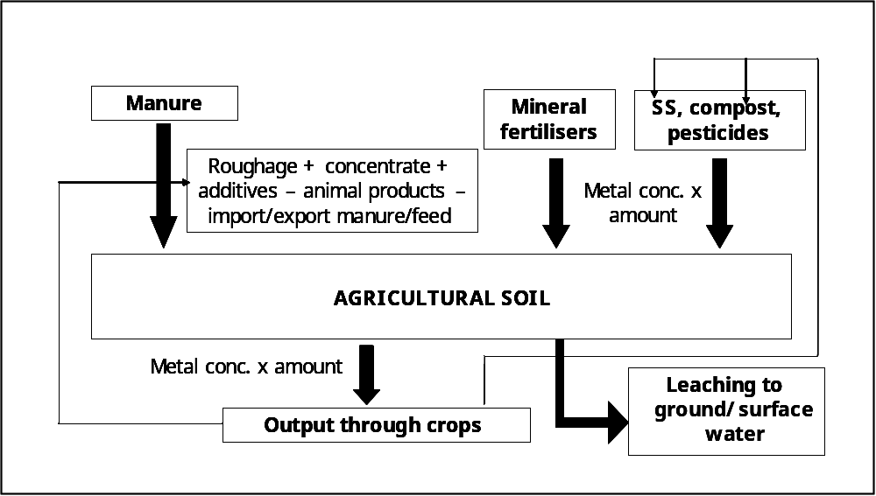
Figure 4.7.34: Agricultural balance for the EU-15 (continental scale)

Input to agricultural soils
Input through manure, mineral fertilisers and sewage sludge will be calculated here.

Manure
As indicated previously, input through manure is the result of the animal feed, where a lot of the metals involved are part of an internal cycling system (metals from manure are taken up by crops and are used as feed for the animals). Therefore:
Input of manure = Roughage + Concentrates

Rhoughage
Rhoughage is produced locally and will in most cases be recirculated on the farm. Consumption of roughage will therefore not be taken into account.

Concentrate
A lot of cereals, meals from seeds and beans, oils and fats are used in animal feed concentrates. The use of the most important products in animal feed concentrates in the EU-15 is available through the Foreign Agricultural Services (FAS) of the United States Department of Agriculture (USDA). These statistics provide production data, imports, total supply, exports and consumption of the products, with a distinction in consumption in industry, in food, in feed and as waste. Since consumption in feed and waste is reported aggregated, a ‘worst case’ scenario is calculated by assuming that all consumption in this category is for production of animal feed. As a result specific consumption in animal feed in the EU-15 is available for wheat, barley, maize, oat, rye, other cereals, soybeans, rapeseeds, sunseeds, peanuts, copra, palm kernel and fishmeal.
For other products like animal fats, citrus fruit pulp, milling products, … no EU-15 statistics are publicly available. For these products, consumption data were extrapolated to the EU-15 from Dutch consumption data with an extrapolation factor of ’10’. The extrapolation factor was determined based on the ratio between the production of compound feed in the EU-15 and the Netherlands, as well as the livestock ratio of the EU-15 and the Netherlands, assuming that feed consumption is related to the livestock and the compound feed production. Table 4.7.85 shows the data to calculate the extrapolation factor.
Table 4.7.85: Livestock and compound feed production in the EU-15 and the Netherlands
 | EU-15 | The Netherlands | Ratio EU-15/NL
Livestock (bovine, pigs, chickens) in 1000 heads | 1 272 487 | 121 203 | 10.5
Compund feed production (in 1000 tons) | 123 155 | 12 450 | 9.9

Based on the consumption data and the average lead concentration of these feed products a lead input through concentrates of 93.7 tons can be estimated.

Net export manure
Little is known about the export of manure from agriculture in Europe. The results of a survey on solid manure in Europe (Menzi H. et al. 1998) shows that apparently this export is of minor importance all over Europe. We can state that as far as we are aware there is very little export of manure outside of Europe. Therefore export is assumed to be negligible.

Mineral fertilisers
To estimate the lead emissions to soil from the use of fertilisers, following data are needed:
- Consumption data of mineral fertilisers
- Average lead concentrations

Consumption data
The International Fertilisers Industry Association (IFA) publishes annual fertilisers’ consumption data on a country basis (IFA, 2004). These data are shown is Table 4.7.86.
Table 4.7.86: Overview of total annual consumption (1999/2000) and composition of mineral fertilisers in the EU-15 (IFA, 2004)
 |  | Consumption |  | Average composition | Consumption (in ktons product)
NITROGEN
 | Ammonium sulphate | 207 | ktons N | 21 %N | 986
 | Urea | 1415 | ktons N | 45.5 %N | 3110
 | Ammonium nitrate | 1804 | ktons N | 34 %N | 5306
 | Calcium amm. nitrate | 1985 | ktons N | 24 %N | 8271
 | Ammonia direct applic. | 18 | ktons N | 31.1 %N | 58
 | Nitrogen solutions | 1114 | ktons N | 28 %N | 3979
 | Other straight N | 372 | ktons N | 30.6 %N | 1216
 | Total straight N | 6915 | ktons N |  | 22924
 | Ammonium phosphate N | 257 | ktons N | 11 %N | 2340
 | Other NP N | 192 | ktons N | 20 %N | 961
 | NK N | - | ktons N | 19 %N
 | NPK N | 1815 | ktons N | 15 %N | 12105
 | Total compound N | 2265 | ktons N
Total N |  | 9181 | ktons N |  | 38330
PHOSPHATE
 | Basic slag | 2 | ktons P₂O₅ | 31 % P₂O₅ | 6
 | Ground rock | - | ktons P₂O₅ | 30 % P₂O₅
 | Single superphosphate | 71 | ktons P₂O₅ | 18 % P₂O₅ | 394
 | Triple superphosphate | 265 | ktons P₂O₅ | 46 % P₂O₅ | 575
 | Other straight P | 88 | ktons P₂O₅ | 31 % P₂O₅ | 281
 | Total straight P | 426 | ktons P₂O₅ |  | 1257
 | Ammonium phosphate P | 667 | ktons P₂O₅ |  | ⁽¹⁾
 | Other NP P | 130 | ktons P₂O₅ |  | ⁽¹⁾
 | PK P | 348 | ktons P₂O₅ | 18.5 % P₂O₅ | 1881
 | NPK P | 1385 | ktons P₂O₅ |  | ⁽¹⁾
 | Total compound P | 2530 | ktons P₂O₅
Total P₂O₅ |  | 3450 | 2955.5 |  | 3138
POTASH |  | - | -
 | Potassium chloride | 966 | ktons K₂O | 60 % K₂O | 1609
 | Potassium sulphate | 101 | ktons K₂O | 50% K₂O | 202
 | Other straight K | 50 | ktons K₂O | 55 % K₂O | 91
 | Total straight K | 1117 | ktons K₂O |  | 1902
 | NK K | 9 | ktons K₂O |  | ⁽¹⁾
 | PK K | 380 | ktons K₂O |  | ⁽¹⁾
 | NPK K | 1878 | ktons K₂O |  | ⁽¹⁾
 | Total compound K | 2267 | ktons K₂O
Total K₂O |  | 3383,60 | ktons K₂O |  | 1902
 |  | -
Total N + P₂O₅ + K₂O |  | 15520 |  |  | 43371
(1) in the IFA-statistics, some of the fertilisers were mentioned twice, e.g. ‘other NP’ fertilisers are mentioned as ‘N-fertilisers’ and as ‘P-fertilisers’, these were left out the calculations to avoid double-counting

About the consumption of lime in agriculture not a lot of information is available. Therefore a consumption of 1305 ktons is taken into account based on data from Ireland (FAI, 2004)and Finland (Finfood, 2004). The International Lime Association will be able to provide me with total consumption data on an EU-15 level (personal communication, ILA, Mr. Novotny).

Average metal concentrations
A literature review was performed in order to determine the lead concentrations in several mineral fertilisers. A dataset of about 100 data was set up and metal concentrations were determined for following groups of fertilisers:
- N/P-fertilisers
- N/P/KP-fertilisers
- Other N-fertilisers
- P/K-fertilisers
- Other P-fertilisers
- K-fertilisers
- Lime
These groups were distinguished based on the fact that:
- The analysed data showed no significant differences between specific types of fertilisers within these groups;
- Consumption data for these groups are available.
Starting from the complete database some outliers, identified according to the statistical approach proposed in the TGD (2003), were excluded.
Table 4.7.87 gives the results of the literature review on metal concentrations in fertilisers. The median metal concentration, the range and the 90-percentile of several types of fertilisers are given.
Table 4.7.87: Overview of median, range and 90P Pb concentrations in fertilisers
Type of fertiliser | Pb-concentration (mg Pb/kg)
 | Median | Range | 90P
NP-fertilisers | 5.11 | 1.5-22.8 | 14.6
NPK-fertilisers | 1.43 | 0.6-9.1 | 2.77
Other N-fertilisers | 0.90 | 0.04-21.4 | 13.11
P/K-fertiliser | 3.75 | 3.0-6.6 | 5.6
Other P-fertilisers | 7.55 | 1.3-15.3 | 14.39
K-fertilisers | 2.60 | 0.3-18.2 | 10.17
Lime | 5.25 | 0.9-130.0 | 23.68

Pb-input through use of fertilisers on agricultural soil
The total Pb-input from the use of mineral fertilisers on agricultural soil in the EU-15 is estimated based on the total consumption of the fertilisers in 2000/2001 (IFA, 2004) and median Pb-concentrations per type of fertilisers. The total Pb-input per type of fertilisers is given in Table 4.7.88.
Table 4.7.88: Overview of Pb-input in agricultural soil per type of fertiliser
Type of fertiliser | Pb-input (tons Pb)
 | Based on median value | Based on P90-value
NP-fertilisers | 16.87 | 48.19
NPK-fertilisers | 17.31 | 33.53
Other N-fertilisers | 20.63 | 300.54
P/K-fertiliser | 5.64 | 10.53
Other P-fertilisers | 4.71 | 18.09
K-fertilisers | 4.95 | 19.35
Lime | 6.85 | 30.90
TOTAL | 76.96 | 461.14

Sewage sludge
The input of lead through the use of sewage sludge on agricultural soil in the EU is available on a country-specific basis. Therefore, the lead emissions from the use of sewage sludge in agriculture on a total EU-15 level will be estimated by taking into account the amount of sludge used in agriculture in 1999 and the average Pb-concentration of that sludge on a country-specific basis instead of extrapolating the regional emissions. The use of sewage sludge and the average Pb-concentration in each EU Member State is given in Table 4.7.89.
Table 4.7.89: Total sludge production and quantities used in agriculture (CEC, 2003) and lead concentration in sewage sludge (European Commission, 2001)
 | Sludge used in agriculture
 | Tons of sludge (DM) | Pb concentration (mg Pb/kg DM) | Lead input (tons)
Austria | - | 109 | 0
Belgium | 14 914 | 97 ⁽¹⁾ | 1 447
Denmark | 96 200 | 59.9 | 5 762
Finland | 23 000 | 43 | 989
France | 552 000 | 119.9 | 66 185
Germany | 861 631 | 67.7 | 58 332
Greece | 0 | 211.8 | 0
Ireland | 8 734 | 150 | 1 310
Italy | 95 913 | 97 ⁽¹⁾ | 9 304
Luxembourg | 5 600 | 128 | 717
Portugal | 66 547 | 97 ⁽¹⁾ | 6 455
Spain | 413 738 | 97 ⁽¹⁾ | 40 133
Sweden | 56 000 | 48.2 | 2 699
The Netherlands ⁽²⁾ | 36 | 145 | 5
UK | 554 924 | 221.5 | 122 916
Sum for EU-15 | 2 748 537 | - | 316 254
(1) if no country-specific concentration was given, an EU mean concentration of 97 mg Pb/kg dry matter was used; this concentration is calculated by Ecolas as an average based on a minimum and maximum concentration of 160 and 373 mg/kg dry matter
(2) municipal sludge has not been used in agriculture since 1995. The values given here therefore relate only to sewage sludge produced by private facilities.

Taking into account mean country-specific lead concentrations, a total lead input of 316 tons of lead on agricultural soil in the EU can be calculated.

Output from agricultural soils
As already mentioned, two pathways can cause an output of metals from agricultural soil, being output through crops and leaching.

Output through crops
The output through crops can be calculated based on the yearly crops production and the average metal concentrations in the crops. An important part of the crops, being harvested in the EU-15, are given to the EU-15 cattle as roughage and become an input to agricultural soils. For that reason roughage is not taken into account, neither as input, nor as output. Eurostat (2003) provides data on the total production of important crops, vegetables and fruits. Linking those consumption data to metal concentrations in crops, vegetables and fruits enables to estimate a lead output through crops of about 186 tons (compare with using the Dutch data and an extrapolation factor of 10: 22.84 tons x 10 = 228.4 tons).

Leaching
Ecolas is not aware of the availability of data on leaching of metals from agricultural soil on an EU-15 level. Several parameters have an influence on the leaching profile of soils. The extrapolation of leaching profiles from the Dutch to the European scale, implies a lot of inaccuracies. Since no other option is available, this extrapolation is performed in this report, taking into account that:
- Leaching is dependant on soil type (leaching is higher in sandy soils) and soil properties (leaching is higher for low pH);
- “In the Netherlands no use is made of household STP sludge. In several other European countries STP sludge is applied in agriculture. Inputs through sludge are smaller than through animal manure if compared on P₂O₅-basis and the loss through leaching is larger when applied through manure than through sludge. This is another reason why the data for The Netherlands cannot be used to derive accumulation estimates for other European countries” (van Tilborg et al., 2003).
- “The alluvial nature of The Netherlands differs substantially from hilly and mountainous regions of the EU. Differences in geological formations might cause differences in leaching as well as in erosion.” (van Tilborg et al., 2003).
Despite all mentioned differences, leaching from agricultural soil on a continental scale is estimated in the current report as a percentage of the input to agricultural soils. Note that this is only an indication of the leaching. The percentage of leaching is derived from the Dutch data. Leaching data, estimated here, will however not be used as an input for the EUSES-model. Net input (total input – removal through crops) is used as an input to agricultural soil, where leaching and runoff is estimated by the model itself (cf. remark section of this report).

Erosion
Erosion is an important factor influencing emissions from agricultural activities to surface water. Sensitivity of soils for erosion is significantly different throughout Europe as a result of difference in geological formations. Currently, there is not enough information available to take this factor into account.

Total balance on continental scale
The results of the calculation of all individual parameters, described in previous sections, are given in Table 4.7.90.
Table 4.7.90: Input of lead (tonnes per year) into agricultural soil on a EU-15 scale
Source | Pb (tons)  (based on median values)
Input to agricultural soil ⁽¹⁾
Manure
- Concentrate | 93.7
- Net export manure | 0
- Animal products | 14.0
- Feed for dogs, cats | 3.5
- Net export compound feed | 7.7
Fertilisers | 76.96
Sewage sludge | 316.3
Total input | 461.7
Output through crops | 186.0
Net input to agricultural soil | 275.7
(1) biocides and pesticides have not been taken into account as they are subject to separate RAs.

As already indicated on a regional scale, the net input (tons) to agricultural soil of 275.7 tons will be used as an input to agricultural soil and leaching will be estimated with the EUSES-model.

Other sources in agriculture
Extrapolation parameter: livestock / production
Extrapolation factor: 10 (for animal farms) and 13 (for crop farms)

4.8 Traffic

Road transport

Passenger cars, delivery cars, motorcycle, moped, special vehicles
Extrapolation parameter: passenger kilometres per person per year (pkm);
Extrapolation factor: 25 (3787,8x 10⁶ for EU-15 / 150,6x 10⁶ for the Netherlands (Eurostat, 2003e)).

Busses
Extrapolation parameter: passenger kilometres per person per year (pkm)3;
Extrapolation factor: 32 (406.2 x 10⁶ for EU-15 / 12.6 x 10⁶ for the Netherlands (Eurostat, 2003f)).

(Articulated) truck
Extrapolation parameter: haulage on national territory (1000 million tkm);
Extrapolation factor: 27 (1321.9 x 10⁹ for EU-15 / 48.6 x 10⁹ for the Netherlands (Eurostat, 2003g)).

Loss of balance weights
Extrapolation parameter: total amount of vehicles in use
Extrapolation factor: 27 (205.8 x 10³ for EU-15 / 7.5 x 10³ for the Netherlands (ACEA, 2000)).

Navigation

Ships - inland waterways
Extrapolation parameter: transport equipment on inland waterways (self-propelled goods vessels, tugs and pushers, dumb and pushed bags);
Extrapolation factor: 3 (19745 for EU-15 / 6267 for the Netherlands (Eurostat, 2003h)).
This extrapolation factor is derived from statistics from 1996. Also the amount of goods transported on inland waterways differs with a factor 3 from NL to EU-15, for this parameter we have more updated data and in 2001 the ratio between the goods transport on inland waterways in NL (41.9x109 tkm) to EU-15 (125x109 tkm) is 3.

Ships at berth
Extrapolation parameter: port traffic in most important harbours in the EU-15 (tons loaded/unloaded)
Extrapolation factor: 4: the ratio between port traffic in NL (382.1 x10⁶ tonnes loaded/unloaded in Rotterdam and Amsterdam) to EU-15 (1666.6 x106 tonnes loaded/unloaded).

Boats
Extrapolation parameter: number of inhabitants;
Extrapolation factor: 24 (377.1 x 10⁶ for EU-15 / 15.8 x 10⁶ for the Netherlands (Eurostat, 2003d)).
Since emissions from boats refer to emission from an activity in the sector of recreation, it was assumed that the emission from fuel use by boats is connected to the number of inhabitants.
The use of antifouling paints is tackled by specific risk assessment studies and will therefore be not be discussed in detail here.

Rail transport

Wear of collector shoes
Extrapolation parameter: total length of electrical lines (km) – wear of contact wires is only relevant for electrified lines
Extrapolation factor: 34 (134710 km for EU-15 / 3939 km for the Netherlands (Union Internationale des Chemins de Fer, 2001))

Aviation
Extrapolation parameter: total movements of aircrafts (take-off and landing) at major airports;
Extrapolation factor: 16 (6386 x 10⁶ for EU-15 / 410 x 10⁶ for the Netherlands (Eurostat, 2003k)).

Mobile machinery
Extrapolation parameter:
- Agricultural machinery: total use of fertilisers (ton);
- Machinery used in construction industry: value of production for the industry
- Others: number of inhabitants;
Extrapolation factor:
- Agricultural machinery: 28.5
- Machinery used in construction industry: 23 (cf. Industry, section Error: Reference source not found)
- Others: number of inhabitants: 24 (cf. Households and public services, section )

4.9 Miscellaneous

Real estate, renting and business activities
Since the emission data from the Netherlands from this source are data from point sources according to the SBI-codes (standard nomenclature for economic activities) and this reporting methodology connects closest to the methodology for collection industrial emission data, we assume that these emissions are included in the continental emission data from industry.

Use of Pb-containing ammunition
Total emissions on an EU-15 scale were estimated in the “Targeted risk assessment on lead in ammunition” (Annex A, Verdonck et al., 2007). The emissions were based on:
- Total consumption of lead containing ammunition for hunting and clay pigeon shooting in the EU-15;
- A corrosion rate of 1% per year;
- Current emissions of historic use.
Details on the methodology can be found in the full report (Annex A, Verdonck et al., 2007). The calculated emissions per year, taking into account a cumulative corrosion of 1% per year, are then after 100 years (including current emissions from historical use of Pb in ammunition): 1,648,760 kg Pb to surface water and 23,450,657 kg to soil.

Emissions to surface water from storm water overflow, separate sewage systems, sewage systems not connected to STP
For the quantification of regional releases to water, the reported emissions on a regional as well as on a continental scale, are always those emissions entering the surface water directly at the source. The part of the emissions, entering the sewage system at the source can eventually appear in the regional emission inventory, as emissions from following sources:
- Emissions from sewage treatment plants (STP, already discussed in section );
- Emissions to surface water from storm water overflow;
- Emissions to surface water from separate sewage systems;
- Emissions to surface water from sewage systems not connected to STP.
The emissions from the abovementioned sources need to be quantified on a total EU-15 scale also. As already indicated, the lead emissions from wastewater treatment plants in the EU-15 are estimated in section based on the total Pb-load calculated in the sewage sludge from wastewater treatment plants in the EU-15 and an average efficiency for lead of 84%.
The other sources (stormwater overflow (SWO), separate (sSS) and not connected sewage systems (SS)) are dependant on:
- The production of wastewater;
- The connectivity rate to the sewage system (SS) in the EU;
- The share of separate and mixed sewage systems;
- The amount of overflow from mixed sewage systems.
Only for the connection rate of households to the sewage system, data on EU-15 level are available. It is assumed that, the amount emitted through stormwater overflow and the amount discharged through separate sewage systems, are dependant of the connection rate of households to sewage systems. Only taking into account the difference in connection rate of households between the Netherlands and the EU-15, it is assumed that the relative share of mixed sewage systems, the relative amount of stormwater overflow, as well as the share of wastewater coming from other sources than households (runoff from roads, industry, ...) in the Netherlands is representative for the EU-15.
Although this assumption is a simplification of the reality, total emissions from these three sources in the EU-15 as a whole (without separating per source) will show a quite accurate result. Therefore first of all the total discharge through SWO, sSS and SS not connected to STP’s are extrapolated by the ratio of the total number of inhabitants in the EU-15 to the total number of inhabitants in the Netherlands (24 = 377x10⁶ /15.8x10⁶). Secondly this total emission is corrected by the ratio of households connected in the EU-15 (85%) to the households connected in the Netherlands (98%), resulting in an extrapolation factor of 20.8.
It must be noted that this will be a slight underestimation. In the Netherlands all sewage systems are connected to an STP, resulting in the fact that emissions from SS not connected to STP are “zero” on a regional scale. Extrapolating “0” with a factor 20.8 still give “0”, while in other countries in the EU-15, an average of about 6% of the households connected to the SS are not connected to a STP.

Quantification of regional and total EU-15 releases

5.1 Quantification of regional releases – selected region
The regional exposure assessment for the risk assessment is based primarily on the Dutch national emissions inventory. In order that emissions are not double counted by including them as point and diffuse, it is important to note that in the Netherlands:
- there are no lead producers
- there is one lead sheet producer
- there are no lead stabiliser producers
- there is one lead oxide producer (ELOA, personal communication)
- there are no lead crystal producers (TNO, personal communication)
- there are no lead battery producers
- there is one producer of technical lead glass
- there are several ceramics companies using lead oxides
Consequently, it is probable that the emission data of the above mentioned companies are accounted for in the quantification of regional releases.
Based on the previous sections, a quantification format for the Netherlands (as selected EU region) was accomplished. Based on the quantification methods selected for this format and specific activity data for the Netherlands, lead emissions per source were calculated.
An overview of regional lead emissions is given in Table 5.1.91.
Table 5.1.91: Overview of regional lead emissions for the Netherlands as selected region (kg Pb/year)
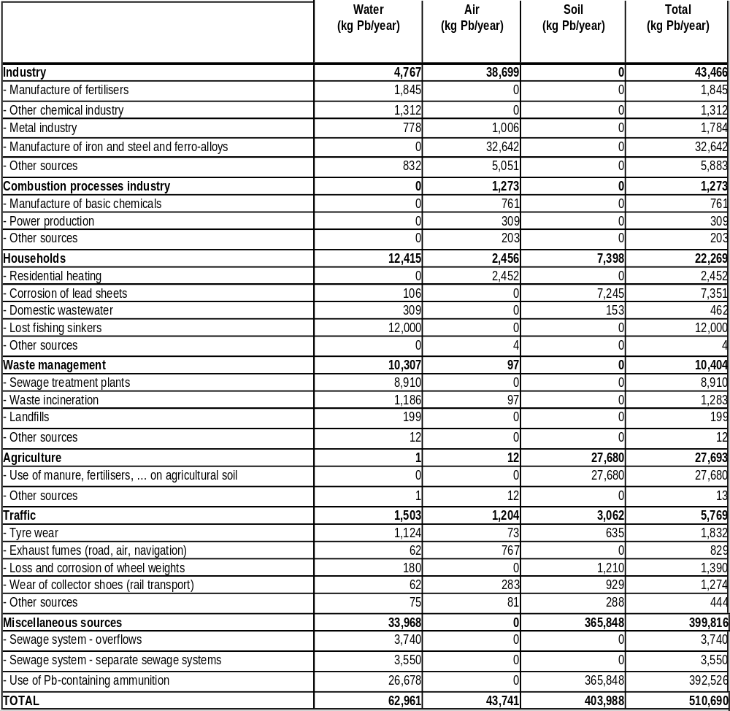

Figure 5.1.35 shows the importance of the different source categories compared to total regional emissions and emissions per environmental compartments air, water and soil.
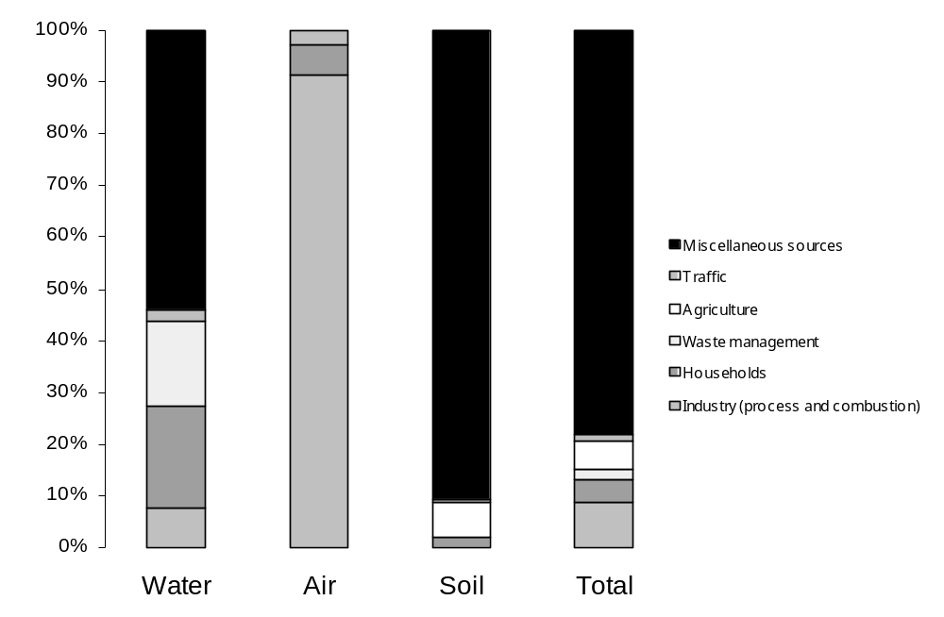
Figure 5.1.35: Allocation of the regional lead emissions per environmental compartment to the different source categories
Based on the combination of the results from Table 5.1.91 and Figure 5.1.35 a few conclusions can be drawn:
- The source categories, most responsible for the emissions to the water compartment, are ‘households’, ‘waste management’ and ‘miscellaneous sources. They each account for respectively 20%, 16% and 54% of total emissions to surface water. The loss of fishing sinkers account for 97% of total emissions to water from households’. In ‘waste management’, the effluents of the sewage treatment plants account for 86% of total emissions and in the ‘miscellaneous sources’, 79% of emissions to water come the use of Pb-containing ammunition.
- The ‘industry’ is responsible for 91% of total emissions to the air compartment, of which 84% comes from processes in the iron and steel industry.
- The most important source category for emissions to soil is ‘miscellaneous sources’, accounting for 91% of total Pb-emissions to soil. These emissions all come from the use of Pb-containting ammunition; The the use of manure and fertilizers on agricultural soil accounts for another 7% of total Pb-emissions to soil.

5.2 Quantification of total EU-15 releases
As already mentioned in the beginning of section 5, total EU-15 releases are quantified based on following equation:
Total EU-15 emissions = [Source-specific regional to EU-15 extrapolation factor x regional emissions]
In the current section, the total EU-15 emissions are quantified based on the methodologies described in section .
Table 5.2.92 gives an overview of the total EU-15 lead emissions aggregated per source category.
Table 5.2.92: Summary of the total lead emissions for the EU15 (tons/year)
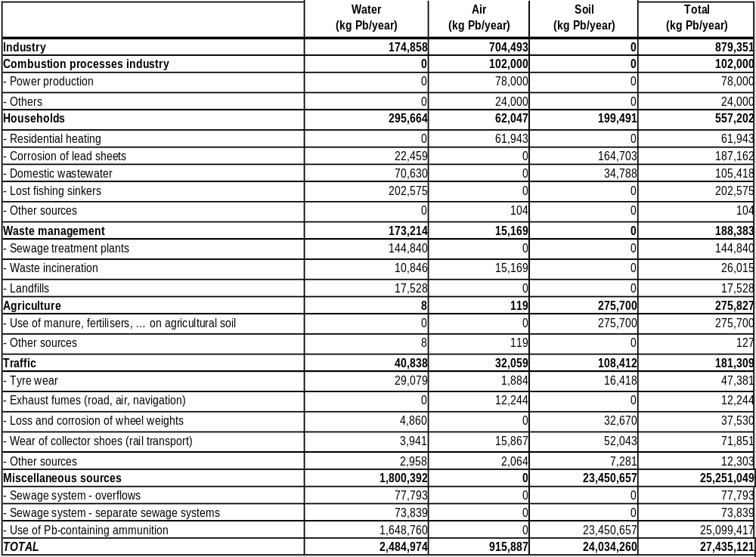
Figure 5.2.36 shows the importance of the different source categories compared to total EU-15 emissions and emissions per environmental compartments air, water and soil.

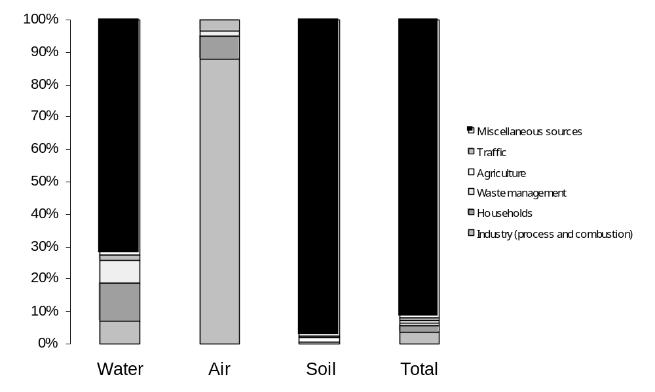
Figure 5.2.36: Allocation of the total EU-15 lead emissions per environmental compartment to the different source categories
Also by combining the results shown Figure 5.2.36 and Table 5.2.92 a few conclusion can be drawn:
- The source categories ‘industry’, ‘waste management’ and ‘households’ account for respectively 7%, 7% and 12% of total lead emissions to surface water. In ‘waste management’, the effluents of the sewage treatment plants account for 84% of the emissions. The influent of sewage treatment plants is a combination of different sources: ‘households’, ‘traffic’, ‘industry’,… In the source category ‘households’ (responsible for about 20% of total emissions to water), 69% of the emissions result from the loss of fishing sinkers. ‘Miscellaneous sources’ account for 72% of total emissions to water, in which 92% comes from the use of Pb-containing ammunition. For ‘industry’ (7% of total emissions), no distinction can me made, based on the current knowledge between different industrial sectors. Although the EPER data were not taken over in the current emission inventory (but used as validation), an indication of those industrial sectors, accounting for an important share in total industrial water emissions can be found in Figure 4.4.1 of the Pb emissions inventory background document (ECOLAS, May 2005).
- ‘Industry’ is responsible for 88% of total emissions to the air compartment. Again an indication of those industrial sectors, accounting for an important share in total industrial air emissions can be found in Figure 4.4.1 of the Pb emissions inventory background document (ECOLAS, May 2005).
- ‘Miscellaneous sources’ is the most important source category for emissions to soil and accounts for 97% of total emissions to the soil compartment. These emissions include only emissions from the use of Pb-containing ammunition.
A detailed overview of these total released are shown in Table 5.2.93 next to the regional emission and the methodologies used to quantify regional as well as total EU-15 emissions.
Table 5.2.93: Detailed overview of regional and total EU-15 emissions and methodologies used to quantify regional and total EU-15 emissions (see Excel-sheet in Annex 2).

5.3 Additional scenario’s for sensitivity analysis in the VRAR

Emission data for the selected region (The Netherlands) without cumulative and historical emissions
In this scenario, Pb-emissions for the selected region (The Netherlands) are calculated without taking into account the cumulative and historical emissions from the use of Pb-containing ammunition. The only difference thus with the emissions for the selected region as shown in Table 5.1.91 are the emissions from the use of Pb-containing ammunition. In Table 3.2.37only the emissions, resulting from the use of Pb-containing ammunition in one year are taken into account.
Table 5.3.94: Overview of regional emissions for the selected region (The Netherlands) not taken into account cumulative nor historical emissions
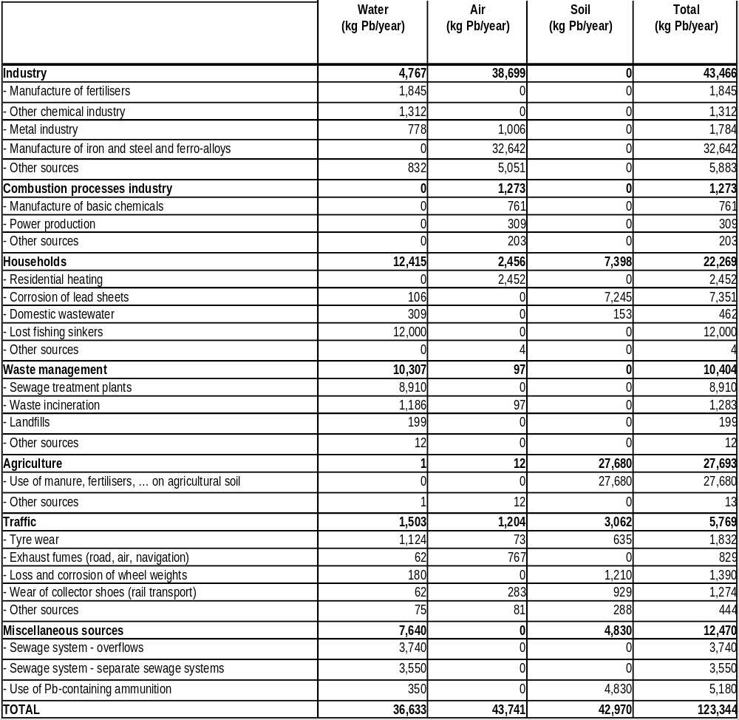

Emission data for EU-15 without cumulative and historical emissions
As in the previous paragraph, here, Pb-emissions for the EU15 are calculated without taking into account the cumulative and historical emissions from the use of Pb-containing ammunition. Results are shown in Table 5.3.95. As for Table 5.3.94 it can be noted here that, the only difference thus with the emissions for the EU15 as shown in Table 5.2.92 are the emissions from the use of Pb-containing ammunition.
Table 5.3.95: Overview of regional emissions for the EU15, not taken into account cumulative nor historical emissions
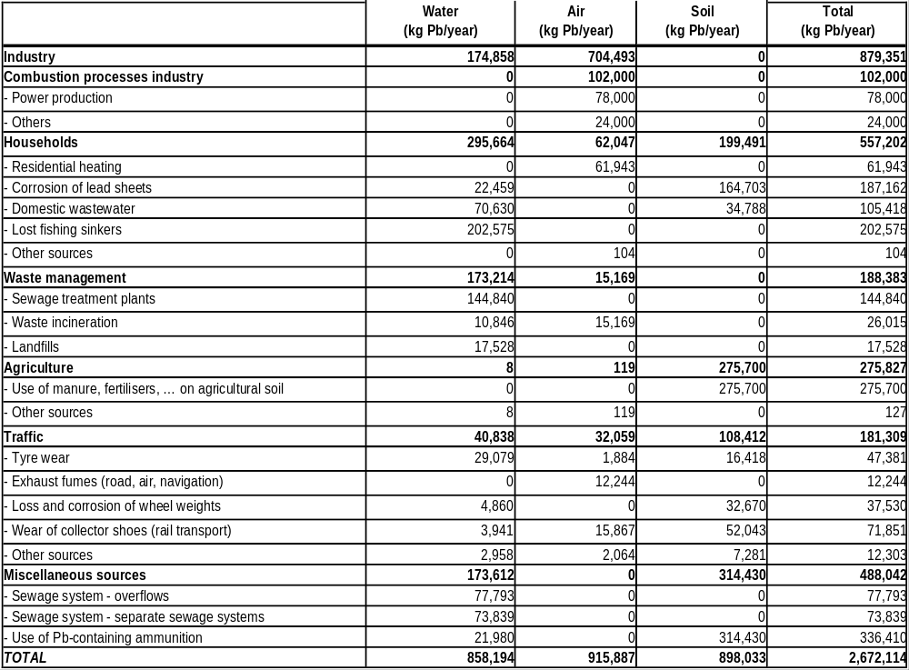

Emission data for the generic region (10% of EU15) without cumulative and historical emissions
According to the TGD (EC, 2003), by default, it is assumed that 10% of the European production and use of a substance takes place within the regional area and therefore regional emissions can be estimated as 10% of total European emissions (cf. p.230-231). Table 5.3.96 shows the result of this calculation.
According to the TGD (EC, 2003), by default, it is assumed that 10% of the European production and use of a substance takes place within the regional area and therefore regional emissions can be estimated as 10% of total European emissions (cf. p.230-231). Table 5.3.96 shows the result of this calculation.
Table 5.3.96: Overview of regional releases for a generic region (kg/year)
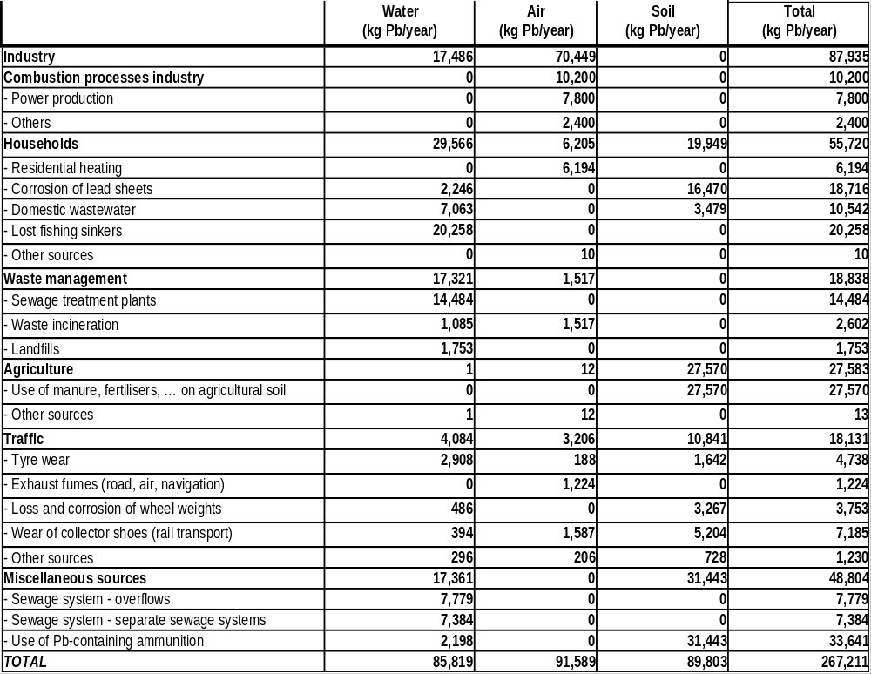
.

Comparison of emissions from the selected and the generic region
In Figure 5.3.37 the estimated regional emissions for a selected and a generic region are compared.
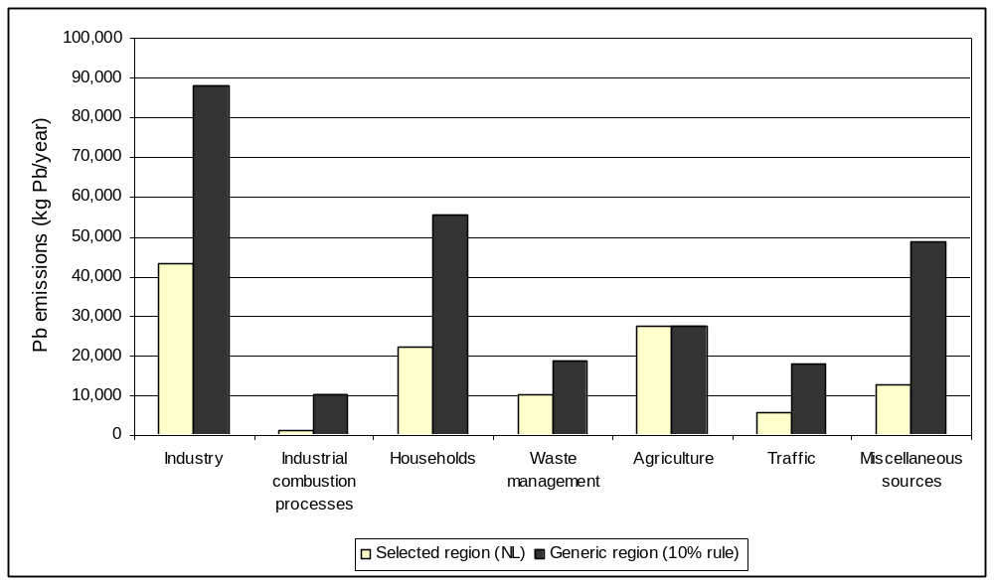
Figure 5.3.37: Comparison of total regional lead emissions per source categories, calculated for the default region (10% rule according to TGD, 2003) and for a selected region (The Netherlands)

Based on Figure 5.3.37, following conclusions can be drawn on the comparison between the generic regional emissions and the emissions from the selected region (The Netherlands (NL)):
- Total industrial emissions (process + combustion emissions) are much higher for the generic region as for the selected region (96 tons compared to 45 tons). This can be explained by the fact that:
- there is more important industry (not specifically Ni-industry) in other European countries compared to The Netherlands, resulting in the fact that the industrial emissions in The Netherlands are much lower than 10% of EU-15 emissions;
- the coal consumption for combustion in industry in the Netherlands is only 1/17th of that in the EU-15, instead of 1/10th.
- Emissions from households are much higher in the generic regional calculation. This can be explained by the fact that the STP connection rate is much higher in the NL compared to the EU-15 (98% compared to 79% in the EU-15). Taking into account that the water consumption (and wastewater emission) in the NL is only 4% of the water consumption in the EU-15, it is reasonable that emissions in NL are much lower than the generic region (10% of EU-15);
- The higher estimation of emissions from waste management in the generic region can also be explained by the difference in water consumption in The Netherlans compared to the generic region (default 10%);
- The fact that emissions from agricultural activities in the generic region and the selected region are comparable is explained by the fact that the livestock density and compound feed production in the NL is about 10% of those in the EU-15;
- Higher traffic emissions in the generic region could be explained by the fact that the mileage of cars and trucks in the EU-15 is a factor of respectively 25 and 32 higher thatn in the NL (instead of 10). The length of railways is a factor 34 higher in the EU-15 than in the NL;
- Higher emissions from stormwater overflow and separate sewage systems in the default region can again be explained by the difference in water consumption.

5.4 Input data for regional exposure assessment
The emission as shown in Table 5.1.91, for the region, and Table 5.2.92, for the EU15, are used as input data for the EUSES 2.0 model. For a regional assessment modelling with EUSES 2.0, two types of input data are needed:
Regional emissions
Continental emissions = EU15-emissions – regional emissions
Two scenario’s are calculated :
Regional emissions for a selected region, The Netherlands
Regional emissions for a generic region, being 10% of EU15 emissions

Input for regional assessment for selected region
Emission data taken forward here are taken over from Table 5.1.91 (for regional emissions for selecte region) and Table 5.2.92 (for EU15 emissions).
On a regional scale (for the selected region, The Netherlands) input data for EUSES 2.0 are:
emissions to air: 43 741 kg
emissions to water: 62 961 kg
emissions to agricultural soil: 393 528 kg
emissions to natural/industrial soil: 10 460 kg
As an input for the EUSES 2.0-model not the total EU-15 emissions, but the continental emissions, the difference between European emissions and regional emissions (TGC, EC, 2003), are used. The continental input data (for the selected region) can therefore be calculated as follows:
emissions to air: 872 146 kg
emissions to water: 2 422 013 kg
emissions to agricultural soil: 23 332 829 kg
emissions to natural/industrial soil: 297 443 kg

Input for additional scenario’s for sensitivity analysis
The data, shown in Table 3.1-79a, Table 3.1-79b and Table 3.1-80 are used to perform a sensitivity analysis.

5.5 COmparison between E-PRTR diffuse sources emission inventory and emissions reported in the RAR
The E-PRTR is the European Pollutant Release and Transfer Register established on the basis of the European PRTR Regulation 166/2006/EC, which entered into force in February 2006.
The Regulation has incorporated the provisions of the UN-ECE Protocol on Pollutant Release and Transfer Register under the Aarhus Convention, which was adopted at the Ministerial Conference 'Environment for Europe' in Kiev in May 2003 and has been ratified for the European Union by Council Decision 2006/61/EC.
First Member State reporting to European PRTR is foreseen for Member States in June 2009 for the reporting year 2007.
In the field of pollutant emission registers EPER - the first European-wide pollutant emission register for releases from industrial facilities - has been in place since 2000. It has been established by Commission Decision 2000/479/EC to implemented the provisions of article 15 (3) of the IPPC Directive on public accessibility of the results of monitoring. According to the provisions of the EPER Decision, Member States for the first time in June 2003 delivered data on releases into air and water of industrial facilities for 50 pollutants if threshold values as specified in Annex A1 of the EPER Decision were exceeded.
Since the European PRTR Regulation includes more pollutants and activities than those contained in EPER and since, in addition to releases into air and water, releases to land and off-site transfers of waste have to be reported by the facilities, it has been necessary to upgrade and extend the EPER into a fully comprehensive European PRTR.
As an innovation of the European PRTR in comparison with EPER - according to Article 8 of the European PRTR Regulation - information on releases from diffuse sources shall be included in the reporting where such information exists and has already been reported by the Member States. This shall serve the aim to clarify the relation of releases from large point sources and diffuse sources not covered by the E-PRTR regulation.
According to the definition in the European PRTR Regulation diffuse sources are the many smaller or scattered sources from which pollutants may be released to land, air or water, whose combined impact on those media may be significant and for which it is impractical to collect reports from each individual source (Source: European PRTR Regulation, Art. 2 (12))
The emission inventory part of the RARs aims at setting up an emission inventory for the EU15 (or EU16) to the compartments air, water and soil. These data are used as input data for the EUSES 2.0 model to calculate the regional PEC (Predicted Environmental Concentrations) values for each environmental compartment. The inputs for the regional assessment are the anthropogenic point and diffuse emissions to air, wastewater, surface water, agricultural soil and industrial/urban soil.
First of all it must be noted that in the European PRTR, only atmospheric emissions are included for heavy metals. Therefore only a comparison of the atmospheric emission data is feasible. To compare the two emission inventories following aspects are described:
- The reporting year;
- Area coverage;
- Identified emission sources;
- Actual emission data.
The European PRTR Diffuse Source inventory gives access to data from existing reporting activities and inventories, where data have been calculated following a harmonised methodology. As the attention of reporting and controlling on releases was focused on point sources and specific pollutants in the past, the status quo of reporting on releases from diffuse sources however differs significantly for compartments (air, water, land), sectors, pollutants and Member States. The data therefore are far from complete. While data on releases to air are relatively complete for a number of pollutants, data for releases into water are highly limited and data for releases to land are hardly available.

Reporting year
The reference year for data in the E-PRTR diffuse sources inventory is 2003. The database shows however that for Greece and Portugal 2000 data are taken forward. In the RAR’s the reference year is 1999-2000 (emission data for 1999 are assumed to be representative for 2000). Differences in emission data could therefore partly be explained by the fact that maybe there is an evolution in emission data between 1999 and 2003.

Area coverage
In this chapter the area coverage of the data in the different emission inventories is evaluated. Following area coverage is aimed in the different reports:
- The PRTR covers the EU25
- The RARs currently only cover the EU15 (EU16).
In the following sections a more detailed overview of the coverage is given.
In the RAR’s, emission data are reported for the EU15 for all identified sources. For each source an estimation of the emissions is performed based on e.g. the number of inhabitants, the number of employees, the energy consumption in industry, by households, in agriculture, …, the total water consumption by households, the use of sewage sludge on agricultural land, … in the EU15. This means that all reported emissions in this study are representative for the EU15, independently of the availability of official emission data, reported by the MS themselves. As a result the RAR’s cover: Austria, Belgium, Denmark, Finland, France, Germany, Greece, Ireland, Italy, Luxembourg, Portugal, Spain, Sweden, The Netherlands and the UK. Norway is not included in the RAR.
The PRTR is based on reported data per Member State. MS who do not report their emission data are not included in the total reported emissions. For lead, emissions from all EU15 MS are included except for Greece. This means that those MS report emissions for at least 1 source, this does not imply however that all these MS report emissions for all sources taken into account in the E-PRTR Diffuse sources emission inventory.
Table 5.5.97 gives an overview of the individual source categories reported per MS and the total amount of MS reporting emissions for a specific source category.
Table 5.5.97: Overview of the individual source categories reported per Member State
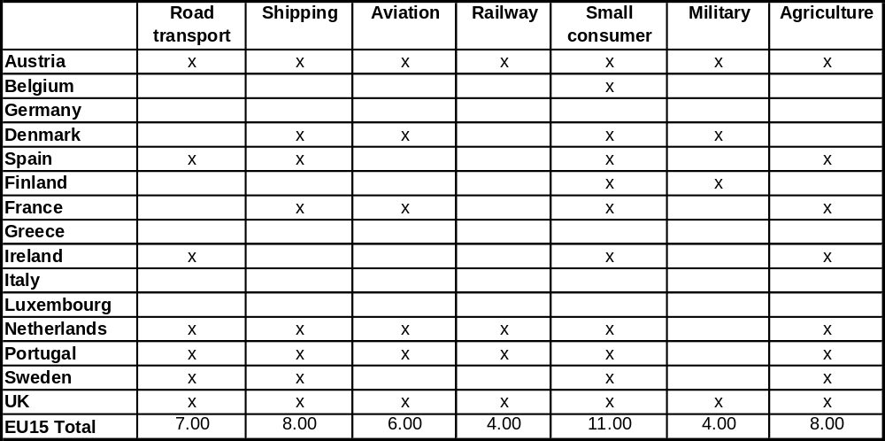

Table 5.5.97 shows that only for “small consumer fuel combustion”, 11 MS did report emissions, for other source categories, the amount of MS, reporting specific emissions ranges between 4 an 8.

Coverage of emission sources
A next parameter to be evaluated is the coverage of emission sources. Therefore all emission sources, taken into account in the RAR and the E-PRTR are listed, in order to evaluate whether one of the studies lacks sources and to what extent this difference in coverage of sources influences (or may influence) the total emission data. Note that only emission sources to the air are taken into account, since only these sources are only reported in the PRTR for heavy metals.
The identified sources for atmospheric emissions, taken forward in the RARs and the E-PRTR are shown and compared in Table 5.5.98.

Table 5.5.98: Overview of the emissions sources, identified in the RAR’s and the E-PRTR
LEAD RISK ASSESSMENT |  | E-PRTR Diffuse sources
Sources | Source definition | Sources | Source definition
Industry |  | /
Combustion | This source includes emissions from combustion processes in industry | /
Process emissions | This source includes emissions from combustion processes in industry | /
Households | This sector includes air emissions from residential heating | Small consumer fuel combustion | Small consumer fuel combustion is a diffuse source sector used within the inventory of releases to air. It corresponds to emissions from fuel combustion in widespread and scattered appliances. Thus data in the inventory sum up NFR codes 1A4a "commercial and institutional fueo combustion" as well as NFR 1A4b "residential combustion", including residential plants and mobile household and gardening appliances.
Waste management | For emissions to air, emissions from waste incineration plants are included here. | /
Agriculture | Emissions to air from agricultural sources only include emissions from heating (stables, greenhouses, …) | Agriculture | With respect to releases to air, agriculture sums up releases from fuel combustion in agriculture, fishing and forestry (NFR 1A4c), enteric fermentation (NFR 4D), manure managements (NFR 4B), rice cultivation (NFR 4C), agricultural soils (NFR 4D), field burning of agricultural wastes (NFR 4F)and other agricultural processes (NFR 4G) These sub-categories are not always strictly diffuse but it can be stated that a maximum of 10% of the releases compiled under agriculture as diffuse source sector in this inventory might originate from point sources as defined under E_PRTR in reality.
Traffic |  | /
Road transport | Road transport includes emissions from exhaust fumes, wear (road, tyre, brake). | Road transport | Road transport is a diffuse source sector used for the inventory of releases to air. Data in the inventory sum up figures from NFR codes NFR 1A3b "fuel combustion in road transportation" including (i-vii) combustion releases from passenger cars, light and heavy duty, mopeds and motorcycles, gas evaporation, tyre and brake wear and road abrasion and NFR 1A3e "other transportation" composed of pipeline compressors and other mobile machinery.
Rail transport | Rail transport includes emissions from exhaust fumes, wear of overhead wires and collector shoes | Railway | Railway is a diffuse source sector used in the inventory of releases to air. In this context data compiled in the inventory refer solely to releases from fuel combustion (NFR 1A3c).
Water transport | This sector includes emissions from exhaust fumes from:  - ships – inland waterways  - ships – marine navigation  - ships at berth  - boats | Shipping | Shipping is a diffuse source sector used for the inventory of releases to air. In this context exclusively releases from fuel combustion from NFR code "national navigation" (NFR 1A3d ii) have been summed up.
Air transport | This sector includes emissions from exhaust fumes during LTO and for auxiliary and general power units. | Aviation | Aviation is a diffuse source sector used in the inventory of releases to air. In this context only releases from domestic aviation (1A3a ii including LTO and cruise) have been summed up.
/ |  | Military | Military is used as a diffuse source sector in the inventory on releases to air. Figures reported for this sector correspond to "other stationary fuel combustion activities including military" (NFR 1A5a) and "other mobile fuel combustion activities including military" (NFR 1A5b). Stationary activities are included as military installations are similarly scattered and widespread as is the residential sector and are not included in reporting on "large" point sources..
/ |  | Solvent use | The diffuse source sector solvent use listed in the inventory of releases to air sums up data for paint application (NFR 3A), degreasing and dry cleaning (NFR 3B) and other applications including products containing HM and POPs (3D). Available data for this sector are not strictly diffuse, but partially include releases from point sources like the chemical industry. These sectors are not strictly diffuse; however based on comparison of data with EPER, it can be stated that a maximum of 10 % of the releases compiled under solvent use as diffuse source sector in this inventory might originate from point sources.
/ |  | Fossil fuel distribution
/ |  | Roofing and road paving with asphalt | Asphalt roofing and road paving with asphalt is a diffuse source sector used in the inventory of releases to air summing up data from NFR codes 2A5 and 2A6.

It can be concluded that important differences exist between the sources coverage in the RARs and the E-PRTR. Most important differences are:
- the E-PRTR does not include industrial sources, in contrast with the RAR’s;
- the E-PRTR covers sources like solvent use, fossil fuel distribution, roofing and road paving with asphalt, which are not taken into account in the RAR’s; these sources are however not important in the framework of heavy metal emissions; the source ‘military ’ is not included in the RAR and may contribute to heavy metal emissions.

Emission data per individual source
In this third step of the study, the actual emission data per individual source are compared in order to detect important differences.
Except for the emissions from industry, the Pb-emissions to air in the RAR’s are estimated for the EU15 as a whole and not as the sum of emissions from individual countries. Therefore, emission data cannot be compared on a country-basis but only on EU15 level.
Table 5.5.99 shows the comparison between the lead emissions reported in the E-PRTR and the RAR’s.
Table 5.5.99: Total atmospheric lead emission data in the EU15 reported in the RAR and the E-PRTR (kg Pb/year)
SOURCES | E-PRTR (EU-15) |  | ECOLAS (EU-15)
SOURCES | Emissions  (kg Pb/year) | Number of countries reported | Emissions  (kg Pb/year)
Road transport | 45135 | 7.00 | 5014
Shipping | 459 | 8.00 | 138
Aviation | 18381 | 6.00 | 11040
Railway | 350 | 4.00 | 15867
Small consumer fuel combustion | 45675 | 11.00 | 62047
Military | 329 | 4.00
Agriculture | 639 | 8.00 | 119
TOTAL | 110968 |  | 94225

Table 5.5.99 shows that total emissions reported for those 7 sectors are quite comparable, being 94 tons in the E-PRTR compared to 111 tons in the Pb-RAR. Looking at individual sources however, important differences are detected. For the sector “road transport” however the emissions reported in the RAR (being representative for the EU15) are only 11% of the emissions reported in the E-PRTR, representing the emissions from 7 MS. Emissions from “aviation”, are in the E-PRTR (for only 6 MS) about 66% higher than those estimated in the RAR (representing emissions from 15 MS). “Railway” emissions are much higher in the RAR (16 tons compared to 350 kg), which is logic since the E-PRTR only reports emissions from 4 MS. Taking into account that for “small consumer fuel combustion” the RAR estimates 62 tons for 15 MS and the E-PRTR reports 46 tons for 11 MS, it can be concluded that these data are comparable.

References

Amundsen C.E., Almas A. and Singh B.R. (2000). Risk assessment of Cd in mineral fertilisers in Norway using model calculations.
Annema J.A. (1991). Mogelijkheden en onmogelijkheden van ketenbeheer zink, RIVM rapportnummer 736301013, Bilthoven. (Possibilities and impossibilities of zinc life cycle management)
Appelman W., van den Roovaart J.C. and Hulskotte J. (2005). Schroefasvet binnenscheepvaart. (Propeller shaft grease inland waterways).
Blok (2002). Data review and model development for exposure of road borders soil to zinc. Final report. Commissioned by the Risk Assessment Management Team of IZA-Europe.
Bonten F.T.C. and Römkens P.F.A.M. (2004). Uitspoeling van zware metalen uit landbouwgronden. Modellering van uitspoeling op regionale schaal: modelaanpak en resultaten modelberekening. (Leaching of heavy metals from agricultural soil. Modelling of leaching on a regional scale).
BUWAL (1995) in Hulskotte et al. (1999). Handbuch emissionsfaktoren für stationäre Quellen, Ausgabe 1995.
Callebaut, K. & Vanhaecke, P. (2001). Actualisatie van stofstroomdossiers voor Vlaanderen in het kader van de Derde Noordzeeverklaring: groep metalen. Eindrapport van een studie in opdracht van de VMM. (Update of life cycle documents for Flanders in the framework of the Third North Sea Conference. Study on behalf of the VMM)
CBS (2003). On line information as available on 22/01/2003 (http://statline.cbs.nl/StatWeb/start.asp?lp=Search/Search).
CITEPA (2002). Inventaire des émissions de polluants dans l'atmosphère en France. (Inventory of air emissions in France).
Coops O. et.al. (1995). Emissies uit stortplaatsen. Publicatiereeks emissieregistratie nr. 28. (Study on emissions from landfills).
COWI (2000). Paradigm for Substance Flow Analyses. Environmental Project No. 577 2000. Guide for SFAs carried out for the Danish EPA.
COWI (2004). Advantages and drawbacks of restricting the marketing and use of lead in ammunition, fishing sinkers and candle wicks. Draft final report, August 2004, for the European Commission Enterprise Directorate-General.
CUWVO (1999). Handreiking regionale aanpak diffuse bronnen: werkgroep VI. Bijwerking voor 1999. (Manual on regional approach towards diffuse sources: working group VI. Update for 1999).
Davis A.P. et al. (2001). Loading estimates of lead, copper, cadmium, and zinc in urban runoff from specific sources. Chemosphere nr. 44, p. 997-1009.
De Graaf W.J. and Eleveld H. (1993). Bladlood in woningbouw. Loodemissies via het regenwater. Rapport nr. 16570. Bouwcentrum Advies, Rotterdam. (Study on lead sheet in residential building. Emissions of lead through rainwater).
Delahaye et al. (2003). Emissie van zeven zware metalen naar landbouwgrond. Centraal Bureau voor de Statistiek. Voorburg/Heerelen. (Emissions of seven heavy metals to agricultural soil).
Desmet H. et.al. (2001). Bepaling van het huishoudelijk lozingsgedrag in Vlaanderen in het kader van de wetenschappelijke onderbouwing van de milieuheffing. EPAS nv, studie in opdracht van VMM. (Determination of municipal wastewater in Flanders in the framework of the environmental levies, study on behalf of VMM).
EC (2003). European Commission. Economic and Financial Affairs. Economic studies and research. Indicators.Ameco database. Online information available on 17/04/2003.
http://europa.eu.int/comm/economy_finance/indicators/annual_macro_economic_database/ameco_applet.htm
ECOLAS (2005a). Assessment of point and diffuse environmental sources of copper and copper compounds as a basis for regional exposure assessment under European Council Regulation (EEC) N°793/93. Study commissioned by the European Copper Institute (ECI). Draft April 2005.
ECOLAS (2005b). Assessment of point and diffuse environmental sources of nickel and nickel compounds as a basis for regional exposure assessment under European Council Regulation (EEC) N°793/93. Study commissioned by the Nickel Producers Environmental Research Association (NiPERA). January 2005.
EEA (2003). EMEP-CORINAIR atmospheric emission inventory guidebook. Third edition. European Environmental Agency.
Elzenga et.al. (1998). PROMISE: een scenariomodel voor de prognoseberekening van emissies naar het oppervlaktewater. Rapport nr 773003006. In opdracht van RIVM/RIZA.
Emissieregistratie RIVM Nederland. Emissions from 1999 (1998 for air). Data asked through http://dm.milieumonitor.net/
Environment Australia (1999a). Emissions Estimation Technique Manual for Aggregated Emissions from Commercial Ships/Boats and Recreational Boats. September 1999 Version 1.0.
Environment Australia (1999b). Emissions Estimation Technique Manual for Aggregated Emissions from Domestic Lawn Mowing. November 1999 Version 1.0.
Environment Australia (1999c). Emissions Estimation Technique Manual for Aggregated Emissions from Paved and Unpaved Roads. September 1999 Version 1.0.
EPA (1995). Compilation of Air Pollutant Emission Factors, AP-42, fifth edition, U.S. Environmental Protection Agency, Research Triangle Park, North Carolina, November 1996.
Esher-Antes (1994). Stofdossier lood. Eindrapport van een studie, opgemaakt in opdracht van de Vlaamse Milieumaatschappij. (Life cycle document on lead. Study on behalf of the VMM).
Euras (2004). Waste stream analysis and emission assessment.
Euras, KUL and Ecolas (2005). European Union Environmental Risk Assessment on lead metal (CAS no: 7439-92-1), lead oxide (CAS no: 1317-36-8), lead tetroxide (CAS no: 1314-41-6 and lead stabiliser compounds. Draft April 2005.
European Commission (2001). Pollutants in urban waste water and sewage sludge. 61 p.
European Commission (2003). Sewage sludge: current situation in the EU and future perspectives. Presentation from Luca Marmo of DG Environment.
Eurostat (2003a). Datashop. Industry, trade and services. Manufacturing - value of production at current prices - in Mio ECU - annual. http://europa.eu.int/comm/eurostat/Public/datashop/print-product/EN?catalogue=Eurostat&Product=4-t4050toa-EN&mode=download
Eurostat (2003b). Energy and transport in Figures. European Union: gross electricity generation. http://europa.eu.int/comm/energy_transport/etif/energy_electricity/generation.html
Eurostat (2003c). Energy and transport in Figures. European Union: final energy consumption. http://europa.eu.int/comm/energy_transport/etif/energy_general_overview/final_consumption.html
Eurostat (2003d). Energy and transport in Figures. General data: population. http://europa.eu.int/comm/energy_transport/etif/general_data/population.html
Eurostat (2003e). Energy and transport in Figures. Transport: passenger transport: passenger cars. http://europa.eu.int/comm/energy_transport/etif/transport_passenger_a/road_car_pkm.html
Eurostat (2003f). Energy and transport in Figures. Transport: passenger transport: buses and coaches. http://europa.eu.int/comm/energy_transport/etif/transport_passenger_a/road_buses_pkm.html
Eurostat (2003g). Energy and transport in Figures. Transport: goods transport: road: haulage on national transport. http://europa.eu.int/comm/energy_transport/etif/transport_goods_a/road_haulage_territory.html
Eurostat (2003h). Energy and transport in Figures. Transport: means of transport: Inland waterways transport equipment. http://europa.eu.int/comm/energy_transport/etif/transport_means_other/iww_equipment.html
Eurostat (2003i). Energy and transport in Figures. Transport: goods transport: sea port traffic (major seaports). http://europa.eu.int/comm/energy_transport/etif/transport_goods_a/sea_seaports_tonnes.html
Eurostat (2003j). Energy and transport in Figures. Transport: infrastructure: railways (length of lines). http://europa.eu.int/comm/energy_transport/etif/transport_infrastructure/rail_length_lines.html
Eurostat (2003k). Energy and transport in Figures. Transport: means of transport: major airports, total movements of aircrafts. http://europa.eu.int/comm/energy_transport/etif/transport_means_other/movements_of_aircraft.html
Eurostat, Statistical Office of the European Communities (2003). Datashop. Webpage available at 21/03/2003.
http://europa.eu.int/comm/eurostat/Public/datashop.
FAO (2004). Statistics on livestock in Europe. FAOSTAT.
http://faostat.fao.org/faostat/servlet
Finfood (2004). Statistics on use of fertilisers and lime in Finland.
http://www.finfood.fi/finfood/
Fuchs S. et.al. (2002). Emissions of heavy metals and lindane into river basins of Germany, on behalf of the Federal Environmental Agency (Umweltbundesambt). Report number UBA-FB 200 22 233.
Graaf, de, W.J. and Eleveld H. (1993) Bladlood in woningbouw. Loodemissies via het regenewater, Rapportnr. 16570. Bouwcentrum Advies, Rotterdam. In Bentum F, Verstappen G.G.C. and Wagemaker F.H. (1996). WSV-doelgroepstudie bouwmaterialen, een analyse van de problematiek in aquatisch milieu.
Haskoning (2000). Onderzoek naar emissies uit huishoudens. Eindrapport van een studie in opdracht van het Rijksinstituut voor Integraal Zoetwaterbeheer en Afvalwaterbehandeling (RIZA). Ref. H2425.AO/R005/IK/AS. (Study on emissions from households. Final report of a study on behalf of the RIZA).
Hillenbrand T., Dominik T., Böhm E., Fuchs S., Scherer U., Rudolphi A. and Hoffmann M. (2005). Discharges of copper, zinc and lead to water and soil – analysis of the emission pathways and possible emission reduction measures.
Hulskotte J.H.J., Sulilatu W.F. and Willemsen A.J. (1999). Monitoringsystematiek openhaarden en houtkachels. TNO-rapport TNO-MEP R 99/170. (Monitoring system of fire places and wood stoves).
ICON (2001). Pollutants in urban wastewater and sewage sludge. Final report for Directorate-General Environment of the European Commission.
ICPR (1996). Procedure, basics and models for the inventory of diffuse contributions 1996. International Commission for the Protection of the Rhine (C-d 1/96, rev. 5.05.97).
IFA (International Fertiliser Industry Associaton, 2004). Nitrogen, phosphate and potash statistics 1973-1973/74 to 2001-2001/02. http://www.fertilizer.org/ifa/statistics/IFADATA/dataline.asp).
IISI (2001). International Iron and Steel Institute. Steel statistical yearbook 2001.
IWSA (1999). Data on water consumption in Europe from 1997. Water Congress 1999. The International Water Services Association (IWSA) is now called the International Water Association (IWA).
Jenkins David (1998). The effect of reformation of household powder laundry detergents on their contribution to metals levels in wastewater. Water Environment Research, Volume 70, Number 5, p. 980-983.
Jönsson H. et.al. (1997). Source separated urine-nutrient and metal content, water saving and faecel contamination. Water Science and Technology, Volume 35, Number 9, p. 145-152.
Klein, J., van den Brink, R., Hoen A., Hulskotte, J., van Duynhoven N., van de Burgwal E. en Broekhuizen D. (2004). Methoden voor de berekening van de emissies door mobiele bronnen in Nederland (Methodologies for the calculation of emissions from mobile sources in the Netherlands). Rapportagereeks Milieumonitor Nr. 13, Februari 2004.
Klein, J., van den Brink, R., Hulskotte, J., Annema, J.A., van den Roovart, J., Borst, M., Gense, R. & van de Burgwal, E. (2002). Methoden voor de berekening van de emissies door mobiele bronnen in Nederland (Methodologies for the calculation of emissions from mobile sources in the Netherlands). Rapportagereeks Milieumonitor Nr. 4, Januari 2002.
Lewis, R.J. & Caldwell, D.J. (1999). Scientific basis for an air quality standard for nickel. Prepared for CONCAWE, report N° 99/53.
LLINCWA (2001). Newsletter nr. 1-2. Greases in and around surface water. The Llincwa-project is sponsored by the European DG Enterprise.
MATE (2002). Principaux rejets industriels en France. Bilan de l'année 2000. (Inventory of the principal industrial emissions in France).
Milieumonitor (2002a). Datawarehouse Emissieregistratie Nederland. ERC-Metadata. RWZI Effluent. http://dwhont.geodan.nl:4322/.
Milieumonitor (2002b). Datawarehouse Emissieregistratie Nederland. ERC-Metadata. Vuurhaarden. http://dwhont.geodan.nl:7778/.
Milieumonitor (2002c). Datawarehouse Emissieregistratie Nederland. ERC-Metadata. Industrie bijschatting water. http://dwhont.geodan.nl:4322/.
Milieumonitor (2002d). Datawarehouse Emissieregistratie Nederland. ERC-Metadata. Industrie bijschatting lucht. http://dwhont.geodan.nl:4322/.
Nicholson F.A., Smith S.R., Alloway B.J., Carlton-Smith C., Chambers B.J. (2003). An inventory of heavy metals inputs to agricultural soils in England and Wales.
Nordic Council of Ministers (2003). Lead Review. Prepared by COWI.
OECD (Organisation for Economic Development and Co-operation) (2004). Key environmental indicators.
Pagotto, C. (1999). Etude sur l’émission et le transfert dans les eaux et les sols des éléments traces métalliques et des hydrocarbures en domaine routier. Thèse pour obtenir le grade de docteur de l’Université de Poitiers. Discipline: chimie et microbiologie de l’eau. Présentée et soutenue publiquement, à l’école des Mines de Nantes.
Piron, C. & Vanderborght, J-P. (2001). Reactualisation des dossiers relatifs à l’émission de substances prioritaires en Belgique. Plomb: rapport final. Etude coordonnée par l’Unité de Gestion du Modèle Mathématique de la Mer du Nord et de l’Estuaire de l’Escaut. (Updating of documents on emissions of priority substances in Belgium. Lead: final report. Study co-ordinated by the Management Unit of the North Sea Mathematical Models).
Richardson, G.M., Garrett, R., Mitchell, I., Mah-Paulson, M. & Hackbarth, T. (2001). Critical review on natural global and regional emissions of six trace metals to the atmosphere. Prepared by Risk Scientific Services, Inc. for the International Lead Zinc Research Organization (ILZRO), the International Copper Association (ICA), and the Nickel Producers Environmental Research Association (NiPERA).
Römkens P.F.A.M., Bonten L.T.C., Rietra R.P.J.J., Groenenberg J.E., Plette A.C.C. and Bril J. (2003). Uitspoeling van zware metalen uit landbouwgronden. Schatting van de bijdrage van de uitspoeling uit landbouwgronden aan de belasting van het oppervlaktewater: modelaanpak en resultaten. (Leaching of heavy metals from agricultural soil. Estimation of the contriubtion of leaching from agricultural soils to the total load to surface water).
Scheinost A..C. 2003. Literature review: weathering rates of lead in soil and controlling factors. Report by Andreas Scheinost for LDAI.
Scheuhammer A.M., Money S.L., Kirk D.A. and Donaldson G. (2003). Lead fishing sinkers and jigs in Canada: review of their use patterns and toxic impacts of wildlife. Occasional paper, Number 108, Canadian wildlife service.
STORA (1985) in Haskoning (2000). Het inwonersequivalent getoetst. RIZA, 1985.
Stotz G. and Knoche G. (1999). Herkunft und Auswirkungen von Cu, Zn, Pb, und Hg aus diffusen Quellen auf Oberflächengewässer. Teil A. UBA Forschungsvorhaben 295 24 519 Berlin, p. 121-23.
Swedisch EPA (1993). Metals and the environment. The environment in Sweden - Status and Trends.
Swedish EPA & Statistics Sweden (2002). Discharges to water and sludge production in 2000: municipal waste water treatment plants and some coastal industry.
TGD (2003). Technical Guidance Document on Risk Assessment in support of Commission Directive 93/67/EEC on Risk Assessment for new notified substances, Commission Regulation (EC) No 1488/94 on Risk Assessment for existing substances and Directive 98/8/EC of the European Parliament and of the Council concerning the placing of biocidal products on the market. Part II: Environment.
Thornton, I., Rautiu, R. & Brush, S. (2001). Lead the facts. An independent report on Lead and its industry. Prepared by IC Consultants Ltd, London, UK.
US EPA (1997). Compilation of Air Pollution Factors, vol 1, Stationary Point and Area Sources, AP-42, 5th ed, Supplement D, Section 13.2.1. Paved Roads, US EPA, Research Triangle Park, North Carolina, USA.
US EPA (1998). Compilation of Air Pollution Factors, AP-42, 5th edition, US EPA Research Triangle Park, North Carolina, USA.
US EPA (1998). Compilation of Air Pollution Factors, vol 1, Stationary Point and Area Sources, AP-42, 5th ed, Supplement E, Section 13.2.2. Unpaved Roads, US EPA, Research Triangle Park, North Carolina, USA.
Van Bentum et.al. (1996). WSV-doelgroepstudie bouwmaterialen: een analyse van de problemen in aquatisch milieu. Watersysteemverkenningen 1996. RIZA nota nr. 96.023.
Van Bon J. and Boersema JJ. (1988). Sources, effects and management of metallic leas pollution: the contribution of hunting, shooting and angling. Contam. Soil 3, 269-271
Van den Roovaart J.C. (2001). Schroefasvet binnenscheepvaart. Emissieschattingen diffuse bronnen, volgnummer 1. Werkdocument in opdracht van het Rijksinstituut voor Integraal Zoetwaterbeheer en Afvalwaterbehandeling (RIZA). Ref. 2001.088X. (Study on leaching of propeller shaft grease from boats. Report of a study on behalf of the RIZA).
Van der Most, P.F.J. & Veldt, C. (1992). Emission factors manual PARCOM-ATMOS. Emission factors for air pollutants 1992. Reference number 92-235.
Van der Most, P.F.J. et al. (1998). Publicatiereeks emissieregistratie nr. 44. Methoden voor de bepaling van emissies naar lucht en water. (Methodologies for the determination of emissions to air and water).
Van Rompaey, H., Theys, G. & Wuyts, H. (2000). Collectieve registratie van industriële emissies: bijwerking voor 1998. Studie uitgevoerd in opdracht van de VMM, contract 991428/N9325. (Collective registration of industrial emissions: update for 1998. Study carried out on behalf of the VMM).
van Tilborg W.J.M. (2004). Non-ferrous metals balances in agricultural soils. Report no 0303.
Veldt C. (1993). Emissiefactoren microverontreiniging uit verbrandingsprocessen, Publikatiereeks Emissieregistratie, Rapportnr 9, April 1993.
Waeterschoot H., van Tilborg W. and Coursier A. (2001). Discussion document on agricultural scenario’s for the regional and continental analysis of the Zn Risk assessment Report.
Wilson D.N. (2003). Atmospheric corrosion of lead. (European Lead Sheet Industry Association).
Contacts
LDA: Paul Marsh (tel: 0044/20/7499 8422; fax: 0044/20/7493 1555; mail: marsh@ldaint.org

Annexes
Annex 1: Description of emission inventories for Pb for different EU-15 Member States.
1 Emissions of lead in Austria
Point and diffuse emissions of lead to the different environmental compartments in Austria are listed in Table 1.
Table 1: Point and diffuse sources of lead in Austria (cf. Excel-sheet in Annex 2)
A detailed documentation of the methodology for the preparation of the Austrian air inventory system for heavy metals is not yet available.
Emission data for lead were taken from Austria’s annual reporting obligation under the UNECE/CLRTAP convention and its Protocols for the year 2001. The new “Nomenclature For Reporting” format (NFR) was used. The inventory itself follows the EMEP/CORINAIR Atmospheric Emission Inventory Guidebook. The reporting is based on the Austrian Air Emission Inventory 2001 (Österreichische Luftschadstoff-Inventur, OLI 2001), prepared by the Federal Environment Agency Austria for the years 1980-2000. The latter only reports lead emissions as total anthropogenic national annual emissions. For the year 2000 these emissions equalled 13.18 tons.
The UNECE/EMEP Emission Database (WebDab) combines two types of emission data: officially reported emission data and expert estimates of emissions. Official emission data for year 2000 submitted before the end of April 2002 are included here, as well as expert estimates used by the Meteorological Synthesising Centre - West (MSC-W) of EMEP. Expert estimates are generally made in order to fill in gaps in the reported time series. All gridded data have been scaled by MSC-W, and are therefore regarded as expert estimates, even though they are based on reported data whenever available (http://webdab.emep.int).
A detailed inventory of air emissions for lead will not be provided before 2004 in the “Emission Data Report”,that will be compiled to meet the requirements of the UNECE Convention on Long-range Transboundary Air Pollution (CLRTAP).

2 Emissions of lead in Belgium
Quantification methodologies
This chapter reveals the methodologies, which were used to quantify the emissions of lead in Belgium.
Belgium is a federal state, which implies that the policy authority is divided between the federal government and the 3 regions being the Flemish Region, the Walloon Region and the Brussels Capital Region. Since the regions act autonomously in reporting their emissions, they may use different calculation methods. Because of this, a distinction to the regional level is necessary to clarify the reported national lead emissions.
For each emission source, the quantification methodology is explained. It accounts for all environmental compartments, unless otherwise stated.
Industry
Flemish Region: the Flemish Environmental Agency (VMM) administers the annual inventory of industrial emissions of various substances to air and to water: the Flemish Emission Registry (FER). For each substance a limit emission value to air and to water is set. Companies are obliged to report all emissions that exceed these limit values. These emissions are either measured or calculated from emission factors and an activity level. However, this distinction was not made for the reported emissions.
Refineries
Flemish region: emissions were measured/calculated by individual companies and reported to the FER;
Walloon Region: water: emissions were provided by the taxation of wastewater department of the DGRNE. Some data were based on measurements, other data were based on an conversion coefficient. No information regarding this factor was available.
It should be noted that emissions from the chemical industry are also included in the figure for refineries.
Power units
Flemish region:
- air: data from the Federation of Producers and Distributors of Electricity in Belgium (BFE). Emissions from the burning of charcoal are calculated from emission factors, which were approved by the Flemish and Brussels regional authorities. These factors are being adapted when new analyses become available or charcoal from new origins are used;
- water: emissions were measured/calculated by individual companies and reported to the FER;
Walloon Region:
- air: a distinction was made between emissions from charcoal and emissions from heavy fuel oil:
charcoal: emissions are calculated from an emission factor and the amount of charcoal used. Due to the complex calculation methodology the BFE preferred to provide emissions, rather than basic data;
heavy fuel oil: emissions are calculated as:
E (kg) = EF*10⁻³ * amount of heavy fuel oil used in Belgium (tons) * DC;
where:
- EF = emission factor of 1.1 g Pb/ton fuel from the PARCOM-ATMOS emission factors manual (van der Most & Veldt, 1992). It was assumed that all of the lead, contained in the fuel, was emitted to the air;
- DC = regional distribution code regarding the use of liquid combustibles (90% FR, 10% WR and 0% BCR). This distribution code is account for by the correction factor;
- water: data were obtained from the taxation of wastewater department of the Walloon Region. Some data were based on measurements, other data were based on an emission factor from sector-specific studies. No information regarding this factor was available.
Brussels Capital Region: no activity.
Iron- and steel industry
Flemish Region: emissions were measured/calculated by individual companies and reported to the FER;
Walloon Region:
- air: data are taken from the CORINAIR inventory 1997. However, it is not clear whether the reported emissions were based on measurements or whether they were calculated from emissions factors;
- water: the emissions were calculated from the measured concentrations in the wastewater and the volume of wastewater discharged. This information was obtained from the taxation of wastewater department of the Walloon Region. Some data were based on measurements, other data were based on an emission factor from sector-specific studies. No information regarding this factor was available. It should be noted that the figure only includes emissions from iron production and cokes production (cokeries et usines a gaz).
Brussels Capital Region: no activity.
Metallurgy
Flemish Region: water: emissions were measured/calculated by individual companies and reported to the FER.
Non ferro industry
Flemish region: emissions were measured/calculated by individual companies and reported to the FER;
Walloon Region:
- Air: the report refers to the CORINAIR database. However, it is not clear whether the reported emissions were based on measurements or whether they were calculated from emissions factors;
- Water: the emissions were calculated from the measured concentrations in the wastewater and the volume of wastewater discharged. This information was obtained from the taxation of wastewater department of the Walloon Region. Some data were based on measurements, other data were based on an emission factor from sector-specific studies. No information regarding this factor was available;
Brussels Capital Region: air: emissions were extrapolated from a study, performed by the federation of the non ferro industry. In this study, emissions from the Flemish non ferro industry were measured in the period 1985-1990. Emissions for 1995 were estimated, based on future emission reduction measures and alternative fuels. The following assumptions were taken into account to estimate emissions for the BCR:
- on the basis of primary and secondary production is was assumed that 75% of the emissions originate in Flanders;
- it was assumed that 20% of the Belgian emissions originated from the Walloon Region and 5% from the Brussels Capital Region;
- it was assumed that the annual emission reduction rate equals 10% in the Walloon Region and the BCR.
Metal processing industry
Flemish region: emissions were measured/calculated and reported by individual companies;
Walloon Region: water: data were obtained from the taxation of wastewater department of the Walloon Region. Some data were based on measurements, other data were based on an emission factor from sector-specific studies. No information regarding this factor was available.
Mineral non metal production
Flemish region: emissions were entirely due to the glass industry:
- air: emissions were reported by the Belgian Federation for the Glass Industry;
- water: emissions were measured/calculated and reported by individual companies to the FER;
Walloon Region:
- air: data were provided by the Belgian Federation for the Glass Industry;
- water: data were obtained from the taxation of wastewater department of the Walloon Region. Some data were based on measurements, other data were based on an emission factor from sector-specific studies. No information regarding this factor was available;
Brussels Capital Region: air: emissions were calculated from:
- national production figures;
- an emission factor: 1 g Pb/ton glass (van der Most & Veldt, 1992);
- a regional distribution of the production being: 60% FR, 30% WR and 10% BCR. The latter is represented by the correction factor.
Textile industry
Flemish region: water: emissions were measured/calculated and reported by individual companies;
Walloon Region: water: data for 1998 cover the textile and the leather industry. They were obtained from the taxation of wastewater department of the Walloon Region. Some data were based on measurements, other data were based on an emission factor from sector-specific studies. No information regarding this factor was available. Data for the year 1999 were obtained in the same manner. They solely originate from the textile refining industry.
Chemical industry
Flemish region: water: emissions were measured/calculated and reported by individual companies;
Walloon Region:
- air: data were provided by the CORINAIR emission inventory. However, it is not clear whether the reported emissions were based on measurements or whether they were calculated from emissions factors;
- water: cf. source “refineries”, for the year 1998. For the year 1999, data were obtained from the taxation of wastewater department of the Walloon Region. Some data were based on measurements, other data were based on an emission factor from sector-specific studies. No information regarding this factor was available. The following sectors are included: organic chemical industry, manufacturing of detergents, transformation of plastics, production of chlorinated hydrocarbons and other chemical industries.
Food and stimulants industry
Flemish region: water: emissions were measured/calculated and reported by individual companies;
Walloon Region: water: data were obtained from the taxation of wastewater department of the Walloon Region. Some data were based on measurements, other data were based on an emission factor from sector-specific studies. No information regarding this factor was available. For the year 1999, the following sectors were included: dairies, preparation of fish, beverage industry, slaughterhouses, conservation of fruit and vegetables, transformation of meat, treatment of potatoes and finally animal and vegetable fats and oils.
Rubber & plastics
Flemish Region: emissions were measured/calculated and reported by individual companies;
Walloon Region: water: data were obtained from the taxation of wastewater department of the Walloon Region. Some data were based on measurements, other data were based on an emission factor from sector-specific studies. No information regarding this factor was available.
Paper and editing industry
Flemish Region: water: emissions were measured/calculated and reported by individual companies. This source also covers the graphical industry;
Walloon Region: water: data were obtained from the taxation of wastewater department of the Walloon Region. Some data were based on measurements, other data were based on an emission factor from sector-specific studies. No information regarding this factor was available. It should be noted that the reported data for 1998 also include emissions from the graphical industry. No information regarding the emission factor used to calculate the latter was available.
Graphical industry
Flemish Region: air: cf. the source “paper and editing industry”;
Walloon Region: water: cf. the source “paper and editing industry”, for the year 1998.
Surface treatment
Flemish region: water: emissions were measured/calculated and reported by individual companies.
wood and furniture manufacturing industry
Flemish region: air: emissions were measured/calculated and reported by individual companies.
Lime industry
Walloon Region: air: data were taken from the CORINAIR inventory (1998). However, it is not clear whether the reported emissions were based on measurements or whether they were calculated from emissions factors.
Laundries
Walloon Region: water: data were obtained from the taxation of wastewater department of the Walloon Region. Some data were based on measurements, other data were based on an emission factor from sector-specific studies. No information regarding this factor was available.
Paint, varnish and ink manufacturing industry
Walloon Region: water: data were obtained from the taxation of wastewater department of the Walloon Region. Some data were based on measurements, other data were based on an emission factor from sector-specific studies. No information regarding this factor was available.
Production of drinking water
Walloon Region: water: emissions were provided by the taxation of wastewater department of the DGRNE. Some data were based on measurements, other data were based on a conversion coefficient. No information on these factors was available.
Car repair facilities
Walloon Region: water: emissions were provided by the taxation of wastewater department of the DGRNE. Some data were based on measurements, other data were based on a conversion coefficient. No information on these factors was available.
(Sand) quarries, cement prodution, dredging
Walloon Region:
- air: data for cement production were taken from the CORINAIR inventory (1998). However, it is not clear whether the reported emissions were based on measurements or whether they were calculated from emissions factors;
- water: data were obtained from the taxation of wastewater department of the Walloon Region. Some data were based on measurements, other data were based on an emission factor from sector-specific studies. No information regarding this factor was available.
Other industries
Walloon Region:
- air: the source “other industries” includes emissions from metallic constructions. It is not specified from which process the emissions arise. The data was taken from the CORINAIR-inventory, however it was not reported how the emissions were quantified;
- water: data were obtained from the taxation of wastewater department of the Walloon Region. Some data were based on measurements, other data were based on an emission factor from sector-specific studies. No information regarding this factor was available. The following sources are included: pharmaceutical industry, laboratories, manufacturing industry, production of fireworks, the cleaning of barrels and the production of chipboards.
All industries
Brussels Capital Region:
- air: cfr. “glass industry”;
- water: emissions cover all industries except “non ferro” and “iron and steel”. It was not specified which industries were included. Emissions were calculated from data for the Flemish region, taking into account:
- the regional spreading of the industrial sectors involved;
- the delayed implementation, compared to Flanders, of legally binding tools such as wastewater quality standards and taxes on water use.
Industrial combustion processes
Flemish Region: air: emissions due to industrial combustion processes were calculated from a study, carried out by VITO (Van Rompaey & Wuyts, 1999). This study determined the collectively registered emissions for nine sectors from:
- the total sectoral energy use, registered by the Flemish Energy Balance;
- a sectoral correction factor, being the difference between the total sectoral energy use (Flemish Energy Balance) and the individually registered emissions (annual emission report);
- an emission factor for dust per fuel type;
- metal speciation profiles for dust, linked to the fuel type used.
The total lead emissions due industrial combustion processes were extrapolated by Ecolas from the collectively registered emissions by means of the sectoral correction factor.
Walloon Region: air: emissions were calculated from:
- the inventory of fuel, used in the Walloon Region;
- an emission factor of 1.1 g Pb/ton fuel used (van der Most & Veldt, 1992). This is an average value of a series of emission factors, experimentally determined in the Netherlands and Germany. It should be noted that this factor only relates to the burning of charcoal.
Households and public services
Burning of fossil fuels
Flemish Region: air: emissions were calculated from:
- the amount of coal/fuel used in Flanders;
- emission factors per fuel type (US EPA):
- individual heating charcoal: 0.00052 g/kg;
- central heating charcoal: 0.00648 g/kg;
- central heating gas oil: 0.05 g/m³;
- central heating light fuel oil: 6/10⁻⁵ g/kg;
- central heating medium heavy fuel oil: 0.00054 g/kg;
- central heating heavy fuel oil: 0.00053 g/kg;
- central heating extra heavy fuel oil: 0.00052 g/kg;
Walloon Region: air: emissions were calculated from:
- the Belgian fuel use inventory;
- an emission factor of 0.2 g Pb/ton diesel used (van der Most & Veldt, 1992). Since it was assumed that all metals in fuels are emitted, the emission factor results from a survey of the lead contents of diesel in the Netherlands;
- a regional distribution code for fuel use: 58% FR, 33% WR, 9% BCR. This code is accounted for in the correction factor;
Brussels Capital Region: cf. Walloon Region.
Direct discharge of wastewater
Flemish Region: water: emissions were calculated from:
- the number of inhabitants not connected to a STP;
- an emission factor of 840 mg Pb/pers.year for the antropogenic part (Haskoning, 2000);
- an emission factor of 60 mg Pb/pers.year for the natural part (feces, urine) (Haskoning, 2000);
Walloon Region: water: emissions were calculated from:
- the percentage of inhabitants not connected to a STP. This is accounted for in the correction factor;
- the annual amount of water used;
- an emission factor of 20 µg Pb/l water used (Berdowski (1996) in Piron & Vanderborght (2001));
Brussels Capital Region: cf. Walloon Region.
Corrosion of building materials
Walloon Region: water: the lead emission from the corrosion of building materials was extrapolated from Dutch data. A distinction was made between private and industrial buildings:
private buildings:
- the number of private buildings;
- an emission factor: 13 g Pb/building.year, based on:
- exposed lead surface in 1990: 15.7*10⁶ m² (van Bentum, F. et al, 1996 in CUWVO, 1999);
- corrosion factor in 1990: 5 g Pb/m².year (Annema, J.A. et al., 1991 in CUWVO, 1999). It was assumed that this factor did not change between 1990 and 1994;
- total number of houses in 1990: 5.892.000;
- partitioning between soil and surface water: 30%/70%. This is accounted for in the correction factor.
2) industrial buildings:
- exposed lead surface: extrapolated from the surface in 1990, taking into account a growth of the industrial area of 1.2% per year (RIVM);
- an emission factor: 0.124 g Pb/m².year (CUWVO, 1999), calculated from:
- lead surface in 1990: 12.5*10⁶ m² (van Bentum, F. et al, 1996 in CUWVO, 1999);
- corrosion factor in 1990: 5 g Pb/m².year (Annema, J.A. et al., 1991 in CUWVO, 1999). It was assumed that this factor did not change between 1990 and 1994;
- an industrial area of 503.860.000 m² in 1990;
- partitioning between soil and surface water: 30%/70%. This is accounted for in the correction factor.
Brussels Capital Region: cf. Walloon Region.
Hunting
Walloon Region: water: emissions were extrapolated from Dutch data, based on:
- the amount of cartridges used;
- an emission factor of 6.86*10⁻³ kg Pb/cartridge in 1994, based on:
- 7 millions of lead cartridges used (RIVM);
- 1.5 millions of cartridges used in 1994 * 0.0329 kg Pb/cartridge (Van Bon & Boersema, 1988, in CUWVO, 1999);
- partitioning between soil and surface water: 85%/15%.
The Dutch methodology assumes that 1% of the lead, emitted to surface waters, annually dissolves.
Fishing
Walloon Region: water: emissions were extrapolated from Dutch data, based on:
- the ratio of inhabitants in the Netherlands and in the Walloon Region;
- an emission factor of 1.84*10⁻³ kg Pb/pers in 1994, based on:
- 15.34 millions of inhabitants in 1994 (CBS);
- an emission of 28 tons of lead in fresh water, due to fishing lead (Working Group “Fishing lead”, 1994).
- The Dutch methodology assumes that 1% of the lead, emitted to surface waters, annually dissolves.
Waste management
Waste incineration
Flemish region: air: emissions were measured and reported by individual companies;
Walloon: air: emissions were obtained from a monitoring campaign (ISSEP), carried out in the years 1998-1999 at the 4 regional incinerators. From the lead emissions and the amount of domestic wasted burned in 1999, an emission factor of 1.28 g Pb/ton waste can be calculated. The factor relates to installations with electrofilters and a flue gas stripping system;
Brussels Capital Region: air: emissions were calculated from:
- the amount of waste incinerated;
- an emission factor of 1.35 mg Pb/m³ flue gas;
- a standard flow of flue gases: 5,000 Nm³/ton waste incinerated.
The emission factor is an average of 2 estimation methods:
- emission factor of 6.3 mg Pb/m³ flue gas from:
average dust concentration in flue gases in 1995: 63 mg/m³ (SIOMAB);
2% of lead in dust (van der Most & Veldt, 1992);
- emission factor of 1.44 mg Pb/m³ flue gas from:
average concentration of heavy metals (Pb+Cr+Cu+Mn) in flue gases in 1995: 1.8 mg/m³ (monitoring campaign, 1995);
share of lead in total heavy metal concentration: 80%.
Effluent of municipal sewage treatment plant
Flemish region: water: emissions were measured and reported by individual plants;
Walloon Region: water: emissions from STP are calculated by means of the following formula:
E (kg) = P_{c} * W*10⁻³ * EF*10⁻¹² * E_{ff}
where
P_{c}= the percentage of inhabitants connected to a STP;
W_{a} = the annual use of water (m³);
EF = an emission factor: 20 µg Pb/l water used (Berdowski (1996) in Piron & Vanderborght (2001));
E_{ff} = the efficiency of the STP: 69% (CBS (1996) in Piron & Vanderborght (2001)).
The correction factor takes into account the percentage of inhabitants connected to an STP and the efficiency of the STP.
Brussels Capital Region: cf. Walloon Region.
Waste recycling
Flemish region: emissions were measured and reported by individual companies.
Treatment and recycling of waste
Walloon Region: water: data were obtained from the taxation of wastewater department of the Walloon Region. Some data were based on measurements, other data were based on an emission factor from sector-specific studies. No information regarding this factor was available. The following treatment technologies are included: recycling, reconditioning, landfilling and incineration. Since an individual figure for landfilling was reported it is unclear whether this was included in the emission, reported under “treatment and recycling of waste”.
Landfills
Walloon Region: water: data were obtained from the taxation of wastewater department of the Walloon Region. Some data were based on measurements, other data were based on an emission factor from sector-specific studies. No information regarding this factor was available.
Agriculture
Drift of fertilizers
Flemish Region: water: emissions of lead to surface waters from drift of fertilisers was calculated according to the methodology of the International Committee for the Protection of the Rhine (ICPR, 1996):
E (kg) = load of lead in fertiliser (mg/kg) * amount of fertiliser used (kg) * drift factor * 10⁻⁶. The correction factor represents the drift factor;
Walloon Region: water: lead emissions to surface water due to drift of fertilisers was calculated from:
E (kg) = loss rate * 10⁻³ * amount of arable land (ha) * percentage entering surface waters;
where:
- loss rate = 27.6 g Pb/ha.year. It was assumed that the loss rate due to drift is twice the loss rate due to run-off (Feenstra et al (1986) in Esher-Antes (1994)). For manure, this is confirmed by the ICPR-methodology, when comparing the drift factor to the run-off factor;
- percentage entering surface waters: 2%.
It was assumed that the arable surface remained the same since 1991.
Run-off of fertilizers
Flemish Region: water: emissions of lead to surface waters from run-off of fertilisers was calculated according to the methodology of the International Committee for the Protection of the Rhine (ICPR, 1996):
E (kg) = load of lead in fertiliser (mg/kg) * amount of fertiliser used (kg) * run-off factor * 10⁻⁶. The correction factor represents the drift/run-off factor;
Walloon Region: water: lead emissions to surface water from run-off of fertilisers were calculated from:
E (kg) = loss rate * 10⁻³ * amount of arable land (ha) * percentage entering surface waters;
Where:
- loss rate = 13.8 g Pb/ha.year;
- percentage entering surface waters: 2%.
It was assumed that the arable surface remained the same since 1991.
Loss of fertilizers
Walloon Region: water: the loss of fertilizers covers the seepage of lead from sludge from STP, spread on agricultural land. No specific information regarding the quantification was provided.
Soil erosion
Flemish Region: water: emissions of lead to surface waters from soil erosion were calculated according to the methodology of the International Committee for the Protection of the Rhine (ICPR, 1996):
- E (kg) = load of lead in soil (mg/kg) * erosion rate (kg/ha.year) * 10⁻⁶ * amount of arable land (ha) * (1-sedimentation factor)
- where:
- erosion rate = 1.13 ton/ha.year;
- sedimentation factor = 0.9.
- The correction factor accounts for the soil erosion rate and the sedimentation factor.
Burning of fossil fuels
Walloon Region: air: lead emissions from the burning of fossil fuels in agriculture were already accounted for under ‘Households and public services’.
Traffic
Exhaust fumes
Flemish region: air: emissions were taken from a national environmental trends report (MIRA-S), which took into account emission restrictions due to the European Directive 98/70/EC. The emissions were allocated to densely populated and sparsely populated areas, by means of the percentage of kilometres travelled within these areas by passenger cars;
Walloon Region: air: emissions of lead due to exhaust fumes were calculated by means of:
- the number of vehicles per fuel type (gasoline/diesel);
- the fuel usage by vehicle type: total amount of fuel used/number of vehicles per fuel type:
- passenger car: 0.8738 tons/vehicle.year. It was assumed that the annual consumption of diesel equals the annual consumption of gasoline. It was also assumed that all gasoline was used by passenger cars;
- heavy/light duty vehicles: 6.989 tons/vehicle.year. This figure was calculated by subtracting the total annual amount of diesel consumed by passenger cars from the total annual diesel consumption. Subsequently this figure was divided by the number of heavy/light duty vehicles;
- an emission factor per fuel type:
- 0.15 g Pb/l / 0.76 kg/l * 75% emitted (van der Most & Veldt, 1992) = 197,4 g Pb/ton gasoline. The report does not mention how the lead content of gasoline was determined. From 01/01/2000, European directive 98/70/EC establishes a limit value for lead in gasoline of 0.005 g/l (or 6.58 g Pb/ton);
- 20 g Pb/kg diesel (van der Most & Veldt, 1992). This emission factor is an average of data, mentioned by several literature sources;
Brussels Capital Region: cf. Walloon Region.
Losses of lubricating oil
Flemish region: emissions were calculated by means of emission factors, set by the Netherlands (Berdowski et al. (1996) in CUWVO, 1999), and the number of kilometres driven in densely populated and sparsely populated areas. The emission factors were calculated, based on:
- profiles for road types (asphalt and stone);
- a ratio asphalt/stone of 2:1;
- vehicle type;
- number of kilometres driven per road type, distinguishing for densely populated and sparsely populated areas.
The following partitioning is taken into account:
- Emission factor densely populated area: 2.34 * 10⁻³ kg Pb/10⁶ km:
- Air: 50%;
- Water: 50%;
- Soil: 0%.
- Emission factor sparsely populated area: 26.2*10⁻⁴ kg Pb/10⁶ km:
- Air: 0%;
- Water: 20%;
- Soil: 80%.
Propeller shaft grease
Flemish Region: water: emissions were calculated by means of:
- the number of inland navigating boats;
- an emission factor of 1.28 kg Pb/boat (Working Group “Inland navigation (1997), in CUWVO, 1999), based on:
- 91.3 kg grease/boat with greased propeller shaft;
- 1.7 wt% Pb in grease
- 80% of boats have greased propeller shaft.
Country-specific information
The emissions shown in the Excell table, were calculated as explained under section of this Annex.
Table 2: point and diffuse emissions of lead in Belgium (cf. Excel-sheet in Annex 2)
All remarks, needed to accurately interpret these data, are given below on a source-specific basis. When no specification is made regarding the emission pathway (air/water), the remark applies to both compartments.
Industrial activities
No recent information was available regarding the aquatic emissions from industrial activities in the Brussels Capital Region. The estimated emissions for the year 1995 were extrapolated to the year 2000 by assuming a 50% emission reduction, since this was the trend for the other regions.
Iron and steel
Walloon Region: air: the following activities contribute to the emissions:
- Cokes production: 2,258 kg;
- Agglomeration: 27,129 kg;
- Pig iron/blast furnaces: 6,308 kg;
- Electrical furnaces: 20,598 kg.
Non ferro
Walloon Region: air: only the companies, which give raise to significant lead emissions, were taken into account (2 companies). Since 1995, one company uses a flue gas treatment system, which reduces dust emissions by 90%. It remains unclear how the emissions for the year 2000 were estimated for the other company.
Mineral non metal production
Brussels Capital Region: air: it is unclear how national production data were estimated for the year 1995.
Industrial combustion processes
Burning of fossil fuels to realize systems of general interest
Flemish Region: systems of general interest include production and distribution of electricity, of natural gas and the distribution of steam and water. Emissions due to the energy requirements to realise these activities are given.
Other industries
Flemish Region: the source ‘other industries’ includes:
- the wood and furniture industry;
- the rubber and plastics industry;
- the recycling of waste;
- the construction industry.
Walloon region: it should be noted that the emission factor used relates to the burning of coal. Since the activity data used include all fossil fuels, the emissions are not accurate. Whether the emissions are under or overestimated depends on the emission factor for fuel oil.
Households and public services
Burning of fossil fuels
Flemish Region: the quantity of the different types of fuel used were not specified. Only the overall emission was provided;
Walloon Region: emissions from the burning of fossil fuels also includes the emissions from this activity in the agricultural sector.
Direct discharge of wastewater
Walloon Region: water:
- it was assumed that the amount of water used remained stable since 1995;
- percentage of inhabitants not connected to STP: Ministry of the Walloon Region: Water Department;
Brussels Capital Region: water: it was assumed that the amount of water used remained stable since 1995.
Corrosion of building materials
Flemish Region: an emission factor of 9,100 mg Pb/private building (CUWVO, 1999) was mentioned in the report (Ecolas, 2001). However, this source was not quantified, due to the lack of accurate information on the number of private buildings in Flanders. Emissions from industrial buildings were neither calculated.
Walloon Region: water: emissions were extrapolated from results for the Netherlands by means of the partitioning of inhabitants in the year 1995:
- The Netherlands: 15.9 millions;
- Belgium: 10.2 millions: Walloon Region: 33%.
It was assumed that the emissions remained constant since 1994. Consequently, emissions for 1994 were retained for the year 2000.
Brussels Capital Region: water: emissions were extrapolated from results for the Netherlands by means of the partitioning of inhabitants in the year 1995:
- The Netherlands: 15.9 millions;
- Belgium: 10.2 millions: Brussels Capital Region: 9%.
It was assumed that the emissions remained constant since 1994. Consequently, emissions for 1994 were retained for the year 2000.
The methodology used by the Walloon and the Brussels Capital Region allows for a calculation of lead emissions to soil from the corrosion of building materials. Since these emissions were not reported, Ecolas calculated them.
Hunting and fishing
Flemish Region: emissions from fishing and hunting were not quantified, since it was assumed that the metallic form of lead is not readily bioavailable (Mohaupt et al. (2000) in Callebaut & Vanhaecke (2001)).
Walloon Region: lead emissions from hunting and fishing were extrapolated from the emissions in the Netherlands in 1994 by means of population differences. It was assumed that 50% of the emissions took place in the Walloon Region. Both partitioning factors are accounted for in the correction factor.
The methodology used by the Walloon Region allows for a calculation of lead emissions to soil from hunting. Since these emissions were not reported, Ecolas calculated them.
Waste management
Waste incineration
Flemish Region: the type of waste was not specified. Presumably the emissions account for both domestic and industrial waste;
Walloon Region: the figure only relates to the incineration of domestic waste, since no information regarding industrial waste was available.
Brussels Capital Region: the figure only relates to the incineration of domestic waste, since no information regarding industrial waste was available. Furthermore it should be noted that only one waste incinerator exists in the Brussels Capital Region.
Effluent of municipal sewage treatment plant
Walloon Region: water:
- it was assumed that the use of water remained stable since 1995;
- amount of water used: Ministry of the Walloon Region, Water Department;
- percentage of connected inhabitants: Etat Wallon de l’Environment;
Brussels Capital Region: water: it was assumed that the use of water remained stable since 1995.
Agriculture
Loss of fertilisers
Walloon Region: water:
- it was assumed that the emissions remained stable since 1995. Consequently, emissions for the year 2000 are the same as those calculated in 1995;
- the correction factor accounts for the regional partitioning of the arable land and the percentage of fertilisers directly entering the surface water.
Soil erosion
Walloon Region: water:
- it was assumed that the emissions remained stable since 1995. Consequently, emissions for the year 2000 are the same as those calculated in 1995;
- the correction factor accounts for the regional partitioning of the arable land and the percentage of fertilisers directly entering the surface water.
Traffic
Exhaust fumes
Flemish Region: emissions for the year 2000 were partitioned to densely populated and sparsely populated areas by means of the vehicle kilometres travelled in these areas in the year 1999. Data were obtained from the responsible authority (AWV):
- densely populated areas: 5,760 millions vehicle kilometres;
- sparsely populated areas: 40,040 millions vehicle kilometres.
Walloon Region: emissions for the year 2000 are based on activity data for the year 1999:
- number of vehicles per fuel type: National Institute for Statistics (NIS);
- amount of fuel used: pers. comm. By W. Hecq (Centre for Economic and Social Studies of the Environment, University of Brussels (ULB));
Brussels Capital Region: cf. Walloon Region.
inland shipping
Flemish Region: water: the number of inland navigation ships was obtained from regional governmental statistics: VRIND. It was assumed that 65% of the boats are equipped with a greased propeller shaft. It should be noted that the emissions were underestimated, since only 65% of the boats were taken into account whilst the emission factor was already corrected for this aspect (80% in the Netherlands). The actual emissions should be calculated according to:
- 1.6 kg Pb/kg greased shaft * number of inland navigating boats * 0.65 = 1,108 kg Pb in 1998 or
- 1.28 kg Pb/inland navigating boat * number of inland navigating boats = 1,364 kg Pb in 1998.
The first calculation method was retained for reporting in Table 1, since more country-specific information for Belgium (Flanders) is included. The correction factor represents the Flemish share of inland navigating boats (0.75) and the share of boats, equipped with a greased shaft in Flanders (65%).
Gaps in knowledge
Some gaps in knowledge can be identified from the available documents. These are discussed below. It should be noted that this is not a limited list. More gaps may be revealed when this information will be compared to the available information for other European countries.
Households and public services
The use of metallic products
The previous report (Esher, 1994), established in the framework of the 4th North Sea Conference, mentions lead emissions from the domestic use of metallic products. The emissions were based on:
the number of inhabitants;
an emission factor: 0.04 g Pb/pers (Institut Wallon in Esher-Antes, 1994). The origin of this factor was not explained.
3 Emissions of lead in Denmark
Point and diffuse emissions of lead to the different environmental compartments in Denmark are listed in Table 3.
Table 3: Point and diffuse sources of lead in Denmark (cf. Excel-sheet in Annex 2)

The Danish EPA and the National Environmental Research Institute provided the information, presented in this report.
Data on air emissions were retrieved from the LRTAP report for 2000. The air emissions from area sources (diffuse) are based on the "Joint EMEP/CORINAIR Atmospheric emission inventory guidebook" and the emissions from point sources (large combustion plants and large industries) are based on measurements at Danish plants. No detailed information about these measurements was given.
For emissions to water and soil no standardised methodology is used to make an inventory. Emissions to water (Danish EPA, 2002, personal communication) are limited to total emissions from wastewater treatment plants, from industries in general and from scattered settlements. Emissions to water were estimated based on mean concentrations, determined by measurements, and the total amount of wastewater discharged by the mentioned sources. More detailed information, if available, is given in Table 3. was completed with emission data of 1992 and 1994 from a publication on substance flow analysis (COWI, 2000). No detailed information was given about the methodology used to estimate the emissions mentioned in Table 3.
Industry
Lead casting
It was mentioned that emissions from "lead casting" (1994) were determined with high uncertainty and was mainly due to casting in the open air without improved flue gas cleaning.
Industrial effluents
The data on emissions to water are partly based on measurements, resulting from the national monitoring program 2000, including different industrial outlets, and partly from measurements conducted by the counties as a part of their supervision on a regular basis. In total the survey includes information on 82 industrial outlets. From the national monitoring programme, weekly aggregated samples are collected four times a year from outlets. For each plant the mean value from the four samples is calculated. Samples from the regular supervision are taken approximately 2-6 times a year. Mean values are calculated for the 2-6 samples from the regular supervision as well as from the 4 samples of the national programme. The total amount of heavy metals, discharged from industries, is the sum of the 82 industrial outlets. Since the national monitoring program is relatively new, it is not yet possible to calculate effluent concentrations and loads per industrial sector.
In the emissions data to water (1992) from "other industrial processes", discharge of lead with wastewater is not included. This discharge is included in "discharge of wastewater and storm water".
Waste management
Wastewater treatment plants
For water emissions, measurements are conducted every third year on each plant. Weekly aggregated samples are collected 4 times a year at the inlet and the outlet. In the sludge one sample per year is taken. For each plant (37 in total) the mean from the four samples is calculated. These 37 values are used to calculated a mean value for Denmark as a whole. The multiplication of the mean lead concentration in the outlet and the mean wastewater amount in Denmark in the period from 1998 to 2000, gives the total yearly lead emission of wastewater treatment plants in Denmark.
Scrap disposal
Discharge of lead with wastewater from "scrap disposal" (1994) to the municipal sewage system is included in "wastewater and sewage sludge".
Traffic
Emission from road, air and rail transport and from navigation and military machinery only refer to exhaust emissions. This means that road, brake, tire wear is not taken into account in these emission data.
Miscellaneous sources
The water emissions (1994) from "use of building materials" do not contain discharge of lead with wastewater. This discharge is included "wastewater and sewage sludge".
Scattered settlements
No monitoring campaigns are conducted to estimate emissions to water from scattered settlements. The calculations are based on the number of settlements and standard values for the treatment conducted on each site. A load per person is based on measurements from 7 wastewater treatment plants, which only treat domestic wastewater. The lead concentration at the inlet of these 7 wastewater treatment plants is used for the calculation, along with information on the number of PE (person equivalents) in the inlet to the treatment. The total discharge to the treatment plants is calculated from the number of households in the countryside multiplied with the average load per person. This load is corrected for the efficiency of the treatment techniques used. In Denmark 44% is treated mechanically (with a removal efficiency of 50%) and 27% is treated mechanically followed by field drain (with a removal efficiency of 75%). Even though these emissions were reported separately, they could be classified as emissions from 'wastewater treatment plants'. The remainder (29%) of the wastewater from scattered settlements is not treated but infiltrates locally into the soil. These emissions can be classified as direct emissions from 'households and public services'.
4 Emissions of lead in Finland
Point and diffuse emissions of lead to the different environmental compartments in Finland are listed in Table 4.
Table 4: Point and diffuse sources of lead in Finland (cf. Excel-sheet in Annex 2)

The Finnish Environment Institute (FEI) provided emission data. The Finnish heavy metal emission inventory is based on:
- data, reported by the companies, according to their monitoring obligation. In these cases the data are often based on site-specific measurements, the reported values are checked and approved by the supervising environmental authorities and registered in the database. The FEI collects this emission data directly from the environmental authorities database, implying that no emission factors have to be used;
- estimations made by the FEI, based on nationally evaluated emission factors. This is the case when a company has no monitoring obligation for heavy metals.
No further details were given by the FEI on the exact emission factors or methodologies used by companies to measure their emissions.
The emission data received from the FEI, were the data used for international reporting:
for water: reported to EU, HELCOM, OECD, OSPAR, Eurostat;
for air: reported to the UNECE/CLRTAP.
In 2003, more information on heavy metal emissions and calculation methodologies will be available.
5 Emissions of lead in France
Point and diffuse emissions of lead to the different environmental compartments in France are listed in Table 5.
Table 5: Point and diffuse sources of lead in France (cf. Excel-sheet in Annex 2)

Emission data were derived from the Ministry of Spatial Planning and Environment (MATE, Ministère de l'Aménagement du Territoire et de l' Environnement) and the Interprofessional Technical Education Centre on Atmospheric Emissions (CITEPA, Centre Interprofessional Technique d'Etude de la Pollution Atmosphérique). These data were completed with information from the EMEP database (http://webdab.emep.int). Data on emissions to water were only available for industry, based on the results of a survey (MATE, 2002). The air emissions inventory is based on the principles of the CORINAIR methodology. Where available, more detailed information on the methodology used is described per individual source category.
Industry
Data on emissions to surface water (MATE, 2002) are restricted to an inventory of the most important industrial emissions, based on a national survey. Only emissions exceeding a certain threshold value have to be reported. For lead this threshold value is 0.1 tons of lead per year. As a result, the aquatic emissions inventory of lead does not cover all industrial aquatic emissions in France. The inventory distinguishes:
direct emissions to the surface water;
emissions to sewage systems;
leaching by agricultural activities.
The MATE report (2002) mentions that emissions were not always allocated to the different environmental compartments since this was not always possible.
It must be noted that the source specific total emission, reported by France, sometimes represent an addition of emission data from different reference years, when no data of 2000 are available. These totals include both direct emissions and emissions to the sewage system, which will not reach the surface water directly.
Air emission data are taken over from the a CITEPA publication (2002).
Chemical industry
The chemical industry includes the manufacture of several dozen different products. Most frequently they involve a limited number of sites, very often combining different workshops relating to various processes. Production and/or the quantities of raw material consumed are collected in the vast majority of cases on an individual basis. They are completed by estimates based on national statistics or on the features of each installation and may be based on emission factors when more precise knowledge is missing.
Non-ferrous metal industry
Air emissions from this sector are in general determined from production statistics and specific emission factors.
Iron and steel industry
Emissions in this sector are calculated based on statistics, relating to these sectors and from various sources for emission factors.
For following industrial sites:
- CEAC (1200 kg);
- Hawker (100 kg),
the reported emission of lead is an emission to the sewage system, which means that no direct emissions to the surface water appears. As a result a correction factor of "0" is mentioned.
Mineral industry and paper and cardboard industry
Emission data were collected on an individual basis. It is not clear however whether the provided data were measured or calculated.
Mechanical industry and treatment of surfaces
Aquatic emission data from "Peugeot" are emissions to the sewage system, which means that no direct emissions to the surface water appear. Also in this case a correction factor of "0" is mentioned.
Waste management
Treatment of wastes
In general, emissions from incineration plants were collected individually. For landfills, emissions from approximately 500 sites are estimated on the basis of emission factors that take into account different criteria (in particular the type of waste, type of tip with or without recovery of waste gases, etc.) and on hypotheses drawn from various studies. Other treatments such as water purification, sludge spreading, composting, the manufacture of bio-gas or of derived energy products, are tackled on the basis of general statistics and of rather imprecise emission factors.
Also for following industrial sites:
- U.I.O.M. (TIRU);
- U.I.O.M. (CCUAT),
the reported emission of lead is an emission to the sewage system, which means that no direct emissions to the surface water appear. Analogous with previous cases, a correction factor of "0" is mentioned.
Traffic
The emission data do not include emissions due to wear of roads, tires and brakes. Emissions from aviation correspond with emissions from national aviation. International traffic is excluded.
Road traffic
Emissions are determined by means of the European model COPERT from an estimate of the total number of vehicles derived from the database OPALE (Ordonnancement du PArc en Liason avec les Emissions), from a range of hypotheses relating to conditions of use and from functions of consumption and emissions.
Rail and river transport
Emissions are determined on the basis of consumption of energy in this sector and on emission factors.
Sea transport
Only national traffic is included. National traffic is defined as traffic within the same country. Emissions due to national traffic are determined on the basis of the energy consumed by the traffic. A study carried out by CITEPA on harbour traffic and considerations relating to different types and sizes of ships, leads to a ratio of approximately 4% of the national tonnage. Fishing in (inter)national waters is fully taken into account by means of the energy consumption in this sector.
Aviation
The national total emissions include:
- Emission below 1000 m;
- Domestic emissions, meaning traffic between two airports in the same country.
Emissions are estimated from statistics of movements detailed by point of departure and point of arrival, taking into account the type of plane and the type of engine. Various characteristics of the flight, including consumption during the different phases (taxiing, takeoff, ascent, cruising, approach and landing), are taken into account in determining emission factors.

6 Emissions of lead in Germany
An overview of the point and diffuse sources of lead in Germany to the compartments air and water is given in Table 6.
Table 6 : Point and diffuse sources of lead in Germany (cf. Excel-sheet in Annex 2)

These emission data were retrieved from several sources.
The Federal Environmental Agency of Germany provided a publication on the emissions of heavy metals into River basins of Germany (Fuchs S. et.al., 2002). Within the scope of the balancing of nutrient emissions into German river systems, the MONERIS model (Modelling Nutrient Emissions in RIver Systems) was developed at the Institute for Freshwater Ecology and Inland Fisheries. MONERIS allows a pathway-specific calculation of emissions originating from municipal wastewater treatments plants as well as the calculation of all diffuse pathways relevant to nutrient transport. Given the present state of knowledge, the available data-base and the size of the areas to be studied, a detailed, dynamic process-oriented modelling of large river systems is not possible. The MONERIS system allows the quantification of six diffuse pathways:
- direct input to the water surface by atmospheric deposition;
- input via run-off from unpaved areas (including rainfall run-off and fertiliser wash-off);
- input via erosion;
- input via drainage;
- input via groundwater and;
- diffuse input from urban areas (sewer systems and not connected inhabitants).
Direct industrial discharges were quantified based on individual concentration measurements (reported to the environmental protection authorities of the Federal States, completed with calculations and data referring to reports from river basin commissions (CIPR, ICPE) as well as international report commitments. The input via municipal wastewater treatment plants was quantified following two different procedures:
- calculation of loads based on measured concentrations at the treatment plant and the total sewage flow treated;
- calculation by means of the wastewater treatment plant module of the MONERIS model.
Recently (August, 2005) a report was published by Hillenbrand et al. on discharges of copper, zinc and lead to water and soil. This project was set up in the framework of the basic need for action to reduce the environmental pollution due to diffuse emissions of copper, zinc and lead because of the pollution situation for these heavy metals and due to the significance of the diffuse emission sources. The first aim of this project was to first quantify the application-based emissions of the metals copper, zinc and lead to water and soil. An improved database is essential in order to be able to estimate the significance of individual sources for pollution and to be able to develop suitable strategies for reducing the discharge of these metals into water and soil.
For lead following conclusion was drawn in the report: “… the biggest environmental emissions stem from vehicles. Similar to the other two metals, the predominant share here enters the soil. With regard to emissions to water, those from roofs and facades are the largest. Lead plays only a minor role in drinking water distribution.” The emissions of the sources, mentioned here were not reported separately in the previous mentioned German reports and are therefore included in this overview. The sources taken into account in the report with an estimation of the emissions to water and soil are shown in
Tabel 5.5.1: Overview of application based emissions of lead (Hillenbrand et al. (2005)
Source | Emissions (in tons) to:
 | Total | Soil | Water
Drinking water supply (incl. geogenic origin of Pb in drinking water); | 3 | 2 | 1
roof run-off; | 19 | 5 | 17
vehicles (total emissions): | 77 | 67 | 10
balance w eights ⁽¹⁾ | 8
tyre w ear ⁽¹⁾ | 2
road w ear ⁽¹⁾ | 7
brake pads ⁽¹⁾ | 60
(1) these data are estimations from Ecolas based on the interpretation of figures shown in the Hillenbrand et al. (2005) report. Regarding emissions of heavy metals to air, the most recent data available are related to the reference year 1995. This was confirmed by the data available in the EMEP database (http://webdab.emep.int). The EMEP database data of 1995 were used in Table 6.

7 Emissions of lead in Ireland
No quantitative information on lead emissions in Ireland was available. Companies have to report lead emissions to water as a part of the company’s annual environmental report. Atmospheric emissions have to be reported as “total heavy metals”. At present, this information only exists as hard copy, but it is planned to make this information available on the Environmental Protection Agency’s web-site.
In relation to the industrial licensing (IPC), point sources of lead are monitored.
No emissions were reported to the EMEP-database.
8 Emissions of lead in Luxembourg
Point and diffuse emissions of lead to the different environmental compartments in Luxemburg are listed in Table 8.
Table 8: Point and diffuse sources of lead in Luxemburg (cf. Excel-sheet in Annex 2)

The UNECE/EMEP Emission Database (WebDab) was the only document provided by Luxembourg. It combines two types of emission data: officially reported emission data and expert estimates of emissions. Official emission data for year 2000 submitted before the end of April 2002 are included here, as well as expert estimates used by the Meteorological Synthesising Centre - West (MSC-W) of EMEP. Expert estimates are generally made in order to fill in gaps in the reported time series. All gridded data have been scaled by MSC-W, and are therefore regarded as expert estimates, even though they are based on reported data whenever available (http://webdab.emep.int).

9 Emissions of lead in Spain
Point and diffuse emissions of lead to the different environmental compartments in Spain are listed in Table 9.
Table 9: Point and diffuse sources of lead in Spain (cf. Excel-sheet in Annex 2)
The UNECE/EMEP Emission Database (WebDab) was the only document provided by Spain. It combines two types of emission data: officially reported emission data and expert estimates of emissions. Official emission data for year 2000 submitted before the end of April 2002 are included here, as well as expert estimates used by the Meteorological Synthesizing Centre - West (MSC-W) of EMEP. Expert estimates are generally made in order to fill in gaps in the reported time series. All gridded data have been scaled by MSC-W, and are therefore regarded as expert estimates, even though they are based on reported data whenever available (http://webdab.emep.int).

10 Emissions of lead in Sweden
Table 10 gives an overview of point and diffuse emissions of lead in Sweden to the different environmental compartments.
Table 10: Point and diffuse sources of lead in Sweden (cf. Excel-sheet in Annex 2)

The Swedish EPA provided much of the emission data, presented in this report.
The air emission data are the data reported in the framework of the CLRTAP. The reporting was very limited since the calculation methodology was not always specified (Swedish EPA, personal communication). As from 2001, the Swedish EPA runs a project, which aims at updating the methodology for heavy metals and to correct all data in a retroactive manner. This is the reason why no emission data for heavy metals were reported for 2000 and 2001. No data will be reported to the CLRTAP until 2003. As a consequence, emission data of 1999 were taken from the CLRTAP report (http://webdab.emep.int) and no details on the methodology used, were available.
Water emissions from municipal wastewater treatment plants and use of sewage sludge were published in 'Discharge to water and sludge production in 2000 (Swedish EPA & Statistics Sweden, 2002)'. Direct emissions to water from individual industrial sources and the so-called 'emissions from watercourses' were retrieved from the Swedish EPA (1993), because these data were not updated since that publication (Swedish EPA, personal communication). Direct industrial sources are those sources discharging directly into the sea or coastal waters and the emission data are measured. The 'emissions from watercourses' into the sea are the monitored rivers in Sweden completed with the unmonitored rivers. These data are calculated and the result is the total waterborne load in the surrounding waters of Sweden. This metal load contains the emission from all sources (wastewater treatment plants, industries, traffic, agriculture, forestry, …) as well as the natural leakage from all kind of land in the corresponding drainage areas of the rivers.
11 Emissions of lead in the U.K.
Point and diffuse emissions of lead to the different environmental compartments in the U.K. are listed in Table 11.

Table 11: Point and diffuse sources of lead n the U.K. (cf. Excel-sheet in Annex 2)
The different literature sources, used to gather these data, are briefly discussed below.
The National Atmospheric Emissions Inventory (NAEI) compiles data for source categories given by van der Most (1992) and EMEP/CORINAIR (1996). Most of the emissions are estimated using emission factors applied to fuel consumption statistics (DTI, 1999) and, in the case of industrial processes, production statistics.
UK data are used for the metal contents of coal and fuel oils where available. Emissions from the combustion of liquid fuels are based on data reported by Wood (1996) and other sources in literature (Sullivan, 1992; Lloyds, 1995). Lead emissions from petrol combustion are based on detailed data on the lead content of petrol published by the Institute of Petroleum (1999). The emissions from coal and oil fired power stations are based on estimates reported in the Pollution Inventory (Environment Agency, 1999) or the operators’ annual reports. Emissions from other coal combustion sources follow the PARCOM methodology (van der Most, 1992) but use data based on UK coal (Smith, 1987). Many of the emission factors for industrial processes such as iron & steel, primary lead/zinc manufacture, lead-glass, have been based on a study sponsored by DETR (now DEFRA), which reported emissions based on Environment Agency data (Smyllie, 1996). Emissions from other non-ferrous metal processes, cement production and coke ovens are based on data reported in the Pollution Inventory (Environmental Agency, 1999). Emissions from waste incineration are based on data from the Environment Agency (1999). Where UK-specific emission factor data were unavailable, other sources of emission factor data were used, such as EMEP/CORINAIR (1996), van der Most (1992) and Jockel and Hartje (1991).
The Pollution Inventory of the Environmental Agency (PI) provided emission data to air, controlled water and sewers. The PI data are used as a sub-set of the National Atmospheric Emission Inventory (NAEI) data. The PI has site specific data (measured, calculated or estimated), submitted to the agency by the industrial operator. This is a so-called "bottom up" method of compiling data. The NAEI uses national use statistics with other data sets such as the PI and uses a "top down" approach.
The UNECE/EMEP Emission Database (WebDab) combines two types of emission data: officially reported emission data and expert estimates of emissions. Official emission data for the year 2000 submitted before the end of April 2002 are included here, as well as expert estimates used by the Meteorological Synthesising Centre - West (MSC-W) of EMEP. Expert estimates are generally made in order to fill in gaps in the reported time series. All gridded data have been scaled by MSC-W, and are therefore regarded as expert estimates, even though they are based on reported data whenever available (http://webdab.emep.int).
Annex 2: Excel-sheet added to this document with an overview of information tables referred to in the main document as well as in Ann

Appendix f Added risk approach. Derivation of local exposure values

- Issue
It has been requested that the Pb risk assessment conducted using the total risk approach aslo includes assessments based on the added risk approach. The reasoning is that, whereas the total risk approach may be the most scientifically defensible option in the context of a risk assessment, but for regulatory purposes (e.g. the setting of environmental quality standards) the added risk approach may have merits.

- Discussion

  - Introduction

The presence of metals in the environment due to natural processes (resulting in a natural background concentration of metals in all environmental compartments, including organisms) and the chemical processes that affect the speciation of metals in the environment have implications for both the environmental exposure and effects assessment of metals and thus for the risk characterisation/environmental quality setting of metals in general.
Currently, no clear guidance is available on how to deal with elements that have a natural background concentration in the environment, such as metals. Both approaches have been used in the EU Risk Assessments context for metals: e.g. “added risk approach” (according to Struijs et al., 1997 and Crommentuijn et al., 1997) – cfr. Zn RAR - and the “total risk approach” – cfr. Cd RAR, Pb RAR and Cu RAR.
The added risk approach assumes that only the anthropogenic added fraction of a natural element that contributes to the risk for the environment should be regulated/controlled. Although this approach acknowledge that negative effects from the bioavailable fraction of the background concentration on some organisms in the ecosystem may occur or that organisms may even have become acclimated/adapted to it, from an environmental policy point of view such effects may be ignored and may even be regarded as desirable, since these effects may in theory lead to an increase in ecosystem differentiation or biodiversity (Crommentuijn et al, 1997). The maximum permissible concentration is calculated as the sum of a maximum permissible addition and the background concentration.
In theory, the use of the added risk approach avoids as such the potential problem of deriving PNEC/EQS values below the natural background concentration, as could be the case when the total risk approach is used. In the added risk approach both the "Predicted Environmental Concentration"(PEC) and the "Predicted No Effect Concentration" (PNEC) are expressed as metals added by man, resulting in an “added Predicted Environmental Concentration” (PEC_{add}) and “added Predicted No Effect Concentration” (PNEC_{add}), respectively.

  - Use of Added Risk Approach (ARA) concepts in the context of chemical safety management

    - Application

- Use in chemicals safety management

Potential environmental risks (RQ) are characterized based on the following quotient:
RQ = PEC_{add}/PNEC_{add}
Where PEC_{add} = PEC_{tot} – Cb_{site/region} and PNEC_{add} = PNEC_{tot} – Cb_{culture medium}

With Cb_{site/region} the background concentration of the specific site/region under investigation; Cb_{culture medium} the metal concentration in the culture media.

- Use in EQS settings
Although the same principles apply for EQS settings, the added risk approach is used somewhat differently. Indeed compliance of the monitoring data (PEC_{tot}) with the proposed EQS (i.e. PNEC) is estimated after addition of the Cb_{site/region} to the PNEC_{add}. Compliance checking is therefore realized by comparing:
PEC_{tot} - Cb_{site/region} with PNEC_{tot} = PNEC_{add} (i.e. PNEC_{tot} – Cb_{culture medium}).

2.2 Further considerations when using the added risk approach

However, the added risk approach should be considered with caution for the following reasons:

- This approach ignores the possible contribution of the natural background (Cb_{culture medium} /Cb_{site/region}) concentration to the toxic effects of metals to ecological systems. As currently used in risk assessment exercises (e.g., Zn RAR) only the anthropogenic added fraction of a natural element that contributes to the risk for the environment is considered. However, organisms are not able to distinguish between the natural and the anthropogenic part of the metal present in the environment. Consequently, part of the natural background will be bioavailable and could therefore contribute to the total available metal concentration to which the organisms are exposed, and could therefore cause toxicity to the organisms.
- In order to use this approach correctly, the natural background of a particular location and/or a specific region (Cb_{site/region}) needs to be established. Limited knowledge of the geographical distribution of metal background concentration in ecological systems may hamper the proper implementation of the added risk approach. However, significant work is ongoing in relation to soil and sediments in the UK, Australia and some other countries. Significant efforts have been made to use extensive databases and intrinsic knowledge of the relationships between soil and sediment structural components and geogenic metal concentrations.
- To apply the added risk approach also involves correctly quantifying the metal concentration to which the test organisms are adapted/acclimatised (Cb_{culture medium}). Indeed, for several metals (particularly essential metals) a relationship has been demonstrated between the sensitivity of the organism and the culture condition metal concentrations. Organisms cultured in media with low metal concentrations (which is often the case in standard media) are generally more sensitive than when cultured in higher metal concentrations. However, organisms are often cultured in media (e.g. treated tap water or natural water) with varying metal background concentrations or even with unknown metal concentrations, which therefore complicates the proper implementation of the added risk approach. It must be stressed that culture media often differ from the standard test media used in the toxicity tests, suggesting that test organisms may not be acclimatised/adapted to the metal background concentrations in toxicity tests.
- The added risk approach ‘pragmatically’ accounts for the effects of acclimation/adaptation on the sensitivity of the organisms. Indeed, accounting for higher Cb_{site/region} will result in higher EQS/PNEC_{total;site/region} values (lower sensitivity) or lower potential risks (lower sensitivity). This approach therefore suggests a relationship between the natural background concentration of the site/region (Cb_{site/region} ) and the sensitivity of the organisms.
- The remaining uncertainty on the effects assessment should be properly characterised/quantified. Indeed, the added risk approach ‘allows (opens the door to)’ the application of overly conservatism (e.g. using assessment factors, AF) as the reality check will always result in total EQS/PNEC values (EQS/PNEC_{total;site/region}) above background concentrations of the site/region under investigation (Cb_{site/region} ).

Example calculation for Pb metal production sites

As explained above, the PECadd for different environmental compartments is calculated as follows:

PEC_{add}=PEC_{total} – Cb_{site/region}

Due to the lack of site or region-specific natural/pristine ambient backgrounds, it is currently proposed to use EU background concentrations as extracted from the FOREGS database.

Cb_{region}=natural or pristine ambient Pb background concentrations in EU surface waters, sediments and soils are taken from the FOREGS database (Pb exposure report, section 3.1.9.3.1 and 3.1.9.3.2).

PEC_{total}=Clocal + PECregional_{total}
C_local=calculated exposure value derived on the basis of site emissions only
PECregionaltotal: measured ambient Pb concentrations in environmental compartments (generic or country-specific section x)

In the tables presented below, as an example, PECadd values for water, sediment and soil have been calculated for Pb metal production sites;

Surface water
Site n° | Emission to water (kg/d) | C_local water (dissolved; µg/l)  calculated | PECtotal water  (dissolved; µg/l)  calculated  (PECtotal reg. measured: 0.61 µg/l) | PECadd water (dissolved; µg/l)  Calculated  = (PECtotal-(Cbsite/region)=x µg/l) | Comments
LDA-01 | 0.065 | 0.009  (ss: 0.004) | 0.62  (ss: 0.61) | 0.53 | FOREGS bg country  Cb=0.093 µg/l
LDA-02 | 0.71 | 0.19  (ss: 0.023) | 1.10  (ss: 0.93) | 0.97 | discharge of 3 effluents together to estuary  Country-specific reg. bg water = 0.91 µg/l  FOREGS bg country  Cb=0.129 µg/l
LDA-03 | 0.023 | 3.48 | 4.09 | 4.00 | FOREGS bg country  Cb=0.093 µg/l
LDA-16 | Plant emits only cooling water and run-off water, NO PROCESS WATER | 0.15 | 0.76 | 0.72 | FOREGS bg country  Cb=0.039 µg/l
LDA-17 | 0.044  process water, rinse water and run-off water is treated before discharge to sea | 0.006 | 0.05 | - | 2001  bg marine water = 0.05 µg/l  FOREGS bg country  Cb=0.1 µg/l
LDA-27 | 0.016 | 0.001  (ss: 0.0001) | 0.69  (ss: 0.69) | 0.61 | Country-specific bg water = 0.69 µg/l  FOREGS bg country  Cb=0.079 µg/l
LDA-31 | 0.049 | 0.009 | 0.70 | 0.62 | Country-specific bg water = 0.69 µg/l  effluent conc: 90P value, measured Pb level in effluent STP: <0.5 µg/l  FOREGS bg country  Cb=0.079 µg/l
LDA-39 | 0.14 | 0.75 | 1.44 | 1.36 | Country-specific bg water = 0.69 µg/l  FOREGS bg country  Cb=0.079 µg/l
LDA-40 | 0.00022 | 0.016 | 0.71 | 0.63 | Country-specific bg water = 0.69 µg/l  FOREGS bg country  Cb=0.079 µg/l
LDA-41 | 0.12 | 0.044  (ss: 0.003) | 0.73  (ss: 0.69) | 0.66 | Country-specific bg water = 0.69 µg/l  FOREGS bg country  Cb=0.079 µg/l
LDA-56 | 0.037 | 0.035  (ss: 0.007) | 0.73  (ss: 0.70) | 0.65 | Country-specific bg water = 0.69 µg/l  No process water, cooling water only  FOREGS bg country  Cb=0.079 µg/l
LDA-63 | 0.55 | 0.24 | 1.15 | 1.02 | Country-specific bg water = 0.91 µg/l  FOREGS bg country  Cb=0.129 µg/l
LDA-66 | 0.009 | 0.007  (ss: 0.0001) | 0.55  (ss: 0.54) | 0.41 | Country-specific bg water = 0.54 µg/l  FOREGS bg country  Cb=0.134 µg/l
LDA-67 | NA | 0.92  (ss: 0.0037) | 1.53  (ss: 0.61) | 1.43 | unknown part of this value is process water (is recirculated in process) other part is run-off water; is directed to the river after treatment on site  FOREGS bg country  Cb=0.099 µg/l
LDA-68 | 0.01 | 0.011 | 0.06 | - | bg marine water = 0.05 µg/l  FOREGS bg country  Cb=0.1 µg/l
LDA-70 | 0.17 | 0.16 | 0.77 | 0.67 | Effluent conc.: removal at STP (84%) + extra dilution factor STP: 4  FOREGS bg country  Cb=0.099 µg/l
LDA-74 | 0.03 | 0.04 | 0.65 | 0.55 | Effluent conc.: removal at STP (84%) + extra dilution factor STP: 20  FOREGS bg country  Cb=0.099 µg/l
LDA-75 | 0.00068 | 0.013 | 0.55 | 0.42 | Country-specific bg water = 0.54 µg/l  Effluent conc.: removal at STP (84%) + extra dilution factor STP: 20  FOREGS bg country  Cb=0.134 µg/l
LDA-76 | No emissions ? To clarify | 0 | 0.54 | 0.41 | Country-specific bg water = 0.54 µg/l  FOREGS bg country  Cb=0.134 µg/l
LDA-77 | No emissions. Recycling of industrial waste water | 0 | 0.61 | 0.55 | FOREGS bg country  Cb=0.059 µg/l
LDA-98 | 0.0039 | 0.03  (ss: 0.0028) | 0.64  (ss: 0.61) | 0.54 | FOREGS bg country  Cb=0.093 µg/l
LDA-100 | 0.02 | 0.02 | 0.63 | 0.53 | Effluent concentration: Pb removal and extra dilution in STP: 23.5  FOREGS bg country  Cb=0.099 µg/l
LDA-101 | 0.0036 | 0.01 | 0.62 | 0.57 | Effluent conc.: removal at STP (84%) + extra dilution factor STP: 20.4  FOREGS bg country  Cb=0.059 µg/l

Sediment
Site n° | Emission to water (kg/d) | C_local sediment (mg/kg dw)  calculated | PECtotal sediment  (mg/kg dw)  calculated  (PECtotal reg. modelled: 55.4 mg/kg dw) | PECtotal sediment  (mg/kg dw)  calculated  (PECtotal reg. measured: 100.1 mg/kg dw) | PECadd sediment (mg/kg dw  Calculated  = (PECtotal-(Cbsite/region=x mg/kg dw))  modelled | PECadd sediment (mg/kg dw  Calculated  = (PECtotal-(Cbsite/region=x mg/kg dw))  measured | Comments
LDA-01 | 0.065 | 2.58  (ss: 1.19) | 58  (ss: 57) | 110  (ss: 108) | 28 | 80 | Country-specific bg sediment = 107.3 mg/kg dw  Tidal river  FOREGS bg country  Cb=29.8 mg/kg dw
LDA-02 | 0.71 | 174.88  (ss: 21.77) | 230  (ss: 77) | 275  (ss: 122) | 196 | 241 | discharge of 3 effluents together to estuary  FOREGS bg country  Cb=33.8 mg/kg dw
LDA-03 | 0.023 | 1016 | 1,071 | 1,123 | 1041 | 1093 | Country-specific bg sediment = 107.3 mg/kg dw  FOREGS bg country  Cb=29.8 mg/kg dw
LDA-16 | Plant emits only cooling water and run-off water, NO PROCESS WATER | 42.99 | 98 | 143 | 89 | 134 | FOREGS bg country  Cb=8.9 mg/kg dw
LDA-17 | 0.044  process water, rinse water and run-off water is treated before discharge to sea | 10.71 | 66 | 64 | 54 | - | Country-specific bg sediment = 53.2 mg/kg dw  FOREGS bg country  Cb=12.3 mg/kg dw
LDA-27 | 0.016 | 1.05  (ss: 0.09) | 56  (ss: 55) | 101  (ss: 100) | 39 | 83 | FOREGS bg country  Cb=17.7 mg/kg dw
LDA-31 | 0.049 | 2.69 | 58 | 103 | 40 | 85 | FOREGS bg country  Cb=17.7 mg/kg dw
LDA-39 | 0.14 | 217.88 | 273 | 318 | 256 | 300 | FOREGS bg country  Cb=17.7 mg/kg dw
LDA-40 | 0.00022 | 4.71 | 60 | 105 | 42 | 87 | FOREGS bg country  Cb=17.7 mg/kg dw
LDA-41 | 0.12 | 12.90  (ss:0.88) | 68  (ss: 56) | 113  (ss: 101) | 41.1 | 95 | FOREGS bg country  Cb=17.7 mg/kg dw
LDA-56 | 0.037 | 10.21  (ss:2.16) | 66  (ss: 58) | 110  (ss: 102) | 48 | 93 | FOREGS bg country  Cb=17.7 mg/kg dw
LDA-63 | 0.55 | 70.93 | 126 | 171  (ss: 100) | 93 | 137 | FOREGS bg country  Cb=33.8 mg/kg dw
LDA-66 | 0.009 | 1.93  (ss:0.03) | 57  (ss: 55) | 85  (ss:83) | 40 | 68 | Country-specific bg sediment = 83.3 mg/kg dw the river takes drainage water from hundreds of lead mines so there appears to be little point in trying to relate sediments to this site  FOREGS bg country  Cb=17.7 mg/kg dw
LDA-67 | NA | 269  (ss:1.08) | 324  (ss: 56) | 369  (ss: 101) | 305 | 349 | FOREGS bg country  Cb=19.4 mg/kg dw
LDA-68 | 0.01 | 19.02 | 74 | 72 | 62 | - | Country-specific bg sediment = 53.2 mg/kg dw GENERIC  FOREGS bg country  Cb=12.3 mg/kg dw
LDA-70 | 0.17 | 45.77 | 101 | 146 | 83 | 128 | FOREGS bg country  Cb=18.3 mg/kg dw
LDA-74 | 0.03 | 11.99 | 67 | 112 | 49 | 94 | FOREGS bg country  Cb=18.3 mg/kg dw
LDA-75 | 0.00068 | 3.87 | 59 | 87 | 42 | 69 | Country-specific bg sediment = 83.3 mg/kg dw  FOREGS bg country  Cb=17.7 mg/kg dw
LDA-76 | No emissions ? To clarify | 0 | 55 | 83 | 38 | 66 | Country-specific bg sediment = 83.3 mg/kg dw  FOREGS bg country  Cb=17.7 mg/kg dw
LDA-77 | No emissions. Recycling of industrial waste water | 0 | 55 | 78.4 | 40 | 63 | Country-specific bg sediment = 78.4 mg/kg dw  FOREGS bg country  Cb=15.7 mg/kg dw
LDA-98 | 0.0039 | 7.79  (ss:0.81) | 63  (ss: 56) | 115  (ss: 108) | 33 | 85 | Country-specific bg sediment = 107.3 mg/kg dw  FOREGS bg country  Cb=29.8 mg/kg dw
LDA-100 | 0.02 | 91 | 61 | 105 | 42 | 87 | FOREGS bg country  Cb=18.3 mg/kg dw
LDA-101 | 0.0036 | 4.21 | 60 | 83 | 44 | 67 | Country-specific bg sediment = 78.4 mg/kg dw  FOREGS bg country  Cb=15.7 mg/kg dw

Soil
Site n° | Emission to air (kg/d) | C_local soil (mg/kg dw)  calculated | PECtotal soil  (mg/kg dw)  calculated  (PECtotal reg. measured: 28.3 mg/kg dw) | PECadd soil (mg/kg dw  Calculated  = (PECtotal-(Cbsite/region=x mg/kg dw)) | Comments
LDA-01 | 8.11 | 1.00 | 30.3 | 1.61 | FOREGS bg country  Cb=28.7 mg/kg dw
LDA-02 | 6.50 | 0.80 | 29.1 | 2.80 | FOREGS bg country  Cb=26.3 mg/kg dw
LDA-03 | 1.70 | 0.19 | 28.5 | 0 | FOREGS bg country  Cb=28.7 mg/kg dw
LDA-16 | 1.26 | 0.14 | 28.4 | 10.04 | FOREGS bg country  Cb=18.4 mg/kg dw
LDA-17 | 3.20 | 0.26 | 28.6 | 19.46 | FOREGS bg country  Cb=9.1 mg/kg dw
LDA-27 | 1.11 | 0.14 | 28.4 | 7.04 | FOREGS bg country  Cb=28.7 mg/kg dw
LDA-31 | 3.90 | 0.48 | 28.8 | 7.38 | FOREGS bg country  Cb=21.4 mg/kg dw
LDA-39 | 0.28 | 0.034 | 28.3 | 6.93 | FOREGS bg country  Cb=21.4 mg/kg dw
LDA-40 | 0.28 | 0.033 | 28.3 | 6.93 | FOREGS bg country  Cb=21.4 mg/kg dw
LDA-41 | 0.51 | 0.038 | 28.3 | 6.94 | FOREGS bg country  Cb=21.4 mg/kg dw
LDA-56 | 0.65 | 0.05 | 28.4 | 6.95 | FOREGS bg country  Cb=21.4 mg/kg dw
LDA-63 | 1.73 | 0.20 | 28.5 | 2.20 | FOREGS bg country  Cb=26.3 mg/kg dw
LDA-66 | 0.67 | 0.07 | 28.4 | 7.07 | FOREGS bg country  Cb=21.3 mg/kg dw
LDA-67 | 0.38 | 0.04 | 28.3 | 12.34 | FOREGS bg country  Cb=16 mg/kg dw
LDA-68 | 0.63 | 0.05 | 28.3 | 19.25 | FOREGS bg country  Cb=9.1 mg/kg dw
LDA-70 | 3.89 | 3.59 | 31.9 | 7.39 | FOREGS bg country  Cb=24.5 mg/kg dw
LDA-74 | 3.75 | 0.91 | 29.2 | 4.71 | FOREGS bg country  Cb=24.5 mg/kg dw
LDA-75 | 0.23 | 0.03 | 28.3 | 7.03 | FOREGS bg country  Cb=24.5 mg/kg dw
LDA-76 | 0.55 | 0.04 | 28.3 | 7.04 | FOREGS bg country  Cb=24.5 mg/kg dw
LDA-77 | 0.87 | 0.06 | 28.4 | 11.96 | FOREGS bg country  Cb=16.4 mg/kg dw
LDA-98 | 0.37 | 0.03 | 28.3 | 0 | FOREGS bg country  Cb=28.7 mg/kg dw
LDA-100 | 1.57 | 0.46 | 28.8 | 4.26 | FOREGS bg country  Cb=24.5 mg/kg dw
LDA-101 | 1.53 | 0.24 | 28.5 | 12.14 | FOREGS bg country  Cb=16.4 mg/kg dw

Appendix g Use of measured agricultural soil concentrations for different European countries as regional background for PEClocal soil determination

Additional scenario next to the use of forest soil concentrations (natural soil) as regional background

Table 1: Overview of Pb PEC values in agricultural soils for different European countries
Region | Agricultural soils  RWC ambient PEC  Mg/kg dw
Austria | -
Belgium | Flanders soils (90P):  Clay soil: 21.8  Loam soil: 26.8  Sandy loam soil: 29  Sandy soil: 35.8  Avg of 90P=28.4
Denmark | 16.3 (avg)
Finland | -
France | Plough layer of agricultural soils  43.8 (90P)  Cultivated soils  57.8 (90P)  Avg of 90P=50.8
Germany | Agricultural soil on sand (90P)  40  Agricultural soil on loam(90P)  59  Agricultural soil on sandloam (90P)  35  Avg of 90P=44.7
Italy | -
The Netherlands | Arable soils (avg)  31
Norway | -
Portugal | -
Spain | -
Sweden | Arable soils (90P)  26
Median for Europe | 29.7

From Table 1 it can be concluded that measured ambient PECs for agricultural soils are available for 6 EU-countries (Belgium, Denmark, France, Germany, the Netherlands and Sweden). The ambient Pb levels for agricultural soils range from 16.3 mg/kg dw (Denmark, average value!) to 50.8 mg/kg dw (France, 90P).
Due to the limited availability of measured Pb concentrations in natural soils for different European countries, the modelled PEC natural soil of 28.3 mg/kg dw for the hypothetical TGD region was used as regional background value.
From the comparison of the modelled natural soil value and measured agricultural soil data, it can be concluded that Pb concentrations for both soil types are either comparable i.e. the Netherlands (31 mg/kg dw); Belgium (28.4 mg/kg dw); Sweden (26 mg/kg dw) versus 28.3 mg/kg dw-; situated below the modelled level for natural soil; Denmark (16.3 mg/kg dw) or situated above the modelled level of 28.3 mg/kg dw; France (50.8 mg/kg dw) and Germany (44.7 mg/kg dw).
As a consequence, when using the country-specific measured agricultural soil concentrations instead of the modelled natural soil value, PEClocal soil remain the same for sites located in the Netherlands, Belgium, Sweden. For sites located in Denmark PEClocal soil decreases with 12 mg/kg dw maximally. For sites located in Germany and France; PEClocal soil increases with 16.4 mg/kg dw and 22.5 mg/kg dw, respectively.
In Table 2 - Table 7 presented below, an overview is given of PEClocal soil values using a modelled natural soil regional background compared to a measured agricultural regional background.

In summary, local PECsoil values for different industry sectors on the basis of modelled regional natural soil background and measured regional agricultural soil background are the following:
- Lead metal producers: 28.3-31.9 mg/kg dw (natural soil) versus 26.1-50.9 mg/kg dw (agricultural soil)
- Lead sheet producers: 28.3-28.4 mg/kg dw (natural soil) versus 29.7-50.9 mg/kg dw (agricultural soil)
- Lead battery producers: 28.3-105.0 mg/kg dw (natural soil) versus 29.7-127.5 mg/kg dw (agricultural soil)
- Lead oxide producers: 28.3-28.4 mg/kg dw (natural soil) versus 29.7-50.9 mg/kg dw (agricultural soil)
- Lead stabiliser producers: 28.3-29.5 mg/kg dw (natural soil) versus 21.3-31.3 mg/kg dw (agricultural soil)
- Lead crystal glass producers: 28.3-37.3 mg/kg dw (natural soil) versus 29.7-50.8 mg/kg dw (agricultural soil)
Table 2: Local Csoil/PECtotal soil from lead metal producing plants in the EU
 |  | Modelled soil bg | Agricultural soil bg
Plant N° | Emission to air (kg/d) | PEC_{total} local soil (mg/kg dw)  Calculated  (PEC_{regional}  total: 28.3 mg/kg dw; modelled) | PEC_{total} local soil (mg/kg dw)  Calculated  (PEC_{regional}  total: 29.7 mg/kg dw; measured) | Comments
LDA-01 | 8.11 | 30.3 | 30.41 | Natural soil bg=28.3 mg/kg dw  Agr soil bg=28.4 mg/kg dw
LDA-02 | 6.50 | 29.1 | 30.50 | Natural soil bg=28.3 mg/kg dw  Agr soil bg=29.7 mg/kg dw
LDA-03 | 1.70 | 28.5 | 28.59 | Natural soil bg=28.3 mg/kg dw  Agr soil bg=28.4 mg/kg dw
LDA-16 | 1.26 | 28.4 | 29.84 | Natural soil bg=28.3 mg/kg dw  Agr soil bg=29.7 mg/kg dw
LDA-17 | 3.20 | 28.6 | 26.26 | Natural soil bg=28.3 mg/kg dw  Agr soil bg=26.0 mg/kg dw
LDA-27 | 1.11 | 28.4 | 44.84 | Natural soil bg=28.3 mg/kg dw  Agr soil bg=44.7 mg/kg dw
LDA-31 | 3.90 | 28.8 | 45.18 | Natural soil bg=28.3 mg/kg dw  Agr soil bg=44.7 mg/kg dw
LDA-39 | 0.28 | 28.3 | 44.73 | Natural soil bg=28.3 mg/kg dw  Agr soil bg=44.7 mg/kg dw
LDA-40 | 0.28 | 28.3 | 44.73 | Natural soil bg=28.3 mg/kg dw  Agr soil bg=44.7 mg/kg dw
LDA-41 | 0.51 | 28.3 | 44.74 | Natural soil bg=28.3 mg/kg dw  Agr soil bg=44.7 mg/kg dw
LDA-56 | 0.65 | 28.4 | 44.75 | Natural soil bg=28.3 mg/kg dw  Agr soil bg=44.7 mg/kg dw
LDA-63 | 1.73 | 28.5 | 29.90 | Natural soil bg=28.3 mg/kg dw  Agr soil bg=29.7 mg/kg dw
LDA-66 | 0.67 | 28.4 | 50.87 | Natural soil bg=28.3 mg/kg dw  Agr soil bg=50.8 mg/kg dw
LDA-67 | 0.38 | 28.3 | 29.74 | Natural soil bg=28.3 mg/kg dw  Agr soil bg=29.7 mg/kg dw
LDA-68 | 0.63 | 28.3 | 26.05 | Natural soil bg=28.3 mg/kg dw  Agr soil bg=26.0 mg/kg dw
LDA-70 | 3.89 | 31.9 | 33.29 | Natural soil bg=28.3 mg/kg dw  Agr soil bg=29.7 mg/kg dw
LDA-74 | 3.75 | 29.2 | 30.61 | Natural soil bg=28.3 mg/kg dw  Agr soil bg=29.7 mg/kg dw
LDA-75 | 0.23 | 28.3 | 50.83 | Natural soil bg=28.3 mg/kg dw  Agr soil bg=50.8 mg/kg dw
LDA-76 | 0.55 | 28.3 | 50.84 | Natural soil bg=28.3 mg/kg dw  Agr soil bg=50.8 mg/kg dw
LDA-77 | 0.87 | 28.4 | 29.76 | Natural soil bg=28.3 mg/kg dw  Agr soil bg=29.7 mg/kg dw
LDA-98 | 0.37 | 28.3 | 28.43 | Natural soil bg=28.3 mg/kg dw  Agr soil bg=28.4 mg/kg dw
LDA-100 | 1.57 | 28.8 | 30.16 | Natural soil bg=28.3 mg/kg dw  Agr soil bg=29.7 mg/kg dw
LDA-101 | 1.53 | 28.5 | 29.94 | Natural soil bg=28.3 mg/kg dw  Agr soil bg=29.7 mg/kg dw
Summary |  | 28.3-31.9 mg/kg dw | 26.1-50.9 mg/kg dw

Table 3: Local Csoil/PECtotal soil from lead sheet producing plants in the EU
 |  | Modelled soil bg | Agricultural soil bg
Plant N° | Emission to air (kg/d) | PEC_{total} local soil (mg/kg dw)  Calculated  (PEC_{regional}  total: 28.3 mg/kg dw; modelled) | PEC_{total} local soil (mg/kg dw)  Calculated  (PEC_{regional}  total: 29.7 mg/kg dw; measured) | Comments
LDA-24 | 0.004 | 28.4 | 31.12 | Natural soil bg=28.3 mg/kg dw  Agr soil bg=31.0 mg/kg dw
LDA-25 | 0.0051 | 28.3 | 29.70 | Natural soil bg=28.3 mg/kg dw  Agr soil bg=29.7 mg/kg dw
LDA-26 | 0.81 | 28.4 | 29.76 | Natural soil bg=28.3 mg/kg dw  Agr soil bg=29.7 mg/kg dw
LDA-28 | 0.05 | 28.3 | 44.70 | Natural soil bg=28.3 mg/kg dw  Agr soil bg=44.7 mg/kg dw
LDA-29 | 0.18 | 28.3 | 29.71 | Natural soil bg=28.3 mg/kg dw  Agr soil bg=29.7 mg/kg dw
LDA-50 | 0.49 | 28.3 | 44.74 | Natural soil bg=28.3 mg/kg dw  Agr soil bg=44.7 mg/kg dw
LDA-51 | 0.14 | 28.3 | 28.41 | Natural soil bg=28.3 mg/kg dw  Agr soil bg=28.4 mg/kg dw
LDA-73 | 0.49 | 28.4 | 50.90 | Natural soil bg=28.3 mg/kg dw  Agr soil bg=50.8 mg/kg dw
LDA-99 | 0.06 | 28.3 | 29.71 | Natural soil bg=28.3 mg/kg dw  Agr soil bg=29.7 mg/kg dw
Summary |  | 28.3-28.4 mg/kg dw | 29.7-50.9 mg/kg dw

Table 4: Local Csoil/PECtotal soil from Pb battery producing plants in the EU
 |  | Modelled soil bg | Agricultural soil bg
Plant N° | Emission to air (kg/d) | PEC_{total} local soil (mg/kg dw)  Calculated  (PEC_{regional}  total: 28.3 mg/kg dw; modelled) | PEC_{total} local soil (mg/kg dw)  Calculated  (PEC_{regional}  total: 29.7 mg/kg dw; measured) | Comments
LDA-32 | 3.41 | 29.4 | 30.80 | Natural soil bg=28.3 mg/kg dw  Agr soil bg=29.7 mg/kg dw
LDA-33 | 0.14 | 28.8 | 30.22 | Natural soil bg=28.3 mg/kg dw  Agr soil bg=29.7 mg/kg dw
LDA-34 | 0.43 | 28.3 | 29.73 | Natural soil bg=28.3 mg/kg dw  Agr soil bg=29.7 mg/kg dw
LDA-35 | 3.42 | 29.6 | 30.99 | Natural soil bg=28.3 mg/kg dw  Agr soil bg=29.7 mg/kg dw
LDA-36 | 0.0013 | 29.1 | 45.52 | Natural soil bg=28.3 mg/kg dw  Agr soil bg=44.7 mg/kg dw
LDA-37 | 1.10 | 28.4 | 44.79 | Natural soil bg=28.3 mg/kg dw  Agr soil bg=44.7 mg/kg dw
LDA-38 | 0.54 | 28.3 | 50.84 | Natural soil bg=28.3 mg/kg dw  Agr soil bg=50.8 mg/kg dw
LDA-42 | 0.0077 | 29.3 | 45.69 | Natural soil bg=28.3 mg/kg dw  Agr soil bg=44.7 mg/kg dw
LDA-43 | 0.69 | 105.0 | 127.52 | Natural soil bg=28.3 mg/kg dw  Agr soil bg=50.8 mg/kg dw
LDA-44 | 0.92 | 28.6 | 51.09 | Natural soil bg=28.3 mg/kg dw  Agr soil bg=50.8 mg/kg dw
LDA-45 | 2.21 | 28.5 | 29.87 | Natural soil bg=28.3 mg/kg dw  Agr soil bg=29.7 mg/kg dw
LDA-46 | 1.34 | 28.4 | 29.80 | Natural soil bg=28.3 mg/kg dw  Agr soil bg=29.7 mg/kg dw
LDA-47 | 0.70 | 28.4 | 29.76 | Natural soil bg=28.3 mg/kg dw  Agr soil bg=29.7 mg/kg dw
LDA-48 | 0.08 | 28.3 | 44.71 | Natural soil bg=28.3 mg/kg dw  Agr soil bg=44.7 mg/kg dw
LDA-49 | 0.04 | 28.3 | 44.71 | Natural soil bg=28.3 mg/kg dw  Agr soil bg=44.7 mg/kg dw
LDA-52 | 0.09 | 30.5 | 31.87 | Natural soil bg=28.3 mg/kg dw  Agr soil bg=44.7 mg/kg dw
LDA-53 | NA | 29.0 | 30.44 | Natural soil bg=28.3 mg/kg dw  Agr soil bg=29.7 mg/kg dw
LDA-54 | 0.02 | 28.3 | 44.70 | Natural soil bg=28.3 mg/kg dw  Agr soil bg=44.7 mg/kg dw
LDA-55 | 0.067 | 29.9 | 52.38 | Natural soil bg=28.3 mg/kg dw  Agr soil bg=50.8 mg/kg dw
LDA-57 | 0.45 | 28.4 | 44.75 | Natural soil bg=28.3 mg/kg dw  Agr soil bg=44.7 mg/kg dw
LDA-58 | 2.44 | 28.5 | 50.99 | Natural soil bg=28.3 mg/kg dw  Agr soil bg=50.8 mg/kg dw
LDA-59 | 0.29 | 28.3 | 29.7 | Natural soil bg=28.3 mg/kg dw  Agr soil bg=29.7 mg/kg dw
LDA-60 | 1.54 | 31.5 | 32.92 | Natural soil bg=28.3 mg/kg dw  Agr soil bg=29.7 mg/kg dw
LDA-61 | 0.038 | 29.1 | 30.45 | Natural soil bg=28.3 mg/kg dw  Agr soil bg=29.7 mg/kg dw
LDA-62 | 1.47 | 28.4 | 29.82 | Natural soil bg=28.3 mg/kg dw  Agr soil bg=29.7 mg/kg dw
LDA-64 | 0.003 | 29.1 | 45.48 | Natural soil bg=28.3 mg/kg dw  Agr soil bg=44.7 mg/kg dw
LDA-71 | 0.7 | 73.7 | 75.07 | Natural soil bg=28.3 mg/kg dw  Agr soil bg=29.7 mg/kg dw
LDA-72 | 0.387 | 28.3 | 29.74 | Natural soil bg=28.3 mg/kg dw  Agr soil bg=29.7 mg/kg dw
LDA-96 | 1.14 | 28.4 | 29.78 | Natural soil bg=28.3 mg/kg dw  Agr soil bg=29.7 mg/kg dw
LDA-97 | 5.59 | 29.0 | 30.42 | Natural soil bg=28.3 mg/kg dw  Agr soil bg=29.7 mg/kg dw
LDA-102 | 0.04 | 29.6 | 46.01 | Natural soil bg=28.3 mg/kg dw  Agr soil bg=44.7 mg/kg dw
Summary |  | 28.3-105.0 mg/kg dw | 29.7-127.5 mg/kg dw

Table 5: Local Csoil/PECtotal soil from lead oxide producing plants in the EU
 |  | Modelled natural soil bg | Agricultural soil bg
Plant N° | Emission to air (kg/d) | PEC_{total} local soil (mg/kg dw)  Calculated  (PEC_{regional}  total: 28.3 mg/kg dw; modelled) | PEC_{total} local soil (mg/kg dw)  Calculated  (PEC_{regional}  total: 29.7 mg/kg dw; measured) | Comments
LDA-20 | 0.11 | 28.3 | 29.71 | Natural soil bg=28.3 mg/kg dw  Agr soil bg=29.7 mg/kg dw
LDA-21 | 0.034 | 28.3 | 29.70 | Natural soil bg=28.3 mg/kg dw  Agr soil bg=29.7 mg/kg dw
LDA-22 | 0.62 | 28.3 | 50.88 | Natural soil bg=28.3 mg/kg dw  Agr soil bg=50.8 mg/kg dw
LDA-69 | 1.16 | 28.4 | 44.82 | Natural soil bg=28.3 mg/kg dw  Agr soil bg=44.7 mg/kg dw
Summary |  | 28.3-28.4 mg/kg dw | 29.7-50.9 mg/kg dw

Table 6: Local Csoil/PECtotal soil from lead stabiliser producing plants in the EU
 |  | Modelled  natural soil value | Agricultural soil bg
Plant N° | Emission to air (kg/d) | PEC_{total} local soil (mg/kg dw)  Calculated  (PEC_{regional}  total: 28.3 mg/kg dw; modelled) | PEC_{total} local soil (mg/kg dw)  Calculated  (PEC_{regional}  total: 29.7 mg/kg dw; measured) | Comments
LDA-04 | 1.36 | 29.5 | 30.88 | Natural soil bg=28.3 mg/kg dw  Agr soil bg=29.7 mg/kg dw
LDA-04 | 1.36 | 28.3 | 29.70 | Natural soil bg=28.3 mg/kg dw  Agr soil bg=29.7 mg/kg dw
LDA-05 | 0.11 | 28.3 | 44.71 | Natural soil bg=28.3 mg/kg dw  Agr soil bg=44.7 mg/kg dw
LDA-06 | 0.020 | 28.3 | 29.70 | Natural soil bg=28.3 mg/kg dw  Agr soil bg=29.7 mg/kg dw
LDA-07 | No emissions | 28.3 | 29.70 | Natural soil bg=28.3 mg/kg dw  Agr soil bg=29.7 mg/kg dw
LDA-08 | 0.37 | 28.3 | 29.74 | Natural soil bg=28.3 mg/kg dw  Agr soil bg=29.7 mg/kg dw
LDA-09 | 0.16 | 28.4 | 29.76 | Natural soil bg=28.3 mg/kg dw  Agr soil bg=29.7 mg/kg dw
LDA-10 | 0.88 | 28.4 | 29.77 | Natural soil bg=28.3 mg/kg dw  Agr soil bg=29.7 mg/kg dw
LDA-11 | 0.00073 | 28.3 | 29.70 | Natural soil bg=28.3 mg/kg dw  Agr soil bg=29.7 mg/kg dw
LDA-12 | 0.31 | 28.3 | 28.44 | Natural soil bg=28.3 mg/kg dw  Agr soil bg=28.4 mg/kg dw
LDA-13 | 0.18 | 28.5 | 44.89 | Natural soil bg=28.3 mg/kg dw  Agr soil bg=44.7 mg/kg dw
LDA-23 | 0.20 | 28.4 | 44.77 | Natural soil bg=28.3 mg/kg dw  Agr soil bg=44.7 mg/kg dw
Summary |  | 28.3-29.5 mg/kg dw | 29.7-44.9 mg/kg dw
Table 7: Local Csoil/PECtotal soil from lead crystal glass producing plants in the EU
 |  | Modelled natural soil bg | Agricultural soil bg
Plant N° | Emission to air (kg/d) | PEC_{total} local soil (mg/kg dw)  Calculated  (PEC_{regional}  total: 28.3 mg/kg dw; modelled) | PEC_{total} local soil (mg/kg dw)  Calculated  (PEC_{regional}  total: 29.7 mg/kg dw; measured) | Comments
LDA-78 | 0.01 | 28.3 | 50.80 | Natural soil bg=28.3 mg/kg dw  Agr soil bg=50.8 mg/kg dw
LDA-79 | 0.01 | 28.3 | 44.70 | Natural soil bg=28.3 mg/kg dw  Agr soil bg=44.7 mg/kg dw
LDA-80 | 0.06 | 28.3 | 50.80 | Natural soil bg=28.3 mg/kg dw  Agr soil bg=50.8 mg/kg dw
LDA-81 | 0.43 | 29.7 | 31.14 | Natural soil bg=28.3 mg/kg dw  Agr soil bg=29.7 mg/kg dw
LDA-82 | 0.23 | 29.0 | 30.43 | Natural soil bg=28.3 mg/kg dw  Agr soil bg=29.7 mg/kg dw
LDA-83 | 0.00 | 28.4 | 44.78 | Natural soil bg=28.3 mg/kg dw  Agr soil bg=44.7 mg/kg dw
LDA-84 | 0.68 | 28.4 | 26.07 | Natural soil bg=28.3 mg/kg dw  Agr soil bg=26.0 mg/kg dw
LDA-85 | NA | 37.3 | 38.74 | Natural soil bg=28.3 mg/kg dw  Agr soil bg=29.7 mg/kg dw
LDA-86 | NA | NA | NA
LDA-87 | 0.09 | 28.3 | 32.66 | Natural soil bg=28.3 mg/kg dw  Agr soil bg=29.7 mg/kg dw
LDA-88 | 0.10 | 28.3 | 29.71 | Natural soil bg=28.3 mg/kg dw  Agr soil bg=29.7 mg/kg dw
Summary |  | 28.3-37.3 mg/kg dw | 26.1-50.8 mg/kg dw

any chemical substance which has been marketed after 18 September, 1981 is called a new chemical
coming together 4 times per year
Folkloristic shooting refers to the use of ammunition during folkloristic events (games, parades, honoring, …). These activities are typically not submitted to strict regulations
Note that the actual number of rifles tested is confidential but can be obtained from Industry upon request.
EU emission = Regional emission + Continental emission
Drift is defined as the movement of fertilisers from the soil through the air towards surface water with the help of wind velocity.
Folkloristic shooting refers to the use of ammunition during folkloristic events (games, parades, honoring, …). These activities are typically not submitted to strict regulations.
1 pkm = 1 passenger transported a distance of 1 kilometre
1 tkm = 1 tonne-kilometre = 1 tonne transported a distance of 1 kilometre
this second step of the formula is used for most of the emission sources (exceptions are: industrial emissions (scenario 2), domestic wastewater, use of sewage sludge on agricultural soil, …)
Military is used as a diffuse source sector in the inventory on releases to air. Figures reported for this sector correspond to "other stationary fuel combustion activities including military" (NFR 1A5a) and "other mobile fuel combustion activities including military" (NFR 1A5b). Stationary activities are included as military installations are similarly scattered and widespread as is the residential sector and are not included in reporting on "large" point sources.
The emission factors used for road transport in E-PRTR apparently are quite high (personal communication, TNO) and maybe are not representative for the current situation
PEC_{add} = PEC_{total} – Cb_{region/site}
PNEC_{add} = PNEC_{tot} – Cb_{culture medium}
PNEC_{total;site/region} = PNEC_{add} + Cb_{site/region}
Added Risks = (PEC_{total;region/site}- Cb_{site/region})/PNEC_{add}
PNEC_{total;site/region} = PNEC_{add} + Cb_{site/region} = (HC5_{add}/AF) + Cb_{site/region}

